APT report on
RADIO Frequency BEAM WIRELESS POWER Transfer/
TRANSMISSION (WPT)

No. APT/AWG/REP-133
Edition: May 2023

Adopted by

31st Meeting of APT Wireless Group
22 – 26 May 2023, Ha Noi, Viet Nam

(Source: AWG-31/OUT-17)

APT report on

RADIO Frequency BEAM WIRELESS POWER Transfer/

TRANSMISSION (WPT)

Contents

1. Introduction

2. Terminologies and definitions

2.1 Definitions

2.2 Abbreviations and acronyms

3. Radio frequency BEAM WPT technologies overview

3.1 Concept

3.2 Radio Frequency Beam WPT Types

3.2.1 WIDE-BEAM WPT

3.2.2 NARROW-BEAM WPT

4. Key applications of Radio Frequency Beam WPT

4.1 Portable electronic devices for smart home

4.2 Wireless sensors
4.3 Wireless charging for electronic price tags
4.4 Wireless charging lamp

5. Radio Frequency Beam WPT standardization status

5.1 International standards development organization

5.2 EMC standards

5.3 EMF standards

5.4 ICNIRP

6. Radio Frequency Beam WPT’s spectrum

6.1 Frequency ranges considered for the use of Radio Frequency Beam WPT in APT countries

6.2 Japan

6.2.1 920 MHz band

6.2.2 2.4 GHz band

6.2.3 5.7 GHz band

7. Technical regulation issues for Radio Frequency Beam WPT in some APT member countries

7.1 Regulation status for the use of Radio Frequency Beam WPT in APT countries

7.2 Japan

7.3 Korea (Republic of)

7.4 Viet Nam

8. Examples of studies on the impact of Radio Frequency Beam WPT in some APT member countries

8.1 Study-A: Impact to radiocommunication systems in 920 MHz, 2.4 GHz, and 5.7 GHz bands

8.2 Study-B: Impact to GSM mobile cellular systems in the 900 MHz band

9. Human hazard issues

10. Summary

Reference

Annex

Annex 1 RF exposure environmental control to comply with the Radio Protection Guidelines

1. Introduction

Wireless Power Transmission (WPT) technology is used to transfer power wirelessly from power sources to devices that use or consume power. Significant innovations in WPT can free users from needing electric power cords or changing batteries if electric power is supplied wirelessly. There are two major categories in WPT technologies. One of them is non-beam WPT technology, which transfers power to devices using magnetically, capacitively or inductively coupled means in the near field region and is typically used to charge devices, such as mobile phones and electric vehicles. The other category of WPT is Radio Frequency Beam WPT, which transfers power wirelessly using radio waves over longer distances (several meters or more, and the potential to cover wider areas).

Regarding non-beam WPT, international harmonization of frequency range has been discussed in ITU-R. The guidance on frequency ranges was already published as Recommendation ITU-R SM.2110-1 for WPT for electric vehicles (EVs) and Recommendation ITU-R SM.2129 for mobile devices. Impact on the other wireless systems has also studied in ITU-R. Those study results were already published as Report ITU-R SM.2303-3 for all non-beam WPT systems and Report ITU-R SM.2451-1 for WPT systems for EVs. On the other hand, studies for Radio Frequency Beam WPT have been also started in ITU-R WP 1A. The applications of beam WPT systems were already summarized in Report ITU-R SM.2392-1[1]. Studies on impact from Radio Frequency Beam WPT to other radiocommunication services were also discussed in WP 1A. The results of these impact studies were summarized and published as Report ITU-R SM.2505[2] in 2022. At the same time, discussion towards new ITU-R recommendation for frequency ranges for Radio Frequency Beam WPT was finalized in ITU-R SG1 meeting in 2022. New ITU-R Recommendation was approved and published as Recommendation ITU-R SM.2151[3], September 2022. In this ITU-R Recommendation, four frequency ranges, 920 MHz band, 2.4 GHz band, 5.7 GHz band and 61 GHz band, are recommended as guidance on frequency ranges for the operation of WPT via radio frequency beam (beam WPT), including wireless charging of mobile/portable devices and wireless powered & charging of sensor networks. In some administrations in Region 3, the compatibility study of beam WPT is still ongoing and the available frequency ranges for beam WPT are still under consideration.

Important information, such as demands for radio frequency beam WPT systems and their applications, status of market, status of regulations and assigned or candidate frequency ranges in APT countries, was investigated by circulate questionnaire in past AWG meetings. Questionnaire responses were summarized and published as “APT Survey Report on radio frequency beam WPT (APT/AWG/REP‑122)”. This APT Survey Report describes that some APT countries have much interest in development, commercialization, rule-making and standardizations regarding Radio Frequency Beam WPT. Considering provision of guidance to the APT administrations wishing to allow implementation of beam WPT technologies in the proposed frequency ranges in order to minimize the potential impact of beam WPT on radiocommunication services, an APT Recommendation on suitable WPT frequency ranges may be needed when this Report was fully discussed and approved in AWG. From this background, the scope of this new APT Report is,

- Radio Frequency Beam WPT technologies for electric devices,
- Service applications, activities of standardization in international and/or national standard bodies, frequency ranges, national rule-making among APT countries, and impact studies in some APT member countries of Radio Frequency Beam WPT technologies.

The purposes of this new APT Report are,
- To survey frequency ranges and service applications used for Radio Frequency Beam WPT technologies in order to enhance their commercialization to APT countries,
- To share the information regarding activities of standardization in international and/or national standard bodies in order to accelerate international collaboration international standards.
- To survey frequency ranges used for Radio Frequency Beam WPT technologies for electric devices among APT countries in order to harmonize the frequency ranges for Radio Frequency Beam WPT
- To share the information regarding national rule-making among APT countries in order to harmonize the frequency ranges for Radio Frequency Beam WPT and contribute to international rule-making
- To share the information regarding impact studies in some APT member countries.

2. Terminologies and definitions

2.1 Definitions

1) | Wireless Power Consortium (WPC) | WPC is a group founded in 2008 to establish WPT standards and promote WPT. Major global electronic communication companies as well as mobile telecommunication providers are participating in the group, including Samsung and LG of South Korea. The brand name developed by this group is called “Chee” and denoted by “Qi”. [4]
2) | AirFuel | AirFuel is an interface standard developing organization for wireless electrical power transfer based on the principles of magnetic resonance. The air Fuel system consists of a single power transmitter unit (PTU) and one or more power receiver units (PRUs). The interface standard supports power transfer up to 50 watts, at distances up to 5 centimeters. The power transmission frequency is 6.78 MHz, and up to eight devices can be powered from a single PTU depending on transmitter and receiver geometry and power levels. A Bluetooth Smart link is defined in the Airele system intended for control of power levels, identification of valid loads and protection of non-compliant devices. [5]
3) | WIDE BEAM | WIDE-BEAM WPT technology is categorized as Radio Frequency Beam WPT technology using a wide-angle beam and/or multiple beams. WPT Near field charging transmitter is also included in WIDE-BEAM WPT technologies in this report.
4) | NARROW BEAM | Higher directive gain transmitting antennas are required for higher power and longer distance WPT systems, such as point-to-point WPT systems, wireless sequentially charging systems for multiple mobile devices or sensors, WPT systems to moving flying target, wireless charging systems for electric vehicles and WPT systems transferred from solar power satellites. The distances between transmitter and receiver may be from several meters to several hundred kilometers. Radio Frequency Beam WPT technology used for these applications is categorized as NARROW-BEAM WPT technology.

2.2 Abbreviations and acronyms

CJK | China, Japan, and Korea
ICNIRP | International Commission on Non-Ionizing Radiation Protection
IEC | International Electrotechnical Commission
IoT | Internet of Things
ITU | International Telecommunication Union
ITU-R | ITU Radiocommunication Sector
WG | Working Group
Wi-Fi | Wireless-Fidelity
WP 1A | Working Party 1A
WPC | Wireless Power Consortium
WPT | Wireless Power Transfer/Transmission

3. Radio Frequency Beam WPT technologies overview

3.1 Concept

According to Report ITU-R SM.2392-1, major characteristics of the WPT via radio frequency beam are: 1) long distance WPT, 2) no electromagnetic coupling between a transmitting antenna and a receiving antenna, which is different from an inductively coupled WPT and a resonance coupling WPT, and 3) various applications, e.g., weak powered sensors, high power wireless chargers, huge power transfer from power station, etc.

3.2 Radio Frequency Beam WPT Types

WPT technologies could be categorized in aspect of angle or distance of affecting zone. In this report, it could be divided into Wide-beam and Narrow-beam WPT with angle aspect, and then considered suitable distance for each.

3.2.1 WIDE-BEAM WPT

Wireless powered sensor network and wireless charger of mobile devices are the first commercialization target of applications using Radio Frequency Beam WPT technologies. In these applications, power is supplied to multiple sensors located in wide areas such as rooms, factories, or outdoor structures. Microwave power transmission systems with a wide-angle beam are effective to supply power to each sensor. In addition, to reduce the power loss due to multipath, or to concentrate the electric power in a specific place, a multi-beam system with a number of antennas is also effective. Such systems can supply power to charge mobile devices in settings such as conference rooms, provide power to manufacturing process sensors in a production environment such as a factory, charge sensors in vehicles (e.g., tire pressure monitoring sensors), or provide power and/or charging for sensors used in body-worn medical monitoring.
WIDE-BEAM WPT technology transmitter can deliver power to receiver devices up to 10m or so in the distance practically.

By distance, there are WPT near field charging transmitters which may also be called short range/middle range devices. This category includes devices from WPT contact charging to few meters charging transmitter range. This type of transmitter can use single or multiple low gain antenna (>8dBi) to form pocket of energy around transmitter which can work as charging zone for multiple client devices. WPT near field charging transmitters may use bandwidth of 200 kHz energy to charge an authorized client device. The following figure describes spectrum line of a RF beam WPT device.

FIGURE 3.2.1.1
Description on the emission spectrum from one RF beam WPT device
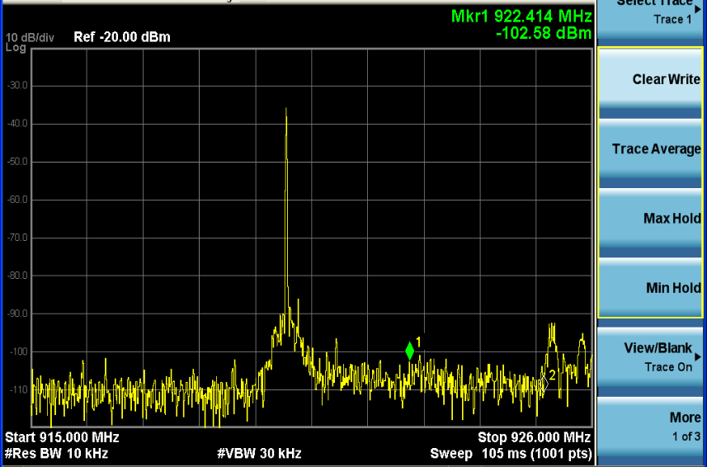

3.2.2 NARROW-BEAM WPT

Typical directive gain of power transmitting antenna is adaptable to the ranges of wireless power transmission.
FIGURE 3.2.2.1
Beam pattern diagram of narrow beam WPT
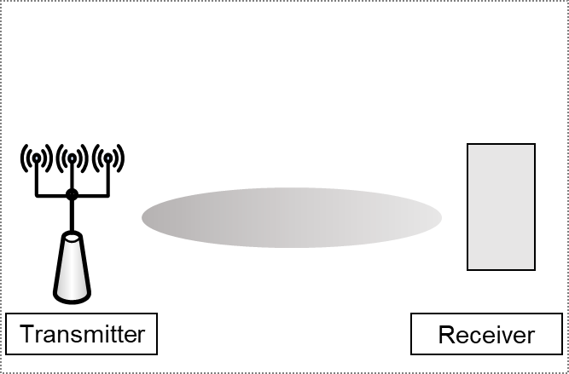

Narrow beam WPT has the same effect as the spotlight shed on an actor on stage. In an antenna array, the signals of each antenna are filtered or added depending on the frequencies of adjacent signals. TX transfers power to limited targets by forming directional beam patterns using constructive interference or destructive interference at certain angles. Narrow beam WPT may occur at TX or RX to achieve spatial selectivity. It is different from wide beam WPT transmission and reception in that signals can be directional.

The signal radiation principle of narrow beam WPT type can be briefly summarized as matching phases between the radiating signals of adjacent antennas. Each antenna offsets signals in unwanted directions for radiating signals in a desired direction. Each antenna is designed to control the direction of signals to obtain the antenna gain of the signals in a desired direction. For example, each antenna pattern is designed to be a constant pattern so that it could be half the used electromagnetic wave frequency. In this way, when electromagnetic waves are transmitted, the delay between the transmitted signals becomes a fixed value, making it possible to control the signals generated by all antennas. By adjusting the phase of each antenna in this way, the transmission direction and magnitude of the entire beamforming signals of an array antenna system can be controlled.
FIGURE 3.2.2.2
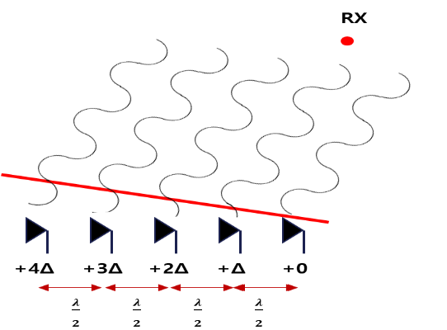
Electromagnetic wave at each pattern antenna in narrow beam WPT
FIGURE 3.2.2.3
Narrow beam WPT (a) description on delay generation at each pattern antenna (b) delay adjustment method to transmit desired signals
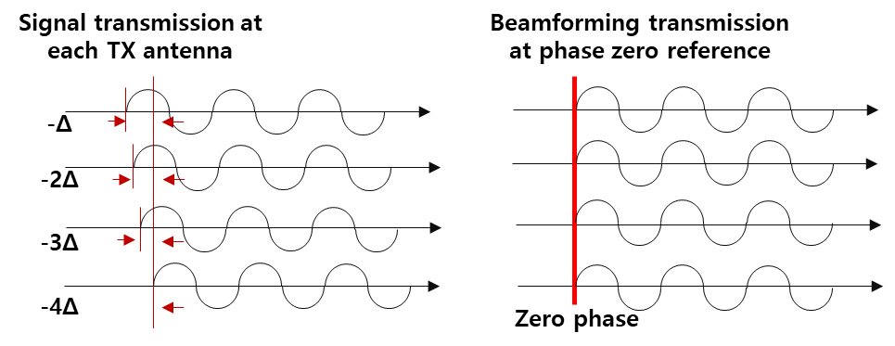
(a) (b)

FIGURE 3.2.2.4
Example of beam pattern formation by the delay and direction adjustment of the transmission signals of each antenna 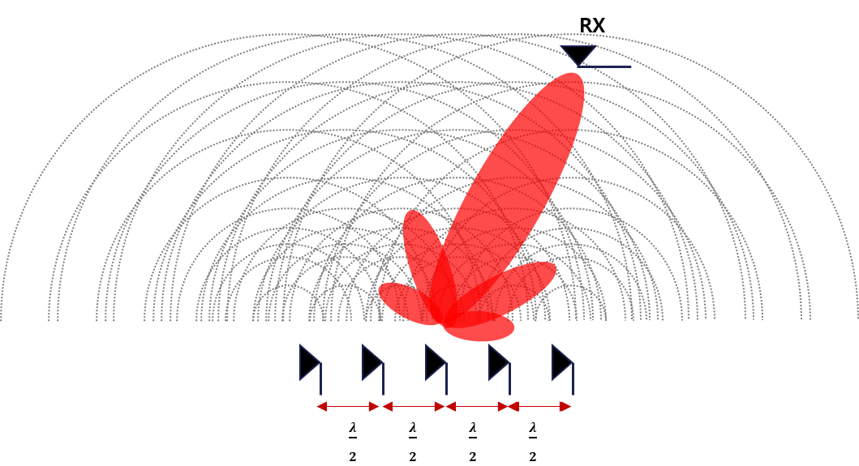
By distance, there are long range WPT transmitters which may include any WPT transmitter which has capability to change client device more than few meters. Typically, this type of systems needs high power and high directive antenna gain (narrow beam) to achieve long range WPT function.

4. Key applications of Radio Frequency Beam WPT

4.1 Portable electronic devices

In this application, electricity is supplied to mobile devices, wearable devices that are indoors or inside a vehicle. Microwave power transmission systems with a wide-angle beam and/or multi-beam are proposed to supply power to each mobile device or wearable device.
In this application, since people are often in the vicinity, control is required so that power density will be 1 mW/cm² or less in places where human is present.
Radio Frequency Beam WPT can power many types of small mobile devices while people are using them without having to place the device on a charging base. This means that devices can be powered without the user being conscious that they are charging. For example, smart watches and other wearable devices will always be able to monitor human activity without losing power or needing to be recharged (Figures 4.1.1 and 4.1.2).
FIGURE 4.1.1
WPT to mobile and wearable devices in a room
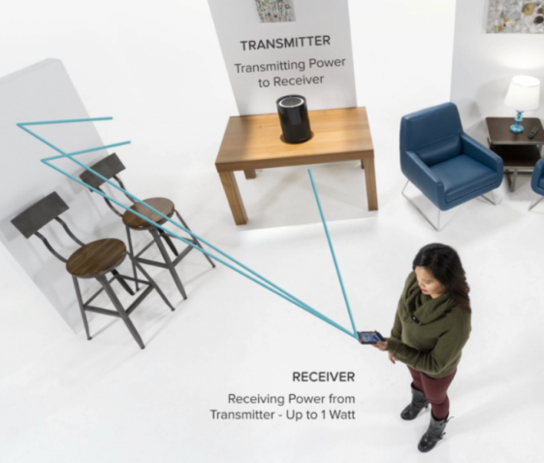
FIGURE 4.1.2
WPT to mobile and wearable devices in public space
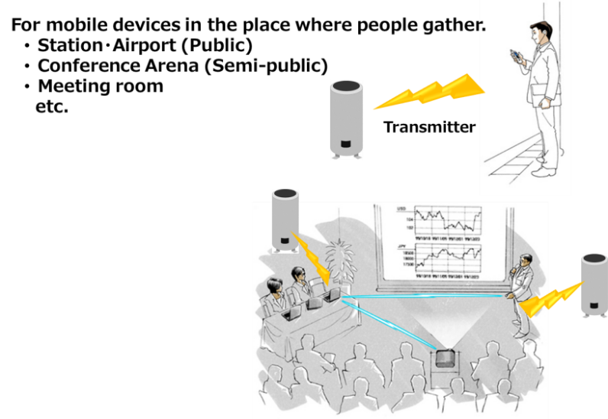

4.2 Wireless sensors

4.2.1 IoT devices

Various sensors are attached to production equipment such as processing machines and robots in the factory. Advanced factories utilizing IoT devices are trying to grasp the situation in real time by collecting all the sensing data of manufacturing.
However, the need to install dedicated wiring is a constraint on the number of sensors that can be deployed in a particular environment. By using wireless power transmission, it is possible to improve productivity and quality by collecting various sensing information without the need for dedicated wiring (Figures 4.3.1 and 4.3.2).
FIGURE 4.3.1
WPT to production equipment sensors in factory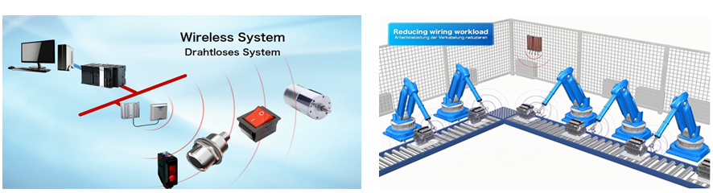
FIGURE 4.3.2
WPT to machine and line management sensors

FIGURE 4.3.3
2.4 GHz RF Beam WPT Antenna and Home Applications

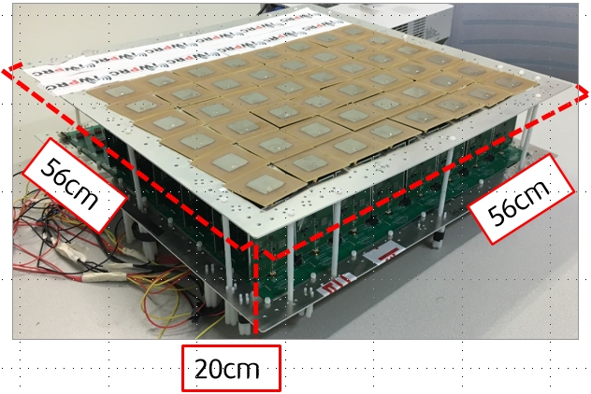 | 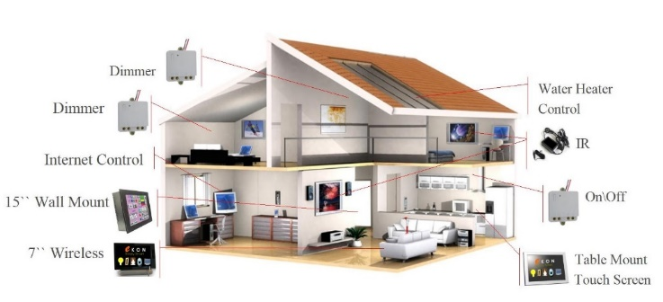
RF Beam Intelligent Selective Antenna | Wireless Charging Applications for IOT Devices

In Korea, IWPRC of Kyung Hee University introduced a charging technology using electromagnetic waves. The 3D intelligent selective space WPT that uses RF antennas is a technology also under development. It recognizes places to receive or avoid wireless power through the RF beam type and synthesizes the radio wave flow in the optimal direction to obtain the highest efficiency. The microwave type will be developed so that power can be supplied wirelessly to low-power IoT sensors several meters away. Power loss increases as the distance between the charging pad and the device is longer. If power is supplied consistently, the number of IoT devices to be charged does not affect the charging speed.

4.2.2 Sensors in vehicle

Power can be supplied to devices inside vehicles by WPT. For example, WPT to the key fob improves maintainability such as battery replacement. The WPT to TPMS (Tire Pressure Monitoring System) also improves maintainability. In addition, WPT can wirelessly connect movable parts to in-car electronic equipment such as steering wheel, door switch and seat. (Figure 4.3.3).
FIGURE 4.3.3
WPT to key-fob, TPMS, steering, door SW, seat sensors in vehicle
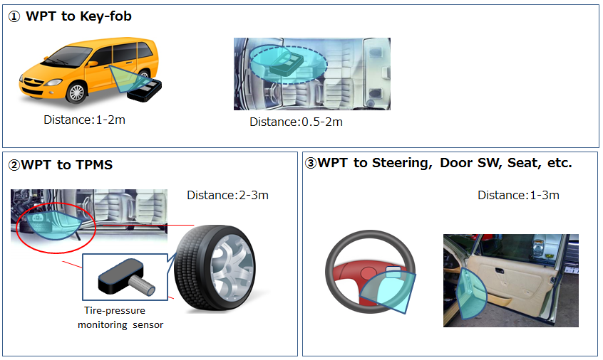
Also, many sensors are installed in the engine compartment, but if WPT is implemented between these sensors and ECU (Engine Control Unit), it is possible to reduce weight and improve fuel economy (Figure 4.3.4).
FIGURE 4.3.4
WPT to sensors in engine room in a vehicle
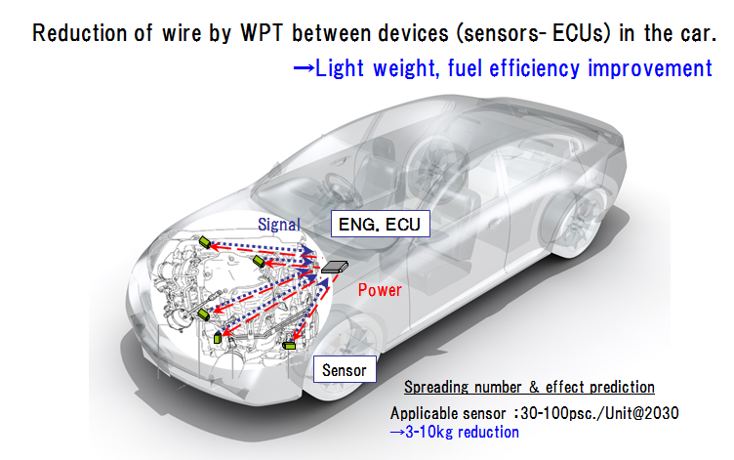

4.2.3 Watching sensor in nursing home

With the advent of an aging society, nursing care is becoming more necessary. However, shortage of human resources such as doctors, nurses and caregivers are remarkable even in the field of nursing care. By transmitting power to various sensors such as heartbeat and blood pressure at the site of nursing care, information sensing without batteries or dedicated wiring is possible (Figure 4.3.5).
FIGURE 4.3.5
Watching sensor in nursing home
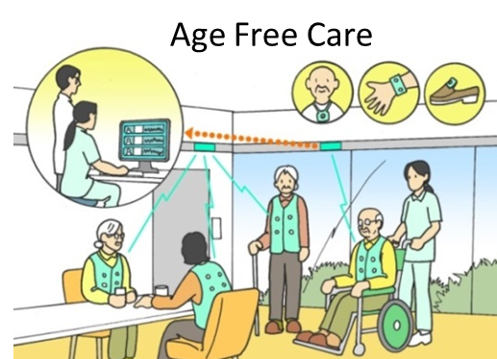

4.2.4 Wireless charging for medical devices

Korea's Biomedical Wireless Power Transmission Research Center of Sungsil University has developed an RF Beam type wireless power transmission system suitable for medical sensors for monitoring unconstrained biological signals. In addition, the center is researching new materials and device technologies that satisfy requirements such as harmlessness, miniaturization, high efficiency, high reliability, and flexibility due to wireless power transmission and implantation of medical devices to the human body, and are applying them to actual medical devices.
FIGURE 4.3.6
Bio-medical implant
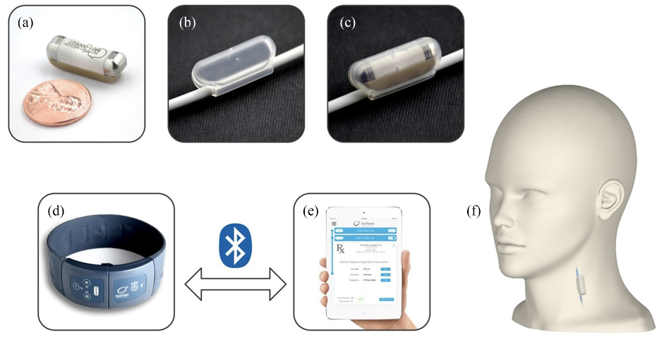

4.3 Wireless charging for electronic price tags

You can increase the manpower utilization efficiency by changing the price tag with an electronic price indicator without the need to change frequently in a hypermarket.
FIGURE 4.4.1
WPT to electronic price tags
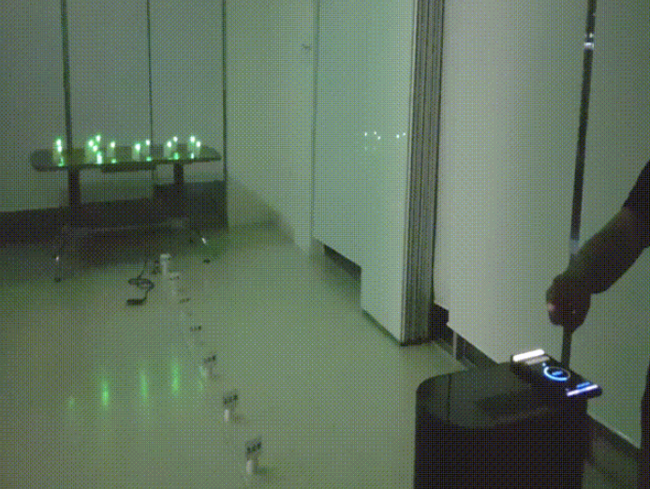

4.4 Wireless charging lamp

The wireless charging lamp can be used to charge small devices up to 50 cm from the lamp light center, such as a mouse, keyboard, cell phone, electric shaver, clock on your desk.
FIGURE 4.5.1
Wireless charging lamp
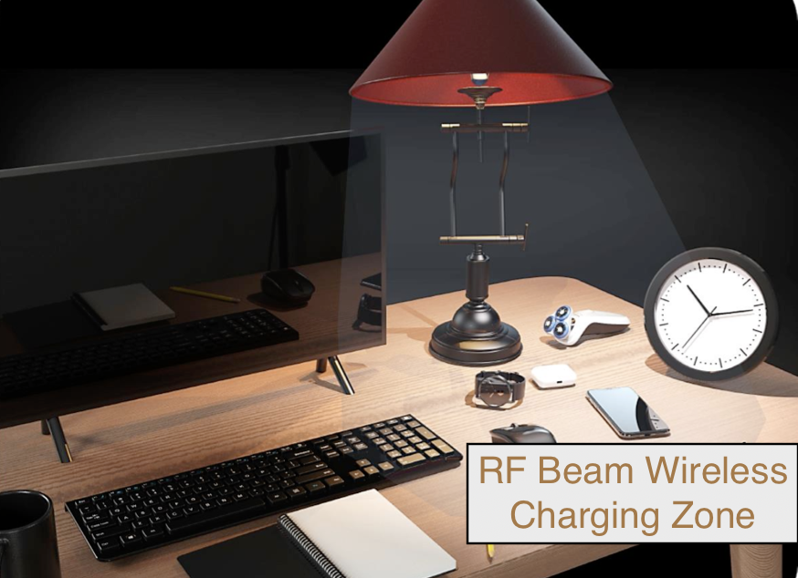

5. Radio Frequency Beam WPT standardization status

5.1 International standards development organization

International standardization organizations for WPT include ITU-R Study Group 1 (SG1), APT Wireless Group (AWG), and International Electrotechnical Commission (IEC), as well as AirFuel Alliance, which are de facto standardization groups.

CISPR/B established a working team in order to develop a Working Document on the WPTAAD (At a Distance).

CISPR/Steering is still discussing on whether RF beam WPT should consider as a radio equipment or an ISM equipment.

(1) IEC TC 100

WPT TA15 was established in 2014, and published several WPT-related international standards.

New Proposal “Parasitic communication protocol for radio-frequency wireless power transmission” related to omnidirectional RF beam WPT was approved in January 2018, and a project is under way.

(2) IEC TC 106

TC 106 established the WG9 which addresses methods for assessment of Wireless Power Transfer (WPT) related to human exposures to electric, magnetic and electromagnetic fields.

After published TR 62905 which reports exposure assessment methods for wireless power transfer systems below 10 MHz, WG9 focuses on exposure assessment method related to RF WPT systems.

(3) ITU-R SG1 WP1AThe applications of beam WPT systems were already summarized in Report ITU-R SM.2392-1[1]. Studies on impact from Radio Frequency Beam WPT to other radiocommunication services were also discussed in WP 1A. The results of these impact studies were summarized and published as Report ITU-R SM.2505[2] in 2022. At the same time, discussion towards new ITU-R recommendation for frequency ranges for Radio Frequency Beam WPT was finalized in ITU-R SG1 meeting in 2022. New ITU-R Recommendation was approved and published as Recommendation ITU-R SM.2151[3], September 2022.

TABLE 5.1.1
Activities Standardization Organizations related to RF Beam WPT
Category | Organization |  | Standardization status
De Jure Standards Organization | IEC | TC100 | Founded WPT TA15 in 2014 and enacted multiple WPT-related international standards.  NP (New Proposal) “Parasitic communication protocol for radio-frequency wireless power transmission, IEC 62980” voting related to wide beam WPT was passed in January 2018, and a project is CDV stage now.
 | ITU-R | SG1 WP 1A | Based on Question ITU-R 210-3/1 approved in 2012, the category of WPT, the radio frequency bands for WPT, and the methodologies and requirement to protect the other radio communication services from WPT operations, are being studied. In ITU-R, WPT is separated into two categories, Non-Beam WPT (including magnetic coupling and capacitive coupling WPT) and Beam WPT (WPT via radio frequency beam). Mission of WP 1A is to develop Reports and/or Recommendations on technical and operational characteristics of WPT. On the other hands, mission of WP 1B is to discuss regulatory and spectrum management issues for WPT regarding WRC-19 urgent study items. After WRC-19, all discussion items for WPT will be concentrated in WP 1A.
 | APT | AWG | TG-WPT was established under WG-TECH in AWG-12, 2012. APT Report and/or APT Recommendation for Non-Beam WPT and Beam WPT are discussing in TG-WPT. Regarding APT Recommendation for WPT, agreement from WG-SPEC is also necessary.
De Facto  Standards Organization | AirFuel |  | Published standards for magnetic resonance WPT in 2012, and AirFuel Alliance was founded by merging A4WP and PMA in 2015.  Research on 2.4 GHz Bluetooth communication and RF beam remote WPT using 2.4 GHz and 5.8 GHz frequencies is under way and to be completed in 2018.  Final objective is to develop standards for multi-mode WPT, which is the combination of the magnetic induction/ resonance/RF beam types.

5.2 EMC standards

International Special Committee on Radio Interference (CISPR) was founded in 1934 to set standards for controlling electromagnetic interference in electrical and electronic devices, and is a part of the International Electrotechnical Commission (IEC).
CISPR* is promoting international standardization related to electromagnetic compatibility (EMC) that protects wireless services from unintentional electromagnetic waves generated from devices and makes devices resistant to electromagnetic waves.

TABLE 5.2.1
Recommendations of Standardization Organizations related to WPT
Category | Organization | Major recent recommendations
Electromagnetic Compatibility | CISPR | It is a standardization organization for frequency influence protection of radio communication systems and EMC requirements, founded in 1934. Currently, all mobile WPT devices must meet the international EMC standards specified by CISPR.  It is revising the EMC regulations (CISPR 14-1) for magnetic-induction WPT devices for homes.  The Standards CISPR 11, 14-1, 15 or 32 may be applied for non-beam WPT equipment. However, the revisions of each standard are under way.  CISPR-B is standardizing EMC issues for ISM devices and CISPR-D for electric vehicles

5.3 EMF standards

In terms of the human health influence regulations, the human body protection standards are following the standards established by the International Commission on Non-Ionizing Radiation Protection (ICNIRP), but there is no international standard for detailed measurement assessment methods. IEC TC 106 is preparing international standards on measurement and calculation methods to assess human exposure to electric, magnetic and electromagnetic fields. WG9 is addressing methods for assessment of Wireless Power Transfer (WPT) related to human exposures to electric, magnetic and electromagnetic fields. TC 106's WG9 is developing a standard for a continuous evaluation method of human exposure to electromagnetic waves for drones and electric vehicle wireless chargers as well as smartphones.
The TR 62905 technical report published in 2018 presents a method of evaluating the exposure of the human body to electromagnetic waves of the electromagnetic wave type wireless charging system using the 900 MHz, 2.4 GHz, and 5.8 GHz bands. After completion of TR 62905, IEC TC 106 is preparing PT 63184 to prepare basic standards for wireless power transmission systems.
TABLE 5.3.1
Recommendations of Standardization Organizations related to Human Exposure
Category | Organization | Major recent recommendations
Human body protection | ICNIRP | An international committee established in 1992 to determine exposure limits for protecting the human body against electromagnetic waves.  Currently, most countries are regulating frequency bands and designating reference levels for the influence of electromagnetic wave on the human body by applying the ICNIRP 1998 standards.
 | IEC TC106 | TC106 established the WG9 which addresses methods for assessment of Wireless Power Transfer (WPT) related to human exposures to electric, magnetic and electromagnetic fields.  After published TR 62905 which reports exposure assessment methods for wireless power transfer systems below 10 MHz, WG9 has focused on exposure assessment method related to RF WPT systems.

5.4 ICNIRP

ICNIRP has released the latest ICNIRP 2020 RF safety Guidelines [6]. This publication replaces the 100 kHz to 300 GHz part of the ICNIRP (1998) radiofrequency guidelines, as well as the 100 kHz to 10 MHz part of the ICNIRP (2010) low-frequency guidelines. This publication intents to provide guideline for the protection of humans exposed to radiofrequency electromagnetic fields (EMFs) in the range 100 kHz to 300 GHz. The main objective of this publication is to establish guidelines for limiting exposure to EMFs that will provide a high level of protection for all people against substantiated adverse health effects from exposures to both short- and long-term, continuous and discontinuous radiofrequency EMFs. [7]
6. Radio Frequency Beam WPT’s spectrum

6.1 Frequency ranges considered for the use of Radio Frequency Beam WPT in APT countries

APT Survey Report on radio frequency beam WPT (APT/AWG/REP‑122) describes that the following frequency bands are considered for the use of Radio Frequency Beam WPT in some APT countries as shown in TABLE 6.1.

TABLE 6.1
Summary of Frequency Ranges Regulated and/or Planned for Radio Frequency Beam WPT

Frequency ranges regulated or planned for radio frequency beam WPT
Frequency band | Frequency range
920 MHz band | 920-923 MHz (Cambodia)  917-920 MHz (Japan)  Not specified (Myanmar)
2.4 GHz band | 2 400-2 500 MHz (Cambodia)  2 400-2 486 MHz (Japan)  Not specified (Myanmar)
5.7 GHz band | 5 725-5 875 MHz (Cambodia)  5 738-5 766 MHz (Japan)  Not specified (Myanmar)
24 GHz band | 24-24.25 GHz (Cambodia)  Not specified (Myanmar)
61 GHz band | 61-61.5 GHz (Cambodia)

6.2 Japan

6.2.1 920 MHz band

Since the 920 MHz band has a longer wavelength than the 2.4 GHz band and 5.7 GHz band, and the propagation loss is smaller than those bands, it can be expected to feed a wide range of sensors.
Because of this, this frequency band is suitable for point-to-multipoint feeding as a power source for factory and nursing care sensor networks.

6.2.2 2.4 GHz band

In 2.4 GHz band, higher gain can be expected with small antennas on devices than in 920 MHz band, which makes devices smaller in size. Moreover, since 2.4 GHz band is most widely and globally used for Wi-Fi and ISM devices, the cost of the radio components for 2.5 GHz band WPT devices can be lower than 920 MHz and 5.7 GHz bands. This leads to benefits for early adaptation of WPT in the initial stage.

6.2.3 5.7 GHz band

The 5.7 GHz WPT band partially overlaps with the 5.8 GHz highest ISM band below 10 GHz. This band is advantageous in terms of antenna miniaturization and availability of off-the-shelf highly efficient RF components. High-gain and highly flexible beam steering based on a compact phased array enables large power delivery to a single receiver as well as distributed power delivery to multiple receivers. In addition, the beam steering can help interference reduction to the existing radio systems and realizing personnel protection

7. Technical regulation issues for Radio Frequency Beam WPT in some APT member countries

7.1 Regulation status for the use of Radio Frequency Beam WPT in APT countries

APT Survey Report on radio frequency beam WPT (APT/AWG/REP‑122) describes regulation status for radio frequency beam WPT systems/devices as shown in TABLE 7.1.

TABLE 7.1
Regulation status for radio frequency beam WPT systems/devices

Country/Region | Current radio regulations | Plans to establish new regulations | Radio regulatory category
Iran  (Islamic Republic of) | No | No | This regulation is developing and not define which category of license will be used yet.
Myanmar  (Republic of the Union of) | Yes | Yes | ISM equipment  SRD  Un-licensed radio equipment
Japan | Yes | Yes  New regulations were enforced in May 2022. | Licensed radio equipment
Indonesia | No | Yes | SRD
China  (People’s Republic of) | No | No | None
Cambodia (Kingdom of) | Yes | Yes | ISM equipment  un-licensed radio equipment
Thailand  (Kingdom of) | No | No | None
Korea  (Republic of) | No | Yes | None

7.2 Japan

Radio Frequency Beam type WPT supplies electric power over the space intentionally by transmitting radio waves using antenna system, which is different from non-beam WPT. An Advisory Board on the effective use of radio waves in Japan considered a possible regulatory framework for Radio Frequency Beam WPT and concluded that Radio Frequency Beam WPT should be basically regulated as the “radio equipment” category as those used for radiotelegraphy, radio telephony, or any other electric equipment for the transmission or reception of radio waves because it would require frequency assignments, licensed operators and regulations to operate transmitting/receiving devices.
In implementing the regulation for Radio Frequency BEAM WPT technologies, the following should be noted and taken into consideration:

– Regulatory framework for treating Radio Frequency BEAM WPT equipment as “radio equipment”, qualification category of the operator, and regulatory type of radio stations since the current regulation system has not fully envisaged WPT.
– Technical requirements for the Radio Frequency BEAM WPT receiving device based on the study of impacts to other radiocommunication stations, considering high level unwanted emission even from the receiving unit in case of receiving high electric power.
- New safety measures to protect human bodies from harmful effects of RF exposure to Radio Frequency BEAM WPT radio waves, which may include human body detection when transmitting, transmission interruption, safety instruction and mechanism, and further protection measures to keep off the people from local transmission region observing higher RF exposure level than the restriction defined in the Radio Protection Guidelines.

A stepwise approach to achieve above is taken in the rulemaking process.
For the 1st step, Radio Frequency Beam WPT Working Group of Information and Communication Council of the Ministry of Internal Affairs and Communications reported the technical conditions of Radio Frequency Beam WPT in July 2020 [7]. It describes technical conditions operating in 920 MHz band, 2.4 GHz band, and 5.7 GHz band for the use indoors (e.g., factories, offices) with human body protection requirements from RF exposure.
The Ministry of Internal Affairs and Communications (MIC) of Japan amended relevant ministerial ordinances in May 2022 to issue ‘premises radio station’ licenses to some types of beam WPT devices. In enforcing the Regulation, an operational coordination mechanism was also established and operated. The way of operational coordination mechanism had been decided by a study group of the Ministry of Internal Affairs and Communications and announced on May 26, 2021. The basic concept of the way of operational coordination mechanism are as follows,

Basic concept of operational coordination mechanism
-Because of the peculiarity of the new radio wave utilization area that WPT transmits power, it is necessary to give due consideration not to interference with other wireless systems. For this reason, the WPT installation applicant or installation / operator (hereinafter referred to as "WPT licensee") should take the initiative in coordination operations, such as providing necessary information to the licensee of the existing wireless system, etc.
-On the other hand, WPT will become a new area for using radio waves and can be one of the basic environments that support the innovation and DX. Licensees of existing wireless systems should flexibly and proactively cooperate with WPT licensees by providing information necessary for individual coordination and technical advice on avoiding interference.
-The construction of an operational coordination system will be an advanced initiative related to radio wave management and expected to be successful examples that will lead to the future. It is expected that both sides will make efforts to bring the coordination to fruition with a perspective of understanding and ingenuity.

The 2nd and later Steps further extend studies for the use outdoors and higher power transmission including new technology development, applications, commercialization, effective spectrum sharing, noise suppression, and etcetera.

7.3 Korea (Republic of)

In Korea, it is possible to experiment with wide and narrow beam type WPT for pilot system in university or laboratory by being sure no interference to other legacy radio services based on the Radio Waves Act. The government began to be interested in RF BEAM wireless power transmission technology and standardization work since 2018. The main points of the discussion are as follows; [8]
– The distribution of dedicated frequency for RF beam WPT,
– Improve of electromagnetic compatibility system and researching human body protection from electromagnetic waves,
– RF BEAM WPT major issues: (1) Technique evaluation standard, (2) RF effect measuring method, (3) Human effects, (4) Electromagnetic interference standard, and (5) Numerical analysis technique for human body protection standard.

7.4 Viet Nam

In Viet Nam, the technical regulation on RF beam WPT has been under study and has not been decided yet. Some technical experiments were conducted during the year of 2018 and 2019. The purpose of the experiments was to assess the feasibility of the technology in the reality and to conduct the impact studies from RF beam WPT to other radio communication systems. Some other matters are under discussion as follows:
- Evaluating application potential and market demands on the usage of RF beam WPT technology and products.
- Studying on suitable frequency bands together with technical and operational requirements for RF beam WPT ensuring that no harmful interference to other radio services.
- Classification for RF beam WPT as a type of radio communication device or radio applied device. In case RF beam WPT devices are treated as radio applied devices, these devices should use ISM bands.
- RF exposure of RF beam WPT devices to human body.

8. Examples of studies on the impact of Radio Frequency Beam WPT in some APT member countries

8.1 Study-A: Impact to radiocommunication systems in 920 MHz, 2.4 GHz, and 5.7 GHz bands

This section discusses studies conducted in Japan on the impact to radiocommunication systems in 920 MHz, 2.4 GHz, and 5.7 GHz bands.

As described in 7.1, Radio Frequency Beam WPT equipment is under consideration to be categorized as “radio equipment”, not but as “ISM equipment”, in Japanese radio regulations. Therefore, the impact studies for other radiocommunication systems are necessary to establish new regulations for Radio Frequency Beam WPT. Studies on the impact from Radio Frequency Beam WPT to radiocommunication systems are in progress assuming future commercial Radio Frequency Beam WPT system specifications and identifying incumbent radio systems to consider as shown in sections 8.1.1 to 8.1.6.

8.1.1 System specifications for Radio Frequency Beam WPT development

The development of Radio Frequency Beam WPT based on the system specifications shown in Table 8.1.1 and Table 8.1.2 is proceeding in Japan. The system specifications System 1, Systems 2, and System 3, shown in Table 8.1.1 are supposed the first commercial systems with practical application objectives in 2021 (Step 1). Table 8.1.2 shows that expected in 2023 and later (Step 2). WPT power levels for these two Steps are almost the same level. However, the major enhancement in performance from the Step 1 to Step 2 is the capability of temporal rate wireless power transmission. In Step 2, the supposed Radio Frequency Beam WPT systems can transfer power over the air at the same time and place where human bodies and concerned radiocommunication systems using the same frequency bands exist, by means of new advanced technologies for Radio Frequency Beam WPT such as detection technologies for human bodies and other wireless systems with advanced beam-forming technology to steer wireless power beam to keep off from human bodies and other wireless systems.

The System 1 is mainly used in WPT for wireless-powered sensor network as shown in Figures 4.3.1, 4.3.2 and 4.3.5. The System 1 is used in indoor and controlled environment where WPT equipment is controlled by managers of factories, nursing homes and so on. The power consumption of the sensor is about several hundred mWs or less.

The System 2 and the System 3 are mainly used in WPT for mobile and wearable devices as shown in Figures 4.1.1 and 4.1.2 in addition to the application of the System 1. The System 2 and the System 3 are used in indoor or outdoor and general environment such as offices and public spaces. The power transmission to the mobile and wearable devices generally requires several watts.

TABLE 8.1.1
Expecting specifications of RF Beam WPT commercial systems in 2021 (Step 1)

System |  | System 1 | System 2 | System 3
Spec. | Frequency | 920 MHz bands  (915-930 MHz) | 2.45 GHz bands  (2.40-2.499 GHz) | 5.7 GHz bands  (5.470-5.770 GHz)
 | Output Power | 1 W | 15 W | 32 W
 | Antenna gain | 6 dBi | 24 dBi | 25 dBi
 | EIRP | 36 dBm | Max. 65.8 dBm | Max. 70 dBm
 | Modulation | NON, G1D, etc. | NON | NON
 | Place of use | Indoor | Indoor | Indoor

TABLE 8.1.2
Expecting specifications of RF BEAM WPT commercial systems in 2023 and later (Step 2)
System |  | System 1 | System 2 | System 3
Spec. | Frequency | 920 MHz bands  (915-930 MHz) | 2.45 GHz bands  (2.400-2.499 GHz) | 5.7 GHz bands  (5.470-5.770 GHz)
 | Output Power | 5 W | 20 W | 32 W
 | Antenna gain | 13 dBi | 25 dBi | 30 dBi
 | EIRP | 50 dBm | 68 dBm | 70 dBm
 | Modulation | TBD | TBD | TBD
 | Place of use | Indoor / Outdoor | Indoor / Outdoor | Indoor / Outdoor

8.1.2 Frequency bands and incumbent radiocommunication systems and services considered in the study

Incumbent radiocommunication systems and services adjacent to or included in 917-920 MHz, 2.410-2.486 GHz, and 5.738-5.766 GHz, which were considered in the study, are listed in Table 8.1.3, Table 8.1.4, and Table 8.1.5, respectively.

TABLE 8.1.3
917-920 MHz radiocommunication systems and services considered in the study

System | Frequency | Protection criterion | References
Digital MCA Service | 930 MHz – 940 MHz (uplink) | −108.8 dBm/MHz  (in band)  −51 dBm (out of band) | ARIB^{*1} STD-T85  (Japan)
940 MHz – 945 MHz
(downlink)
Advanced MCA Service | 895 MHz – 900 MHz  (uplink) | −110.8 dBm/MHz (in band)  −44 dBm (out of band, 12.5 MHz separation) | 3GPP TS36 104 ｖ8.3.0 (2008-9)
 | 850 MHz – 860 MHz  (downlink) | −119 dBm/MHz (in band)  −43 dBm (out of band, modulation)  −15 dBm (out of band, CW) | 3GPP TS36 104 ｖ8.3.0 (2008-9)
LTE-A (Band 8) | 900 MHz – 915 MHz  (uplink) | −110.8 dBm/MHz (in band)  −44 dBm (out of band, 12.5 MHz separation) | 3GPP TS36 104 ｖ8.3.0 (2008-9)
 | 945-960 MHz (downlink) | −119 dBm/MHz (in band)  −43 dBm (out of band, modulation)  −15 dBm (out of band, CW) | 3GPP TS36 104 ｖ8.3.0 (2008-9)
RFID (Passive) | 916.7 MHz – 923.5 MHz | −81 dBm/MHz (in band)  −30 dBm (out of band, 2 MHz separation) | ARIB STD-T106  ARIB STD-T107  (Japan)
RFID (Active) | 915.9 MHz – 929.7 MHz | −127 dBm/MHz (in band)  −80 dBm (out of band) | ARIB STD-T108  (Japan)
Radio astronomy | 1 400 MHz – 1 427 MHz | −197.4 dBW/MHz | Recommendation ITU-R RA.769-2
^{*1}: Association of Radio Industries and Businesses (https://www.arib.or.jp/english/)

TABLE 8.1.4
2 410-2 486 MHz radiocommunication systems and services considered in the study

System | Frequency | Protection criterion | References
Wireless LAN | 2 400 MHz – 2 497 MHz | −92 dBm (co channel)  −66 dBm (adjacent channel),  −50 dBm (alternate adjacent channel) | IEEE Std.802.11-2016
Premises radio | 2 400 MHz – 2 483.5 MHz | −98 dBm  (including 11 dBi antenna gain) | ARIB RCR STD-1  ARIB RCR STD-29  (Japan)
Unmanned mobile image transmission system (Wireless system for drones and other unmanned vehicles) | 2 483.5 MHz – 2 494 MHz | −98 dBm (co channel)  −72 dBm (adjacent channel),  −56 dBm (alternate adjacent channel)  (including 6 dBi antenna gain) | Report on MIC Advisory No. 2034  (Japan)
Geostationary Mobile Satellite Service | 2 500 MHz – 2 535 MHz | −124.9 dBm/MHz (in band)  −41 dBm  (out of band, 10-25 MHz separation) | Report on MIC Advisory No. 2032  (Japan)
Non-Geostationary Mobile Satellite Service | 2 483.55 MHz – 2 500 MHz | −119.4 dBm/MHz | Report on MIC Advisory No. 82  (Japan)
Broadcasting Service: Field Pickup (FPU) | 2 330 MHz – 2 370 MHz | −102 dBm/MHz  (mobile relay Uplink) | Report on MIC Advisory No. 2024  (Japan)
Radio astronomy | 2 695 MHz | −187 dBW/MHz | Recommendation ITU-R RA.769-2
Amateur radio | 2 400 MHz – 2 450 MHz | −110.83 dBm/MHz | JARL^{*2} requirement
^{*2}: The Japan Amateur Radio League, Inc. (https://www.jarl.org/English/0-2.htm)

TABLE 8.1.5
5 838-5 766 MHz radiocommunication systems and services considered in the study

System | Frequency | Protection criterion | References
Wireless LAN (W56) | 5 470 MHz – 5 730 MHz | −63 dBm (adjacent channel),  −47 dBm (alternate adjacent channel) | IEEE Std.802.11-2016
Dedicated Short Range Communication (DSRC) | 5 770 MHz – 5 850 MHz | −42 dBm  (class-2, spurs response rejection),  −100 dBm (class-2) | ARIB STD-T75  (Japan)
Broadcasting Service: Studio to Transmitter Link (STL) & Transmitter to Transmitter Link (TTL) | 5 850 MHz – 5 925 MHz | −101.6 dBm  (equivalent thermal noise level) | ARIB_STD-B22  (Japan)
Broadcasting Service: Field Pickup (FPU) & Transmitter to Studio Link (TSL) systems | 5 850 MHz – 5 925 MHz | −89.4 dBm  (FPU fixed relay station) | ARIB STD-B33  (Japan)
Unmanned mobile image transmission system (Wireless system for drones and other unmanned vehicles) | 5 650 MHz – 5 755 MHz | −98 dBm (in-band),  −72 dBm (adjacent channel),  −56 dBm (alternate adjacent channel) | Report on MIC Advisory No. 2034  (Japan)
Weather radar | 5 250 MHz – 5 372.5 MHz | −120 dBm (noise), −40 dBm (CW) | Recommendation ITU-R M.1849-2
Radio astronomy | 4 700 – 5 140 MHz, 3 000 MHz – 14 000 MHz | −187 dBW/MHz | Recommendation ITU-R RA.769-2
Amateur radio | 5 650 MHz – 5 850 MHz | −110.83 dBm/MHz | JARL requirement

8.1.3 Specifications and parameters used for the study

Expected specifications and system parameters used for the study are shown in Table 8.1.6, Figure 8.1.1, Figure 8.1.2 and Figure 8.1.3.

TABLE 8.1.6
Expected specifications of RF beam WPT commercial systems considered

 | System 1  920 MHz band | System 2  2.4 GHz band | System 3  5.7 GHz band
Transmitter antenna output power | 1W (30 dBm) | 15W (41.8 dBm) | 32W (45.0 dBm)
Frequency channels | 918.0, 919.2 MHz  (2 channels) | 2 412, 2 437, 2 462, 2 484 MHz  (4 channels) | 5 740, 5 742, 5 744, 5 746, 5 748, 5 750, 5 752, 5 758, 5 764 MHz  (9 channels)
e.i.r.p | 36 dBm Max. | 65.8 dBm Max. | 70.0 dBm Max.
Tolerance of occupied bandwidth | 200 kHz | Not specified | Not specified
Transmitter antenna directive gain | 6.0 dBi | 24.0 dBi | 25.0 dBi
Location and height of transmitter antenna | Located indoor area | Located indoor area and set on ceiling to look down | Located indoor area and set on ceiling to look down
 | 2.5 m above floor | 5.0 m above floor | 4.6 m above floor
Transmitter antenna directive pattern | Figure 8.1.1 | Figure 8.1.2 | Figure 8.1.3
Usage environment | Indoor | Indoor | Indoor
 | WPT controlled environment  and/or WPT general environment | WPT controlled environment | WPT controlled environment
Modulation | Not specified | CW | CW
Building entry loss | 10.0 dB | 14.0 dB | 16.0 dB

“WPT controlled environment” and “WPT general environment” are defined. “WPT controlled environment” is defined as,
– Indoor and closed area,
– Environment where limits of Japanese radio exposure guidelines in controllable area can be cleared, and/or the manager/administrator can cut off power transfer of Radio Frequency Beam WPT systems when limits of Japanese radio exposure guidelines in controllable area are happened to be not cleared,
– Environment where the manager/administrator can manage and control both of Radio Frequency Beam WPT systems and incumbent radio communication services in order to avoid or reduce harmful interference from Radio Frequency Beam WPT systems.
“WPT general environment” are defined as the other environment where the above conditions cannot be met.

FIGURE 8.1.1
Transmitter antenna directive pattern for 920 MHz band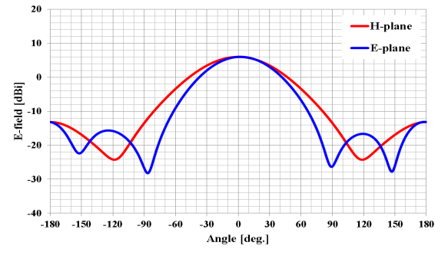

FIGURE 8.1.2
Transmitter antenna directive pattern for 2.4 GHz band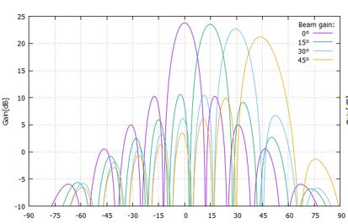
FIGURE 8.1.3
Transmitter antenna directive pattern for 5.7 GHz band
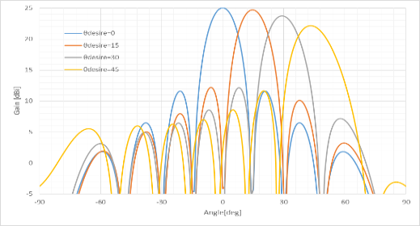

8.1.4 Building entry loss consideration

The study referred to building entry loss defined in Section 3 of Recommendation ITU-R P.2109-1 “Prediction of building entry loss”.
The building entry loss value depends on the outer wall material. Two building types are shown in Recommendation ITU-R P.2109-1. One is "Thermally efficient" that uses heat shield and heat insulating material with high electromagnetic wave reflection characteristics. The other is "Traditional" that does not use them. The median loss Lh can be given by the calculation formula shown below. Moreover, the loss also depends on the frequency.
L_{h} = r + slog(f) + t(log(f) )²
where r, s, and t are the constants shown in Table 8.1.7, and f is the frequency (GHz). Table 8.1.8 shows the calculation results for the median loss for the representative frequencies of the three frequency bands used in the wireless power transmission systems via radio frequency beam.
According to FIGURE 1 of Recommendation ITU-R P.2109-1, the "Thermally efficient" building type has a large loss by about 15 dB compared to "Traditional", but it is unlikely that thermally efficient construction materials are used for all outer walls of the buildings. The examination was based on the value of the "Traditional" type.
Table 8.1.7
Model coefficients used for building entry loss calculation in Recommendation ITU-R P.2109-1
Item | r | s | t
Traditional | 12.64 | 3.72 | 0.96
Thermally efficient | 28.19 | –3.00 | 8.48
Table 8.1.8
Calculation results of the median loss for the three frequency bands used in RF Beam WPT
Item | 920 MHz band | 2.4 GHz band | 5.750 GHz band
Lh (Traditional) | 12.5 dB | 14.2 dB | 16.0 dB
Lh (Thermally efficient) | 28.3 dB | 28.3 dB | 30.8 dB
Table 8.1.9
Building entry loss used for the studies on the impact of RF Beam WPT
Item | 920 MHz | 2.4 GHz | 5.7 GHz
Wall loss | 10.0 dB | 14.0 dB | 16.0 dB

8.1.5 Use case scenarios and conditions for Impact Studies on Radio Frequency Beam WPT

Table 8.1.10 shows the use case scenarios and conditions for Impact Studies on beam WPT systems used for impact studies.
The System 1 is mainly used in WPT for wireless-powered sensor network. The System 1 is used in indoor and controlled environment where WPT equipment is controlled by managers of factories, nursing homes and so on. The power consumption of the sensor is about several hundred μW or less.
The System 2 and the System 3 are mainly used in WPT for small displays in addition to the application of the System 1. The System 2 and the System 3 are used in indoor and controlled environment where WPT equipment is controlled by managers of factories, plants, warehouses and so on. The power transmission to the receiver devices requires up to several watts.
TABLE 8.1.10
Use case scenarios and conditions for RF Beam WPT systems
RF Beam WPT system | System 1  920 MHz band | System 2  2.4 GHz band | System 3  5.7 GHz band
Usage environment | Factory (Indoor), nursing home, etc. | Factory (indoor), plant (indoor), warehouse, etc. | Factory (indoor), plant (indoor), warehouse, etc.
Application | Charging and power supply to sensor network | Charging and power supply to sensors, display and information devices | Charging and power supply to sensors, display and information devices
Number of receiving devices per one WPT transmitter | 5 to 10 devices  (Simultaneous reception) | 1 to several ten devices  (Successive or sequential reception) | 1 to several ten devices  (Successive or sequential reception)
Power range | Several μW to several hundred μW | 50 mW to 2 W | Several mW to several hundred mW
Power transfer distance | Less than 5 m | Less than 10 m | Less than 10 m
Coexistence with other wireless systems | Feasible. Take appropriate interference mitigation and radio protection measures | Feasible. Take appropriate interference mitigation and radio protection measures | Feasible. Take appropriate interference mitigation and radio protection measures
Power transfer while human bodies exist | Possible to transfer under the condition that limits of national radio exposure guidelines are cleared | Off | Off

8.1.6 Study results

For the WPT systems intended the operation in the 920 MHz band, the system parameters assumed for the impact study (See Table 8.1.6) were compliant with the radio regulation including transmission intervals for the RF-ID systems currently operated in the same frequency range. Minimum separation distances were derived in accordance with the Radio Frequency Beam WPT characteristics for the case geographical separation distance is necessary to regulate. In addition, Monte-Carlo system-level simulation was performed to assess interfering likelihood from Radio Frequency Beam WPT to LTE and MCA mobile communication networks.
For the Radio Frequency Beam WPT systems intended for the operation in the 2.4 GHz band and 5.7 GHz band, the study was conducted with the system parameters (See Table 8.1.6) to determine required technical requirements and operational conditions under the current radio regulation including frequency allocation and operational conditions. Study results in 2.4 GHz band and 5.7 GHz band are summarized as follows:
1 Clear Channel Assessment (CCA) mechanism shall be adopted to coexist with WLAN systems and / or Specified Low Power Radio Stations. It turned out that WLAN system performance such as throughput can be maintained without harmful interference by adding CCA mechanism.
2 For radioastronomy, weather radar, and Radio Beacon services, minimum separation distances were specified.
3 For broadcasting systems, mobile satellite communication systems, and Dedicated Short Range Communication (DSRC) system, minimum separation distances were specified. In addition, operational coordination was addressed for the case Radio Frequency Beam WPT causes harmful interference.
4 For unmanned mobile image transmission system (i.e., a wireless communication system for drones and other unmanned vehicles), studies assuming practical use cases showed that spectrum sharing without causing harmful impact was possible by operational coordination as needed between WPT systems and unmanned mobile image transmission systems.
5 For amateur radio services, Radio Frequency Beam WPT installation conditions for spectrum sharing were specified. In addition, Radio Frequency Beam WPT systems shall not use the frequency band for Earth-Moon-Earth (EME) systems and repeater systems. Operational coordination is undertaken between WPT systems and amateur radio systems.
Furthermore, a comprehensive Radio Frequency Beam WPT management rule regarding WPT operation environment and WPT radio frequency EMFs was defined and can be applied specific use cases using the frequency bands to abide by the Radio Radiation Protection Guidelines. See Annex 1 for details. Thus, required technical requirements and operational conditions not to cause harmful impact to the existing systems and services were determined.
Below shows individual summaries of the study per incumbent system.

8.1.6.1 917-920 MHz

(1) Digital MCA Service
The study referred to the examination methodologies and results on the past coexistence study when RFID system was introduced in 917-920 MHz. Radio Frequency Beam WPT in the band was assumed almost the same technical conditions for assessment as RFID. Possibility of harmful impact is extremely low while keeping the given conditions and expecting additional propagation loss due to building entry loss. The condition includes the separation distance, adjustment of setting conditions, and measures to mitigate interferences.
(2) Advanced MCA Service
WPT can be shared by the control station (base station: downlink) by considering vertical directivity.
The mobile station (uplink) can be shared when both systems do not exist in the same room, which was shown by Monte-Carlo simulation using the extended Hata formula (300 m or less).
In the case of the same room, the required improvement amount is about 10 dB, but it can be shared because it is expected to be attenuated by obstacles and the human body in the room.
However, regarding the use with the WPT system in the same room, the WPT users will be alerted the possibility of interference to MCA stations.
(3) LTE-A (Band 8)
The WPT system can be shared in a WPT general environment even when there is no transmission time limit. On the other hand, the WPT system can be shared in the management environment by limiting the transmission time (stopping transmission for 50 msec within 4 seconds of the transmission).
(4) RFID (Passive)
The WPT system and RFID system can be shared on the same channel if a separation distance of about 6 m is secured. If the separation distance cannot be secured, those system can coexist by changing the WPT transmit channel and/or RFID channel, or shield with a wall.
(5) RFID (Active)
The passive RFID system is assumed coexisting with the active RFID system. The WPT system can be coexist with active RFID system because of the specification of WPT system is almost same as passive RFID interrogator.
(6) Radio Astronomy
The separation distance was calculated with free space loss model to be 37.5 km using the spurious ability value (-60.5 dBm / MHz). The WPT system has set that distance from radio astronomy as a restricted installation area.

8.1.6.2 2.410-2.486 GHz

- Wireless LAN
The simulation using the CCA mechanism on the Radio Frequency Beam WPT system was conducted to study the impact to the Wi-Fi devices located outside of the WPT controlled environment. The decline of the throughput of those Wi-Fi devices could be suppressed with appropriate parameters of CCA mechanism, compared with the case when another Wi-Fi AP was operated at the same location instead of the Radio Frequency Beam WPT inside the WPT controlled environment. Antenna directions should be adjusted not to directly face each other to prevent the device being damaged.
- Premises Radio
Within the Radio Frequency Beam WPT controlled environment the operation of the premises radio can be managed and controlled by the same operator as for the Radio Frequency Beam WPT. Moreover, within the 84.9 m from the Radio Frequency Beam WPT location it can be suppressed the transmission with the CCA mechanism when premises radio is transmitting. Antenna directions should be adjusted not to directly face each other to prevent the device being damaged.
- Unmanned mobile image transmission system
Separation distance was calculated with extended Hata model, and it is 3.6 km on co channel from the Radio Frequency Beam WPT to the unmanned mobile image transmission system outdoor. However, since the system is usually operated outside the cities and the usage time and places are planned, the harmful interference can be avoided by the coordination procedure.
- Geostationary Mobile Satellite Service
Separation distance was calculated with worst case scenario of out of band interference, where antenna directivity direction of the GEO MSS receiver was perfectly matched to the beam direction of the Radio Frequency Beam WPT. It is 30 m in the northern part of Japan. With the separation distance and coordination procedure, if necessary, harmful interference can be avoided. If necessary, the operational coordination is performed between WPT systems and mobile satellite communication systems.
- Non-Geostationary Mobile Satellite Service
Separation distance was calculated of in band interference with extend Hata model and it was 0.96 km. Since Non-Geostationary Mobile Satellite Service is generally used in the location where cellular mobile system cannot be reached in Japan and the Radio Frequency Beam WPT does not possibly exist, the harmful interference can be avoided. If necessary, the operational coordination is performed between WPT systems and mobile satellite communication systems.
- Broadcasting Service: Field Pickup (mobile Electronic News Gathering)
Separation distance was calculated in various scenarios and systems and with the antenna directivity it does not cause harmful interference when satisfying 10 m separation distance outside the WPT controlled environment. Radio Frequency Beam WPT systems shall abide by the condition of the necessary separation distance and installation.
- Radio Astronomy
Separation distance was calculated for each radio astronomy site operating 2 695 MHz considering clutter loss. The separation distances are 5.7 km or 1.6 km depending on the environment of the site. To avoid the harmful interference to radio astronomy restricted area around the sites are set with those separation distances.
- Impact study for Radio Amateur
Separation distance was calculated considering clutter loss. 2 out of 4 frequencies of Radio Frequency Beam WPT are co-channel with Radio Amateur, which need 4.4 km separation distance with 18 dBi Radio Amateur antenna. Considering antenna directive loss and using adjacent band, if necessary, the harmful interference can be avoided. If necessary, the operational coordination is performed between WPT systems and amateur radio systems.

8.1.6.3 5.738-5.766 GHz

(1) Wireless LAN
Simulation was conducted to study the impact of the Radio Frequency Beam WPT system to the Wi-Fi system that operate outside the WPT controlled environment. When CCA mechanism with appropriate parameters was applied to the Radio Frequency Beam WPT system, the impact to the Wi-Fi throughput was equivalent to the case when another Wi-Fi system existed instead of the Radio Frequency Beam WPT system. In the WPT controlled environment, assuming the condition to be under control by the identical system operator of both systems, carrier sensing works well. Antenna directions should be adjusted not to directly face each other to prevent the device being damaged.
(2) Dedicated Short Range Communication (DSRC)
Study on separation distance was made for the worst-case scenario, where antenna directivity of the DSRC system perfectly matched to the beam direction of the Radio Frequency Beam WPT system. The separation distance was calculated with free space loss model to be 2.6 km from the Radio Frequency Beam WPT system to the DSRC Class 2 base station. Additional propagation loss due to building entry loss and directivity loss of DSRC antenna can be expected to further avoid harmful interference.
(3) Broadcasting Service: Studio to Transmitter Link (STL) & Transmitter to Transmitter Link (TTL)
Separation distance was calculated with free space loss model to be 836 m for out band noise signal from the Radio Frequency Beam WPT to the STL/TTL base station. When difference in height is more than 5 m, 20 dB of directivity loss of STL/TTL antenna can be expected to further avoid harmful interference.
(4) Broadcasting Service: Field Pickup (FPU) & Transmitter to Studio Link (TSL) systems
Separation distance was calculated to be 80 m for out band noise signal from the Radio Frequency Beam WPT to the FPU base station. When difference in height is more than 25 m, more than 14 dB of directivity loss of FPU antenna can be expected to further avoid harmful interference.
Separation distance was calculated with free space loss model to be 1 485 m for out band noise signal from the Radio Frequency Beam WPT system to the TSL base station. When difference in height is more than 7 m, 20 dB of directivity loss of STL/TTL antenna can be expected to further avoid harmful interference.
(5) Unmanned mobile image transmission system
Separation distance was calculated with free space loss model to be 23 km on co-channel and 185 m on the alternate adjacent channel from the Radio Frequency Beam WPT system to the unmanned mobile image transmission system outdoor, respectively. However, since the system is usually operated outside the cities and the usage time and places are scheduled, harmful interference can be avoided by such as coordination procedure.
(6) Weather radar
Separation distance was calculated with free space loss model to be 3 308 m for out band noise signal from the Radio Frequency Beam WPT system for each weather radar site. To avoid the harmful interference, separation distance should be kept.
(7) Radio Astronomy
Separation distance was calculated with free space loss model to be 1.1 km or 1.7 km for 4 995 MHz and 10 650 MHz radio astronomy sites. To avoid the harmful interference, separation distance should be kept.
(8) Impact study for Radio Amateur
Separation distance was studied considering clutter loss. The calculated separation distance with free space loss model was 1.5 km and 262 m for 30 dBi and 15 dBi Radio Amateur antennas, respectively. Antenna directivity and coordination procedure can avoid harmful interference. The operational coordination will be undertaken between WPT systems and amateur radio systems.

8.1.7 Conclusion of the impact studies in Japan

The results of the studies show that proposed Radio Frequency Beam WPT systems can feasibly coexist with other wireless systems under the condition of taking appropriate interference mitigation and radio protection measures such as keeping separation distance or the operational coordination.

8.2 Study-B: Impact to GSM mobile cellular systems in the 900 MHz band

Authority of Radio Frequency Management of Viet Nam has conducted a field test for RF Wide beam contact charging WPT devices operating in the 923 MHz frequency channel (BW: 200 kHz, RF output power: 200 mW EIRP, 5 devices under field test). The objective of the field test was to study the interference from the RF Wide beam contact charging WPT devices to GSM mobile cellular systems in the 900 MHz band (UL: 880-915 MHz, DL: 925-960 MHz).

8.2.1 Test scenarios and results

a. Interference from RF Wide beam contact charging WPT devices to GSM 900 MHz DL

The Rx frequency of GSM UE was locked on the frequency 925.1 MHz (the edge frequency of 900 MHz DL band) to assess the potential interference from the RF Wide beam contact charging WPT. The interferer (RF Wide beam contact charging WPT devices) and the victim (GSM UE Rx) were spaced 1m and 3m apart. The measured results by spectrum analyzer and statistical quality of signal reception level at 900 MHz mobile Rx (TEMS equipment) as shown in the following table:

Case | Interferer vs Victim separation (m) | Guard band | RF output power of WPT | TEMS analysis
 |  |  |  | % samples with RxQual below 4 level (*)
1: No interferer | N/A | N/A | 0 | 62.3
2: With interferer | 01 (m) | 2 MHz | 200 mW EIRP | 28.3 (degraded 34% compared to case 1)
(*): As accepted by a Viet Nam mobile network operator, Rx Quality indicator below 4 meant that the network would be under normal operation status.
At a distance of 1 meter and 2 MHz guard band, the WPT devices with the Tx output power 200 mW EIRP) significantly degraded the Rx signal quality of GSM system under the field test. The cause of the interference was assessed to be due to high out-of-band emission of the WPT devices and blocking phenomenon (see the spectrum lines below).
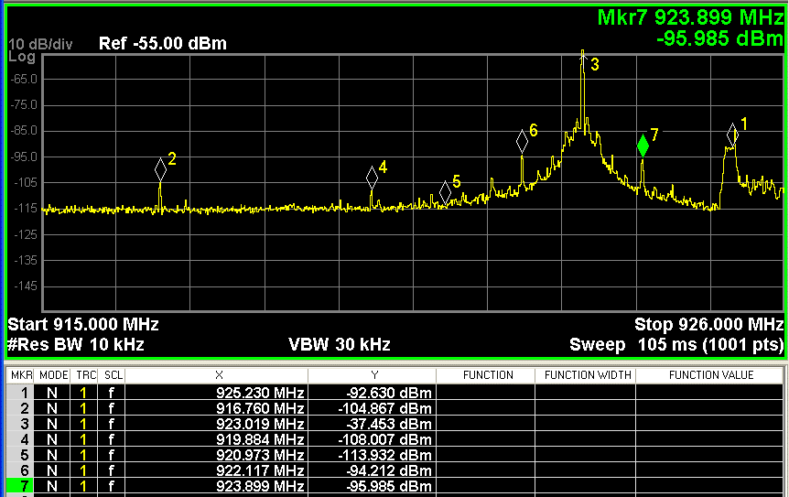
Figure 8.2. The emission of RF wide beam WPT devices in the field test

b. Interference from RF wide beam WPT devices to GSM 900 MHz (UL)
At a distance of 50 meters between GSM BS 900 MHz and WPT devices and 5-8 MHz guard band between two systems, the GSM 900 MHz BS Rx in the field test operated on the normal status without having significant interference from WPT devices transmitting at the RF output power 200 mW EIRP.

8.2.2 Conclusion

The RF wide beam WPT devices under the field test have the potential of causing harmful interference to GSM 900 MHz DL Rx in a few certain conditions. The harmful interference in the GSM 900 MHz UL Rx was not observed with the guard band 5-8 MHz between two systems.
Further field tests should be carried out on the latest commercial RF beam WPT devices with improved out of band and spurious emission to determine feasible technical requirements (eg. maximum RF output power, Tx spurious emission and guard band with mobile cellular network in 900 MHz band).
Viet Nam has not used the frequency band of 920 MHz for RF beam WPT devices yet due to interference issues and non-ISM status of this frequency band.

9. Human hazard issues

Human exposure to electromagnetic fields (EMF) is addressed by a number of regulatory agencies as well as international expert organizations such as the World Health Organization (WHO), the Institute of Electrical and Electronics Engineers (IEEE), and the International Commission on Non Ionizing Radiation Protection (ICNIRP). The determination of EMF safety limits is addressed by these groups and are not in the scope of ITU-R’s work. There are a number of different guidelines on human exposure to EMF that have been published by these organizations, across several frequency ranges. These guidelines include: ICNIRP guidelines of 1998, 2010, and 2020 and IEEE C95.1-2019 - IEEE Standard for Safety Levels with Respect to Human Exposure to Electric, Magnetic, and Electromagnetic Fields, 0 Hz to 300 GHz. Many Administrations have or may at some point adopt these guidelines or modified/updated guidelines based on their own experts’ studies. System designers, manufacturers, and operators of WPT equipment should consider steps to adequately protect the public from the hazardous effects of EMF and should consider these limits in their planning and deployment of WPT systems.
Unlike non-beam WPT, Radio Frequency Beam WPT in the practical implementation would employ microwave transmission systems using 920 MHz band, 2.4 GHz band, and 5.7 GHz band to transmit the power. Microwaves may be beamed from an antenna, by way of point-to-point or point-to-multipoint, over a distance of several meters or more. Unlike wireless communication uses, the level of transmitted electromagnetic power required for commercial implementation of Radio Frequency Beam WPT could be greater to some extent or substantial. It is deemed appropriate that a human (including medical devices) exposure to Radio Frequency Beam WPT EMF should be assessed and managed with additional measures to be compliant with the current guidelines in the Radio Frequency Beam WPT planning and operation.
To cope with above-mentioned unique and standing technical requirements, some current Radio Frequency Beam WPT implementations are considering adoption of human body detection mechanisms in the area with expecting greater RF exposure than the guidelines to cease power transmission and / or steer the power beam direction when detected. To facilitate implementation such technical measures and ensure compliance with the guidelines, study on regulatory environmental conditions for Radio Frequency Beam WPT is also undertaken in some administrations. See Annex 1 for details.

10. Summary

This new APT Report covers some WPT technologies and explained several types of Radio Frequency Beam WPT. It reports key service applications, frequency ranges, and impact studies of Radio Frequency Beam WPT technologies and showed the potential and the possibility of practical use of Radio Frequency Beam WPT technologies. Furthermore, activities of standardization in international and/or national standard bodies and rule-making among APT countries are described. The information reports the contribution to harmonize the frequency ranges, international standards and international rules for Radio Frequency Beam WPT and enhances commercialization of Radio Frequency Beam WPT technologies in APT countries.

Reference

[1] Report ITU-R SM.2392-1, “Applications of wireless power transmission via radio frequency beam”, https://www.itu.int/pub/R-REP-SM.2392-1-2021
[2] Report ITU-R SM.2505, “Impact studies and human hazard issues for wireless power transmission via radio frequency beam”, https://www.itu.int/pub/R-REP-SM.2505
[3] Recommendation ITU-R SM.2151, “Guidance on frequency ranges for operation of wireless power transmission via radio frequency beam for mobile/portable devices and sensor networks”, https://www.itu.int/rec/R-REC-SM.2151/en[4] Wireless Power Consortium, https://www.wirelesspowerconsortium.com/about/about-wpc
[5] AirFuel Alliance, https://airfuel.org/
[6] ICNIRP, “Guidelines for Limiting Exposure to Electromagnetic Fields (100 kHz to 300 GHz)”, ICNIRP, 2020
[7] https://www.soumu.go.jp/main_content/000697267.pdf (in Japanese)
[8] https://www.rra.go.kr/ko/reference/lawList_view.do?lw_seq=65&lw_type (in Korean)

___________
Annex 1
RF exposure environmental control to comply with
the Radio Protection Guidelines

1 Radio Frequency Beam WPT installation environments
Information and Communication Council of the Ministry of Internal Affairs and Communication (MIC) of Japan defined the WPT indoor installation environments by the names of the WPT controlled environment and the WPT general environment to manage and control radiofrequency EMF exposure generated from the Radio Frequency Beam WPT system to human bodies in the operation of Japanese 920 MHz band (915-930 MHz), 2.4 GHz band (2.400-2.499 GHz), and 5.7 GHz band (5.470-5.770 GHz) to comply with their Radio Protection Guidelines (the Guidelines, thereafter) as follows.

1.1 WPT controlled environment
The WPT controlled environment is summarized as shown below:
– It is categorized as indoor and closed space for Radio Frequency Beam WPT operation
– In the environment, WPT radio frequency EMF levels meet the allowable range specified for the controlled environment in the Radio Protection Guidelines. (Power transmission shall be ceased when detecting an individual entering the area where EMFs surpass the limits of the controlled environment specified in the Guidelines.)
– When a Radio Frequency Beam WPT system is operated in the WPT controlled environment, for the purpose of avoiding and mitigating harmful effect to other radiocommunication systems, the WPT system installation personnel, the WPT system operator, the WPT licensee, and other authorized personnel shall be able to manage and control the use of other radiocommunication systems and device installation conditions in an integrated manner.
– When the concerned WPT controlled environment is bordering other indoor space (e.g., side-by-side rooms or upper-and-lower floors), WPT radio frequency EMF levels shall meet the allowable range of specified spectrum sharing conditions with the other radiocommunication systems even in those indoor spaces, or the identical WPT manager to the concerned indoor WPT controlled environment shall be able to manage the coordinated spectrum sharing in the integrated manner. (This clause is applied to the 2.4 GHz and 5.7 GHz bands operation only)

1.2 WPT general environment
The WPT general environment is one of the categories of WPT indoor installation environment and means a WPT use environment that does not fulfil the definition of the WPT controlled environment. (e.g., wireless power transmission to quality management sensors in a logistics warehouse (920 MHz band application only), wireless power transmission to observation sensor devices in an elder nursing care facility (920 MHz band application only).

2 Compliance with the Radio Protection Guidelines

2.1 Separation distance
To comply with the radio frequency EMF exposure requirements in the Radio Protection Guidelines, the following separation distances were derived and specified.
Table [A-01-1]
Separation distances to meet the RF exposure limits of the Radio Protection Guidelines
 | Environmental condition defined in the Radio Protection Guidelines | Reflection coefficient  K = 1^{(*1)} | Reflection coefficient  K = 2.56^{(*2)} | Reflection coefficient  K = 4^{(*3)} | Adding 6 dB to EMF  strength^{(*4)}
 |  |  |  |  | Reflection coefficient  K = 2.56 | Reflection coefficient  K = 4
920 kHz band | Controlled environment | 0.102 m | 0.163 m | 0.203 m | 0.325 m | 0.4065 m
 | General environment | 0.227 m | 0.364 m | 0.456 m | 0.727 m | 0.912 m
2.4 GHz band | Controlled environment | 2.45 m | 3.92 m | 4.90 m | 7.82 m | 9.80 m
 | General environment | 5.48 m | 8.76 m | 10.95 m | 17.49 m | 21.90 m
5.7 GHz band | Controlled environment | 4.00 m | 6.40 m | 8.00 m | 12.80 m | 16.00 m
 | General environment | 9.00 m | 14.30 m | 17.80 m | 28.50 m | 35.70 m
^{(*1)} No reflections counted.
^{(*2)} Reflections from the ground counted.
^{(*3)} Reflections from the water surface and from those other than the ground counted.
^{(*4)} 6 dB is added in the case greater reflection is expected to observe due to buildings such as an office building nearby the evaluation point.

2.2 Directions
The Radio Frequency Beam WPT systems being considered for the operation in the 920 MHz band, the separation distance to meet the limits in the Guideline is comparatively short; and therefore, it is possible for them to operate in the WPT general environment.
Those for the 2.4 GHz band and the 5.7 GHz band assume adoption of human body detection mechanisms in the area expecting greater RF exposure than the limits of Guidelines to cease power transmission when detected. In addition, the systems are to take safety measures to ensure correct functioning of the detect and protect mechanism. Moreover, some alert such by indicating attentional area and setting a fence is conducted, too.
Radio Frequency Beam WPT transmitters are not used at a very close proximity (within 20 cm) from the human body according to use case scenarios and also taking appropriate safety measures mentioned above. Therefore, study on specific energy absorption rate (SAR) for the human body nearby is not necessary.

