

APT REPORT

On

THE STANDARDIZATION PROGRESS OF Fixed Mobile Convergence (FMC)

No. APT/AWF/REP-17
Edition: September 2010

Adopted by

The 9th APT Wireless Forum Meeting
13 – 16 September 2010
Seoul, Republic of Korea

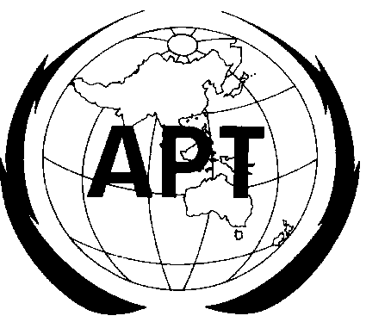 | ASIA-PACIFIC TELECOMMUNITY
 | The APT Wireless Forum
Soure: AWF-9/OUT-06

APT REPORT OF THE STANDARDIZATION PROGRESS OF
Fixed Mobile Convergence (FMC)

1. Purpose of the Document

One of the Convergence Sub-WG A (formerly Task Group-2) within the APT Wireless Forum (AWF) tasks, is to develop guidelines and to identify requirements for facilitating the convergence of fixed networks (e.g. PSTN / ISDN) that utilize FWA (Fixed Wireless Access) system that uses IMT-2000 terrestrial radio interfaces (e.g. WCDMA or CDMA2000 1X) with IMT-2000 (3G) mobile radio communications; and also to study the Fixed Mobile Convergence. Furthermore, Convergence Sub-WG A is entrusted to study the Standardization progress of Fixed Mobile Convergence (FMC).

The progress report of the study on the fixed mobile convergence standardization is presented in this document. The first version of this document was developed in the AWF-3 in Hanoi Vietnam, September 2006 (document no. AWF-3/ 32 (Rev.1)), and continuously updated in every AWF meeting and put as a TMP document.

Although the development of the FMC standardization is still progressing, this report is finalized as of September 2010 in AWF-9 meeting.

2. Fixed-Mobile Convergence Definitions, Objectives and Principles

There are several definitions of Fixed Mobile Convergence (FMC), such as from ETSI, ITU-T Draft New Recommendation Q.1762/Y.2802 (formerly Q.FMC-REQ), ITU-T Recommendation Q.1763/Y.2803: FMC service using legacy PSTN or ISDN as the fixed access network for mobile network users, (formerly Q. FMC-PAM: PSTN Access for Mobile Users), ITU-T Recommendation Q.1761 and ITU-T Draft of Rec. FMC-IMS. These ITU-T draft recommendations are jointly developed by SG-13 (NGN) and SG-19 (Mobile).

ETSI states that Fixed Mobile Convergence (FMC) is concerned with the provision of network capabilities which are independent of the access technique [1]. This does not imply the physical convergence of networks. It is concerned with the development of converged network architecture and supporting standards. The set of standards may be used to offer fixed, mobile or hybrid services. An important feature of fixed mobile convergence is the separation of the subscriptions and services from individual access points and terminals and to allow users to access a consistent set of services from any fixed or mobile terminal via any compatible access point. An important extension of this principle is related to inter-network roaming; by which users should be able to roam between different networks and be able to use the same consistent set of services through those visited networks.

ITU Rec. Q.1762/Y.2802 “FMC General Requirements“ [43], which is intended to be used as general requirement document taking the lead in the development of recommendations, standards and implementation guidelines for the realization of FMC, defines the general objective of FMC as:
- Seamless services operation from the user perspective across the heterogeneous fixed (i.e., PSTN, ISDN, PSDN, WAN/LAN/CATV, etc) and mobile networks subject to any limitations imposed by the characteristics of the particular access technology being used
- Seamless service provisioning from the operator perspective across the heterogeneous fixed (i.e., PSTN, ISDN, PSDN, WAN/LAN/CATV, etc) and mobile networks subject to any limitations imposed by the characteristics of the particular access technology being used
- Generalized Mobility is supported in FMC (i.e., terminal device mobility, user mobility and session mobility). For a given scenario, different levels of mobility may be needed
- Ubiquity of service availability where the end-users can enjoy virtually any application, from any location, on any terminal device subject to any limitations imposed by the characteristics of the particular access technologies and terminal devices being used, given that the service has been subscribed
- Support of multiple user identifier and authentication/authorization mechanisms

ITU Draft Recommendation Q.1763 “FMC service using legacy PSTN or ISDN as the fixed access network for mobile network users” [45,68] describes the service features, service architecture and capability requirements for using the PSTN or ISDN as a fixed Access network for Mobile network users (PAM service) and provides an example of the implementation of the PAM service. The mobile network in this Recommendation refers specifically to the CS domain of mobile networks, including GSM/UMTS [ITU-T Q.1741] networks and ANSI-41/cdma2000 [ITU-T Q.1742] networks. The PAM service provides a mobile user with access to voice and video telephony services utilizing PSTN access with an appropriate dual mode mobile terminal.

Recommendation ITU-T Q.1761 “Principles and Requirements for Convergence of Fixed and Existing IMT-2000 Systems” [2] addresses the opportunities in the near to medium term that may be enabled by providing capabilities to enable IMT-2000 roaming users to access their basic and enhanced services, possibly excluding terminal mobility, in environments where IMT 2000 is not yet deployed. The draft new Recommendation Rec. FMC-IMS “Fixed Mobile Convergence with a common IMS session control domain” [3] moves on from Q.1761 to address the longer-term fixed-mobile convergence opportunities offered by IMS-based Networks.

ITU Draft New Recommendation Q.1761 [2], defines that the FMC is a mechanism by which an IMT-2000 user can have his basic voice as well as other services through a fixed network as per his subscription options and the capability of the access technology. The Recommendation describes requirements for the use of fixed networks in the role of fixed access networks for IMT-2000 networks. This convergence of fixed networks and IMT 2000 networks enables mobile users to roam outside the serving area of their IMT 2000 network and still have access to the same set of services outside their IMT-2000 network boundaries as they do within their IMT-2000 boundaries. The recommendation also describes the framework for fixed mobile convergence and the capability requirements for enhanced fixed terminals that may be utilized to enhance the roaming experience of IMT2000 users. The mobility management functional requirements in fixed networks in support of roaming IMT 2000 subscribers are also covered.

ITU Working Draft of Rec. FMC-IMS [3] states that the FMC is the use of wired and wireless access technologies in conjunction with IMS-based Core Networks. The recommendation describes principles and requirements for convergence of fixed and mobile networks and describes the general framework for fixed-mobile convergence and the mobility management functional requirements. Particularly, this recommendation focused on future IMS-based Networks.

Ref [44] stated that ITU Working Draft of Recommendations FMC-IMS was expected to complete in January 2008. However, as stated in [75], Q. FMC-IMS was further re-organised to reflect the decision to limit its scope to convergence mechanisms implemented at the IMS level. It was agreed to defer the target completion date in order to allow, where possible, for alignment with 3GPP R8 specifications on multi-media session continuity and IMS centralised services. According to [79], this recommendation was planned to be approved at September 2008 NGN GSI meeting, but it had been delayed for some modification and editorial reasons to January 2009 meeting. The current status of this recommendation, as stated by [90], Q.FMC-IMS was completed in May 2009 as Y.2808.

3. FMC Motivation and Service Solutions

From operator’s point of view, the motivation for FMC includes [5]:

- In Fixed Operator (with no Mobile assets) perspective, FMC could reverse the loss of voice-service minutes and revenue to mobile providers (MNVOs), reduce CAPEX and OPEX (harmonized network), offer new value-added services, reduce churn rate, attract new customers, and as market “Brand”

- In Fixed Operator (with Mobile assets) perspective, FMC could reduce CAPEX and OPEX (harmonized network) and offer new value-added services / increase revenue

- In Mobile Operator perspective, FMC could reduce CAPEX and OPEX (harmonised network), offer new value-added services and improve coverage (indoor /outdoor – WiFi)

From the operators’ service solution point of view, FMC solutions represent defenses against FMS (Fixed Mobile Substitution) [4,41,42]. In essence there are three types of FMC solutions [4]:
- FMC bundles, where fixed and mobile services are bundled together often as flat-rate packages with a single bill. Verizon, SBC and BellSouth have launched such services
- FMC network-based solutions, which use intelligent network platforms to route calls to the fixed or mobile phone as the customer chooses. One number and a single voicemail are fundamental features of such applications. TDC's Duet, Cingular's Fast Forward and Verizon's iobi are examples of such solutions
- FMC phones, which combine cellular and Bluetooth/WLAN technologies in a handset. The device acts as a normal mobile phone until the user is within the range of a Bluetooth/WLAN base station when the calls are routed to them through the fixed line. Several numbers of operators are running trials and operate of such scheme at present.

Similar approach has been introduced by [26] which categorized the solution into four types of Fixed Mobile Convergence. FMC bundles, FMC network-based solutions and FMC phones in [4] are identified as Commercial convergence, Network convergence and Device convergence respectively. In addition the fourth category, i.e. Service convergence, was introduced, which has several requirements included:
- Full mobility support (service, session, terminal, personal and network mobility)
- Single authentication and authorization for all services and network technologies
- Single and unique user identity for all services, and all network technologies and terminals
- Presence and preference across service and network technology.

Another approach is done in Ireland, where the scheme called “Home-Zone” was introduced [52]. This scheme enables mobile phone customers to make and receive calls in or near their homes at fixed line prices. A mobile customer has both a fixed (geographic) telephone number and a mobile number for a single mobile handset. Calls from and to the home-zone service subscriber are managed with the following approach:
Calls to the home-zone service subscriber:
- Calls to the mobile number: normal rates that apply for calls to mobiles.
- Calls to the fixed number that has been provided to the home-zone service subscriber: fixed line rates (or mobile to fixed rates, if calling from a mobile).
Calls from the home-zone service subscriber
- Calls made from the home-zone: charged at fixed line rates
- Calls made from outside their home-zone: charged at the normal mobile call tariffs

Another example of this home-zone concept is the deployment of O2 Germany “Genion”, where a cheaper “PSTN-like” tariff applies when calling from within a selected “home zone” [61].

There is another similar approach where GSM/UMTS/CDMA solutions is applied to substitute PSTN service. With this approach, GSM/UMTS/CDMA devices can be an ordinary mobile phones or it can be utilized with PSTN “look and feel”, including dial tone as well as PSTN emulation “boxes” with telephone and data connection (RJ45 / RJ11). This scheme is bundled with specific “at home” tariffs, locked into a defined cell cluster (no mobility) [61].

An example of this approach is the TELKOM Indonesia case which uses CDMA20001x for serving areas with no wireline network (brand name is Flexi). The tariff is similar with PSTN/home service and by regulation, it is fixed and no mobility is allowed. However, the operator answers the latter problem by innovating a combo feature so that the Flexi terminal can be used in other cities, by providing other cities’ new number (temporarily). The impermanent number is simply requested by the users via SMS before he goes to another city.

The FMC is also attractive for cable operators, where its offer can become a part of a quadruple bundling of VoIP, video, mobility and broadband access services. FMC market drivers include availability of dual mode cellular-WiFi handsets, increase of the market penetration of broadband, VoIP, and cable modems, increase the mobile operators’ willingness to enter resale or mobile virtual network operator (MVNO) partnerships, and supportive regulatory environments [27].

Thus, from operators’ perspective, generally FMC can provide [33, 43]:
- Ability to offer a wide range of services
- Simplified network deployment and operation through the ability to offer access and terminal device independent services, as opposed to having to provide multiple access-specific and terminal device-specific instances of the same service
- Ability to reuse the fixed-line assets from traditional fixed service providers and mixed service providers in an FMC context
- Ability to provide better coverage and QoS to end-users compared to traditional mobile service providers in an FMC context.

From end users’ perspective, FMC offers [33, 43]:
- Converged services that function consistently independent of the access technology or terminal device being used with associated reduced complexity of telecommunications operation and subscription. This feature may reduce the total cost for communications.
- Convenient access to and usage of a wide range of services through technology that enables easy configuration, with billing and settlement with only one service provider, even when multiple service providers may be involved
- Seamless service experiences, whenever desired and wherever the end-user may be, limited only by the capabilities of the access technology and the terminal device being used, and with the expectation that the user will have access to multiple terminal devices with different ranges of capabilities.

Other FMC benefits for end users are identified by [41], which are:
- Simplified billing
- Single operator to deal with
- Packaged rich services: Fixed, mobile, voice and data
- Optimized delivery of multitude services
- Single terminal
- No network access boundaries (WLAN, DSL, WCDMA, etc.)
- Single contact number
- Service continuity: anytime, anywhere, any service

Several examples of FMC service scenarios, such as: Converged Contacts, Personal Multimedia, Multimedia Call with Data Sharing, Combinatorial Services, Electronic Programme Guide, Automation Control and Monitoring, Convergent Call Control, Multimodal Services, are elaborated and can be found in the document of FMCA Convergence Application Scenarios [38].

A survey that conducted by [28], as shown in Figure 1, showed that various FMC services are expected and the needs of those services are growing.

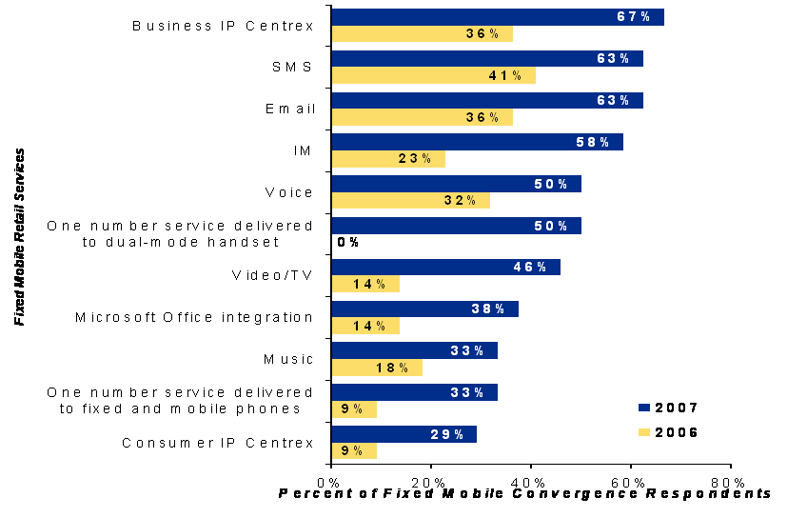

Figure 1. FMC Service Offered Expectation [28,29]

4. Steps Towards FMC

In general, steps to the FMC and the related standardization & industry bodies can be shown in Figure 2, where CTP and UMA (or GAN in 3GPP standard [6]) are the interim solutions towards the IMS based FMC.

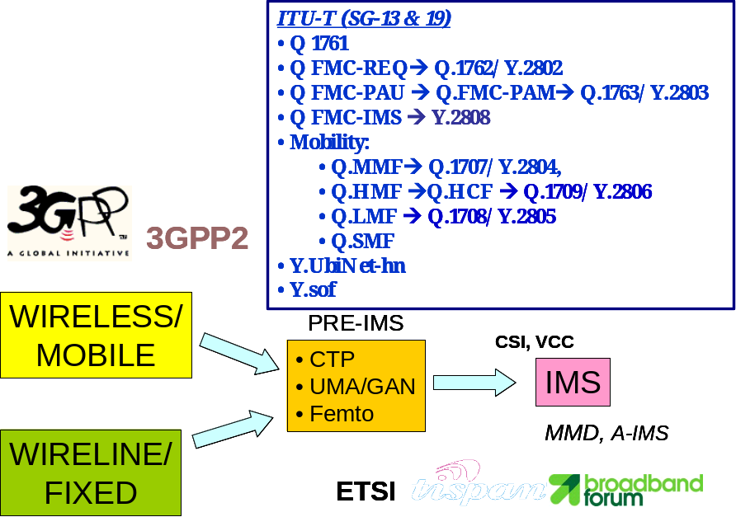

Figure 2. Steps to FMC and Its Related Organizations & Standards

Cordless Telephony Profile (CTP) and Unlicensed Mobile Access (UMA) [23] are, very loosely, two alternative short-range wireless standards that enable fixed-mobile convergence (FMC) solutions. Most players in the FMC space see UMA as the more long-term future technology. However, CTP is being deployed by some manufacturers and some operators as an interim solution, because CTP equipment is available now and can be attached to existing networks without any changes.

CTP [23] is a profile defined within the Bluetooth specification, by the Bluetooth Special Interest Group, which allows a Bluetooth-enabled mobile phone to be used as a cordless telephone when it is within range of a Bluetooth CTP access point. CTP is thus a way of adding limited mobility - cordlessness - to the fixed network. CTP acts as an application on the device - which is sometimes a mobile phone and sometimes a hands-free headset. The simplest implementations simply use Bluetooth as a local air interface comparable to DECT. Here, the access point plugs directly into an analogue telephone line. Bluetooth Class 1 chips that allow communications over ranges 'up to' 100m are beginning to become available and to be included in mobile devices. This is still not as good as DECT range, but CTP has the advantage of being present in mobile devices and having access to their address books and presentation capabilities.
Mobile and fixed access are only loosely converged in CTP. The mobile device retains its GSM number, whereas the CTP access point uses the number associated with the fixed line to which it is attached.

In its earliest implementation, UMA (Unlicensed Mobile Access) [23] is also a way of using Bluetooth to provide limited mobility, using a cordless link and an access point connected to the fixed network. Although it is superficially similar, UMA is actually very different from CTP. CTP is limited to the Bluetooth air interface technology while UMA is an 'air interface agnostic' specification, which can be used in conjunction with Bluetooth, Wi-Fi or even as yet undefined access technologies. The specification has been developed by a group of manufacturers, with limited input from some operators. The group is now taking the specification through the 3GPP GERAN standards process and the solution has now become a 3GPP standard named GAN (Generic Access Network) [6].

Several companies participating in UMA, formed the Unlicensed Mobile Access Consortium (UMAC) [7], where the scope of the consortium is to provide an industry standard specification for Unlicensed Mobile Access (i.e. GSM/GPRS services over Bluetooth and 802.11 with IP as the transport bearer). The consortium also observes initial implementation and IOT test parts, where several functional requirements (Stage1), Architecture (Stage2) and Signaling (Stage3) ready and published in www.umatoday.com [7], which has become www.smart-wi-fi.com.

Despite the similarities, CTP and UMA have quite different strategic implications [23]. CTP is a technology for avoiding the mobile network, and for providing a limited amount of mobility on the fixed network. UMA is a technology for extending the mobile network into the building, and although it uses a part of the fixed network in its access method, the call and the subscriber remain under the control of the mobile network. It is open to fixed operators to deploy a UMA-based network (provided that their regulator and their license conditions allow), but they can only do so if they have equipped themselves with a mobile core network - and indeed with the operator-owned radio access network elements. For fixed operators, deploying UMA is not only a response to mobile operators' strategies, and to the increasing of fixed-mobile substitution; but it is also intended to be a weapon in order to the fight back against cable operators' inroads into the fixed market, with the mobility aspect allowing conventional telephone operators to offer a different kind of 'triple play' package [23].

The development of UMA is illustrated in Figure 3.

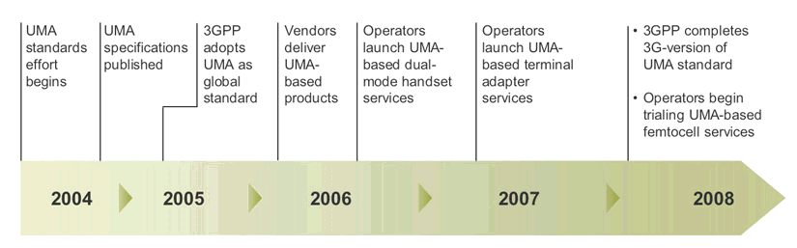

Figure 3. Development of UMA [46]

There are several implementations of this “Pre-IMS Solution” [8, 9, 10, 100], including:
- WLAN/GPRS “Handover” stated by Nokia
- WLAN/GSM VoIP terminal announced by Motorola
- NTT DoCoMo: FOMA – WiFi
- BT “Fusion”: GSM – WiFi
- France Telecom “Business Anywhere”: GPRS-WiFi
- O2 Germany “surf@home”: UMTS-WiFi
- Korean KT & KTF “OnePhone”: CDMA – Bluetooth
- Dual Phone, by Deutche Telekom’s T-Com
- Softbank Mobile WiFi Dual-mode UEs

An example of UMA solution components is shown in Figure 4, where it uses UMA profile in handset enabling roaming into unlicensed access network; UMA “enabled”, plug and play access points which supporting Bluetooth and WLAN; and Standard BSC with minor adjustments to cater for capacity increase in cell handling.

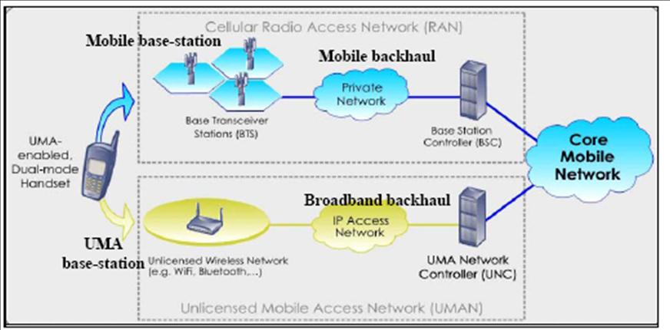
Figure 4. UMA/GAN Solution Components [7]

From network perspective, UMA can be positioned as an HBS (Home Base Station) as shown in Figure 5.

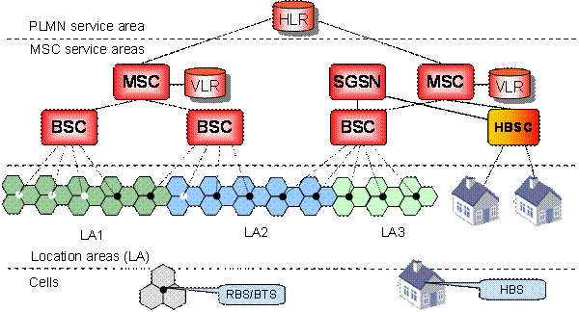

Figure 5. UMA/GAN Network Perspective [11]

Recently, the use of this UMA architecture applies also to the licensed band. In recognition of this, UMA is starting to be redefined as “universal” mobile access. This scenario is shown in the following Figure 6, where UMA Network Controller is utilized also for controlling the Femtocell This femto base station covers a very small radius, from about 30 meters up to 200 meters, in GSM/UMTS band [47, 48] as well as the Next Generation PHS [69].

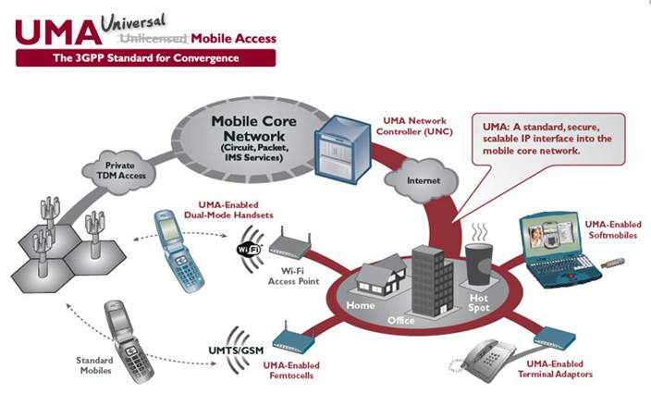
Figure 6. UMA & Femtocell (46,48)

In terms of end user terminals, there is significant difference, i.e.UMA terminals use dual mode (GSM/CDMA & WiFi) handset, whereas Femtocell terminal use standard mobile (GSM/CDMA/Next Gen PHS) handset. [49, 50, 51,69].
Under cooperation between 3GPP, Femto Forum and Broadband Forum, the femtocell standard has been officially published by 3GPP in April 2009. The new standard, which forms part of 3GPP’s Release 8, and interdependent with Broadband Forum extensions to its Technical Report-069 (TR-069), has been completed after 12 months of close cooperation between 3GPP, the Femto Forum and the Broadband Forum [102].
Femtocell architecture, also referred to as the Home Node B (HNB) architecture was agreed in 3GPP. Similar to the current 3GPP UMA/GAN standard, the agreed 3GPP HNB standard will follow an access network-based approach, leveraging the existing Iu-cs and Iu-ps interfaces into the core service network. The architecture defines two new network elements - the HNB (a.k.a. Femtocell) and the HNB Gateway (a.k.a. Femto Gateway). Between these elements there is a new Iu-h interface.

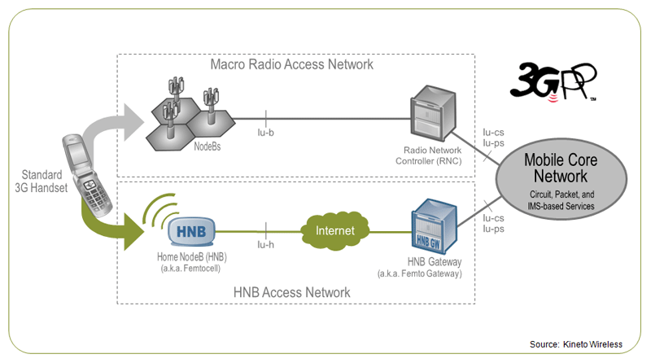

Figure 7. 3GPP Home Node B [77]
Home NodeB (HNB) – Connected to an existing residential broadband service, an HNB provides radio coverage for standard 3G handsets within a home. HNBs incorporate the capabilities of a standard NodeB, as well as the radio resource management functions of a standard Radio Network Controller (RNC).
HNB Gateway (HNB-GW) - Installed within an operator’s network, the HNB Gateway aggregates traffic from a large number of HNBs back into an existing core service network through the standard Iu-cs and Iu-ps interfaces.
Iu-h Interface - Residing between an HNB and HNB-GW, the Iu-h interface includes a new HNB application protocol (HNBAP) for enabling highly scalable, ad-hoc HNB deployments. The interface also introduces an efficient, scalable method for transporting Iu control signaling over the Internet.
Example of femto development is the launching of Femto Cell Solution for home coverage by Ericsson in 2007 [53] and the request for proposals (RFP) from Vodafone Group plc in 2007 [54].

According to [80,81] among the 111 responses from the 79 operators surveyed, 54 percent said that they planned to launch femtocell-based services between the second half of 2009 and the end of 2010, and 33 percent said their commercial femtocell launches were scheduled for 2011 or later.

According to reference [25], in 2006, the UMA approach is not future proof, as it does not support 3G UMTS networks. Additionally, heavy use of UMA clients may require re-sizing of the underlying mobile GSM/GPRS network, whereas using WLAN enabled IMS an operator can shift away load from expensive GSM/GPRS equipment. If compared to the UMA approach, Mobility Management based on IMS is superior, as it is future proof: it supports existing 3G networks, and it is open for future mobile high speed networks.

However, as reported by [88], UMA/GAN turns into 3G, where several handset vendors announced their 3G UMA handsets as well as operators deploy UMA-based services within their 3G network.

As the FMC issue becomes a focus for various telecom players, several FNOs and MNOs founded FMC Alliance (www.thefmca.com) in July 2004, and there are 23 members by September 2009 (33 members by August 2008) [19]. The FMCA objectives are: pushing forward fixed-mobile convergence into Telco market, with sharing technical solution pruning criteria and trial results; advising and influencing device and infrastructure providers; define technical requirements for devices and access points; and accelerate standardization. The work-streams of FMCA are: products requirements definitions, handset requirements, customer experience, standard development organizations, market research & value propositions, emerging applications in convergence. The documents produced includes:
- FMC Market Requirement, in November 2005;
- Release 2.0 FMC Products Requirements (Bluetooth CTP, Wi-Fi GAN (UMA) , Wi-Fi SIP), in May 2006;
- Convergence Services using SIP over Wi-Fi Product Requirement Definitions Release 3.0 Access Point and Gateway Document,
- Technical Handset Requirement, in 31 October 2007
- Product Requirement Definitions (PRD) Release 4.0 (Multi-mode Device Requirements) in 5 November 2008
- Setting Guideline Document for Extensible Authentication Protocol (EAP) in May 2009

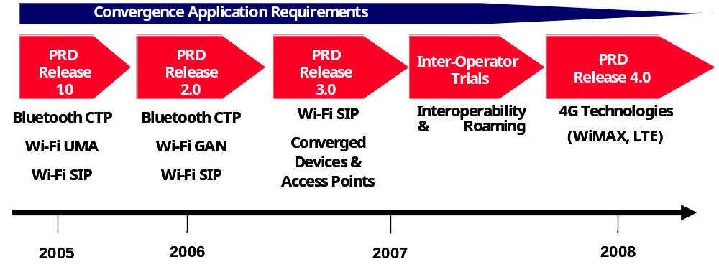
Figure 8. FMCA Convergence Requirements [94]

Regarding the explosion in Wi-Fi usage, according to [93], through roaming agreements between operators, people are able to roam internationally on Wi-Fi. However, the Wi-Fi connection and log-on experience still remains far from an easy plug and play solution. The FMCA and the Wireless Broadband Alliance (WBA) launched a trial to address the following benefits:
- Allowing any Wi-Fi enabled device or gadget to work automatically on the public network
- Providing customers with the same authentication experience anywhere in the world (“you just connect/ like cellular”)
- Automatic authentication of devices and gadgets on public hot-spots with appropriate billing and settlement (for home and international roaming operators)

Regarding the WiFi access, the 3GPP/ Broadband Forum (BBF) FMC Workshop, February 18 - 19, 2010 in San Francisco described the Requirements for WiFi Access as below [101:
- The interworking solution must support operator control of session continuity and session adaptation to terminal capabilities, user preferences, subscriber priorities, network conditions and/or other criteria based on contractual operator agreements.
- The UE must be able to obtain locally, one or more Private IPv4 Address or global IPv4 and/or IPv6 addresses.
- The Interworking solution must ensure that the UE, using any of the aforementioned addresses can reach its mobile home network.
- It must be possible to perform access control on mobile devices that are connecting to WiFi Access based on the subscriber SIM card or other local authentication methods.
- The Interworking solution must provide mechanisms to support QoS requirements agreed between the 3GPP mobile network provider and the fixed broadband network provider.
- The Interworking solution when provides dynamic resource management for wireless access, the timescale must be within the limits acceptable to the 3GPP mobile network provider.
- It must be possible for the Interworking solution to maintain end-to-end QoS without modification when the terminal moves from 3GPP macro network to WiFi Access, and the backhaul system supports the required QoS. The Quality of Service Class Indicators (QCI) values for the 3GPP macro network are specified in Section 6.1.7.2 of TS 23.203.
- It must be possible for the Interworking Solution to change QoS, when the terminal moves from 3GPP macro network to the WiFi Access using fixed broadband as backhaul and the backhaul can not provide the same QoS as the macro network or the WiFi Access can provide higher QoS.
- It must be possible for the Interworking Solution to support service continuity for a terminal moving from 3GPP macro network to WiFi Access using fixed broadband as backhaul.

The Technical Specification of 3GPP, i.e. TS 32.500, “Telecommunication Management; Self-Organizing Networks (SON); Concepts and Requirements,” Dec. 2009. describes the main functionalities of SON for integrated femtocell/ macrocell networks are self-configuration, self-optimization, and self-healing. Currently, 3GPP LTE-Advanced and IEEE 802.16m are standardizing the SON concept for IMT-Advanced networks.

The 3GPP/BBF FMC Workshop, also described Femtocell requirements as below [101]:
- The interworking solution must support operator control of session continuity and session adaptation to terminal capabilities, user preferences, subscriber priorities, network conditions and/or other criteria based on contractual operator agreements.
- The Interworking Solution must support a UE have more than one simultaneously active PDN connections exchanging traffic with more than one peer (external network or other UE), based on network policies and user subscriptions.
- It must be possible for the Interworking Solution to support service continuity for a terminal moving from 3GPP macro network to Femtocell access using fixed broadband as backhaul.
- The Interworking Solution must allow the UE to obtain an IP address using the 3GPP address assignment procedures when using femto to access via fixed broadband network.
- The Interworking Solution must allow the UE to use the IP address acquired from the 3GPP mobile network when moving from the macro network to the fixed broadband network using femto access.
- It must be possible to perform flow admission control on the Femtocell where there is statically provisioned backhaul bandwidth from the fixed broadband provider..
- It must be possible to perform flow admission control on the Femtocell within a dynamic backhaul bandwidth that is set when the Femtocell establishes connectivity with the mobile operator network. This bandwidth allocation is selected once, not on a per-call basis, from the fixed broadband provider.
- It must be possible to perform flow admission control on the Femtocell that is coordinated with flow admission control on the backhaul, where the fixed broadband provider supports admission control and has a contractual agreement to interwork with the mobile operator.
- The Interworking Solution when providing dynamic resource management for wireless access, the timescale must be within the limits acceptable to the 3GPP mobile network provider. Note: Specific signaling timing requirements will be derived via use case
- It must be possible for the Interworking Solution to maintain end-to-end QoS when the terminal moves from 3GPP macro network to Femtocell access, and the backhaul system supports the required QoS.
- The interworking solution must support mobility/roaming between 3GPP accesses in the macro network and 3GPP accesses in the residential environment that use fixed broadband as backhaul.
- The interworking solution must enable support for Local IP Access to the home based network in order to provide access for a directly connected (i.e. using Femtocell radio access) UE to other IP capable devices in the home.
- The Interworking Solution must enable support for simultaneous access from a UE to both the mobile operator’s core network and Local IP Access to the home based network.
- The Interworking Solution must enable support for Local IP Access to the home based network or enterprise IP network without traversing the mobile operator’s core network except Femtocell, except where this is precluded by local regulation.
- The Interworking Solution must not preclude a device in the home based network to communicate to a 3GPP.
- The Interworking Solution supporting Local IP Access to the home based network must not compromise network security of the mobile operator or the fixed broadband operator.
- Subject to roaming agreement between mobile operators, the interworking solution must allow a roaming UE to use Local IP Access.
- The interworking solution must enable support for Selected IP Traffic Offload without traversing the mobile operator network, except where this is precluded by local regulation.
- The Interworking Solution supporting Selected IP Traffic Offload must not compromise network security of the mobile operator or the fixed broadband operator.
- The Interworking Solution must enable support for IP traffic of a UE associated with a particular defined IP network to be offloaded while IP traffic of that same UE associated with other defined IP network(s) is not offloaded.
- The Interworking Solution must enable support for offloading selected IP traffic for a UE without adversely affecting other IP traffic on the same UE.

5. IP Multimedia Subsystem (IMS)

As stated in [3,41] and described in the Section 2, the ultimate FMC will be based on IMS (IP Multimedia Subsystem). IMS is a SIP based standardized architecture for offering multimedia services on the packet domain, where it was originally defined by mobile (3GPP/3GPP2) standards. IMS is defined by 3GPP from Release 5 (2002) onwards [13]. The 3GPP2 equivalent of IMS is the MMD (Multi Media Domain), which is fully interoperable with 3GPP IMS [13].

Regarding the MMD, there is an initiative from Verizon Wireless and its suppliers (Cisco, Lucent, Motorola, Nortel and Qualcomm) to formulate A-IMS (Advance to IMS). The goals of A-IMS are to ease the transition from current networks to the all-IP networks of the future and to fill gaps that IMS (IP Multimedia Subsystem) technology currently leaves open [57, 58].

IMS is also developed by fixed network standard bodies, for example 3GPP (works for GSM development) has been worked together with ETSI TISPAN (works for fixed network and NGN) to coordinate the IMS specifications evolutions to support various Wireless and Wireline access technologies.

ETSI TISPAN NGN R1 standards for an FMC architecture based on IMS were fixed (Q1 2006) [25]. TISPAN NGN Rel-2 are mainly completed, and there are new work items e.g.: [56, 36]:
- Requirements analysis for FMC (with such bodies as FMCA).
- Requirements analysis for home networking (in cooperation with such bodies as HGI).
- Requirements for network capabilities to support IPTV services (in cooperation with e.g. ATIS IIF and DVB).
- IPTV Integration of NGN Services and Capabilities using IMS
- Support of Business Services and Enterprise Network inter-working.

Currently, several drafts of TISPAN NGN Rel-3 are available, and according to the work plan, it was planned to be completed in 2009 [36].

TISPAN and 3GPP synchronization includes [56]:
- Alignment of the timescales and dependencies of TISPAN Rel-1 with the work in 3GPP Release 7
- Alignment of the timescales of TISPAN Rel-2 with the ongoing work in 3GPP Release 8
- TISPAN NGN Rel-2 definition completed in Feb 2007
- TISPAN NGN Rel-2 planned for completion in the end 2007
- 3GPP will freeze Rel-8 requirements by end 2007
- 3GPP Rel-8 will be completed 12-18 months later

The Network Reference Architecture of IMS is shown in Figure 7, where it essentially access independent / access agnostic (service transparency), where it supports broad, mobile packet data. IMS is also able to perform interoperability of new converged services between subscribers and inter-working with PSTN and legacy service.

As stated in 3GPP [35] IMS is access independence which is the ability for the subscribers to access their IP Multimedia services over any access network capable of providing IP-connectivity, e.g. via:
- 3GPP (UTRAN, GERAN)
- Non 3GPP accesses with specified interworking (e.g. WLAN with 3GPP interworking)
- Other non 3GPP accesses that are not within the current scope of 3GPP (e.g. xDSL, PSTN, satellite, WLAN without 3GPP interworking)

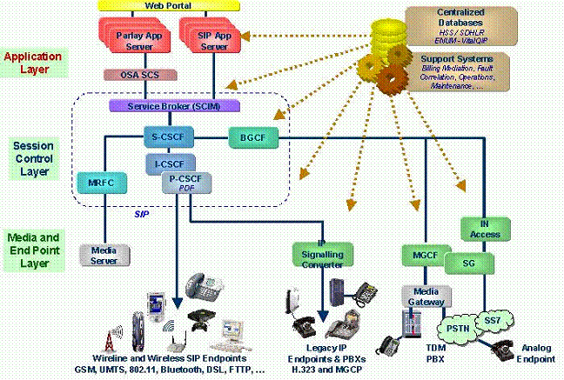

Figure 9. IMS Network Reference Architecture [14]

As 3GPP/3GPP2 and TISPAN more focus on the network architecture, OMA (Open Mobile Alliance) and Parlay Groups adopt IMS for the services standards [41].

The IMS adoption phases was predicted by [24] and summarized in Table 1 below, where the IMS market state would stable in 2010.

Table 1. IMS Adoption Phases [24]

 | 2005-2007 | 2006-2009 | 2010+
Market State | ‘The bandwagon rolls’  Emerging; first-mover advantage being sought | ‘IMS becomes Real’  Early; some benefits are demonstrated | ‘Towards the 4G Vision’  Stable; full IMS benefits being realizable
What ? | Some initial mobile deployment, but services limited in subscriber reach. Likely initial focus in business customers. | Operator interworking and significant IMS-capable service deployments. Broader range of agreements spanning fixed and mobile. | Broad interconnection and availability of IMS services across all fixed and mobile networks for voice and data. VoIP over mobile brings all services into IP domain.
Why ? | Limited handset availability. Initial technology supplier direction and partnerships are enterprise-focused. Simplest IMS services are more of value to businesses. | Billing, customer care and user information issues start to be dealt with consistently. Solution maturity brings mainstream market online. | Mobile VoIP QoS issues dealt with. Now two distinct ‘horizontal’ propositions in both fixed and mobile: one based on services, the other on access.

Survey done by [32] on “Timing for IMS Deployment” showed quite similar results (Figure 10). The survey which was conducted to the early adopting mobile, fixed, fixed/mobile converged operators and most mobile, fixed, fixed/mobile converged operators, showed that around 75% of early adopting operators prefer to deploy IMS in no later than 2008, whereas most operators prefer to do so in 2010 at the latest.

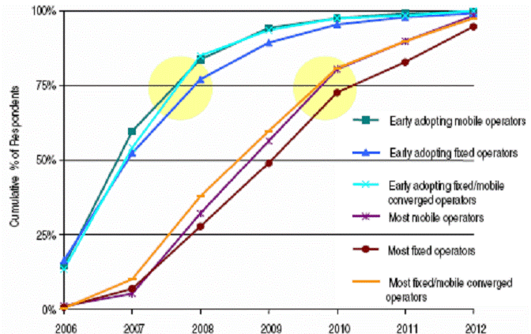

Figure 10. Timing for IMS Development [32,30]

The Light Reading IMS Strategies Survey which was conducted on 13-17 February 2006 examining the driver for IMS deployment. It drew responses from 93 qualified service provider professionals, representing a broad array of network operator types and geographic regions. They were asked “What is the most important factor driving IMS deployment in your company?” and the survey showed that “The need to converge fixed and mobile services” is one of major considerations.

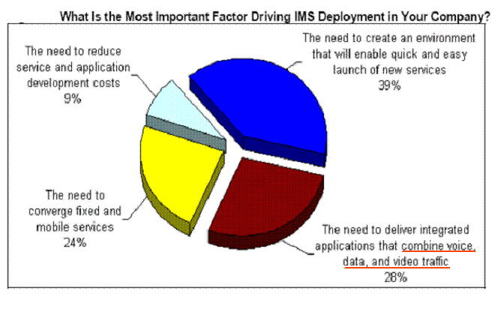
Figure 11. Factors driving IMS development [30,31]

In reality, there were several trials and deployment of IMS, where by Jan. 2005 around 30 operators have conducted IMS trials [24] and by Sept. 2005 around 200 operators are already in trials or in the early stages of IMS deployment [20]. The early deployment examples are [20]: BT Group plc‘21st Century Network, based upon IMS and SIP infrastructure; Telecom Italia Mobile SpA video-sharing service over its 2.5G and 3G networks; and in the U.S., BellSouth Corp. SIP-based infrastructure. There were several SIP interoperability trials [20] such as: GSMA trials using infrastructure based on the IMS standard, where handsets provided by Nokia using test applications such as voice instant messaging, video sharing and gaming, employing both 2G and 3G access networks. Another trials involved six mobile operators (KPN, Orange, SFR, Telenor, TeliaSonera and Vodafone), four GRX carriers (Belgacom, Cable & Wireless, KPN and TeliaSonera), and three infrastructure vendors (Ericsson, Nokia and Siemens). IMS trial conducted by Orange showed that there are several advantages of using IMS, i.e. cost reduction, single number for various access, improved coverage and single traffic billing for cellular and WLAN [21].

As references [21] and [20] were published at Nov 2004 and Sept 2005 respectively, other recent sources in September 2006 show quite significant development on the IMS deployment, such as Siemens IMS trials and deployment with 30 customers (includes KPN and French Telecom) [29,42] and 23 contracts & 50 trials on IMS done by Ericsson (includes Sprint-Nextel, Telefonica, Vodafone) [30].

There are other recent development includes IMS trial for PSTN migration was done in Chunghwa Telecom, Taiwan [60] and 20+ reference of full IMS and 50+ IMS application references done by Alcatel-Lucent [61], as well as IMS (Alcatel-Lucent) deployment in KT to deliver dual mode services (Feature Server with packaged CSCF) to provide seamless roaming and handoff between KTF’s CDMA 1x and WiBro (WiMax) [61].

List of operators and service providers implementing IMS capabilities is reported by [71] in November 2007, as listed in Annex-1, it can be seen that many operators have been implementing IMS capabilities and some of them implement it for converging the fixed and mobile services.

Despite the advances of IMS, J.Kim [17] states that although IMS is a crucial move forward in convergence, however this only addresses the first pillar (i.e. IP services). The second pillar (i.e. personalization), requires another step forward in IMS. For true personalization, intelligence is need to be embedded into the network, so that the following personalization services can be achieved: to track a subscriber’s location and choice of device, maintain personal profiles and service preferences, formulate rules engine to behave according to individual user’s preferences (exhibited and implied), deliver network roaming portability of services, information and messages, furnish context and location-aware services, and seamlessly blend multiples services into a single personalized multimedia experience.

The high level FMC architecture defined in the draft recommendation QFMC-IMS [67] is depicted in figure 10. The architecture assumes a common IMS service platform for the delivery of services over fixed and mobile networks.

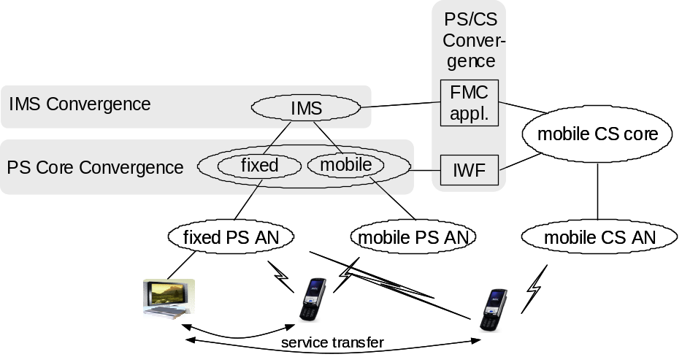

Figure 12. IMS based FMC architecture [67]

This converged IMS platform may be used to transfer services between terminals attached to different networks based on reach-ability, user preferences or at the user’s explicit request. It may also be used to transfer services from one access to another to provide service continuity for multi-mode terminals that can attach to both fixed and mobile access points.

6. FMC IMS Reference Model and 3GPP, 3GPP2 &TISPAN Mapping

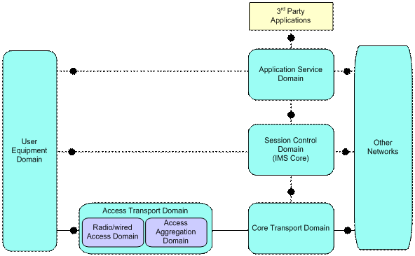

Figure 13. FMC IMS Reference Model [3,67]

The draft recommendation in FMC-IMS [3,67] (which is now Y.2808 [90]), uses the reference points as shown in Figure 11 where represents the network domains that we can distinguish in both fixed and mobile networks in order to describe different level of convergence that operators may take to achieve certain levels of convergence.

The Access Transport Domain provides the connectivity between the User Equipment Domain and the access technology independent Core Transport Domain. Within the Access Transport Domain we can distinguish the physical access media dependent Radio/Wired Access Domain that connects User Equipment to the access nodes of the network (e.g. DSLAMs, 3G Base Stations and RNCs, WLAN Access Points) and the Access Aggregation Domain that aggregates the traffic from multiple Radio/Wired Access Domain instances to an edge node that connects to the Core Transport Domain. GPRS, part of the 3GPP IP Connectivity Access Network, is an example of an Access Aggregation Domain and so is the network that connects DSLAMs to a BRAS/IP Edge device. A mobile Access Aggregation Domain will contain mobility management functions.

The Core Transport Domain may also contain mobility functions in order to support mobility across Access Domains (e.g. MIP Home Agents). The Core Transport Domain interconnects Access Domains to each other and to other networks, supporting media processing functions as necessary. Network attachment and resource and admission control functions are contained in both the Access and Core Transport Domains.

Session control of connectivity between User Equipment is provided by the Session Control Domain that also contains functions in support of presence and location services. The Session Control Domain interfaces with the Core Transport Domain to convey transport resource requests and NAT binding information, if applicable. It may also interface with the Access Transport Domain, for instance to convey location information in case of a Wired Access Domain.

Finally, there is the Application Service Domain that contains functionality that supports so-called application services such as messaging and information services that may be built on top of session control services.

Figure 14 illustrates three possible points of convergence at different network levels (domains). FMC functions can be viewed as functional elements that hide the difference between fixed and mobile access from the next higher level in the domain model and indirectly from the user. The location of the FMC functions determines the point/level at which the convergence takes place.

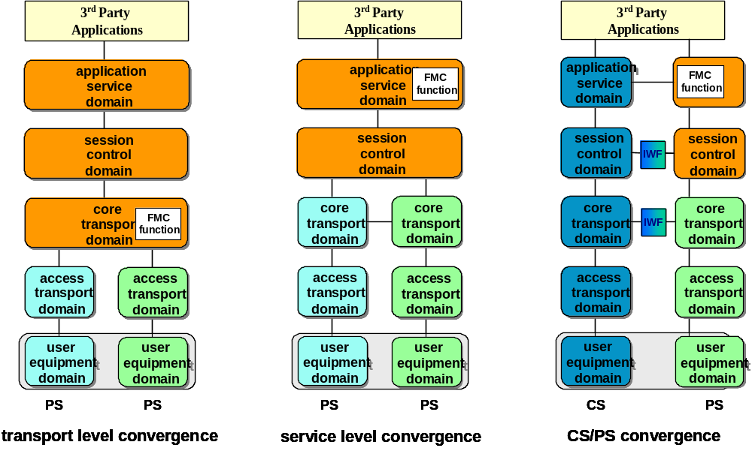

Figure 14. Convergence point and FMC function [79]

In ITU Draft New Recommendation Q. FMC IMS [3], the architecture of current 3GPP, 3GPP2 and TISPAN networks is analyzed to highlight the architectural aspects and interfaces that are relevant for FMC.

The mapping of 3GPP architecture on FMC reference points (as shown in Figure 13) is illustrated in the following diagram:

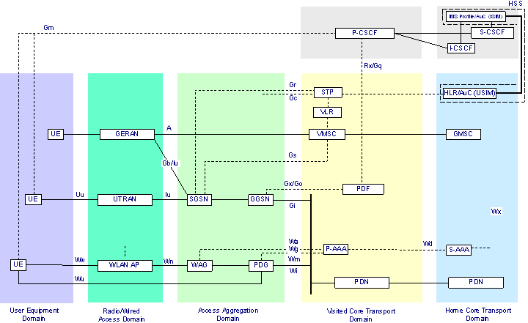

Figure 15. Mapping of 3GPP architecture on FMC domains [3,67]

According to [103], 3GPP is working on the IMS Aspects of Architecture for Home NodeB, where the objective is to investigate the following:
  - an architecture to enable IMS capable HNB Subsystem to use the IMS for CS terminals using a corresponding equivalent IMS services (voice service in IMS Multimedia Telephony);
  - the impacts of the IMS capable HNB Subsystem to idle mode mobility for all supported UE types (e.g. IMS registration/de-registration);
  - service continuity at least in the direction from IMS capable HNB Subsystem to macro network;
  - support for pre-Rel 9 CS and IMS UEs when using IMS capable HNB Subsystem.

The mapping of 3GPP2 network / MMD on FMC domains is illustrated below.

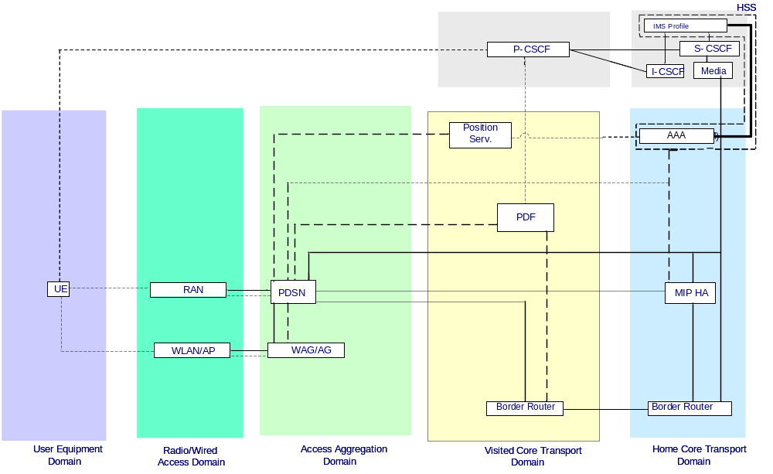

Figure 16. Mapping of 3GPP2 MMD architecture on FMC domains [67]

A tentative mapping of the TISPAN functional architecture on the FMC domains is shown in the next figure.

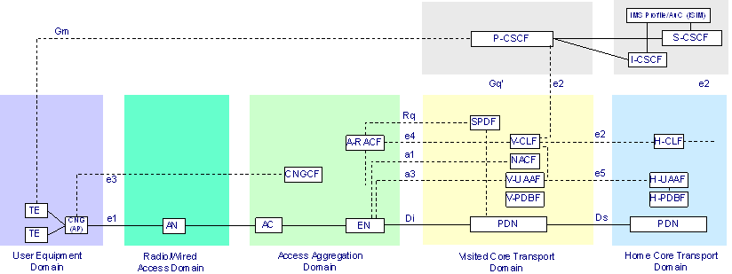

Figure 17. Mapping of TISPAN Functional Architecture on IMS domains [3,67]

The Y.FMC-IMS was planned to be revised (Y.FMC-IMS Rev1), where more scenarios of FMC will be studied and seamless handover / QoS requirements from different FMC services will be investigated [95].

7. Converged Network Architecture Scenarios [3,61,79]

As described in the Section 4, UMA/GAN offers a pragmatic solution for mobile operators with an embedded CS network to extend their coverage using WLAN. However, it does not provide an evolution path to an all-IP NGN, since it keeps voice calls in the CS domain.

There is specification in 3GPP on the combination of Circuit Switched and IMS services (CSI) and this will allow IMS services to be extended to a terminal on a GAN access. This is a rather circuitous way to provide IMS services to a fixed access compared to the fixed network architecture. The latter is therefore recommended by Q.FMC-IMS [3] as an evolution path for the fixed access part of a WLAN/2G fixed mobile convergence solution, in combination with the VCC architecture described below.

Voice Call Continuity (VCC) is an alternative – IMS centric – approach to provide service continuity for voice calls when a multi-mode WLAN-SIP/2G-3G-CS terminal changes its point of attachment. VCC provides the capability to transfer the path of a voice call between a CS and a PS-IMS domain. It assumes that the UE is capable of supporting two separate call legs related to the same voice communications (one over the CS domain and the other via the IMS). The approach for the first set of VCC specifications (part of 3GPP release 7) is static anchoring of all voice calls in the IMS of the user’s home network. This scheme requires SIP enabled dual mode terminals (e.g. WiFI/GSM) and it supports multiple numbering plans (e.g. fixed and mobile number for the same subscriber). The IMS Services Centralization and Continuity is further specified in the 3GPP Release 9 and beyond [89].
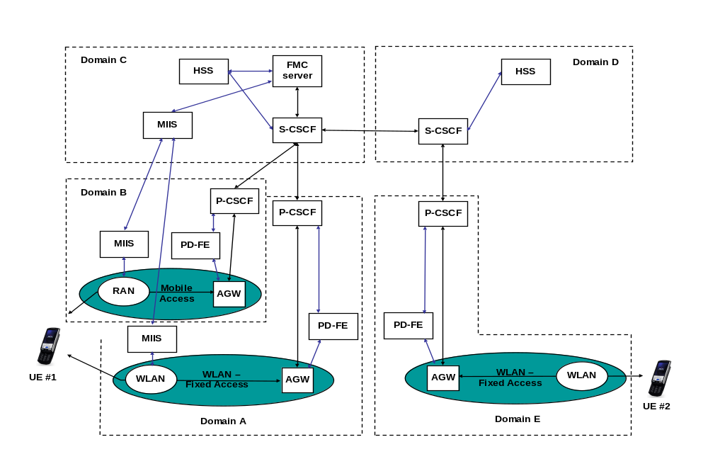
Figure 18. PS – PS Service Level Convergence Architecture [79]

The architectural solution provides completely automatic connectivity from the end-user point of view. The most appropriate network domain (i.e. mobile CS domain or IMS domain) to serve the user is selected based on a combination of user and operator defined policies.

Q. FMC-IMS also address the architecture and FMC functions for PS-PS service continuity [79]. The following figure depicts five network domains. Each domain may belong to a different network operator. Domains A, B, C and E could however also be part of the same operator’s network, in which case domain D is not applicable.

Both A and B may be visited networks, or either one could be part of the home service provider network. In other words the home service provider may either be a fixed or a mobile operator or both.

Regarding the UMA, VCC and Femtocell, brief comparison amongst these technologies is illustrated in Table 2.

Table 2: UMA, VCC and Femto Comparison [61,72,74, 78, 89]
 | UMA | VCC | Femtocell
Standard | 3GPP TS43.318(R6) | 3GPP 24.260(R7);  ETSI TS 182 007 V2.0.0, TISPAN Voice Call Continuity (VCC); Stage 2; | 3GPP TR 25.820 V8.1.1 (2008-05), Technical Specification Group Radio Access Networks;  3G Home NodeB Study Item Technical Report  (Release 8)  Enhanced Home NodeB/ eNodeB(EHNB) (Release 9)
Spectrum | Unlicensed | Unlicensed for WiFi part | Operator existing spectrum
Key New Components | UNC/GAN (IP<->Gb/A) | VCC AS | BSG/BVG etc
CPE Support | BT/GSM or WiFi/GSM, quite a lot models | Need high-end smart phone to embed SIP client | Existing handsets, but need Femtocell
Availability | Now | Now | Trial
Potential Market | Home/Hotspot | Enterprise/Home | Home/SOHO
Value Proposition | Mature standard, support voice | Wide availability of WiFi AP, IMS Evolution | Low cost over DSL backhaul, existing large phone base
Regulatory Issues | Same as VoIP | Same as VoIP | Who owns Femtocell ?
Challenges | OSS over thousands of WiFi AP | IOT between terminal and VCC AS | Large number of femtocell needs to be managed (OSS)
 | No direct support of 3G(not finalized yet), 2M Gb is small for PS service | No large deployment due to evolution of standard itself | Macro cell radio coordination needs to be architecture carefully

Initial proposal for IMS based VoIP over Wi-Fi to circuit switched cellular voice call handover network to handset interoperability guideline based on this emerging Voice Call Continuity standards, has been developed by MobileIGNITE [40]. MobileIGNITE’s Release V1.0 of Functional Specification For Fixed Mobile Convergence Handover specifies a Phase 1 deployment solution for 2007 market deployment based on today’s commercially available network equipment and dual mode terminals – which will continue to function properly to support FMC services throughout network upgrades and evolution to full IMS Release 7 functionality – at a market pace [59].

The proliferation of UMA and Femtocell, leads an advancement of home-zone concept. In the Home-zone as described in section-3 page 4, the main consideration was the low calling rate [52]. The new home-zone 2.0, proposes not only lower calling rate, but also new services such as presence, web and multimedia services [86]. This concept is illustrated in the following Figure 18.

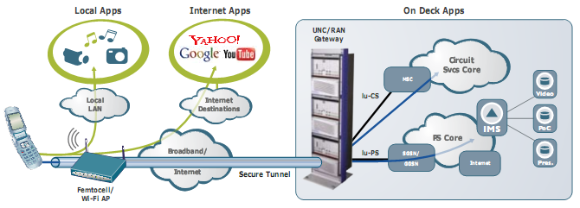

Figure 19. Home-Zone 2.0 [86]

Several operators have already provided this service includes T-Mobile U.S. (Unlimited HotSpot Calling) and Orange (Unik), and it was reported that the number of subscribers are increased significantly [86].

Common service addition of home-zone 2.0 is indicated in Figure 19.

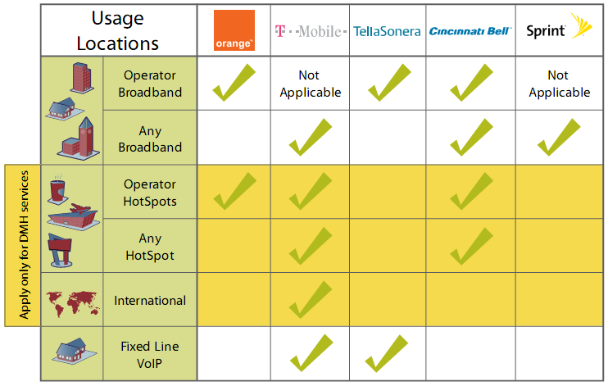

Figure 20. Common service additions to Home Zone 2.0 offers [87]

Regarding the status of ITU-T draft recommendations that are related to FMC, the Q.FMC-IMS needs some minor editorial revision and it planned to submit this document to ITU-T meeting in May 2009 for approval [84]. The current status of this recommendation, as stated by [90], Q.FMC-IMS was completed in May 2009 as Y.2808.

In terms of the mobility management, ITU-T has several recommendations [75, 83] includes:
- Recommendation Q.1707/Y.2804: Generic Framework of Mobility Management for Next Generation Networks (AAP Consented in January 2008, formerly Q.MMF)
- Q.1709/Y.2806 (Q.HCF: Framework of Handover Control for Next Generation Networks (formerly Q.HMF: Framework of Handover Management for Next Generation Networks), was approved in 14 October 2008)
- Q.1708/Y.2805 (Q.LMF: Framework of Location Management for NGN), was approved in 14 October 2008

It is planned also to proposed new ITU-T Draft New Recommendation Q.SMF (Service Mobility Framework / Framework of Mobility Management in Service Stratum for NGN). This document describes the framework of mobility management (MM) in Service Stratum for NGN, which deals with the MM schemes in the NGN Service Stratum. This document addresses the issues on IP mobility in the application/session layers. MM issues considered, include IMS-based MM as well as non-IMS based MM, together with the consideration of QoS support [82]. This Q.SMF is targeted for AAP consent in Q-2 2011 [98].

Besides, a new draft Recommendation Y.MMS (Mobility Management Control Scenarios for NGN) was agreed [95]. This new draft recommendation might also relevant to FMC, as it covers Call/Session continuity where users’ service sessions have to be preserved to the users moving within homogeneous network or among heterogeneous networks.

Another scenario that should be taken into account is SAE (System Architecture Evolution) based Convergence. The architectural evolution of 3GPP mobile networks is currently the subject of a feasibility study. The objectives of the study are not only to provide higher data rates and lower data and control plane latency, but also to provide service continuity between the I-WLAN and 3GPP PS domain and terminal mobility between different access networks in general. The significance of the 3GPP study for FMC is that it includes the connection of a non-3GPP IP access to the Evolved 3GPP Packet Core network, which may be a fixed access network.

It should be noticed as well, that ITU-T SG19 plan to continue the study on specific FMC solutions in the new study period, taking into account the convergence opportunities offered by new technologies such as home Base Stations (a.k.a. femtocells) [75].

As described in AWF-6 input presentation for Convergence Sub-WG A [85], ITU-T SG-13 and SG-19 is now merged with the subject Future Networks Including Mobile and NGN and one of the mandates is to study Mobility Management and Fixed Mobile Convergence. The particular questions in this study group that are relevant with AWF Convergence Sub WG-A are Q.3/13, Q.4/13, Q.5/13, and Q11/13. Their current status are updated by information paper in AWF-7 [90] as follows:
- Q.3/13 (Requirements and implementation scenarios for emerging services and capabilities in an evolving NGN):
  - NGN requirements was completed as Y.2201 Rev.1
  - Working on services including service delivery platform
- Q.4/13 (Requirements and Frameworks for QoS enablement in NGN):
  - Y.2111 rev 2, RACF rev 2 including mobility capabilities, is now developing.
  - Y.IPTV-TM, traffic management architecture for providing IPTV services, is now developing.
- Q.5/13 (Principles and functional architecture for NGN including ubiquitous networking):
  - Working on NGN architecture to provide content delivery services
- Q.11/13 (Convergence of existing and evolving IMT and Fixed Network):
  - Working on seamless mobility between WiMAX and WLAN

Referring to [98], SG-13 meeting in April 2010, decided the merging of Q.8/13 “Mobility management” and Q.11/13 “Convergence of existing and evolving IMT and fixed networks” to form one new Q.22/13 “Mobility Management and Fixed Mobile Convergence”.

As the point of convergence between fixed and mobile can be established at home (e.g. by using UMA/GAN/Femto), there is another draft recommendation that related to FMC which should be taken into account, i.e. Draft Recommendation Y.UbiNet-hn (Framework of home network using ubiquitous networking), [91].

The Draft Recommendation Y.UbiNet-hn describes concept and requirements of connecting to anything for home network using ubiquitous networking and present several technical considerations for identification of all objects and providing connectivity to them.

This Recommendation covers the following: General overview of ubiquitous networking in NGN; Basic concept and requirements of connecting to anything for ubiquitous networking; Technical considerations for connecting to anything; Considerations for applications/services.

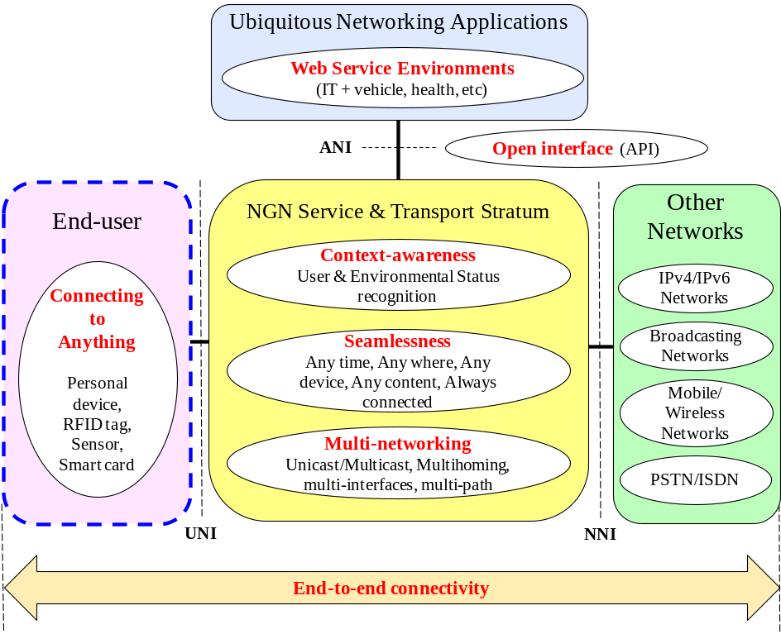

Figure 21. Architectural model for ubiquitous networking in NGN [91]

Remaining work for this recommendation are: specifying several technical considerations, describing examples of ubiquitous networking applications, developing service scenarios and use cases. The target for AAP of Y.UbiNet-hn is in January 2011 [98].

ITU-T Q.14/13 (Service scenarios and deployment models of NGN) also launched the draft Supplement Y.sof (Service scenarios over FMC) [96]. This recommendation introduces overall configuration and scenario models to identify service scenarios over FMC using functional decomposition model [97].

This draft recommendation considers four key elements: Person, Terminal, Network and Contents, where the de-composition of these key elements are then applied. Person can be in the various location; terminal can be single or dual mode; network can be fixed, mobile or wireless; and content can also be various.

The possible overall scenario model is shown in Figure-22, where scenarios between person to terminal, terminal to network, and network to content can be diverse.

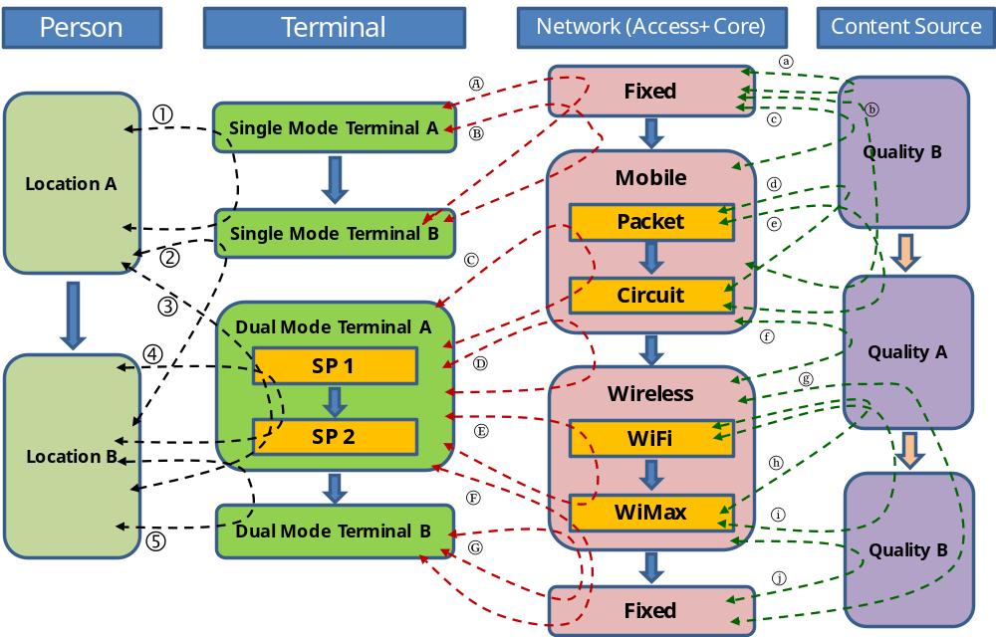

Figure-22 Overall service scenario model over FMC using functional de-compositions [97]

As stated in the ITU-T SG-13 April 2010 meeting [98], the target for Y.sof AAP is in December 2010.

Regarding the converged terminal, some cases of converged terminal in 3G applications in China market was discussed by [99].

8. Conclusions

- The FMC enables mobile users to roam outside the serving area of their mobile networks and still have access to the same set of services outside their network boundaries as they do within those boundaries.
- Several solutions to achieve FMC such as CTP, UMA/GAN and Home Node B / Femtocell were proposed. In the long term, these fixed and mobile services would be controlled by IMS.
- As of September 2010, the standardization of FMC is still progressing. In ITU-T SG-13 the FMC is discussed in Q.22/13 “Mobility Management and Fixed Mobile Convergence” which is formed from Q.8/13 “Mobility management” and Q.11/13 “Convergence of existing and evolving IMT and fixed networks”. Meanwhile 3GPP and BBF are still discussing internetworking between next generation fixed and 3GPP wireless access in WT-203. The 3GPP also reported the IMS Aspects of Architecture for Home NodeB (TR-23.832) by the completion of Release 9 in June 2010, whereas in Release 10 they plan to finalized the Extended HeNB Features, HeNB Security Features and HNB and HeNB Mobility Enhancement.

Glossary:

3G | Third-generation mobile telephone technology
3GPP | 3rd Generation Partnership Project, a cooperation of standards organizations (ARIB, CWTS, ETSI, T1, TTA and TTC) throughout the world for the development of 3G systems, which provide high-speed data transmission over wireless cellphone systems, and specifies standards for 3G technology known as W-CDMA (UMTS)
3GPP2 | The 3rd Generation Partnership Project 2 (3GPP2) is a collaboration agreement that was established in December 1998. It's a co-operation between ARIB/TTC (Japan), CCSA (China), TIA (North America) and TTA (South Korea). The scope of 3GPP2 is to make a globally applicable third generation (3G) mobile phone system specification within the scope of the ITU's IMT-2000 project. In practice, 3GPP2 is the standardization group for CDMA2000
BBF | The Broadband Forum (BBF) is the central organization driving broadband wireline solutions and empowering converged packet networks worldwide to better meet the needs of vendors, service providers and their customers.
Bluetooth | A wireless personal area network (WPAN) technology from the Bluetooth Special Interest Group (www.bluetooth.com) founded in 1998 by Ericsson, IBM, Intel, Nokia and Toshiba. Bluetooth is an open standard for short-range transmission of digital voice and data that supports point-to-point and multipoint applications
BSR | Base Station Router
CPP | Calling Party Pays
CTP | Cordless Telephony Profile (CTP), short-range wireless standards that enable fixed-mobile convergence solution
CS | Circuit Switched
CSI | CS and IMS combinational service, CS domain voice call with additional information e.g. video clip via IMS
DECT | DECT or Digital Enhanced (former European) Cordless Telecommunications is an ETSI standard for digital portable phones, commonly used for domestic or corporate purposes. DECT can also be used for wireless data transfers
ETSI | The European Telecommunications Standards Institute is a standardization organization of the telecommunications industry (equipment makers and network operators) in Europe, with worldwide projection
EvDO | Evolution Data Only or Evolution Data Optimized, often abbreviated as EVDO, EV-DO, EvDO, 1xEV-DO or 1xEvDO is a wireless radio broadband data protocol as part of the CDMA2000 standard
FMC | Fixed Mobile Convergence: in a given network configuration, the capabilities that provide services and application to the end user regardless of the fixed or mobile access technologies being used and independent of the user’s location.
FMCA | Fixed-Mobile Convergence Alliance is an alliance between several companies. The purpose of this alliance is to encourage the seamless integration of mobile and fixed-line telephone services
FNO | Fixed Network Operator
GAN | Generic Access Network, 3GPP standard for UMA
GERAN | GSM/EDGE Radio Access Network is one of 3GPP Technical Specification Group (TSG) which responsible for the specification of the Radio Access part of GSM/EDGE
GPRS | General Packet Radio Service, an enhancement to the GSM mobile communications system that supports data packets. GPRS enables continuous flows of IP data packets over the system for such applications as Web browsing and file transfer
GSM | Global System for Mobile Communications, a digital cellular phone technology based on TDMA that is the predominant system in Europe, but is also used around the world
GSMA | The GSM Association, is the global trade association that exists to promote, protect and enhance the interests of GSM mobile operators throughout the world. At the end of September 2005, it consisted of more than 675 second and third generation mobile operators and more than 150 manufacturers and suppliers
HNB | Home Node-B, 3GPP terms for femtocell
IMS | IP Multimedia Subsystem
IMT-2000 | International Mobile Telecommunications – 2000
MMD | Multi Media Domain, the 3GPP2 equivalent of IMS which is fully interoperable with 3GPP IMS
MNO | Mobile Network Operator
MVNO | Mobile Virtual Network Operator, a reseller of wireless services. MVNOs do not own licensed spectrum and typically do not have any of their own wireless network infrastructure. Like landline telephone resellers, they sell service under their own brand name but use the facilities of existing carriers. However, MVNOs that do have network service centers can add value to their offerings
MPP | Mobile Party Pays
NGN | Next Generation Network
PS | Packet Switched
PSTN | Public Switched Telephone Network, the worldwide digital voice telephone network
QoS | Quality of Service, a defined level of performance in a data communications system
SIP | Session Initiation Protocol, an IP telephony signaling protocol developed by the IETF. Primarily used for voice over IP (VoIP) calls, SIP can also be used for video or any media
TISPAN | Telecoms & Internet converged Services & Protocols for Advanced Networks is a standardization body of ETSI, specialized in fixed networks and Internet convergence
UMA | Unlicensed Mobile Access, short-range wireless standards that enable fixed-mobile convergence solution. Recently, UMA is also known as Universal Mobile Access
UMAC | Unlicensed Mobile Access Consortium
VCC | Voice Call Continuity, voice call continuity between CS domain and PS domain where transition between CS and PS cells without losing the call is required
WT-203 | “Interworking between Next Generation Fixed and 3GPP Wireless Access” Working Group from BBF

References

1. | Roland Thies, "Mobile 2G/3G networks: a Universal Communication and Service solution”, ITU/ITC Regional Seminar on Network Evolution to NGN & FMC for CEE, CIS and Baltic States, 27-30/04/2004
2. | ITU Draft New Recommendation Q.1761;
3. | ITU Draft New Recommendation Q. FMC IMS: Fixed Mobile Convergence with a common IMS session control domain, July 2006
4. | Ovum, Defending Against Fixed-Mobile Substitution, 20 February 2004
5. | Adrian Scrase (ETSI), Mobile Fixed Convergence Progress with the Joint 3GPP and ETSI TISPAN Initiative, 3G World Congress, November 2005
6. | IDC White Paper, Fixed-mobile Convergence: Unifying The Communications Experience, November 2005
7. | www.umatechnology.org (now, redirected to: http://www.umatoday.com/)
8. | Gianluca Zaffiro (Telecom Italia), Convergent Data and Voice Solutions - Data and Voice Solutions Evolution towards an integrated IP Architecture Evolution towards an integrated IP Architecture, 3G World Congress, November 2005
9. | Hoon HAN (KTF), Vision for Korea for Korea’s wireless/ICT Industry s wireless/ICT Industry - New opportunities and directions New opportunities and directions, 3G World Congress, November 2005
10. | International Herald Tribune, 5 September 2005
11. | Landgren & Neuert, Ericsson Solution Presentation, September 22nd 2004
12. | Randy Battat (Airvana, Inc.), 1xEV-DO + VoIP = CDMA Operator Advantage, 3G World Congress, November 2005
13. | Adrian Scrase (ETSI), ETSI Technical and Economic Drivers for Convergence, ITU-T Workshop on “Mobile Telecommunications and Fixed/Mobile Convergence – the realities going forward “ Sept 2005
14. | Lucent Technologies Presentations, 2005
15. | P.Reid, “Towards Mobile-Fixed Convergence”, ETSI, 3G Congress, 17 Nov 2004
16. | Adrian Scrase (ETSI), ETSI Progress in developing Progress in developing Fixed/Mobile Standards, ITU-T Workshop on “Mobile Telecommunications and Fixed/Mobile Convergence – the realities going forward “ Sept 2005
17. | Jeong Kim (Bell Labs Lucent Technologies), Next Generation Mobility - Architecture and Applications, 3G World Congress, November 2005
18. | Gianluca Zaffiro (Telecom Italia), Convergent Data and Voice Solutions - Data and Voice Solutions Evolution towards an integrated IP Architecture Evolution towards an integrated IP Architecture, 3G World Congress, November 2005
19. | www.thefmca.com
20. | Adrian Scrase (ETSI), ETSI Technical and Economic Drivers for Convergence, ITU-T Workshop on “Mobile Telecommunications and Fixed/Mobile Convergence – the realities going forward “ Sept 2005
21. | V. Talaouit, “IMS Operator Experience”, Orange, 3G Congress, Tuesday 16 November 2004
22. | Peter Falshaw (Analysys Consulting), “Fixed-Mobile Convergence Business and Regulatory Issues”, 3G World Congress, November 2005
23. | Ovum, “FMC: Explaining CTP and UMA”, 8 December 2004
24. | Ovum, “IMS: The Hype and The Reality”, 27 January 2005
25. | Siemens, “Fixed Mobile Convergence (FMC) Based on IMS”, April 2006
26. | Wahl, Stefan (Alcatel), “FMC Network Evolution”, VFF IND/IKR Workshop “Dienste im NGN”, March 3rd, 2006
27. | Girish, Muckai (ARRIS), “Fixed Mobile Convergence for Cable Operators”, June 2006
28. | Infonetics Research, Inc. 2006
29. | J.Lorentz (Siemens), “The Roadmap to IMS based FMC, Technical Challenges of IMS Migration”, TELKOM NGN Conference, 13 September 2006
30. | Ahluwalia, Sanjay (Ericsson), “Seamless Service through IMS to Drive New Revenues”, TELKOM NGN Conference, 13 September 2006
31. | Light Reading Insider, http://www.lightreading.com/insider/
32. | IMS Insider, www.ims-insider.com *(this site was changed to: http://ims-insider.blogspot.com/)
33. | ITU Draft New Recommendation Q. FMC Req, July 2006
34. | ITU Draft New Recommendation Q. FMC PAU (FMC service scenario by using PSTN as the fixed Access network for UMTS network), July 2006
35. | 3GPP TS 22.228 V8.0.0 Technical Specification Group Services and System Aspects; Service requirements for the Internet Protocol (IP) multimedia core network subsystem; Stage 1 (Release 8)
36. | www.portal.etsi.org
37. | www.3gpp.org
38. | FMCA Convergence Application Scenarios, Release 1.0, 8th May 2006
39. | Study Group 19 Report of the Geneva meeting (19-27 July 2006)
40. | www.mobileignite.org
41 | Fred Sabour (Huawei), “Fixed Mobile Convergence (FMC)”, Doc. AWF-IM2/41
42 | EngLee TAN (Siemens), “Fixed Mobile Convergence (FMC)”, Doc. AWF-IM2/36
43 | ITU-T Recommendation Q.1762/Y.2802 (formerly Q.FMC-REQ), April 2007
44 | Study Group 19 & 13 Report of Joint Meetings on FMC and Mobility Management, 19-26 April 2007
45 | ITU-T STUDY GROUP 13/19 Draft recommendation FMC-PAM, April 2007
46 | http://www.umatoday.com/
47 | www.umatechnology.org (now is redirected to: http://www.umatoday.com/)
48 | The Case for Home Base Stations Technical White Paper April 2007 V1.1, picoChip Designs Ltd
49 | http://www.electronicsweekly.com/Articles/2007/07/02/41719/open-standards-forum-opens-for-femtocell-firms.htm
50 | http://www.femtoforum.org
51 | M. Heath & A. Brydon, “The Impact of Picocell & Femtocell”, Analysys Webinar
52 | Ireland Commission for Communications Regulation, August 2006
53 | http://www.ericsson.com/ericsson/press/releases/20070209-1103860.shtml, Feb 2007
54 | http://www.unstrung.com/document.asp?doc_id=128344, July 2007
55 | Stephen Hayes, “3GPP and Fixed Mobile Convergence”, TSG-SA presentation
56 | David Boswarthick, “Presentation of TISPAN Activities and Progress”, FMCA meeting, Prague, March 8th 2007
57 | http://www.voip-news.com/feature/verizon-ims-cellular-voip-080906/
58 | Pierre Lynch, “A-IMS, What’s in a name”, Mobile Wireless & IMS, Ixia, Spring VON 2007
59 | MobileIGNITE MoU Industry Group, “Voice Call Handover Service: Functional Specification Version 1.0, September 21, 2006
60 | Hong-Bin Chiou (Chunghwa Telecom Co., Ltd).; David Morrison (Ericsson Taiwan Ltd.); Wanjiun Liao (National Taiwan University); “Experience with an IP Multimedia System Trial for PSTN Migration “, IEEE Communications Magazine Vol.45 No.7 July 2007
61 | Dirk Wolter (Alcatel-Lucent), “Technology and Deployment of FMC”, AWF-4 input presentation, doc. AWF-4/INP-39
62 | PT TELEKOMUNIKASI INDONESIA R&D CENTRE, Survey on IMS Profiles, 2007
63 | Ooh Seng (Huawei), “FMC Updates and Convergence Trends”, AWF-4 input presentation, doc. AWF-4/INP-36
64 | John Visser (ITU-T SG-19), “Current Development in Fixed Mobile Convergence in ITU-T”, AWF-4 input presentation, doc. AWF-4/INF-04
65 | Soma Velayuthan (Nokia-Siemens Network), “Experience on the Operation and Regulation Towards FMC”, AWF-4 input presentation, doc. AWF-4/INP-38
66 | http://www.telkom-indonesia.com/
67 | Proposed output document for Q.FMC-IMS, ITU-T SG 19, January 2008
68 | ITU-T Q.1763/Y.2803: FMC service using legacy PSTN or ISDN as the fixed access network for mobile network users, October 2007
69 | Osamu Kamimura (Willcom), “Next Generation PHS with FWA Concept”, AWF-IM4 input presentation, doc. AWF-IM4/INP-09
70 | Mustapa Wangsaatmadja (Telkom Indonesia), “Concept and Vision of IMS-Based FMC”, AWF-IM4 input presentation, doc. AWF-IM4/INP-28
71 | Light Reading, http://www.lightreading.com/document.asp?doc_id=138038&table_number=1&page_number=3&site=
72 | NEC and Kineto Press Release, NEC and Kineto Propose Approach for Rapid Femtocell Standardization, February 6, 2008
73 | FMCA: Convergence Services using SIP over Wi-Fi Product Requirement Definitions Release 3.0 Access Point and Gateway Document, 31 October 2007
74 | ETSI TS 182 007 V2.0.0, TISPAN Voice Call Continuity (VCC); Stage 2, Desember 2007
75 | ITU-T, Draft SG 19 Meeting Report, Seoul, Korea, 17-24 January 2008
76 | 3GPP Picks Femtocell Standard, http://www.unstrung.com/document.asp?doc_id=155580 , June 04, 2008
77 | The 3GPP Home Node-B (HNB) Standard For Femtocells, http://www.kinetowireless.com/solutions/hnb.html
78 | Technical Specification Group Radio Access Networks; 3G Home NodeB Study Item Technical Report (Release 8), 3GPP TR 25.820 V8.1.1 (2008-05)
79 | Yiwen Liu, ZTE, “Working Draft of Q.FMC-IMS: Fixed Mobile Convergence With A Common IMS Session Control Domain”, doc. AWF-5/INP-18
80 | http://www.unstrung.com/document.asp?doc_id=161972
81 | http://www.heavyreading.com/
82 | Proposed New Draft Rec.SMF on Service Mobility Framework, http://www.itu.int/md/T05-SG19-080912-TD/en
83 | John Visser, ITU-T Study Group 19 Mobile Telecommunication Networks: Summary of Results, Study Period 2005-2008, WTSA-08
84 | Email correspondence with Q.FMC-IMS Editor, Ms. Liu Yiwen, February 2009
85 | Mingdong Li, ZTE Corp, Editor of NGN FRA, “Progress of ITU-T Q.FMC-IMS, Key Ongoing Mobility Relevant Issues and Introduction of the New ITU-T SG13”, (doc AWF-6/INP-16)
86 | Home Zone 2.0 Beyond Cheap Voice, Kineto Wireless, Inc., October 2008
87 | Marketing Home Zone 2.0 Services, Kineto Wireless, Inc., October 2008
88 | UMA Today, SPRING 2009, www.UMAToday.com
89 | Akira Hiroike, Chairman, WG-IMT: Overview of Recent 3GPP Activities, (doc AWF-6/ INP-44)
90 | Hideo Imanaka (ITU-T Q.1/13 Rapporteur), Some topics of NGN-related Standardization in ITU-T (doc. AWF-7/INF-04)
91 | Gyu Myoung Lee (ITU-T Q.12/13 Rapporteur), Framework of home network using ubiquitous networking
92 | Zhenqiang Sun (China Telecom, China), Wireless Harmony, Key to FMC (doc. AWF-7/INP-17)
93 | FMCA 2009 whitepaper (FMCA and WBA spearhead an industy-wide initiative to enhance the customer experience for Wi-Fi roaming and authentication)
94 | Andrew Haworth (Fixed Mobile Convergence Alliance), FMCA Overview and PlugTest Update, July 15, 2009
95 | ITU-T Study Group 13 – Report 15, October 2009
96 | ITU-T Study Group 13 – Report 14, October 2009
97 | ITU-T Study Group 13 – Initial draft of supplement Y.sof “Service scenarios over FMC”, September 2009
98 | Report of the ITU-T Study Group 13 Meeting (Future Networks Including Mobile and NGN), 19–30 April 2010
99 | Zhenqiang Sun (China Telecom, China), Some Cases of Converged Terminal in 3G Applications (doc. AWF-8/INP-22)
100 | Yoshihiko Nodera (Softbank), Convergence in SoftBank Mobile (doc. doc. AWF-8/INP-66)
101 | WT-203 Session at 3GPP/BBF FMC Workshop , February 18 - 19, 2010 on San Francisco
102 | Femto Forum Press Release, 7 April 2009
103 | IMS Aspects of Architecture for Home NodeB, 3GPP TR 23.832 V1.0.0 (2010-03)

ANNEX-1

Examples of Operators & Service Providers Implementing IMS Capabilities [71]

Operator | Location | Type | Notes
Arcor | Germany | Altnet
AT&T / AT&T Wireless | USA | Telco / Mobile | Developing/deploying AT&T Common Architecture for Real-Time Services (CARTS), built on single IP/MPLS network and IMS core to consolidate wireline and wireless networks and support voice, video, data, and other advanced and converged services in a uniform environment
Bharti Airtel | India | Mobile
Brasil Telecom | Brazil | Telco | Deploying TISPAN NGN
BT | UK | Telco | IMS being implemented as part of 21CN NGN
China Mobile | China | Mobile
China Netcom (Beijing) | China | Telco | Residential IP telephony and IP Centrex
China Telecom | China | Telco | Trial of IMS for fixed-network multimedia services
Chunghua Telecom | Taiwan | Telco
Com Hem | Sweden | Cable | Enhanced VOIP services
Commander | Australia | Service provider | IP Centrex
Cox Communications | USA | Cable
CYTA | Cyprus | Telco | Residential IP Telephony, IP Centrex, POC, converged services
Deutsche Telekom | Germany | Telco
Elion | Estonia | Telco | Residential IP telephony and IP Centrex
E-Plus | Germany | Mobile
FarEasTone | Taiwan | Mobile | IMS common system
Fastweb | Italy | Broadband
France Telecom / Orange | France | Telco / Mobile | Fixed/mobile convergence for business services
Frontier Communications | USA | Telco
Fujian Telecom | China | Telco | Subsidiary of China Telecom
Global Crossing | India/USA | Carrier
Global Telecom | Philippines
Jersey Telecom | Jersey, Channel Islands, UK | Telco
Kazakhtelecom | Kazakhstan | Telco | Implementing IMS-ready next-generation network
KPN | Netherlands | Telco | Business trunking – connecting PBXs to IMS
KTF
Magyar Telecom | Hungary | Telco | Converged fixed, mobile, and IP services
Manx Telecom | Isle of Man, UK | Telco | Fixed/mobile convergence
Meditel | Morocco | Mobile | Business trunking deployed over WiMax
MegaFon | Russia | Mobile
Mena Telecom | Kingdom of Bahrain | Mobile | End-to-end network, comprising 3.5GHz WiMax infrastructure, IMS core, customer premises equipment (CPE), voice and data applications, and operational and business support systems. Provides broadband connectivity and advanced voice and nomadic broadband data services to both business and residential customers
Mobilkom Austria | Austria | Mobile
Mobile Satellite Ventures | USA | Mobile | Trial of integrated terrestrial and satellite wireless communications
Neuf Cegetel | France | Altnet | TWIN, a fixed/mobile convergence service
NTT / NTT DoCoMo | Japan | Telco / Mobile
O2 Ireland | Ireland | Mobile
Onemax | Dominican Republic | WiMax
PCCW | China (Hong Kong) | Telco
Rogers Communications | Canada | Cable / Mobile | Trial of converged IMS and quadruple-play services
Softbank Mobile | Japan | Mobile | Claims first live IMS network over 3G. Presence and push to talk
Sonaecom | Portugal | Altnet | Residential IP telephony and IP Centrex
Sprint Nextel | USA | Mobile | Sprint Wireless Integration application for fixed/mobile integration
SPT | Vietnam | Mobile | Residential IP telephony and IP Centrex
Swisscom | Switzerland | Telco | IMS common system for advanced telephony applications planned for 2008
T-Com Hungary | Hungary | Telco
TDC | Denmark | Telco | IMS-enabled managed communications services for enterprise customers, IP Centrex
Telecom Italia | Italy | Telco | IMS part of ongoing development of converged NGN. Plans to support IMS-based push-to-x when available
Telekomunikacja Polska | Poland | Telco | Integration of IMS capabilities into network for such services as multimedia telephony, presence, instant messaging, and IP centrex services, via either fixed or mobile broadband access
Telefonica | Spain | Telco | IMS-based VOIP – residential IP Telephony and IP Centrex
Telenor | Norway, Sweden | Telco | FMC VOIP and IP Centrex application (Sweden)
TeliaSonera | Sweden/Finland | Telco | VOIP, video calling, and instant messaging
Telkomsel | Indonesia | Mobile
Telstra | Australia | Telco | NGN transformation project
Telus | Canada | Telco
TerreStar Networks | USA | Mobile | Planned '4G' IP-based (including IMS standards) integrated satellite/terrestrial mobile network
TIM | Italy | Mobile | Push to talk
Time Warner Cable | USA | Cable
Verizon | USA | Telco/Mobile | Extension of existing CDMA2000 1xEV-DO Revision A network through introduction of A-IMS services including VOIP, push-to-x, mobile video telephony
Vimpelcom | Russia | Mobile
Virgin Media | UK | Cable | Residential IP telephony
Vodafone | Czech Republic, Germany, Portugal | Mobile | IP telephony and multimedia services for both fixed and mobile users (Czech Republic), residential IP telephony (Germany and Portugal)
Wahrid | Uganda | Mobile | IMS core and integrated WiMax access for VOIP and IP multimedia services
Wana | Morocco | Altnet | Enhanced and converged fixed and mobile services over all-IP network
Wateen Telecom | Pakistan | Telco | WiMax access network, IMS core and services, offering residential and corporate voice, applications, and data services nationwide
Whaleback Systems | USA | ASP | CrystalBlue managed voice service
Source: Light Reading, 2007

____________

