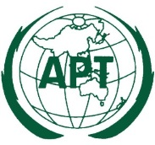 | ASIA-PACIFIC TELECOMMUNITY
 | The APT Conference Preparatory Group for WRC-15
Source: APG15-4/OUT-14(Rev.1)

preliminary views on WRC-15 agenda item 1.17 developed by apg15-4

Agenda Item 1.17:
to consider possible spectrum requirements and regulatory actions, including appropriate aeronautical allocations, to support wireless avionics intra-communications (WAIC), in accordance with Resolution 423 (WRC-12)

APT Preliminary Views:
- APT Members support relevant ITU-R studies on WAIC in accordance with Resolution 423 (WRC-12).
- APT Members support a primary allocation to AM(R)S in the frequency band 4 200-4 400 MHz, limited to WAIC systems.
- APT Members note that studies show that the introduction of WAIC systems do not constrain the incumbent services having primary allocation in the frequency band 4 200-4 400 MHz.
- Some APT Members have decided a specific method (and option) to satisfy the Agenda item, while some others are yet to develop a position on a method to satisfy the Agenda item.

