**Report of the Agenda Item Coordinator during CPM19-2**

Name and email of the Coordinator: Yoshio MIYADERA, miyadera.yoshio@jrc.co.jp

Report Date: 25 February 2019

1. Agenda Item

1.9.2 Satellite component of the VHF Data Exchange System (VDES)

to consider, based on the results of ITU-R studies: modifications of the Radio Regulations including new spectrum allocations to the maritime mobile-satellite service (Earth to space and space-to-Earth), preferably within the frequency bands 156.0125-157.4375 MHz and 160.6125-162.0375 MHz of Appendix 18, to enable a new VHF data exchange system (VDES) satellite component …

1. APT Preliminary Views and/or APT Views for the modification of draft CPM Report (which was submitted to CPM19-2) on the Agenda Item

APT proposed the modifications to the texts in Chapter 5 of the Draft CPM Report related to WRC-19 agenda item 1.9.2 (Addendum 5 to Document CPM19-2/14).

The main proposal is the addition of new Method G.

1. Topics proposed by other regional Groups or ITU Members which are not included in no. 2 above

Norway proposed rearrangement methods.

Japan proposed modification of method F, to remove degradation and to remove constraint, to the frequency usage of VDES terrestrial component. The proposal was only modification of usage of the VDES terrestrial frequencies of method F, the VDES satellite frequencies were unchanged from method F.

Russia proposed new method which using RR No 9.21 for coordination.

1. Progress of discussion during CPM19-2 on the Agenda Item

SWG's drafting has finalized and a TEMP document has been uploaded (CPM19-2/TEMP/27 rev.1).

The addition of Method G is included as an option 2 of method D.

Norwegian proposal is accepted as described in following section.

Japanese proposal is accepted.

Russian proposal is included as a new method E.

4.1 Created method

|  |  |  |  |  |  |
| --- | --- | --- | --- | --- | --- |
| (new)  Method | Option | Frequency plan | Satellite allocation | Coordination | previous method |
| A | - | No change | None | - | A |
| B | 1 | Alternative 2 | Primary | pfd mask 1 | B |
| 2 | Alternative 2 | Primary | pfd mask 2 | E |
| C | - | Alternative 2 | Secondary | - | C |
| D | 1 | Alternative 2 | Secondary | pfd mask 3 | D |
| 2 | Alternative 2 | Secondary | pfd mask 4 | (proposed as G) |
| E | - | Alternative 2 | Secondary | RR No 9.21 | (new) |
| F | - | Alternative 3 rev | Primary | pfd mask 1 | F with modification |



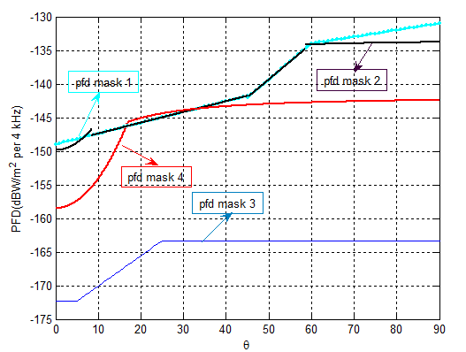

pfd mask 1 : provided in Recommendation ITU-R M.2092-0

pfd mask 2 : provided in Annex 2 of Report ITU-R M.2435-0

pfd mask 3 : provided in section 6.1.2.2.3.2 of Report ITU-R M.2435-0

pfd mask 4 : provided in section 6.1.2.2.2 of Report ITU-R M.2435-0

1. Issues which require discussion at APG Coordination meeting and seek guidance thereafter

None.

*Note: Coordinators are encouraged to conduct informal consultation with interested APT Members on the issues/topics under no. 3 and inform the outcomes of consultation to the Coordination Meeting*.