Report of the Agenda Item Coordinator during WRC-19
Mr. Dong Zhou (dzhou322@gmail.com)
20/11/2019
- Agenda Item
1.14 to consider, on the basis of ITU-R studies in accordance with Resolution 160 (WRC 15), appropriate regulatory actions for high-altitude platform stations (HAPS), within existing fixed-service allocations;
Resolution 160 (WRC 15) – Facilitating access to broadband applications delivered by high altitude platform stations
- APT Common Proposals and APT Views for WRC-19 (which has been submitted to WRC-19)
APT Members support no changes to the Radio Regulations (Method A as contained in the CPM Report) to ensure protection of all existing services to which frequency bands are allocated and their future development in the frequency bands 6 440-6 520 MHz and 6 560-6 640 MHz
In addition, APT Members are of the view that any consideration of the frequency band 24.25-27.5 GHz in Region 2 under this agenda item should not limit the possibility to identify the band for IMT on a global basis under WRC-19 agenda item 1.13.
APT Members consider that protection of all existing services to which frequency bands are allocated and their future development should be ensured.
No consensus was reached among APT Members on any Method to address this agenda item in the frequency bands 27.9-28.2 GHz, 31-31.3 GHz, 38-39.5 GHz, 47.2-47.5 GHz and 47.9-48.2 GHz.
- Topics proposed by other regional Groups or ITU Members which are not included in no. 2 above
- Progress of discussion during WRC-19 on the Agenda Item
- The inter-regional informal meeting set a direction for the ad-hoc meeting, as illustrated below.
 | 6GHz lower band | 6GHz higher band | 28 GHz | 31 GHz | 38 GHz | 38 GHz | 47 GHz
CEPT | NOC | NOC | NOC | ↓↑ | ↓ | ↑ | Alternative 2
ASMG | NOC | NOC | NOC | ↓↑ | ↓ | ↑ | Alternative 2
CITEL | NOC | NOC | NOC | ↓↑ | ↓ | ↑ | Alternative 2
RCC | NOC | NOC | NOC | ↓↑ | ↓ | ↑ | Alternative 2
ATU | NOC | NOC | NOC | ↓↑ | ↓ | ↑ | Alternative 2
APT | NOC | NOC | NOC | ↓↑ | ↓ | ↑ | Alternative 2
- APT coordination meeting on AI 1.14, 17:50 PM, DAHAB (CAPITAL), attendance around 20 delegates.
APT member participants are of the view that the package approach proposed by inter-regional informal meeting can be a compromised way forward. The meeting further discussed the footnote of 38GHz and came up with a text to ad-hoc group. After one hour discussion, all meeting participants went to the Ad-hoc Plenary meeting immediately after the coordination meeting.
- Ad-hoc Plenary 4B1(HAPS) meeting
With the presence of APT members, and based on the comprised package approach proposed by inter-regional meeting, the Ad-hoc meeting concentrated on the drafting work of 38GHz band towards a worldwide HAPS identification on both uplink and downlink, finally consensus was reached on the footnote and new resolution. This proposal, along with others, is expected to be approved in the Plenary.

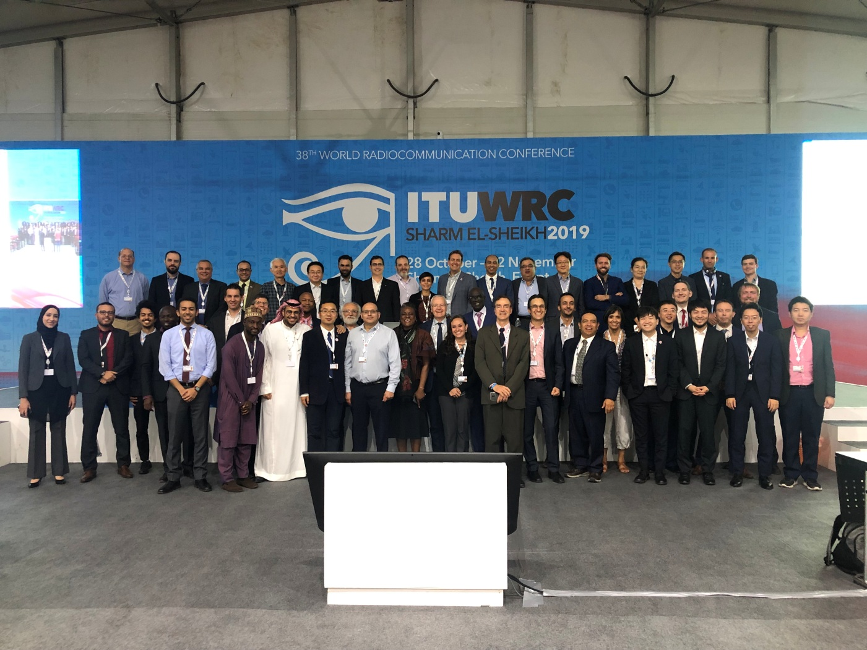
- Issues which require discussion at APT Coordination Meetings and seek guidance thereafter
Note: Coordinators are encouraged to conduct informal consultation with interested APT Members on the issues/topics under no. 3 and inform the outcomes of consultation to the Coordination Meeting. Coordinators can also organize coordination meetings on the respective agenda items whenever necessary.

