Report of the Agenda Item Coordinator during WRC-19
Name and email of the Coordinator: Phung Nguyen Phuong,
phuongpn@rfd.gov.vn
Report Date: 01/11/2019

- Agenda Item 7 issue E
To consider possible changes, and other options, in response to Resolution 86 (Rev. Marrakesh, 2002) of the Plenipotentiary Conference, an advance publication, coordination, notification and recording procedures for frequency assignments pertaining to satellite networks, in accordance with Resolution 86 (Rev.WRC-07), in order to facilitate rational, efficient and economical use of radio frequencies and any associated orbits, including the geostationary-satellite orbit.
Issue E - Resolution related to RR Appendices 30B
- APT Common Proposals and APT Views for WRC-19 (which has been submitted to WRC-19)
APT members support the single method in the CPM text to establish special measures to be applied once with respect to the submission received from an administration having no frequency assignments in the RR Appendix 30B List the details of which are to be contained in a WRC Resolution to facilitate the tasks of those administrations to provide an economically viable satellite service to its national territory as initially considered when the allotment Plan was established in 1988.
APT members additionally propose to consider following matters in the WRC Resolution [A7E-AP30B] (WRC-19):
a) To take into account the relative space station uplink receive antenna gain of the potentially affected assignment at the location of the interfering earth station for uplink PFD criteria;
b) To assist administrations intending to use above mentioned special procedures to be able to implement/ accommodate these satellite networks if all measures mentioned in draft resolution did not help to resolve incompatibility with respect to satellite network in Appendix 30B having Global/Regional coverage. but with final service area limited to few numbers of contiguous or non-contiguous countries; and
c) Take necessary actions for inclusion of above a) and b) in draft Resolution, as appropriate.
- Topics proposed by other regional Groups or ITU Members which are not included in no. 2 above
RCC | CITEL | CEPT | ATU | ASMG | APT
Support single method | No PACP | Support single method | Support single method | Support single method | Support single method

APT, CEPT and ATU supports to amend the single method in the CPM Report with the two explicit amendments discussed at the last ITU-R Working Party 4A meeting in June-July 2019.
RCC and ASMG support the single method.
- Progress of discussion during WRC-19 on the Agenda Item
The meeting focus on the proposal from ATU that proposed on possible group submission could be benefit from special measures to be applied once with respect to the submission received from an administration having no frequency assignments in the RR Appendix 30B List.
It seems that issue is technical issue, in fact, some African countries putting the resource together.
Some concerns have been raised on the proposal from Quatar, France, Australia, RCC..
ATU also mentioned the proposal applied to Group of countries only. Not intent to apply for
ATU, Regional Group.

Some concerns have been raised on the proposal with respect to:
- How to applied for group of countries
- The requirement for change of Rules of procedure to control the matter
- How to interpreter the regulatory
- Date of effective
- How coverage should be designed
The meeting set up small group led by South Africa to draft the text.
Besides that ATU also faced with the problem with uplink similar to APT.

APT view:
- Support proposal of ATU in general;
With respect to group submission:
- Apply to case of all the countries in the groups have no assignments in the List or recorded.
- All the countries of the group are closed (neibouring countries for example).
- Do not touch the test points during technical discussion if required we think that
- Keep the specific date to apply the special procedure as 23 November 2019.
- Take into account the relative space station uplink receive antenna gain of the potentially affected assignment at the location of the interfering earth station for uplink PFD criteria.
- Add further resolves has been proposed to address essential regulatory measures or actions that when an administration having no assignment in the List of Appendix 30B or assignment submitted under § 6.1 of Appendix 30B applies the additional procedures of the draft new WRC Resolution [A7E-AP30B], coordination difficulties can still be encountered.
Small group Meeting yesterday:
The meeting received the proposal from Quatar on the modification of provision 3, bullet c) on the service area to respect the proposal of the submission of group countries.
Some concerns have been raised on how coverage area and service area should be designed (Composite beam covering non-continuous service area, a a minimum ellipse or shaped beam).

- Issues which require discussion at APT Coordination Meetings and seek guidance thereafter
Proposes:
For Part A submission: Administration acting on behalf of group of administrations will submit the Composite beam covering non-continuous service area which includes all the service area of all administration in group.
For Part B submission: Administration acting on behalf of group of administrations will submit the shaped beam generated from the composite beam. At Part B they may submit a shaped beam but that has to be within the envelop of the composite beam.
Composite beam covering continuous service area | Shaped beam generated from the composite beam. At Part B they may submit a shaped beam but that has to be within the envelop of the composite beam
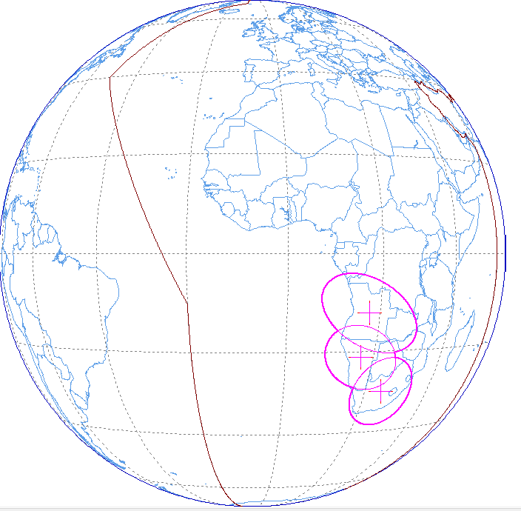 | 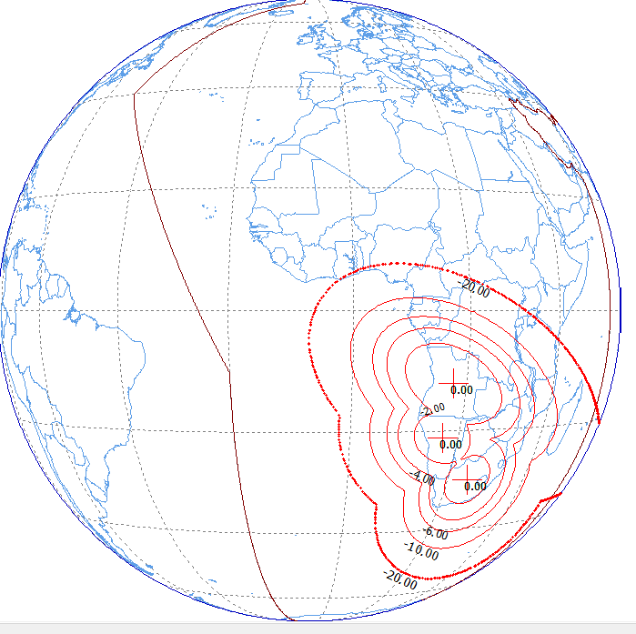
Composite beam covering non-continuous service area | Shaped beam generated from the composite beam. At Part B they may submit a shaped beam but that has to be within the envelop of the composite beam
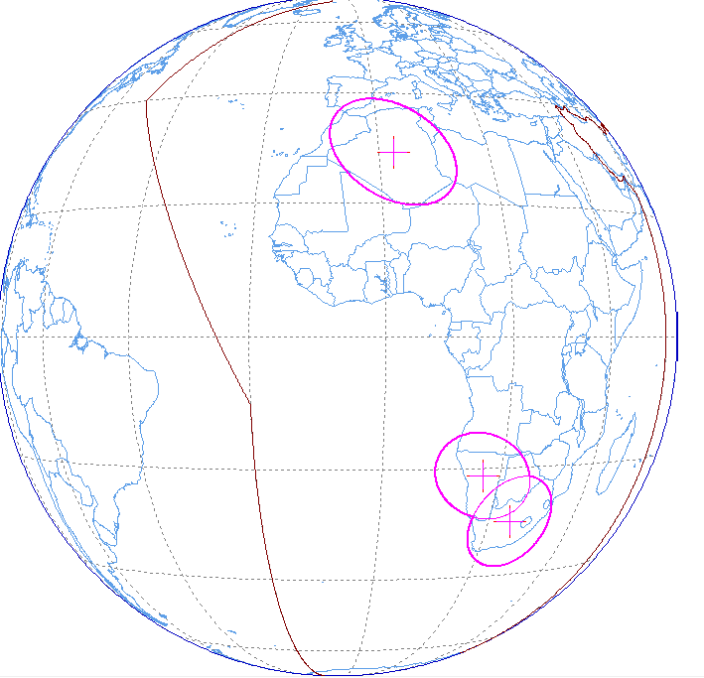 | 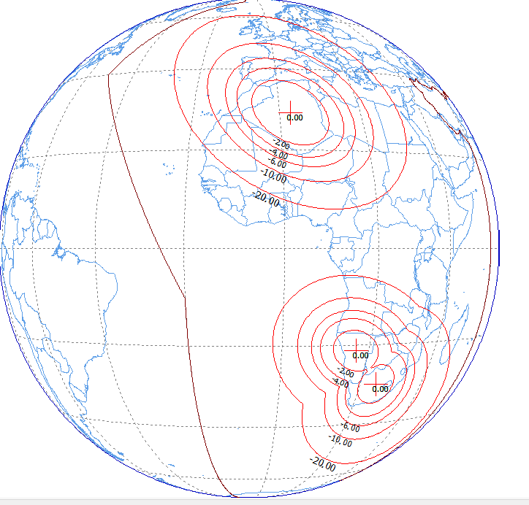

Note: Coordinators are encouraged to conduct informal consultation with interested APT Members on the issues/topics under no. 3 and inform the outcomes of consultation to the Coordination Meeting. Coordinators can also organize coordination meetings on the respective agenda items whenever necessary.

