Report of the Agenda Item 9.1 (Issue 9.1.2) Coordinator during WRC-19
Yongseok SEO (on1yys@korea.kr)
Report Date: 18 Nov. 2019

- Agenda Item
9 to consider and approve the Report of the Director of the Radiocommunication Bureau, in accordance with Article 7 of the Convention:
9.1 on the activities of the Radiocommunication Sector since WRC-15;
9.1 (9.1.2) Resolution 761 (WRC-15) - Compatibility of International Mobile Telecommunications and broadcasting-satellite service (sound) in the frequency band 1 452-1 492 MHz in Regions 1 and 3APT Common Proposals and APT Views for WRC-19 (which has been submitted to WRC-19)

- APT Common Proposals and APT Views for WRC-19 (which has been submitted to WRC-19)
None

- Topics proposed by other regional Groups or ITU Members which are not included in no. 2 above
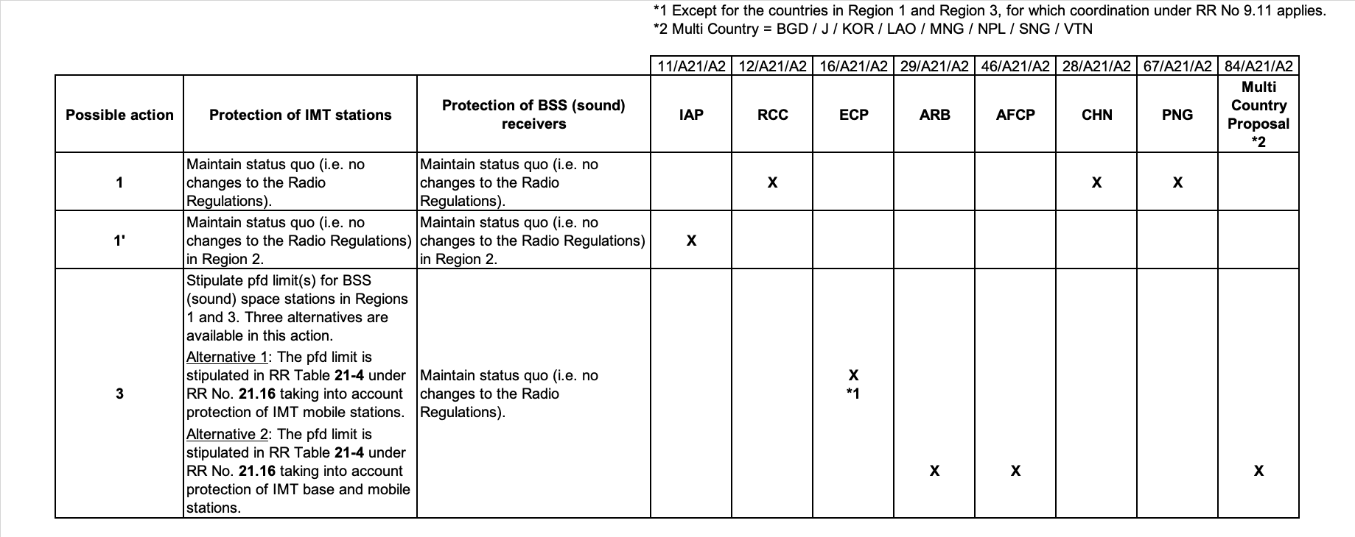

- Progress of discussion during WRC-19 on the Agenda Item
ADH Group dealing with issue 9.1.2 met 5 times and made efforts to reach consensus on creating the solution for the issue 9.1.2. The meeting decided to develop the revised Resolution 761 and spent significant time to discuss on it. Finally, the meeting almost reached to the consensus. However, some issue is under consideration on the off-line discussion. The first Report from Ad Hoc Group on agenda item 9.1 issue 9.1.2 will elevate to Committee 4
- Issues which require discussion at APT Coordination Meetings and seek guidance thereafter
None

Note: Coordinators are encouraged to conduct informal consultation with interested APT Members on the issues/topics under no. 3 and inform the outcomes of consultation to the Coordination Meeting. Coordinators can also organize coordination meetings on the respective agenda items whenever necessary.

