Report of the Agenda Item 9.1 (Issue 9.1.2) Coordinator during WRC-19
Yongseok SEO (on1yys@korea.kr)
Report Date: 20 Nov. 2019

- Agenda Item
9 to consider and approve the Report of the Director of the Radiocommunication Bureau, in accordance with Article 7 of the Convention:
9.1 on the activities of the Radiocommunication Sector since WRC-15;
9.1 (9.1.2) Resolution 761 (WRC-15) - Compatibility of International Mobile Telecommunications and broadcasting-satellite service (sound) in the frequency band 1 452-1 492 MHz in Regions 1 and 3APT Common Proposals and APT Views for WRC-19 (which has been submitted to WRC-19)

- APT Common Proposals and APT Views for WRC-19 (which has been submitted to WRC-19)
None

- Topics proposed by other regional Groups or ITU Members which are not included in no. 2 above
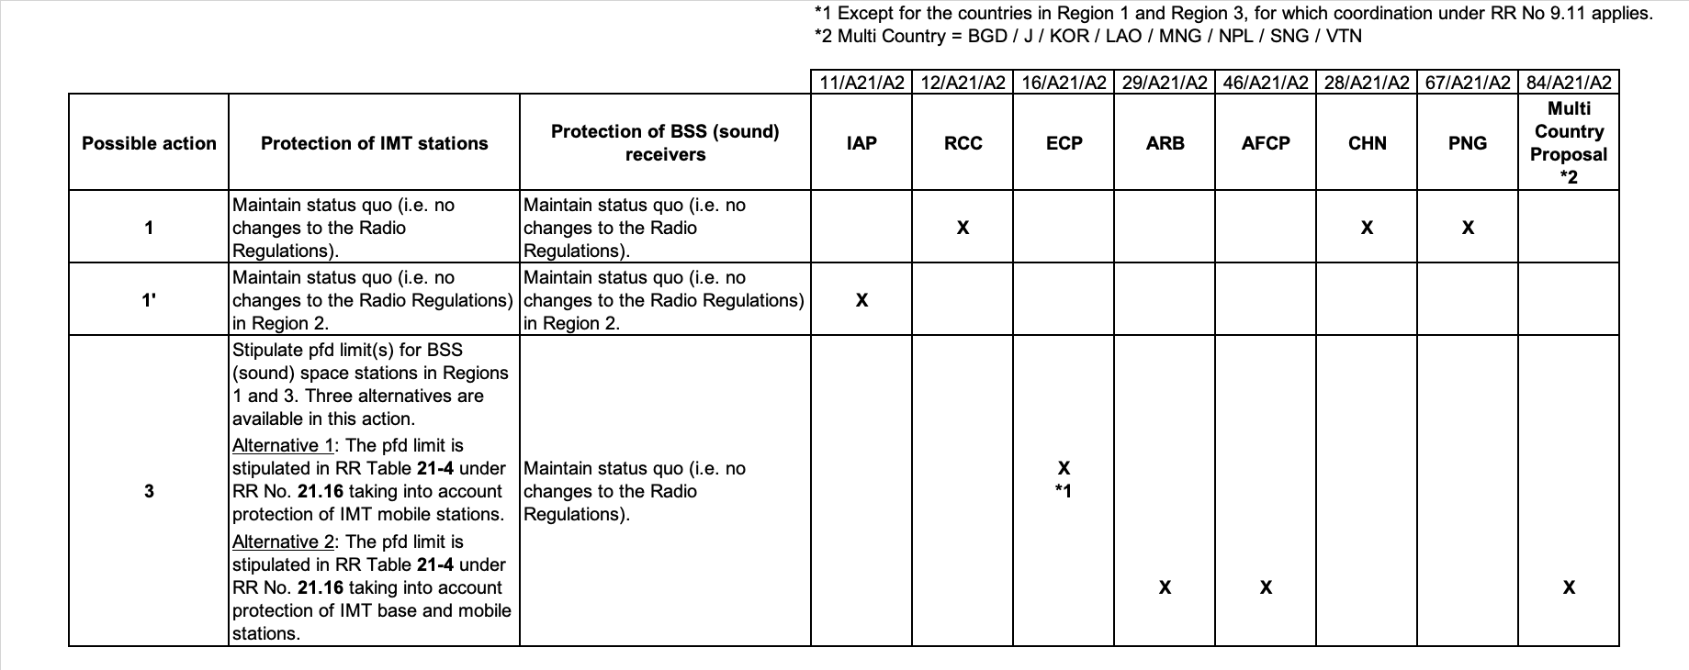

- Progress of discussion during WRC-19 on the Agenda Item
Ad-hoc group for issue 9.1.2 developed the modification of Resolution 761 to resolve this issue. During the discussion in the Ad-hoc meeting, following measures for both BSS and IMT were agreed.
For protection IMT;
- Establish two kinds of pfd values as a hard limit and coordination threshold values in Regions 1 and 3 (except for the territories of the countries listed in No. 5.342).
For protection BSS (sound);
- Establish pfd value at the border of the territory of the notifying administration of a BSS (sound) network.
Except the case of applying pfd as hard limit, generally, the coordination under No. 9.11 is applied to the BSS (sound) and IMT.
The Document 496 as result of issue 9.1.2 was approved at the WRC-19 Plenary on 20. November 2019.
- Issues which require discussion at APT Coordination Meetings and seek guidance thereafter
None

Note: Coordinators are encouraged to conduct informal consultation with interested APT Members on the issues/topics under no. 3 and inform the outcomes of consultation to the Coordination Meeting. Coordinators can also organize coordination meetings on the respective agenda items whenever necessary.

