Contact Details of the APG-19 Office Bearers and Agenda Item Coordinators during WRC-19
(Updated 30 October 2019)

APG-19 Management Team
Designation | Name | Photo | Details | Email
Chairman, APG-19 | Dr. Kyu-Jin Wee (Republic of Korea) |  | Fellow, Korea Radio Promotion Association | kjwee56@rapa.or.kr
Acting Vice-Chairman, APG-19 | Mr. Christopher Hose (Australia) |  | Executive Manager, Australian Communications and Media Authority | Christopher.Hose@acma.gov.au
Acting Vice-Chairman, APG-19 | Ms. Zhu Keer (People’s Republic of China) |  | Director, Space Service Division, Bureau of Radio Regulation, Ministry of Industry and Information Technology, People’s Rep. of China | zhukeer@miit.gov.cn
Chairman, Editorial Committee, APG-19 | Dr. Tommy Chee (New Zealand) |  | Principal Advisor, Ministry of Business, Innovation and Employment, New Zealand | Tommy.Chee@mbie.govt.nz
Special Senior Advisor to APG | Mr. Kavouss Arasteh (Islamic Republic of Iran) | 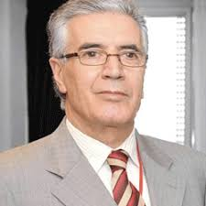 | Senior Advisor, Communications Regulatory Authority, Islamic Rep. of Iran | kavouss.arasteh@gmail.com

WP1: Land Mobile and Fixed Services (Agenda Items 1.11, 1.12, 1.14 and 1.15)
Designation | Name | Photo | Details | Email
Chairman, WP1 | Mr. Jia Huang |  | Deputy Director, State Radio Monitoring Center, Ministry of Industry and Information technology (MIIT), People’s Republic of China | ferrero.huang@srrc.org.cn
Coordinator AI1.11  Coordinator AI1.11 (Acting) | Mr. Liu Bin  (People’s Republic of China)  Mr. Bo Jiang  (People’s Republic of China) | 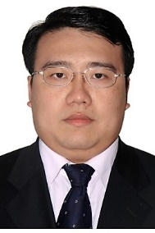 | Deputy Director, State Radio Monitoring Center, People’s Republic of China  Research Assistant, China Academy of Railway Sciences, P. R. of China | liubin@srrc.org.cn  18501053358@163.com
Coordinator AI1.12 | Mr. Hirohito Marubashi (Japan) | 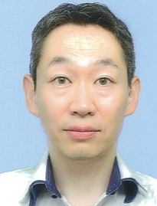 | Assistant Director  Ministry of Internal Affairs and Communications, Japan | h.marubashi@soumu.go.jp
Coordinator AI1.14 | Mr. Dong Zhou (People’s Republic of China) |  | Director, ZTE Corporation, People’s Republic of China | zhou.dong1@zte.com.cn
Coordinator AI1.15 | Mr. Sum Chin Sean (Japan) | 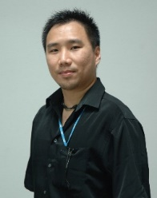 | Cooperative Visiting Researcher, NICT, Japan | sum@wi-sun.org

WP2: Broadband Applications in the Mobile Service (Agenda Items 1.13, 1.16, 9.1 (Issues 9.1.1, 9.1.5, 9.1.8))
Designation | Name | Photo | Details | Email
Chairman, WP2 | Dr. Jaewoo Lim  (Republic of Korea) |  | Senior Researcher, National Radio Research Agency  Ministry of Science and ICT (MSIT)  Republic of Korea | jmlim@korea.kr
Coordinator AI1.13 | Dr. Hiroyuki Atarashi  (Japan) | 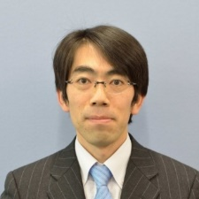 | Senior Manager, NTT DoCoMo Inc., Japan | hiroyuki.atarashi.yt@nttdocomo.com
Coordinator AI1.16 and 9.1 (Issue 9.1.5) | Dr. Fang Ji Cheng  (People's Rep. of China)  Ms. Fu Qiang  (People's Rep. of China) |  | Senior Engineer, National Research Institute of Radio Spectrum Management, People’s Republic of China  Senior Engineer, National Research Institute of Radio Spectrum Management, People’s Republic of China | jchfang@163.com  fuqiangbupt@163.com
Coordinator AI9.1 (Issue 9.1.1) | Dr. Azim Fard  (Islamic Rep. of Iran) | 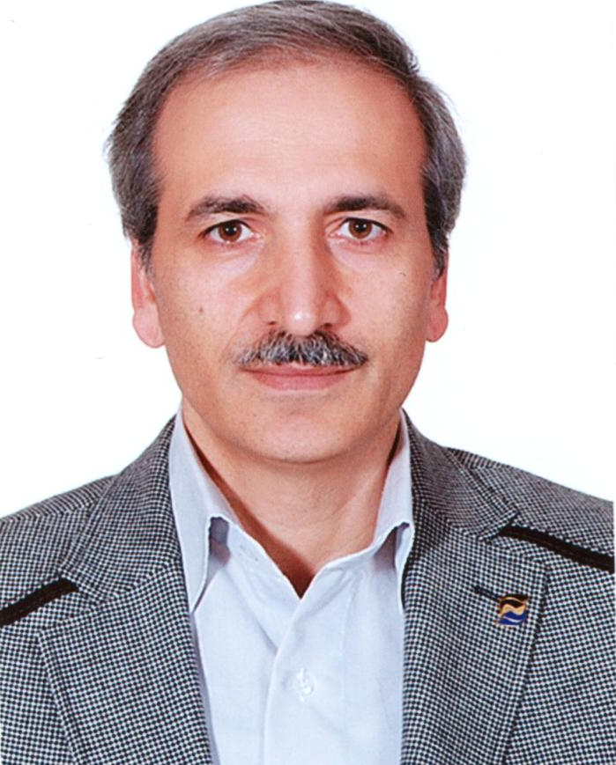 | Director General, Spectrum Planning and Licensing, Communication Regulatory Authority, Ministry of ICT, Islamic Republic of Iran | azimfard@cra.ir
Coordinator AI9.1 (Issue 9.1.8) | Mr. Fierza Pasaribu (Indonesia) | 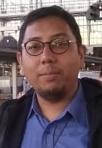 | Directorate of Spectrum Planning and Policy, DG SDPPI, Ministry of Communications and  Informatics (MCI), Indonesia | fierza@postel.go.id

WP3: Satellite Services (Agenda Items 1.4, 1.5, 1.6, 7, 9.1 (Issues 9.1.2, 9.1.3, 9.1.9) and 9.3)
Designation | Name | Photo | Details | Email
Chairman, WP3 | Mr. Muneo Abe  (Japan) | 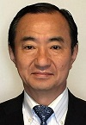 | Executive Manager, Telecommunication Systems Sales and Marketing Division, Mitsubishi Electric Corporation, japan | Abe.Muneo@cj.MitsubishiElectric.co.jp
Coordinator AI1.4 | Mr. Meiditomo Sutyarjoko (Indonesia)  Mr. Kemal Nasir (Indonesia) | 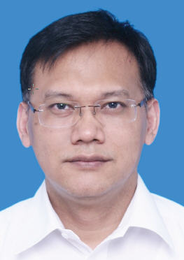 | Assistant Manager, PT. Bank Rakyat Indonesia  BRIsat Regulatory - Coordination Manager  PT. Bank Rakyat Indonesia | Meiditomo.sutyarjoko@bri.co.id  kemal.nasir@corp.bri.co.id
Coordinator AI1.5 | Mr. Noriyuki Inoue  (Japan) | 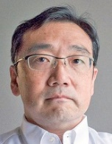 | Manager, KDDI Corporation | ni-inoue@kddi.com
Coordinator AI1.6 | Mr. Dave Kershaw (New Zealand) | 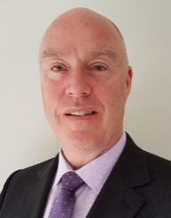 | Managing Director, Dave Kershaw Consulting Ltd., New Zealand | dave.kershaw@dkconsulting.co.nz
Coordinators AI7 | (Issues: C1, C2, C3, C6, C7, E, F, K and M): Mr. Phung Nyugen Phuong (Viet Nam)  (Issues: B, C4, G and J): Ms. Geetha Remy Vincent (Malaysia)  (Issues: A, C5, D, H, I and L): Mr. Iraj Mokarrami (Islamic Rep. of Iran) | 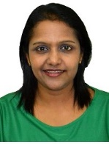  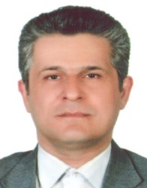 | Director, International Frequency Coordination, Authority of Radio Frequency Management, Viet Nam  Consultant, Measat Satellite Systems, Malaysia  Deputy Director General, Communication Regulatory Authority, Islamic Rep. of Iran | phuongpn@rfd.gov.vn  geetha@measat.com  iraj.mokarrami@cra.ir
Coordinator AI9.1 (Issue 9.1.2) | Dr. Dae-Sub Oh (Rep. of Korea) | 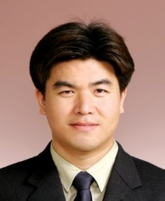 | Special Fellow, Electronics and Telecommunications Research Institute, Rep. of Korea | trap@etri.re.kr
Coordinator AI9.1 (Issue 9.1.3) | Mrs. Cheng Fenhong (People's Rep. of China) | 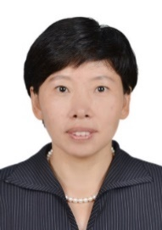 | Deputy Director, China Satellite Communications Co. Ltd | chengfenhong@chinasatcom.com
Coordinator AI9.1 (Issue 9.1.9)
Coordinator AI9.3 | Ms. Geetha Remy Vincent (Malaysia) |  | Consultant, Measat Satellite Systems, Malaysia | geetha@measat.com

WP4: Science Services (Agenda Items 1.2, 1.3 and 1.7)
Designation | Name | Photo | Details | Email
Chairman, WP4 | Dr. Ajmadji W. Soewito (Indonesia) | 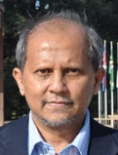 | President Director  RFD Tech, Indonesia | atmadji@rfd-tech.com
Coordinator AI1.2 | Mr. Xiaodong Wang (People's rep. of China) |  | Engineer, State Radio Monitoring Center, People’s Republic of China | wxd@srrc.org.cn
Coordinator AI1.3 | Ms. Amalia Yunitasari (Indonesia) | 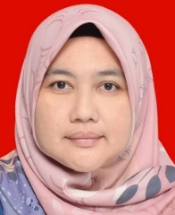 | Senior Officer, Spectrum Harmonization Ministry of Communications and Informatics, Rep. of Indonesia | amalia@postel.go.id
Coordinator AI1.7 | Mr. Nguyen Huy Cuong (Viet Nam) |  | Deputy Director, Frequency Coordination Division, Authority of Radio Frequency Management, Socialist Rep. of Vietnam | cuongnh@rfd.gov.vn

WP5: Maritime, Aeronautical and Amateur Services (Agenda Items 1.1, 1.8, 1.9, 1.10 and 9.1 (Issues 9.1.4)
Designation | Name | Photo | Details | Email
Chairman, WP5 | Mr. Bui Ha Long (Socialist Rep. of Viet Nam) |  | Deputy Head of Frequency, Assignment and Licensing Division  Authority of Radio Frequency Management, Socialist Rep. of Vietnam | longbh@rfd.gov.vn
Coordinator AI1.1 | Mr. Dale Hughes (Australia) |  |  | dalevk1dsh@gmail.com
Coordinators AI1.8 | Dr. Byungok Kim (Rep. of Korea)  Ms. Ge Xia (People's Rep. of China) | 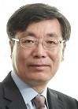 | Professor, Korea Institute of Maritime and Fisheries Technology, Rep. of Korea  Senior Engineer, Beijing Satellite Navigation Center, People’s Rep. of China | kimbo60@hanmail.net  gexia@bsnc.com.cn
Coordinator AI1.9.1 | Mr. Liu Falong (People's Rep. of China) |  | Engineer, China Transport Telecommunications and Information Center, People’s Rep. of China | ctticliufalong@163.com
Coordinator AI1.9.2 | Mr. Yoshio Miyadera (Japan) | 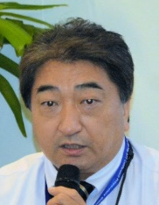 | Manager, Japan Radio Co. Ltd. | miyadera.yoshio@jrc.co.jp
Coordinator AI1.10 | Mr. Zhao Liang (People's Rep. of China) |  | China Aviation Administration | zhaoliang@adcc.com.cn
Coordinator AI9.1 (Issue 9.1.4) | Mr. Yuhistira Prayoga (Indonesia) |  | Senior Engineer, Ministry of Communications and Informatics, Rep. of Indonesia | yudhistira.prayoga@postel.go.id
WP6: General Issues (Agenda Items 2, 4, 8, 9.1 (Issues 9.1.6, 9.1.7) and 10
Designation | Name | Photo | Details | Email
Chairman, WP6 | Mr. Taghi Shafiee (Islamic Rep. of Iran) | 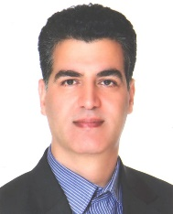 | Director General, Regional Office  Communication Regulatory Authority (CRA)  Islamic Rep. of Iran | shafiee@cra.ir
Coordinator AI2 | Ms. Keiko Mori (Japan) |  | Executive Vice President  Washington CORE, Japan | keikom@wcore.com
Coordinator AI4
Coordinator AI8 | Mr. Neil Meaney (Australia) |  | Director (Asia-Pacific), Boeing Australia Holdings, Australia | neil.j.meaney@boeing.com
Coordinator AI9.1 (Issue 9.1.6) | Mr. Sathoshi Kobayashi (Japan) | 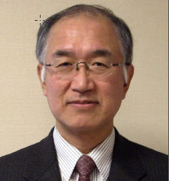 | Associate Member, Information and Communication Council, MICT, Japan | s-koba@suite.plala.or.jp
Coordinator AI9.1 (Issue 9.1.7) | Mrs. Zeng Fansheng (People's Rep. of China) |  | Senior Engineer, State Radio Monitoring Center, People’s Republic of China | zengfs@srrc.org.cn
Coordinators AI10 | Standing Agenda Items:  Mr. Taghi Shafiee (Islamic Rep. of Iran)  IMT, HIBS:  Ms. Lyu Boya (People's Rep. of China)  Others:  Ms. Qian Sun (People's Rep. of China)  Mr. Paul Burford (Australia) |  | Director General, Regional Office  Communication Regulatory Authority (CRA)  Islamic Rep. of Iran  Engineer, Huawei Technologies Co. Ltd. People’s Republic of China  Senior Engineer, China Academy of Space Technology, People’s Republic of China  Principal Engineer, Satellite Coordination, Australian Government | shafiee@cra.ir  lvboya@huawei.com  sun_qian_cast@sina.com  pzburford@gmail.com

