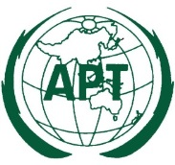 | ASIA-PACIFIC TELECOMMUNITY
 | Coordination Meetings of APT during RA-19/WRC-19
 | 21 October – 22 November 2019, Sharm-el Sheikh, Egypt

agenda of the 2nd coordination meeting during RA-19/WRC-19

Room: SUEZ CANAL
Time: 12:30 – 13:30 Hours, 23 October 2019

- Approval of Agenda

- Update on the issues in RA-19

  - Res. 2-7 (Dr. Choongkeun Oh)
  - New Resolutions: RSTT (Mr. Liu Bin); ITS (Mr. Hirohito Marubashi)
  - Resolutions on IMT: (KOR)

- Issues of the Chairman and Vice-Chairmen for ITU-R Study Groups, CCV, RAG and CPM

  - Candidates for Vice-Chairmen from APT Members

- Any other issues
  - Outcomes of 9th and 10th Meeting of the Informal Group

__________

