 | ASIA-PACIFIC TELECOMMUNITY | Document No.:  ASTAP-31/OUT-20
31st APT Standardization Program Forum
(ASTAP-31)
 | 11–15 June 2019, Tokyo, Japan | 15 June 2019

WG SA

QUESTIONNAIRE ON
TRAFFIC ACCIDENT RECORD AND ITS ANALYSIS METHOD’S GUIDELINES
IN ASIA-PACIFIC REGION

Section 1: Elementary Part

1. Introduction:
In 2015, United Nations has firstly set Sustainable Development Goals (SDGs) on traffic accident, and intended to halve the number of global deaths and injuries from road traffic accidents by 2020 (Goal 3. Target 3.6). In 2016, ASEAN Regional Road Safety Strategy and most of APT member countries has set the goal close to UN’s SDG.
However, according to recent WHO Road Safety Report 2018, global annual road fatality reaches to 1.35 million, 0.2 million more than the level of 2010. Also, traffic accident is the leading killer in the age of 5-29 years.
The Road accident is best definite as “refers to any accident involving at least one road vehicle, occurring on a road open to public circulation, and in which at least one person is injured or killed. Intentional acts (murder, suicide) and natural disasters are excluded” [1].
In order to reduce the traffic accident effectively in APT member countries, it is necessary to understand how accident is happened. Traffic accident record is usually the first hand information to understand what is happened in accident. However, traffic accident record is usually recorded by hand and faces difficulty to database it correctly. By utilizing ICT solutions effectively on digital record and database, it can improve the reliability of traffic accident data.
In 2010, WHO has published “Data systems: a road safety manual for decision-makers and practitioners” to recommend minimum data element to be recorded in ANNEX 1. It is worth to survey the current status in APT member countries and compare to the WHO recommendation.
Furthermore, it is also usually happened that traffic accident record is not fully analyzed due to the poor quality of traffic accident data. By providing basic and common analysis methods such as accident heat map and dangerous vehicle pattern identification, it will help authority to identify the cause of accident and create counter-measure in prompt fashion.
The following is the possible counter-measure that could be generate through the analysis of traffic accident record. In this questionnaire, we would like survey the expectation of counter-measure and the current traffic accident record status in APT member countries.

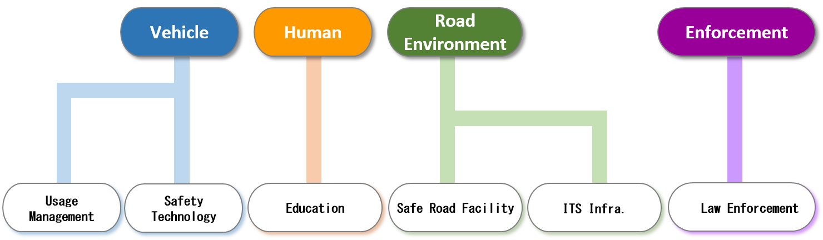 Fig.1 Possible Counter-Measure through Traffic Accident Analysis
In Fig. 1, we can see that the counter-measures can be covered in the aspects of vehicle, human, road environment and enforcement. Fig.2 shows in order to find out the counter-measure, the necessary information should be gathered through traffic accident record.

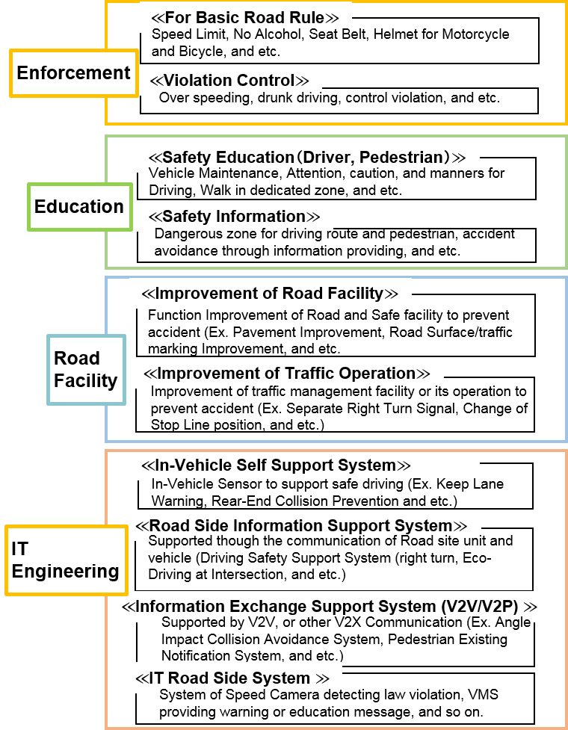
Fig.2 Possible Counter-Measure Menu

2. Objective of the Questionnaire:
The objectives of the questionnaire are to survey the expectation of counter-measure and the current traffic accident record status in APT member countries. For examples, Figure 1 shows categories of expectation and current status of counter-measure that can be realized.
After collecting the questionnaires and analyzing them, we would like to identify the status of traffic accident record and their expectation on how to utilize it, and to identify the guideline topics in order to identify the cause and reduce traffic accident in Asia-Pacific region.
To clarify the term and definition using in the questionnaire, ANNEX 2 provides a number of term and definitions to help the respondent to answer the questionnaire. If further clarification is necessary, it is recommended to contact the Rapporteur of the Questionnaire

3. Responsible Group:
EG IoT / WG SA

4. Rapporteur of the Questionnaire:
Dr. Chang-Yi Luo, TTC, Japan (cyluo@mail.toyota.co.jp)

5. Meeting at which the Questionnaire was approved:
ASTAP-31

6. Target Responder:
APT Members/Associate Members

7. Deadline for Responses:
15 December 2019

Reference
[1] The National Institute of Statistics and Economic Studies, France, “Road Accident”, [On-Line] https://www.insee.fr/en/metadonnees/definition/c1116

Section 2: Questionnaire Part

1. Contact information

1.1. Primary contact information

Date |  | Country
Organization
Title |  | Name
Email |  | Telephone

1.2. Secondary contact (Specialist/Accident Database Owner) information
(Please copy the following table, if there are two or more secondary contact persons)

Date
Organization
Database Name
Title |  |  | Name
Email |  |  | Telephone
Answered section Q. No.
Notes

1.3. Status of this response
Select one: First response / Second response

2. Questions

Question 1: Traffic Accident Analysis

In your country, which area you expect to counter-measure through traffic accident analysis (can choose more than one)?

- Education (Safety Education, Safety Information)
- Law enforcement (For Basic Road Rule, Violation Control)
- Road Facility (Improvement of Road Facility, Improvement of Traffic Operation)
- Traffic IT Solution (Violation Detect System, Road Side Information Support System, In-Vehicle Self Support System, Information Exchange Support System)
Others＿＿＿＿＿＿＿＿＿＿＿＿＿＿＿＿＿＿

  - In your country, which traffic analysis method is desirable (can choose more than one)?
- Find out prone accident spot
- Find out accident mechanism at accident spot
- Find out human cause at accident spot
- Find out the relationship of road facility and traffic operation at accident spot
Others＿＿＿＿＿＿＿＿＿＿＿＿＿＿＿＿＿＿

Question 2: Traffic Accident Record Status

(2-1) Is accident crash location recorded in GPS format?

□ Yes
□ No
Others＿＿＿＿＿＿＿＿＿＿＿＿＿＿＿＿＿＿

(2-2) If YES, how do you transfer crash location to GPS?

□ By Electronic Device at site
□ By Electronic Device after site
Others＿＿＿＿＿＿＿＿＿＿＿＿＿＿＿＿＿＿

(2-3) Does accident impact type recorded as following (can choose more than one)?

- Head On
- Rear End
- Angle Impact
- Side Swipe
Other______________________________________

Total Number_______________________________

(2-4) How road/environment categories are recorded (can choose more than one)?

- Type of roadway (Ex. Highway, Rural)
- Road Sharp (Ex. Curve, Cross)
- Junctional (Ex. U turn, T Junction)
- Traffic control at junction (Ex. Stop sign, Traffic Lights)
- Speed Limit
- Road surface conditions
Other______________________________________

(2-5) How accident cause (Ex. inattentive, road defect, lost brakes) are recorded (can choose more than one)?

- Human factors
- Environmental Factor
- Vehicle Factors
- Illegal Factors
Other______________________________________

(2-6) How many human factors are recorded (can choose more than one)?

- Inattentive
- Wrong Judgement
- Wrong Operation
Other______________________________________

(2-7) How many environmental factors are recorded (can choose more than one)?

- Under Construction
- Road Facility Disorder
- Light Condition
- Road Surface Damage
- Weather Condition
Other______________________________________

(2-8) How many vehicle factors are recorded (can choose more than one)?

- Loss Control
- Dysfunctional Brake
- Vehicle Factors
- Tire Blowouts
Other______________________________________

(2-9) How many illegal factors are recorded (can choose more than one)?

- Ignore Signal
- Over Speeding
- Alcohol use suspected
- No helmet
- Ignore Stop Sign
Other______________________________________

(2-10) How many personal information in 1st party are recorded (can choose more than one)?

- Sex
- Age
- Vehicle Type
- Travel purpose
- Year for license obtained
- Body injure part
Other______________________________________

(2-11) How many personal information in 2st party are recorded (can choose more than one)?

- Sex
- Age
- Vehicle Type
- Travel purpose
- Year for license obtained
- Body injure part
Other______________________________________

(2-12) How many driver status are recorded (can choose more than one)?

- Helmet
- Seat belt
- Using mobile phone
Other______________________________________

Question 3: Future Vision for Traffic Accident Record

  - Is there any under-going project in your country to develop digital record software (definition of digital record in Appendix 1)?

□ Yes
□ No
Others＿＿＿＿＿＿＿＿＿＿＿＿＿＿＿＿＿＿

  - In the future, if there is free digital record software available, are you or is your organization interested in experiencing it (definition of digital record in Appendix 1)?

□ Yes
□ No
Others＿＿＿＿＿＿＿＿＿＿＿＿＿＿＿＿＿＿

Question 4: Future Vision for Traffic Accident Analysis

  - Is there any under-going project in your city to develop automated accident analysis software?

□ Yes
□ No
Others＿＿＿＿＿＿＿＿＿＿＿＿＿＿＿＿＿＿

  - In the future, if there is free automated accident analysis software available, are you or is your organization interested in experiencing it?

□ Yes
□ No
Others＿＿＿＿＿＿＿＿＿＿＿＿＿＿＿＿＿＿

____________

Annex 1

WHO Minimum data element recommednation

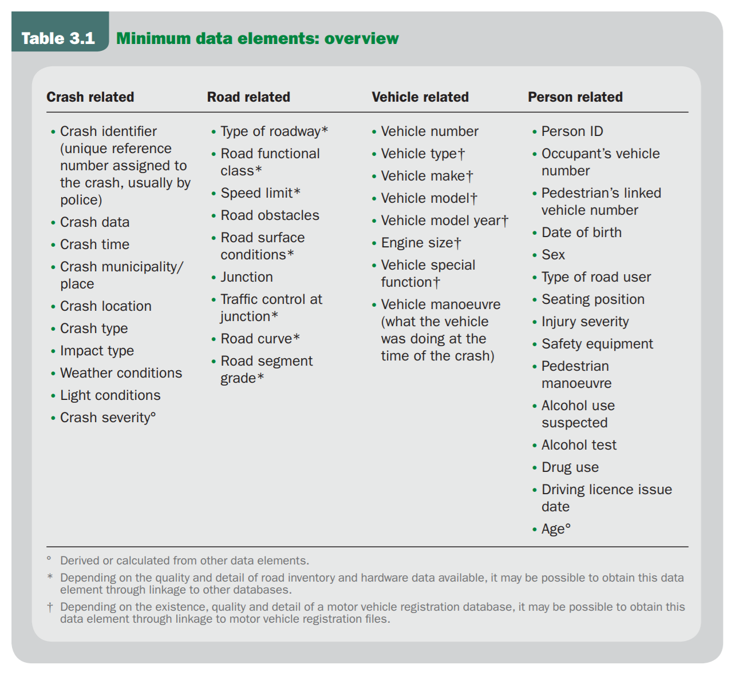
Overview

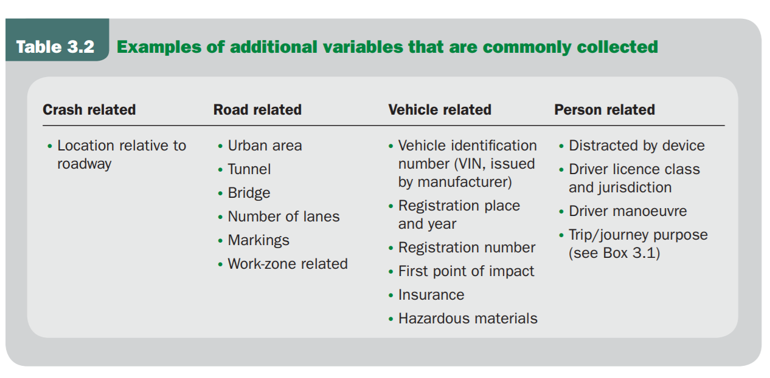
Example of Additional Variables

Reference: World Health Organization, “Data systems: a road safety manual for decision-makers and practitioners”, [On-Line]
https://apps.who.int/iris/bitstream/handle/10665/44256/9789241598965_eng.pdf?sequence=1, 2010.
____________

Annex 2

Term and definition of the questionnaire

Term and definition of the questionnatre is listed in the following. The definition is based on WHO report, “Data systems: a road safety manual for decision-makers and practitioners”.

Alcohol use suspected
Definition: Law enforcement officer suspects that person involved in the crash has used alcohol.

Age
Definition: The age in years of the person involved in the crash.

Crash location
Definition: The exact location at which the crash occurred. Optimum definition is route name and GPS/GIS coordinates if there is a linear referencing system (LRS), or other mechanism that can relate geographic coordinates to specific locations in road inventory and other files. The minimum requirement for documentation of crash location is the street name, the reference point, distance from reference point and direction from reference point.

GPS (Global Positioning System)
Definition: a system that can show the exact position of a person or thing by using signals from satellites.

Impact type
Definition: Indicates the manner in which the road motor vehicles involved initially collided with each other. The variable refers to the first impact of the crash, if that impact was between two road motor vehicles.

Data values:
1 No impact between motor vehicles: There was no impact between road motor vehicles. Refers to single vehicle crashes, collisions with pedestrians, animals or objects.
2 Rear end impact: The front side of the first vehicle collided with the rear side of the second vehicle.
3 Head on impact: The front sides of both vehicles collided with each other.
4 Angle impact – same direction: Angle impact where the front of the first vehicle collides with the side of the second vehicle.
5 Angle impact – opposite direction: Angle impact where the front of the first vehicle collides with the side of the second vehicle.
6 Angle impact – right angle: Angle impact where the front of the first vehicle collides with the side of the second vehicle.
7 Angle impact – direction not specified: Angle impact where the front of the first vehicle collides with the side of the second vehicle.
8 Side by side impact – same direction: The vehicles collided side by side while travelling in the same direction.
9 Side by side impact – opposite direction: The vehicles collided side by side while travelling in opposite directions.
10 Rear to side impact: The rear end of the first vehicle collided with the side of the second vehicle.
11 Rear to rear impact: The rear ends of both vehicles collided with each other.

Junction
Definition: Indicates whether the crash occurred at a junction (two or more roads intersecting) and defines the type of the junction. In at-grade junctions all roads intersect at the same level. In not-at-grade junctions roads do not intersect at the same level.

Light conditions
Definition: The level of natural and artificial light at the crash location, at the time of the crash.

Road surface conditions
Definition: The condition of the road surface at the time and place of the crash.

Safety equipment
Definition: Describes the use of occupant restraints (Seat-belt), or helmet use by a motorcyclist or bicyclist.

Sex
Definition: Indicates the sex of the person involved in the crash.

Speed limit
Definition: The legal speed limit at the location of the crash.

Traffic control at junction
Definition: Type of traffic control at the junction where crash occurred. Applies only to crashes that occur at a junction.

Type of roadway
Definition: Describes the type of road, whether the road has two directions of travel, and whether the carriageway is physically divided. For crashes occurring at junctions, where the crash cannot be clearly allocated in one road, the road where the vehicle with priority was moving is indicated.

Vehicle type
Definition: The type of vehicle involved in the crash.

Weather conditions
Definition: Prevailing atmospheric conditions at the crash location, at the time of the crash.

Data values:
1 Clear (No hindrance from weather, neither condensation nor intense movement of air. Clear and cloudy sky included)
2 Rain (heavy or light)
3 Snow
4 Fog, mist or smoke
5 Sleet, hail
6 Severe winds (Presence of winds deemed to have an adverse effect on driving conditions)
7 Other weather condition
8 Unknown weather condition
____________

