

**APT REPORT ON**

**STUDIES ON THE CO-EXISTENCE BETWEEN IMT-2000 TECHNOLOGIES AND BETWEEN IMT-2000 TECHNOLOGIES AND OTHER WIRELESS ACCESS TECHNOLOGIES IN ADJACENT AND NEAR-ADJACENT FREQUENCY BANDS**

No. APT/AWG/REP-4(Rev.2)

Edition: February 2016

**Adopted by**

**The 19th Meeting of APT Wireless Group (AWG-19)**

**2 – 5 February 2016**

**Chiang Mai, Thailand**

**APT REPORT ON**

**STUDIES ON THE CO-EXISTENCE BETWEEN IMT-2000 TECHNOLOGIES AND BETWEEN IMT-2000 TECHNOLOGIES AND OTHER WIRELESS ACCESS TECHNOLOGIES IN ADJACENT AND NEAR-ADJACENT FREQUENCY BANDS**

**Introduction**

This Report examines the co-existence between different wireless access technologies in various frequency bands and is intended to provide a compilation of useful reference material for the benefit of APT members. A number of APT members have requested guidance on handling co-existence scenarios within their domestic allocation and licensing processes. This Report is expected to address the needs of these APT members.

This Report contains information on the results of analytical studies and live testing measurement that were contributed to the AWG. A number of relevant reference documents have also been embedded into this report.

This Report is not intended to be comprehensive. It is also understood that future modifications to this Report will be made to include additional sharing study results based on further contributions to the AWG.

**Interference Scenarios Covered by this Report**

1) Co-existence between CDMA2000 and WCDMA at 1.9 GHz

See ATTACHMENT 1

1. Co-existence between TD-SCDMA and PHS

See ATTACHMENT 2

3) Co-existence between CDMA2000 and GSM at 900 MHz

See ATTACHMENT 3

4) Co-existence between CDMA2000 networks operating in the 450 – 470 MHz band and other services

See ATTACHMENT 4

**Other Reference Material**

The following reference materials were also considered relevant to the work of Task Group on Sharing Studies on IMT Systems. The reference texts listed below are also included as embedded documents.

**a) ITU-R**

* **RECOMMENDATION ITU-R M.1580-5: *Generic unwanted emission characteristics of base stations using the terrestrial radio interfaces of IMT-2000 (2014).*** This Recommendation establishes spurious emission mask limits to assist the deployment of multiple IMT-2000 interfaces.
* **RECOMMENDATION ITU-R M.1635: *General methodology for assessing the potential for interference between IMT-2000 or systems beyond IMT-2000 and other services (2003).*** This Recommendation provides a methodology for assessing the potential for interference between IMT-2000 and other services in co-frequency and adjacent band deployments.
* **Report ITU-R M.2031: *Compatibility between WCDMA 1800 downlink and GSM 1900 uplink (2003).*** This report analyses band edge interference issues between 1800 MHz WCDMA downlinks and 1900 MHz GSM uplinks and includes deterministic calculations and Monte Carlo simulations that might be useful to a number of interference scenarios.
* **Report ITU-R M.2039-3:** ***Characteristics of terrestrial IMT-2000 systems for frequency sharing/interference analyses (2014).*** This report provides the baseline characteristics of terrestrial IMT-2000 systems

**b) Other**

* **A*nalysis of interference between WCDMA and CDMA2000.* China Communications Standards Association.** This report studies incidents of mutual interference between WCDMA and cdma2000 systems operating in adjacent frequency bands.
* ***Interference analysis and guidelines for coexistence.* Qualcomm Inc.**  This document examines sharing issues between various mobile technologies in co-frequency and adjacent frequency bands.
* ***3GPP TS 25.104 V11.0.0 (2011-12): 3rd Generation Partnership Project; Technical Specification Group Radio Access Network; Base Station (BS) radio transmission and reception (FDD) (Release 11)*. 3GPP.** This document establishes the Base Station minimum RF characteristics of the FDD mode of UTRA, especially Adjacent Channel Selectivity (ACS) and the limitation set for the condition of co-existence operating in the same geographical area with BTS from other cellular systems, one of which is CDMA system.
* ***3GPP2 C.S0010-E Version 1.0 (December 2011): Recommended Minimum Performance Standards for cdma2000 Spread Spectrum Base Stations*. 3GPP2.** This document sets minimum performance standards for base stations of CDMA2000 system.

**Other scenarios identified for possible inclusion in future studies include:**

* CDMA2000 uplink in 1850 - 1910 MHz and the GSM downlink in 1805 - 1880 MHz.
* TDD and FDD systems at 2 GHz.
* PHS systems in the 1885-1920 MHz band and WCDMA uplinks in the 1920-1980 MHz band.

APT members are encouraged to contribute further studies on these scenarios to future meetings of the AWG.

**_______________**

**ATTACHMENT 1**

**Co-existence between CDMA2000 and WCDMA at 1.9 GHz**

**Source:**

**Input Document AWF-2/57 (Rev.1) from DG Postel, Indonesia**

**Input Document AWG-14/43 (Rev.1) from MCIT, Indonesia**

**1. Sharing Study Conducted in Indonesia at 2005**

**1.1 Definition of Interference Scenario**

There is a potential for interference between the CDMA2000 downlink in 1930 – 1990 MHz and the WCDMA uplink in 1920 – 1980 MHz.

|  |  |  |  |
| --- | --- | --- | --- |
| **Wireless Access Technology** | **Mobile Station Transmitter (MHz)** | **Base Station Transmitter (MHz)** | **Duplex**  **Sep (MHz)** |
| **CDMA2000** | **1 850 – 1 910** | **1 930 - 1 990** | **80** |
| **WCDMA** | **1 920 – 1 980** | **2 110 - 2 170** | **190** |

**1.2 Results of Live Testing**

Indonesia submitted an input document to the 2nd meeting of the APT Wireless Forum (AWF) held in September 2005 reporting the results of live testing conducted in Indonesia for this scenario. The test was conducted by DGPT Indonesia together with operators (PT. Telkomsel, PT. Telkom and PT.Indosat) to study the impact of interference on both WCDMA and CDMA 2000 technologies and to determine the required guard band between both technologies.

Previously, DG Posts & Telecommunications (DG Postel) has allocated CDMA 2000 technology at PCS 1900 bands. And recently, DG Postel also allocated WCDMA technology at IMT-2000 band as can be seen in the figure below:



As shown, the CDMA 2000 down link and WCDMA Up link are licensed to operate in adjacent frequency bands. Hence the study and testing was conducted to determine the impact on interference between CDMA 2000 Down link and WCDMA Up link.

**1.3 Testing Scenario --** The testing was conducted by comparing the impact on having the WCDMA system implemented with and without guard band toward the CDMA 2000 system. During the test, the following conditions were tested:

* Between two systems, guard band of 15 MHz, 5 MHz and no guard band were tested.
* 1 WCDMA Node B and 1 CDMA 2000 RBS that close to each other was selected.
* 2 worst sectors / cells on WCDMA system was selected in order to determine the impact of interference on WCDMA up link.
* WCDMA system was set under minimum capacity to simplify testing on the impact of interference toward system capacity.

**1.4 Testing Result –** The testing result show following important point :

* Interference increasing WCDMA noise level -- The noise level of WCDMA system was increase dramatically when there is no guard band with the CDMA 2000 system.
* Interference decreasing WCDMA capacity -- Due to the noise level of WCDMA were increase, The system capacity reduced by 20% as compare to non interferer condition.
* Under worst condition, no calls on WCDMA system can be made -- Highly interferer WCDMA system, where WCDMA and CDMA 2000 close and head to head to each other, without any guard band between the system, the test result show that no call can be made. Moreover, when the mobile station are close to the CDMA 2000 system, the mobile station were not able to make location update due to very strong interference from CDMA 2000 down link.
* 5MHz guard band improved the noise level -- The test result show that with a guard band of 5 MHz between WCDMA and CDMA 2000 will improve the noise level significantly. Moreover, the maximum capacity of the system can be achieved due to less interference on the WCDMA up link.

**1.5 Testing Conclusion**

* The uplink of WCDMA system is interfered by the downlink of CDMA 2000 system and will impact to degradation of capacity– while the impact to CDMA 2000 is negligible.
* The testing showed that the different carrier spacing (guard band) and the geographical distance between CDMA 2000 and WCDMA in 1900 MHz band will cause capacity loss due to interference.
* From the test result it was proven that the noise level in a high-interfered cell is higher than one in a low-interfered cell.
* A high-interfered cell has less capacity. Hence, it can support less UE simultaneously, compared to the low-interfered cell. In the test case results, for Video call application, the number of supported UE’s decreases by 20% compared to the low-interfered cell.
* Minimum Guard band of 5 MHz with sites coordination between the CDMA2000 downlink and the WCDMA uplink is required to overcome the interference problem. Moreover, band pass filter is required to minimize the interference using 5 MHz guard band.
* At the worst case where the sites are close to each other and the antennas are facing each other, the interferences show worst impact not only to capacity loss but cause WCDMA can not make any location update.

**2. Sharing Study Conducted in Indonesia at 2012**

**2.1 Status in Indonesia after conducted sharing study at 2005**

After conducting sharing study of CDMA2000 and WCDMA systems at 2005, a year later (2006), MCIT of Republic of Indonesia set frequency ​​arrangements for 2.1 GHz band to be used by WCDMA system is 1920-1970 MHz / 2110-2160 MHz and frequency ​​arrangements for 1.9 GHz band to be used by CDMA2000 system is 1903.125 - 1910 MHz / 1983.125 - 1990 MHz. Thus, there is enough guard band with a wide of   
13.125 MHz between the upper limit of WCDMA uplink allocation to the lower limit of CDMA2000 downlink allocation.

Due to the increase demand of data traffic through 3G networks and taking into account the results of sharing study conducted at 2012, MCIT run a selection process for adding the WCDMA band allocation to the existing 3G operators, to become 1920-1980 MHz / 2110-2170 MHz. The impact of this selection process is a reduction of the wide guard band between WCDMA uplink to CDMA downlink, from 13.125 MHz (before selection) to 3.125 MHz (after selection).

Below is a figure that pictured the current WCDMA allocation, after the selection process run in early 2013, and also the allocation of CDMA2000 in Indonesia (Figure 1). For additional information, that after the selection is done, it will continue by a total refarming process in WCDMA 2.1 GHz band to realign the whole allocations for each operators.

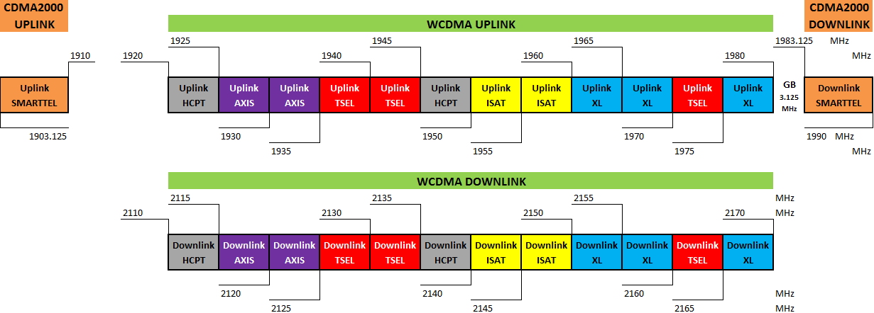

Figure 1. WCDMA and CDMA2000 Current Allocation in Indonesia

**2.2 Background of conducting sharing study at 2012**

As explained earlier, the background for conducting sharing study in 2012 was due to the Government's plan to increase the allocation by 10 MHz wide for WCDMA system. With the additional allocation of 10 MHz, then the guard band between WCDMA uplink and CDMA2000 downlink will be decreased by 10 MHz, from 13.125 MHz to   
3.125 MHz only. Based on the results of the sharing study at 2005 conducted by Indonesia and a study by Qualcomm presented in AWF-3 (Doc. AWF-3/43), it was noted that the need for guard band at least 5 MHz.

To review the results of sharing study at 2005 in more detail and by taking into account the advances in current filter technology, Indonesia conducted new sharing study at 2012 with the aim of seeing the potential interference arising from the condition of this mixed band plan situation and to formulate an interference mitigation solutions that effectively and efficiently can solve the problems between CDMA2000 and WCDMA in 2.1 GHz band.

**2.3 Research Methodology**

Although there are eight possible scenarios of interference between WCDMA system and CDMA2000 system, but taking into account the position of band allocation between those two systems, there are only two possible interference scenarios that should be considered further (see Figure 2) :

1. Scenario 1 : CDMA BTS interfering with WCDMA Node-B; and
2. Scenario 7 : WCDMA UE interfering with CDMA2000 MS.

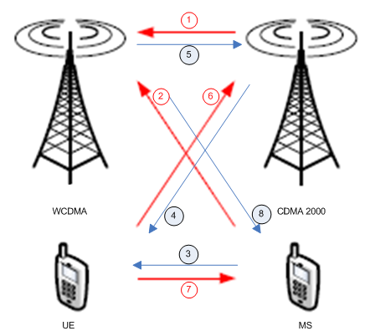

Note :

1. CDMA2000 BTS Tx interfering with WCDMA Node-B Rx
2. CDMA2000 MS Tx interfering with WCDMA Node-B Rx
3. CDMA2000 MS Tx interfering with WCDMA UE Rx
4. CDMA2000 BTS Tx interfering with WCDMA UE Rx
5. WCDMA Node-B Tx interfering with CDMA2000 BTS Rx
6. WCDMA UE Tx interfering with CDMA2000 BTS Rx
7. WCDMA UE Tx interfering with CDMA2000 MS Rx
8. WCDMA Node-B Tx interfering with CDMA2000 MS Rx

Figure 2. Possible Interference Scenarios between WCDMA and CDMA2000

Scenario 2 :

CDMA BTS interfering with WCDMA Node-B

(2110 – 2170 MHz)

Scenario 1 :

WCDMA UE (1920 – 1980 MHz) interfering with CDMA2000 MS



Figure 3. WCDMA and CDMA2000 Interference Scenarios

Referring to the results of the sharing study, especially on the uplink simulation, from China Communications Standard Association presented in AWF-3 (Doc. AWF-3/41) and the study from Association of Unified Telecom Service Providers of India (AUSPI), both are published at 2006, the interference scenario of WCDMA UE interfering with CDMA2000 MS can be considered negligible because the interference is expected to occur in a relatively small percentage of time and very low capacity loss occured. Thus, Indonesia just doing research on the interference scenario of CDMA2000 BTS interfering with WCDMA Node-B.

Methodology of the research are as follows :

1. Performing paper-based studies with reference to the documents of ITU, APT, 3GPP, 3GPP2, and the results of similar studies from other countries to explore the theory of the interference problems and also the mitigation proposals;
2. Organizing intensive discussions with the principal of the CDMA technology and also the vendors of the equipments;
3. Organizing continuous discussions with representatives of all WCDMA and CDMA2000 operators;
4. Composing a Standard Operating Procedure (SOP) document as a preparation to conduct joint measurements, in order to analyze the causes of the interference;
5. Conducting joint measurements involving the representatives of the Government and all the WCDMA and CDMA2000 operators;
6. Analyzing the joint measurement results;
7. Based on the joint measurement results, formulating hypothetical interference mitigation solutions;
8. Testing the effectiveness of the solutions by applying it directly in the field using existing WCDMA Node-B and CDMA BTS which are separated in a distance of   
   5 – 10 meters; and finally
9. Analyzing the results of the field measurements and then determine the provisions to be carried out in the domestic regulations as a guideline for coordination procedures between WCDMA and CDMA2000 operators.

Joint measurement methodologies that are contained in the SOP consists of four different types of measurements, those are :

1. Measurement of spurious emission from the transmitter module inside the CDMA2000 BTS. This measurement intended specifically to get the value of spurious emission level at the point of 1980 MHz when CDMA2000 BTS is transmitting channel 1075 (center frequency = 1983.75 MHz).
2. Measurement of the received filter characteristics in WCDMA Node-B.
3. Measurement of Received Signal Strength Indication (RSSI) read in Operation Support System (OSS) of WCDMA Node-B that is being measured.
4. Measurement of noise floor.

**2.4 Analysis to the Results of the Research**

Referring to the technical provisions contained in document 3GPP TS 25.104 v11.0.0, there are limitations set by the 3GPP for the condition of co-existence in UTRA FDD BTS operating in the same geographical area with BTS from other cellular systems, one of which is CDMA system. Table 6.11 3GPP TS 25 104 v11.0.0, state that the power of spurious emission shall not exceed -47 dBm with a measurement bandwidth of 100 kHz.

In contrast, document 3GPP2 C.S0010-E which highlighted the recommended minimum performance standards for CDMA2000 BTS, there were no provision mentioned for the conditions of co-existence between CDMA system with other cellular systems. The provision of the spurious emission contained in the 3GPP2 document is about the transmitter spurious emission limits (see Table 4.4.1.1.3-2 3GPP2 C.S0010-E). It was stated that maximum value of spurious emission within 2.25 - 4 MHz from the center frequency of transmitted CDMA200 channel is -13 dBm/1 MHz or equivalent to   
-23 dBm for a measurement bandwidth of 100 kHz. The value of -23 dBm/100 kHz was required in 3GPP2 C.S0010-E to be achieved when the condition of the transmitting channel measured is at its maximum power (20 Watt, equivalent to 32 dBm/100 kHz).

The measurement result of spurious emission at the CDMA2000 BTS can be seen in Figure 4. From these figure, it can be seen that the spurious emission at 1980 MHz, which means 3.75 MHz away from the center frequency of channel 1075   
(fc = 1983.75 MHz), equal to -86.14 dBm/100 kHz.

However, because 40 dB attenuator is used when conducting the measurement, then the actual value of the spurious emission is -46.14 dBm/100 kHz. The value of   
-46.14 dBm/100 kHz was reached for the transmitted channel power equal to   
21.76 dBm/100 kHz (-18.24 dBm/100 kHz + 40 dBm). Thus, by scaling, it can be said that for the condition of maximum transmitted power (32 dBm/100 kHz), the value of spurious emission at 1980 MHz is equal to -35.9 dBm/100 kHz.

When compared with the maximum spurious emission limit in 3GPP2 C.S0010-E, it can be said that the transmitter of CDMA2000 measured had a spurious emission comply with the limitation (max -23 dBm/100 kHz).

However, when it is compared to the maximum spurious emission limit for co-existence condition as stated in 3GPP TS 25.104 v11.0.0, the spurious emission from CDMA2000 transmitter (-35.9 dBm/100 kHz) certainly not comply with the limitation (max   
-47 dBm/100 kHz). To make it comply, the CDMA2000 BTS must install an additional filter for each antenna that have rejection value at least -11 dB in 1980 MHz. If the additional filter is not installed, then the receiver at WCDMA Node-B will experience degradation of signal reception sensitivity that is quite severe.

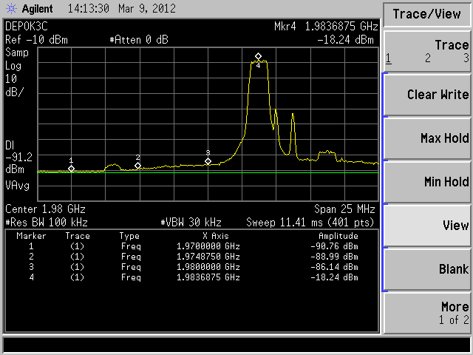

Figure 4. Measurement Result of Spurious Emission from CDMA2000 BTS

The example of CDMA2000 Tx filter specifications can be seen in Figure 5. This example is for rejection value requirement equal to -3.88 dB in 1980 MHz.

After doing research in the CDMA2000 BTS, the research continues in the WCDMA Node-B. For WCDMA Node-B, the conducted measurement is aimed at getting the received filter characteristics. The measurements results on different devices from different vendors indicate that the received filter characteristics installed in WCDMA Node-B still can not reject CDMA transmitted signal at 1983.125 – 1990 MHz very well, even the signal was amplified. Figure 6 shows one measurement result of receiver filter characteristics. It can be seen from the figure that there is no rejection at 1983.125 MHz, the received signal even amplified by 20 dB gain. The rejection value at 1983.125 should be around -3dB to -6 dB. Up to the point of 1990 MHz, the received signal is still amplified, approximately 11 dB gain, and there is no rejection also at this point. The rejection value at 1990 MHz should be -20 dB. Received signal starts not to be amplified at 1995 MHz and the rejection value began to increase thereafter.

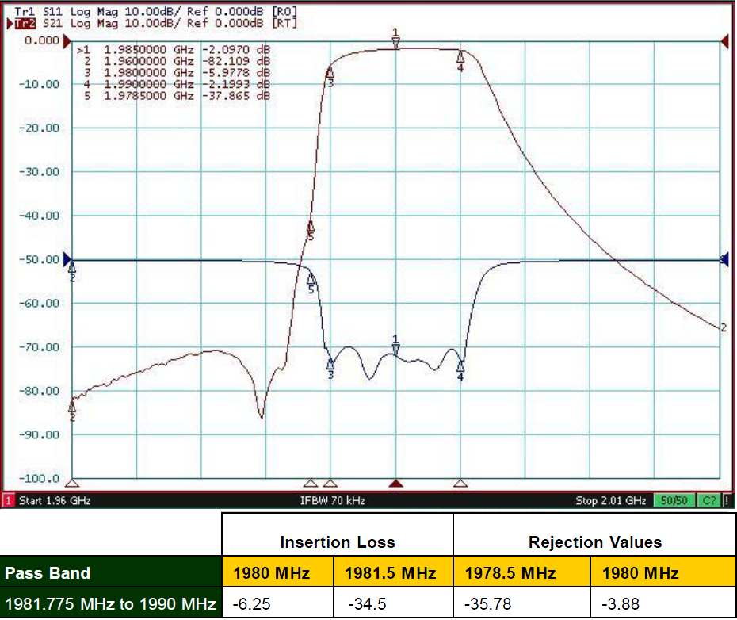

*Source : Qualcomm*

Figure 5. Example of CDMA2000 Transmitter Filter Specifications

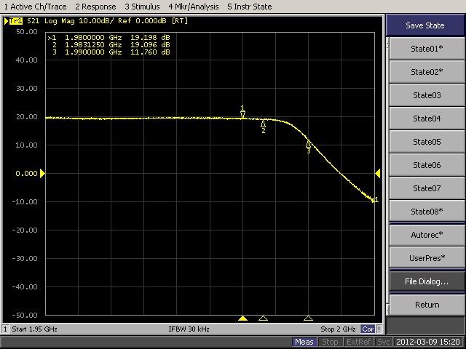

Figure 6. Measurement Result of Received Filter Characteristics at WCDMA Node-B

The received filter characteristics as described in Figure 6 causes Adjacent Channel Interference (ACI) at the receiver of WCDMA Node-B due to the incompatibility situation of Adjacent Channel Selectivity (ACS) limitation, which makes the LNA work in non-linear condition. Solutions that can be taken to address ACI is to combine the antenna isolation techniques with additional filter installation. Based on some experiments, additional received filter at WCDMA Node-B must have a rejection value around -30 dB to -40 dB at 1983.125 MHz. The example of WCDMA Rx filter specifications can be seen in Figure 7. This example is for rejection value requirement equal to -35.96 dB in 1981.5 MHz.

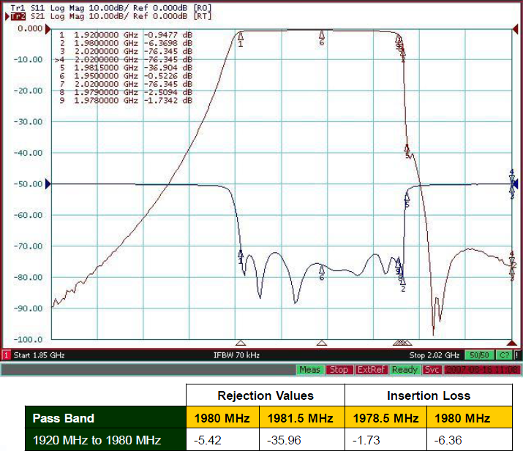

*Source : Qualcomm*

Figure 7. Example of WCDMA Receiver Filter Specifications

Adjacent Channel Selectivity (ACS) is a measure of the receiver ability to receive a wanted signal at its assigned channel frequency in the presence of an adjacent channel signal at a given frequency offset from the center frequency of the assigned channel. ACS is the ratio of the receiver filter attenuation on the assigned channel frequency to the receiver filter attenuation on the adjacent channel(s). The ACS minimum requirement for WCDMA applies as specified in the Table 7.3 of 3GPP TS 25.104 v11.0.0, which stated that the maximum level of interfering signal mean power equal to -52 dBm. Because the channel bandwidth of WCDMA is 5 MHz, then the ACS minimum requirement can be stated as -52 dBm/5 MHz. From one measurement, it can be seen that without enough rejection in 1983.125 – 1990 MHz band, it will lead to incompatibility with ACS requirement. Figure 8 shows the result of received signal from the antenna in WCDMA Node-B.

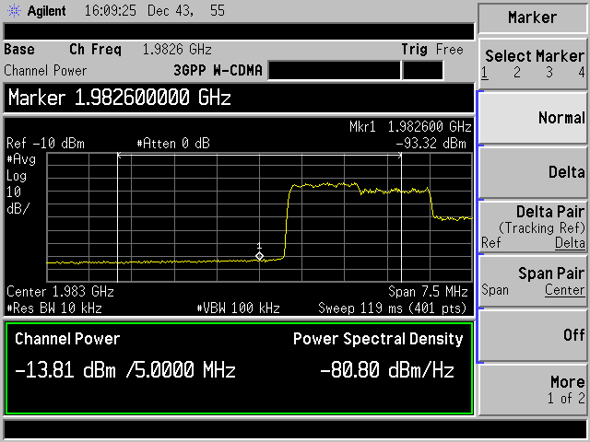

Figure 8. Signal Mean Power Measurement Result of 1980 – 1985 MHz band

Figure 8 shows that without additional received filter, the interfering mean power in the adjacent channel (1980 – 1985 MHz) is higher than the requirement. The measurement result is equal to -13.81 dBm/5 MHz, while the ACS requirement is maximum   
-52 dBm/5 MHz. After installing an additional received filter in WCDMA Node-B, the interfering mean power measured is better and it ends in a linear operation of the LNA.

Due to some difficulties in providing CDMA2000 Tx filter, there were no test involving both filters installed together, in WCDMA Node-B and CDMA2000 BTS, but the condition after the installation of additional filter in WCDMA Node-B is quite good, the RSSI measured in OSS for 1975 – 1980 MHz band is equal to -103 dBm/5 MHz. Before the installation of the additional received filter, the RSSI measured is equal to   
-55 dBm/5 MHz. To get the ideal RSSI which is around -105 dBm, the CDMA2000 operator must install additional filter in their BTS transmitter to achieve spurious emission level at 1980 MHz maximum -47 dBm/100 kHz (for transmitted power equal to 32 dBm/100 kHz).

Figure 9 10 show the difference measurement results of installing additional received filter in WCDMA Node-B.

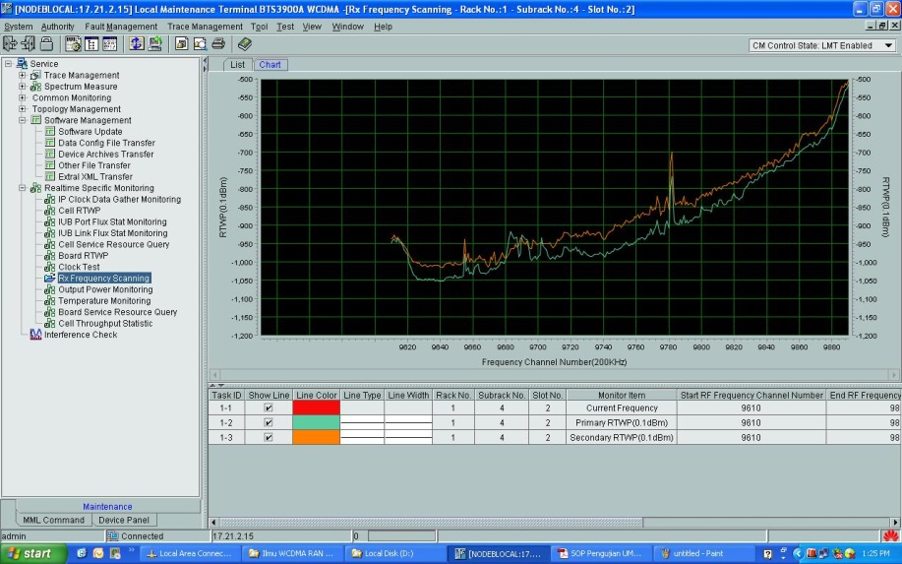

Main Antenna

Diversity Antenna

Figure 9. RSSI Measurement Before Additional Received Filter Installation

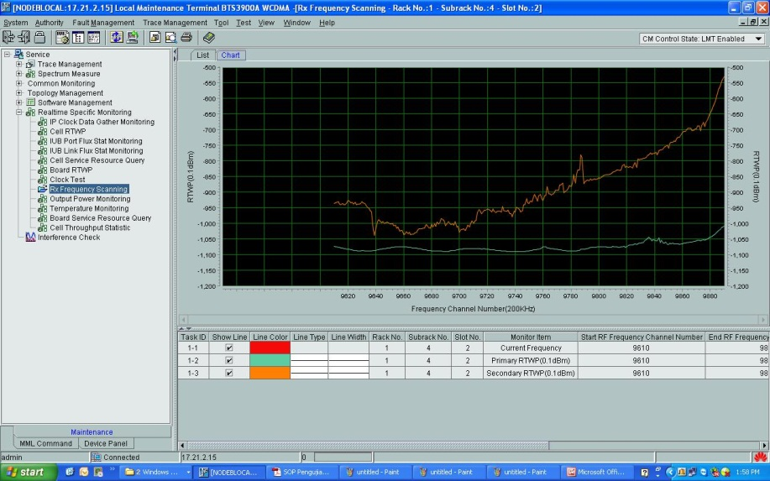

Diversity Antenna

Main Antenna

Figure 10. RSSI Measurement After Additional Received Filter Installation   
(only in Main Antenna, there is still no addtional filter in Diversity Antenna)

There are some cases recorded in our monitoring offices that the case of interference from CDMA2000 BTS transmitter to the WCDMA Node-B receiver were occured not only from the WCDMA operators that had an allocation near to the allocation of CDMA2000 operator, but also from the WCDMA operator that had an allocation in the lowest part of WCDMA uplink band (1920 – 1925 MHz). This could happen because of the geographical location of their Node-B is to close to the CDMA2000 BTS, around   
5 – 15 meters only. The condition was getting worse because the altitude of antennas from those sites are nearly the same and the antennas were situated in a face-to-face condition.

**2.5 Conclusion**

1. The main interference scenario should be considered for a mixed band plan condition of WCDMA in 2.1 GHz band and CDMA2000 in 1.9 GHz band is CDMA2000 BTS transmitter (downlink) interfering with WCDMA Node-B receiver (uplink).
2. The causes of CDMA2000 BTS transmitter interfering with WCDMA Node-B receiver are generated from both sides :
3. High spurious emission level from CDMA2000 transmitter in 1920 – 1980 MHz band, which the limit is maximum -47 dBm/100 kHz (measured in condition of transmitted power equal to 32 dBm/100 kHz), and
4. Low rejection in the embedded received filter of WCDMA Node-B for interfering signal in 1980 – 1985 MHz, which should reject interfering signal so that the measured mean power is maximum -52 dBm/5 MHz.
5. The solution for high spurious emission level from CDMA2000 transmitter is to install an additional filter between base station cabinet and the antenna that lower the spurious emission level as required.
6. The solution for low rejection in the embedded received filter of WCDMA Node-B is to install an additional filter between antenna and the base station cabinet that can reject interfering signal in the adjacent band to a level as required. To minimize the rejection value needed, WCDMA operator can cooperate with the CDMA2000 operator to reconfigure the physical parameters in both antennas to have higher level of antennas isolation.
7. The most critical factor of the interference potential is geographical locations of the CDMA2000 BTS and WCDMA Node-B, not the allocation of the frequency bands. The closer the location of the sites, the greater the potential for interference occured. Especially when antenna’s altitude of both sites are relatively the same and the azimuth directions of the antennas creates a face-to-face condition, it will lead to a higher potential of interference.

**ATTACHMENT 2**

**Co-existence between TD-SCDMA and PHS**

**Source: Input Document AWF-IM3/06 from ZTE Corporation, China**

China Communications Standards Association (CCSA) TC5 WG8 workgroup has completed sharing study between TD-SCDMA and PHS in 1880-1920MHz and the Report “TC5_WG8_2006_Sharing study between TD-SCDMA and PHS” has been approved in CCSA TC5 plenary meeting.

This report includes seven parts as below:

* Introduction
* Research Methodology
* Interference analyses
* System Parameters
* Network Model
* Simulation Results
* Conclusion and suggestion

The contribution provides useful information of this report.

# 1 Introduction

In October 2002, the Radio Administration under the Ministry of Information Industry issued the Notification regarding the Planning of Third Generation Public Mobile Communication System Frequencies, which stipulated the planning rules for 3G system frequencies in China. According to this planning scheme, The TD-SCDMA system has a total of 155 MHz available spectrum. The frequency range 1880-1920MHz/2010-2025MHz is used as the main service frequency range for TD-SCDMA. Meanwhile, Chinese government has allocated 2300-2400MHz to TD-SCDMA as additional spectrum.

Figure 1：TD-SCDMA frequency allocation in china



In china, the band 1900-1920MHz is used for PHS system. Therefore, CCSA TC5 WG8 decided to study coexistence between the TD-SCDMA and PHS system in the band 1880-1920MHz in 2004.

# 2 Research Methodology

The interference scenarios between TD-SCDMA and PHS in adjacent spectrum are as follows.

1. Interference from a PHS Cell station (CS) and PHS Personal Station (PS) to TD-SCDMA BS
2. Interference from a PHS CS and PHS PS to TD-SCDMA UE
3. Interference from TD-SCDMA BS and TD-SCDMA UE to PHS CS
4. Interference from TD-SCDMA BS and TD-SCDMA UE to PHS CS

In the interference analysis, the TD-SCDMA and PHS systems were modeled as operating in a microcellular network. Additionally, the analysis was extended to include macrocellular and picocellular deployment scenarios for the TD-SCDMA system.

This research adopted a simulation methodology to study major incidents of mutual interference between Cell stations and base stations working in adjacent frequency ranges in an environment where both the PHS and TD-SCDMA systems exist. Based on the analysis results, this research will draw a research conclusion with regard to system frequency interference protection and make recommendations to the relevant departments of the Chinese government on how to protect against frequency interference.

# 3 Interference analyses

The causes of interference are diverse. RF interference to mobile communication network may be caused by such factors as an original dedicated radio system occupying an existing frequency resource, improper network configurations by different operators, problematic configuration in the transmitter, cell overlapping, the environment, electromagnetic compatibility (EMC), and intentional interference. Primary forms of interference to mobile communication systems mainly include: common-frequency interference, adjacent-frequency interference, out-of-band emission, inter-modulation emission, and blocking interference.

Coexistence interference between systems working in different frequencies is caused by imperfections in the transmitter and the receiver. The transmitter, when transmitting useful signals, sometimes generates out-of-band emission, which includes adjacent-frequency emission and out-of-band spurious emission, both due to modulation. While the receiver receives useful signals, interfering signals falling into the channel may cause the loss of receiver sensitivity, and the interfering signals falling into the receiving bandwidth may cause in-band blocking; meanwhile, the receiver also has imperfections due to non-linearity, and out-of-band signals (useful signals from the transmitter) will cause out-of-band blocking of the receiver. The interference between the transmitter and the receiver also depends on factors such as the interval between the working frequency ranges of the two systems and the spatial separation between the receiver and transmitter.

# 4 system parameters

The parameters of TD-SCDMA used in the analyses are given in Table 1.

Table 1

TD-SCDMA parameters（directional antenna）

| parameters | Uplink | Downlink |
| --- | --- | --- |
| Simulation type | Snapshot（>=800） | Snapshot（>=800） |
| Transmission Parameters |  |  |
| MCL(including antenna gain) | BS-MS: 70dB  MS-MS: 80dB  BS-BS: 45dB | BS-MS: 70dB  MS-MS: 40dB  BS-BS: 80dB |
| Receiving antenna gain (including  partial loss) | 11+5.3dB(directional antenna) | 0 dBi |
| Transmitting  antenna gain  (including partial loss) | 0 dBi | 11+5.3dB(directional antenna) |
| Lognormal fading | BS-BS: 0 (LOS) 10 (NLOS)  BS-MS: 10  MS-MS: 0 (LOS) 10(NLOS) | BS-BS: 0 (LOS) 10 (NLOS)  BS-MS: 10  MS-MS: 0 (LOS) 10(NLOS) |
| Power control  mode | Based on C/I | Based on C/I |
| Power control step  length | perfect PC | Perfect PC |
| Power control  error | 0 % | 0 % |
| Reference  sensitivity level | -110dBm | -108dBm |
| **Noise parameters** |  |  |
| Nf | 7 | 9 |
| Noise power | -106 dBm | -104 dBm |
| **Transmitting power** |  |  |
| Maximum  transmitting power  at base station |  | 34dBm |
| Maximum  transmitting power  at UE | 21 dBm |  |
| Power control  range | 70 dB | 30 dB |
| User distribution | Random uniform distribution  According to area | Random uniform distribution  according to area |

Table 2 describes system parameters of PHS system.

Table 2

PHS System Parameters

| parameters | Downlink | uplink |
| --- | --- | --- |
| Maximum  transmitting power | 4000mW | 80mW |
| Transmitting  antenna gain | 9dBi | 0dBi |
| Receiving antenna  Gain | 0dBi | 9dBi |
| Gain of sending Diversity | 3dB | 0 dB |
| Gain of receiving Diversity | 0 dBi | 9dB |
| C/I | 19dB | 10dB |
| Adjacent channel leakage power | 2*△f <800nW  3*△f <250nW | 2*△f <800nW  3*△f <250nW |
| Bandwidth | 288kHz | 288kHz |
| Receiver sensitivity | 16dBuv（-91dBm,1*10-2） | <8dBμ（99dBm,1*10-2） |
| Extent of Receiver signal | 16∽80dBμ （-91∽-27dBm） | 8∽60dBμ （-91∽-47dBm） |
| Adjacent channel selectivity | 2*△f： 〉50dB | 2*△f： 〉50dB |

# 5 Network Model

It is assumed that one operator use a network of TD-SCDMA consisting of 27 cells as shown in figure 2.

Figure2: TD-SCDMA network model



The network model of PHS system is shown as below.

Figure3 : PHS network model

# 6 Simulation Result and Analysis

This report gives following simulation results.

## 6.1 PHS－>TD-SCDMA

(1) Interference from PHS PS into TD-SCDMA BS

Figure4: TD-SCDMA uplink capacity loss (PHS UL－>TD-SCDMA UL)

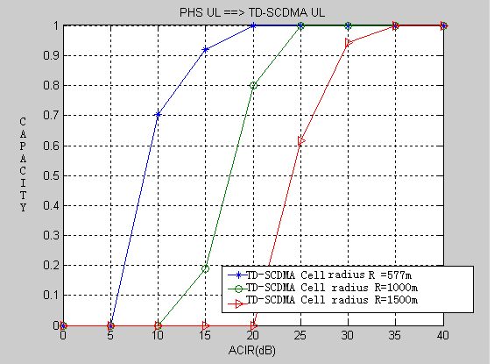

Figure 4 shows TD-SCDMA uplink capacity loss when PHS PS interferes into TD-SCDMA BS.

a) When PHS PS interferes into TD-SCDMA BS in the case of TD-SCDMA cell with radius 577m, in order to achieve the TD-SCDMA uplink capacity loss less than 5%, an ACLR of 18dB is required.

b) When PHS PS interferes into TD-SCDMA BS in the case of TD-SCDMA cell with radius 1000m, in order to achieve the TD-SCDMA uplink capacity loss less than 5%, an ACLR of 24dB is required.

c) When PHS PS interferes into TD-SCDMA BS in the case of TD-SCDMA cell with radius 1500m, in order to achieve the TD-SCDMA uplink capacity loss less than 5%, an ACLR of 31dB is required.

(2) Interference from PHS CS into TD-SCDMA BS

Figure5: TD-SCDMA uplink capacity loss (PHS DL－>TD-SCDMA UL)

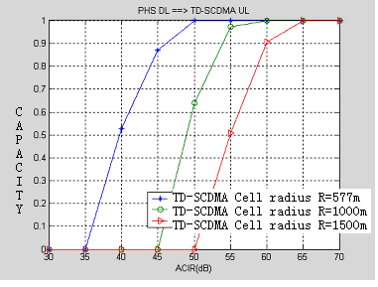

Figure 5 shows TD-SCDMA uplink capacity loss when PHS CS interferes into TD-SCDMA BS.

a) When PHS CS interferes into TD-SCDMA BS in the case of TD-SCDMA cell with radius 577m, in order to achieve the TD-SCDMA uplink capacity loss less than 5%, an ACLR of 48dB is required.

b) When PHS CS interferes into TD-SCDMA BS in the case of TD-SCDMA cell with radius 1000m, in order to achieve the TD-SCDMA uplink capacity loss less than 5%, an ACLR of 55 dB is required.

c) When PHS CS interferes into TD-SCDMA BS in the case of TD-SCDMA cell with radius 1500m, in order to achieve the TD-SCDMA uplink capacity loss less than 5%, an ACLR of 63 dB is required.

(3) Interference from PHS PS into TD-SCDMA UE

Figure6: TD-SCDMA downlink capacity loss (PHS UL－>TD-SCDMA DL)

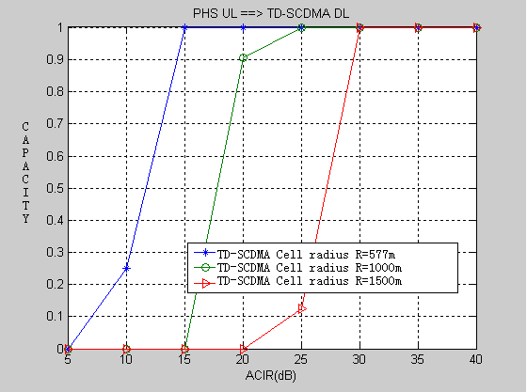

Figure 6 shows TD-SCDMA downlink capacity loss when PHS PS interferes into TD-SCDMA UE.

a) When PHS PS interferes into TD-SCDMA UE in the case of TD-SCDMA cell with radius 577m, in order to achieve the TD-SCDMA downlink capacity loss less than 5%, an ACLR of 15dB is required.

b) When PHS PS interferes into TD-SCDMA UE in the case of TD-SCDMA cell with radius 1000m, in order to achieve the TD-SCDMA downlink capacity loss less than 5%, an ACLR of 23 dB is required.

c) When PHS PS interferes into TD-SCDMA UE in the case of TD-SCDMA cell with radius 1500m, in order to achieve the TD-SCDMA downlink capacity loss less than 5%, an ACLR of 30 dB is required.

(4) Interference from PHS CS into TD-SCDMA UE

Figure7: TD-SCDMA downlink capacity loss (PHS DL－>TD-SCDMA DL)

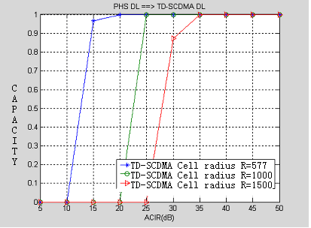

Figure 7 shows TD-SCDMA downlink capacity loss when PHS CS interferes into TD-SCDMA UE.

a) When PHS CS interferes into TD-SCDMA UE in the case of TD-SCDMA cell with radius 577m, in order to achieve the TD-SCDMA downlink capacity loss less than 5%, an ACLR of 15dB is required.

b) When PHS CS interferes into TD-SCDMA UE in the case of TD-SCDMA cell with radius 1000m, in order to achieve the TD-SCDMA downlink capacity loss less than 5%, an ACLR of 25 dB is required.

c) When PHS CS interferes into TD-SCDMA UE in the case of TD-SCDMA cell with radius 1500m, in order to achieve the TD-SCDMA downlink capacity loss less than 5%, an ACLR of 33 dB is required.

## 6.2 TD-SCDMA－>PHS

(1) Interference from TD-SCDMA BS into PHS CS

When using LOW-ALL loss path model between PHS CS and PHS PS, the simulation results are shown in table3.

Table 3 ACLR values when TD-SCDMA BS interferes into PHS CS

|  |  |
| --- | --- |
| Interference path | ACLR |
| TD-SCDMA DCH interferes into PHS TCH | 55dB |
| TD-SCDMA TS0+DCH interferes into PHS CCH | 59~62dB |

(2) Interference from TD-SCDMA BS into PHS PS

Figure8: PHS downlink capacity loss (TD-SCDMA DL－>PHS DL)

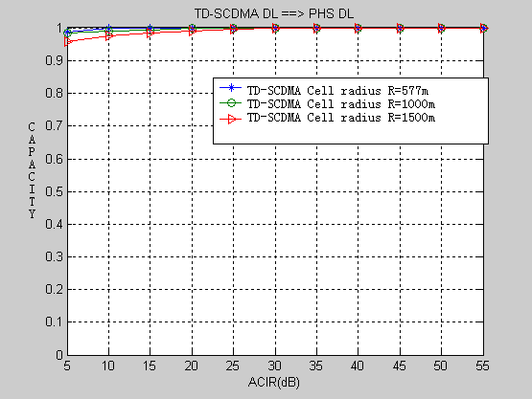

Figure 8 shows PHS downlink capacity loss when TD-SCDMA BS interferes into PHS PS. It can be seen from above figure that TD-SCDMA BS does not interfere into PHS PS when an ACLR value is more than 5dB

(3) Interference from TD-SCDMA UE into PHS CS

Figure9: PHS uplink capacity loss (TD-SCDMA UL－>PHS UL)

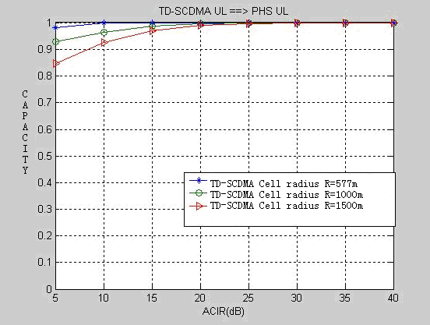

Figure 9 shows PHS uplink capacity loss when TD-SCDMA UE interferes into PHS CS. It can be seen that an ACLR value is very small, so TD-SCDMA BS UE does not interfere into PHS PS.

(4) Interference from TD-SCDMA UE into PHS PS

Figure10: PHS uplink capacity loss (TD-SCDMA UL－>PHS DL)

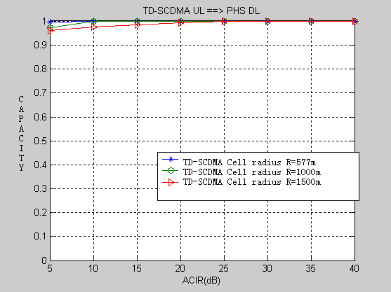

Figure 10 shows PHS uplink capacity loss when TD-SCDMA UE interferes into PHS DL. It can be seen from above figure that TD-SCDMA UE does not interfere into PHS PS when an ACLR value is more than 5dB.

# 7 Conclusion

According to the above simulation results, this report summarizes the results of interference between TD-SCDMA and PHS.

1. PHS CS interferes TD-SCDMA BS

According to the simulation result, when TD-SCDMA BS radius increases from 577m to 1500m, an ACLR value changes from 48dB to 63dB.

1. PHS PS interferes with TD-SCDMA BS

According to the simulation result, PHS PS does not interfere into TD-SCDMA BS.

1. PHS CS interferes with TD-SCDMA UE

According to the simulation result, when TD-SCDMA BS radius increases from 577m to 1500m, an ACLR value changes from 15dB to 33dB.

1. PHS PS interferes with TD-SCDMA UE

According to the simulation result, when TD-SCDMA BS radius increases from 577m to 1500m, an ACLR value changes from 15dB to 30dB.

1. TD-SCDMA BS interferes with PHS CS

The simulation results are shown in the above table3.

1. TD-SCDMA BS interferes with PHS PS

According to the simulation result, TD-SCDMA BS does not interfere into PHS PS.

1. TD-SCDMA UE interferes with PHS CS

According to the simulation result, TD-SCDMA BS UE does not interfere into PHS CS.

1. TD-SCDMA UE interferes with PHS PS

According to the simulation result, TD-SCDMA BS UE does not interfere into PHS PS.

**_______________**

**ATTACHMENT 3**

**Co-existence between CDMA2000 and GSM at 900 MHz**

**Source: Input Document AWF-4/INP-37 from PT Indosat, Indonesia**

This Attachment provides a summary of a study undertaken by PT Indosat in Indonesia directed towards minimizing the guard band required to allow operation between CDMA2000 systems with a downlink in the band 869 – 894 MHz and GSM or WCDMA systems with uplinks in the band 880 – 915 MHz. With a careful choice of equipment this guard band can be optimized and reduced to a value of 685 kHz. This choice was confirmed by on-site testing.

* 1. **Definition of Interference Scenario**

There is a potential for interference between the CDMA2000 downlink in 869 - 894 MHz and the GSM or WCDMA uplink in 880 – 915 MHz.

|  |  |  |  |
| --- | --- | --- | --- |
| **Wireless Access Technology** | **Mobile Station Transmitter (MHz)** | **Base Station Trans (MHz)** | **Duplex**  **Sep (MHz)** |
| **CDMA2000** | **824 – 849** | **869 – 894** | **45** |
| **GSM / WCDMA** | **880 – 915** | **925 - 960** | **45** |

**1.2 Indonesia Minister Communication and Information Decree 181 / 06**

Since December 2006 Indonesian Government release new decree no. 181 / 06

The main purpose of this decree are :

Frequency Allocation:

* M-8 Group : 835,905 – 840,8255 MHz paired with 880,905 – 885,825 MHz (Channel 384, 425, 466 and 507)
* PT Indosat : 842,055 – 844,515 MHz paired with 887,055 – 889,515 MHz (Channel 589 and 630)
* Naturally Guard Band between CDMA and GSM is 485 kHz
* Optimum usage of current frequency allocation (based on the audit by Government)

Channel migration shall be finalized by 31 December 2007.

This decree gives big impact to GSM operator in which too close to CDMA band and that company is PT. INDOSAT.

From the theory CDMA operate close to GSM will create interference or CDMA as interfere and GSM network is the victim.

**Figure of this decision can be seen :**

**37**

**78**

**119**

**160**

**201**

**242**

**283**

37

**384**

**425**

**466**

**507**

**548**

**589**

**630**

825,495

829,185

830,415

834,105

835,905

840,825

842,055

844,515

870,495

874,185

875,415

879,105

880,905

885,825

887,005

889,515

**37**

**78**

**119**

**160**

**201**

**242**

**283**

37

**384**

**425**

**466**

**507**

**548**

**589**

**630**

890

900

UPLINK

DOWNLINK

**BAND-A**

**BAND-B**

**BAND-A**

**BAND-B**

**BAKRIE**

**ESIA**

**TELKOM**

**FLEXY**

**MOBILE-8**

**FREN**

**ISAT**

**\*1**

**BAKRIE**

**ESIA**

**TELKOM**

**FLEXY**

**MOBILE-8**

**FREN**

**ISAT**

**\*1**

New Allocation Scheme

**ISAT**

**GSM**

*Source: Tim Perpindahan Frekuensi StarOne(Dec 06)*

**Need to manage**

**interference**

**2.1 Indosat Way out and share to other States**

Indosat has been finalise their research to manage this situation and the result can be proposed are :

* Put filter in all suspected sites
* Global Frequency Plan in GSM
* During Migration period Indosat borrow Channel 5
* Keep GSM Network alive with optimal quality

**2.2 Filter Specification**

* GSM Filter 890.2 @40B band rejection seems to be better.
* CDMA Filter, 890.2 @65dB band rejection can be better performance and advantages as below
* With those kind of specification there is 685 MHz guard band between CDMA and GSM

Indosat Choose :

* 1. **Better Group Delay**
  2. **Better Ripple**
  3. **Better EVM specification in CDMA Networks**
  4. **Better Insertion Loss**
  5. **Better Network Performance & Quality and System stability**
  6. **Easy tuning and mass-production**

**3 Sharing Experience**

We in Indosat can optimize frequency guard band between CDMA800 and GSM900 and Indosat can achieve 685 kHz. In the future with sophisticated algorithm and technology we believe better solution will bbe reality.

**4 Big Issue and Opportunity in Telecommunication Industry**

1. Filter Business will in Booming era
2. All Government will come to maximize band opportunity between CDMA and GSM in serving the community.

**ATTACHMENT 4**

**Co-existence between CDMA2000 networks operating in the 450 – 470 MHz band   
and other services**

**Source: Rep. ITU-R M.2110 (Sharing studies between radiocommunication services and IMT systems operating in the 450-470 MHz band)**



____________