

**APT REPORT**

**on**

**COExistence Between services at the boundaRy of   
the 700 Mhz and 800 mhz bands**

**No. APT/AWG/REP-44**Edition: March 2014

**Adopted by**

**16th Meeting of APT Wireless Group**

**18 – 21 March 2014  
Pattaya, Thailand**

***(Source: AWG-16/OUT-02)***

**APT REPORT ON COExistence Between services at the boundaRy of the 700 Mhz and 800 mhz bands**

# Purpose

The purpose of this report is to present the results of studies related to the operation of IMT services operating in the band 703-803 MHz (the “APT 700 MHz band”) and other services operating in bands above 803 MHz. It should be noted that studies related to coexistence at the lower edge of the APT 700 MHz band have previously been undertaken and can be found in APT/AWG/REP-24.

This document introduces studies by APT members to assist administrations in implementing services above the 803 MHz boundary, where the APT 700 MHz band plan has been/will be implemented. Studies of the coexistence between a wide range of possible services above the 803 MHz boundary and the IMT services deployed in the 700 MHz band have been undertaken.

# Scope

The scope of this work is to identify conditions under which a range of services may be able to operate above 803 MHz in coexistence with IMT services operating in the 700 MHz band. It considers only the frequency boundary at or near the 803 MHz and does not consider coexistence at the corresponding other ends of the relevant duplex bands. The intent is that it will assist administrations in planning for services that support a wide range of applications, so that the overall utility of the 800 MHz band may be optimized. It will do this by providing information that informs channel planning and infrastructure siting undertaken within administrations.

Applications supported in the 800 MHz band may include, but are not limited to, a variety of narrowband, broadband and wideband services for a range of purposes; however, the intent is that this document will focus solely on technical requirements, based on recognized standards and ITU allocations in the relevant bands.

In particular, this document is concerned with the coexistence between IMT base stations (BS) and user equipment (UE) operating in the 700 MHz band (across a number of bandwidths), and the BSs and UEs (across a number of bandwidths) of a range of possible services operating above 803 MHz, including:

* single frequency fixed point-to-point services with bandwidths of up to 400 kHz,
* two-frequency fixed point-to-point services (single channel) with bandwidths of up to 25 kHz,
* two-frequency fixed point-to-point services (low capacity) with bandwidths of up to 200 kHz,
* trunked land mobile services with bandwidths of up to 25 kHz, or multiples thereof, and
* LTE services with bandwidths of 5 MHz or multiples thereof.

Technical assumptions including out-of-band limits are used to determine the combinations of frequency and distance separations that allow coexistence between these services, so that administrations and operators may make informed decisions about their deployment. Appropriate standards and recommendations are referred to in making technical assumptions that will underpin these studies – the intent of this work is not to impose out-of-band limits or channel plans.

# Background

The harmonized frequency arrangement agreed by APT members for the band 698-806 MHz is contained in APT Report 14. Consensus agreement was reached on two harmonized frequency arrangements for IMT systems in the 698-806 MHz frequency band (see and Figure 2)

45 MHz

45 MHz

698 MHz

806 MHz

694 MHz

*PPDR/LMR*

*DTTV*

*10 MHz centre gap*

5 MHz

3 MHz

**Figure 1: Harmonised FDD Arrangement of 698-806 MHz band**

*PPDR/LMR*

806 MHz

*DTTV*

698 MHz

694 MHz

**Figure 2: Harmonised all-TDD Arrangement of 698-806 MHz band**

3GPP has defined the APT 700 MHz band plan within its nomenclature. In particular, 3GPP has defined the APT 700 MHz band as band 28 (FDD) and band 44 (TDD) as shown in .

**Table 1: APT 700 MHz band plan as defined by 3GPP**

|  |  |  |  |  |  |  |  |
| --- | --- | --- | --- | --- | --- | --- | --- |
| **E‑UTRA Operating Band** | **Uplink (UL) operating band** | | | **Downlink (DL) operating band** | | | **Duplex Mode** |
| **BS receive** | | | **BS transmit** | | |
| **UE transmit** | | | **UE receive** | | |
| **FUL_low – FUL_high** | | | **FDL_low – FDL_high** | | |
| 28 | 703 MHz | – | 748 MHz | 758 MHz | – | 803 MHz | FDD |
| 44 | 703 MHz | – | 803 MHz | 703 MHz | – | 803 MHz | TDD |

There is a broad range of systems, including cellular and narrow band systems, which operate above 803 MHz in the APT region. Examples are shown in overleaf.

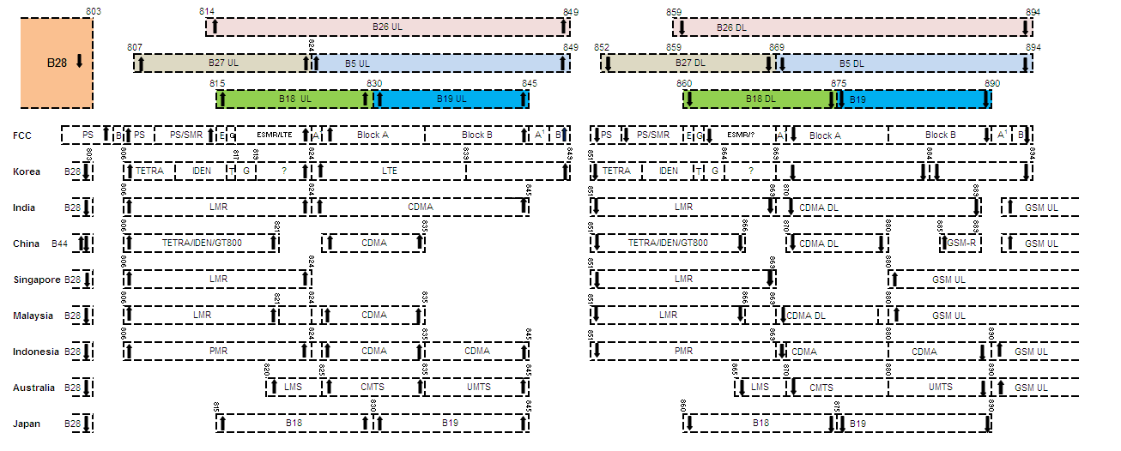

**Figure 3: Examples of services operating above 803 MHz**

Note

1. PS, TETRA, IDEN and LMR indicate narrow band technologies (12.5 kHz to 25 kHz)
2. CMTS indicate cellular mobile telephone service (IMT)
3. CDMA indicates 1.23MHz channel bandwidth based on 3GPP2 specifications
4. Range of services and spectrum allocations are under review in many countries
5. Details From AWG questionnaire on arrangements above 806-960 MHz
6. Australia is currently reviewing the 803-960 MHz band and allocations may change as a result of this review

Annex 1 outlines information on the E-UTRA and UTRA operating bands defined by the 3GPP in the vicinity of the 803 MHz boundary.

A range of other services are potentially suitable for use in the frequency bands including fixed point-to-point services and trunked land mobile services.

This Report presents the results of studies on coexistence between systems at the boundary of the 700 MHz and 800 MHz bands and identifies systems which could be deployed in the frequency bands above 803 MHz. This report provides useful information for national planning for the implementation of these band plans.

## Situations in particular countries

## Australia

Australia has announced that it will be adopting the APT 700 MHz (FDD) plan and is currently reviewing arrangements in the 803-960 MHz frequency range. Expansion of IMT services (from the existing 825-845 MHz/870-890 MHz allocation) is being considered in this review, with provision of 2 x 5 MHz planned to be made to facilitate a broadband capability for Australia’s public safety agencies (broadband PPDR). Spectrum for broadband PPDR will be planned based on the same IMT (LTE) specifications as commercial IMT (LTE) services. Use of other services, including fixed and trunked land mobile services, in the 800 MHz band are also being considered in the review.

## New Zealand

New Zealand is considering the implementation of broadband PPDR services using equipment designed to operate in the 800 MHz band. These potential services are within the band outlined for PPDR operation in ITU-R Resolution **646 (Rev WRC‑12)** and currently used for narrowband PPDR operation in Region 3. It is noted that the agenda for the 2015 World Radiocommunication Conference, resolves 1.3 of ITU-R Resolution **807 (WRC-12)**, provides for the revision of ITU-R Resolution **646 (Rev WRC‑12)** for broadband PPDR operation, which is expected to facilitate the introduction of broadband PPDR applications in this band. Implementation of broadband PPDR is highly likely to use the same IMT (LTE) specifications as commercial telecommunications services.

## Japan

Japan has allocated the band 714 - 750 MHz and 770 - 806 MHz to the terrestrial mobile service. The band 810 - 850 MHz is also allocated to the terrestrial mobile service. Actually the band 718 - 748 MHz and 773 - 803 MHz is assigned to the telecommunication operators for their terrestrial mobile services and used for mobile station to base station (uplink) and for the opposite direction (downlink) respectively. With regard to the 800MHz lower band, the band 815 - 845 MHz (B18 and B19 in the 3GPP band classification) is used for IMT system and mobile terminals of LTE system is transmitting in the band. The 700MHz band is expected to be used for also LTE system. So the broadband systems are operated in 700MHz band and 800MHz band with the separation frequency of 12MHz.

# Relevant Sharing Studies and Analyses

This section describes the three approaches to interference analysis and determination of maximum emission levels, and summarises the key parameter values used in these analyses.

Consistent with ITU-R common practice, deterministic studies are used to derive threshold values to establish co-ordination trigger values for the purposes of initiating cross-border negotiations between sovereign nations. As such, deterministic studies are often characterized as deriving ‘worst case’ values in order to stimulate more detailed investigation of the particular cross-border situation. However, the normal ITU-R approach to determining technical sharing conditions, such as out-of-band emission limits, is to undertake probabilistic studies of the relevant sharing scenarios.

## Scenarios Considered

The following section details the scenarios considered in this report based as summarized in .

**Table 2- Summary of the scenarios considered in the report**

|  |  |  |
| --- | --- | --- |
| Scenario | Source of harmful interference/ transmitter | Subject of harmful interference/receiver |
| (a) | IMT UE Transmitter (Tx) (above 803 MHz [(i.e. 3GPP Bands 26 and 27)]) | IMT UE Receiver (Rx) (below 803 MHz [(i.e. 3GPP Band 28)]) |
| (b) | IMT BS Tx (below 803 MHz [(i.e. 3GPP Band 28)]) | IMT BS Rx (above 803 MHz [(i.e. 3GPP Bands 26 and 27)]) |
| (c) | Trunked land mobile UE Tx (above 803 MHz) | IMT UE Rx (below 803 MHz [(i.e. 3GPP Band 28 and Band 44)]) |
| (d) | IMT BS Tx (below 803 MHz [(i.e. 3GPP Band 28 and Band 44)]) | Trunked land mobile BS Rx (above 803 MHz) |
| (e) | Two-frequency fixed point-to-point (single channel) Tx (above 803 MHz) | IMT UE Rx (below 803 MHz [(i.e. 3GPP Band 28)]) |
| (f) | IMT BS Tx (below 803 MHz [(i.e. 3GPP Band 28)]) | Two-frequency fixed point-to-point (single channel) Rx (above 803 MHz) |
| (g) | Two-frequency fixed point-to-point (Low capacity) Tx (above 803 MHz) | IMT UE Rx (below 803 MHz [(i.e. 3GPP Band 28)]) |
| (h) | IMT BS Tx (below 803 MHz [(i.e. 3GPP Band 28)]) | Two-frequency fixed point-to-point (Low capacity) Rx (above 803 MHz) |
| (i) | Single frequency fixed point-to-point Tx (above 803 MHz) | IMT UE Rx (below 803 MHz [(i.e. 3GPP Band 28)]) |
| (j) | IMT BS Tx (below 803 MHz [(i.e. 3GPP Band 28)]) | Single frequency fixed point-to-point Rx (above 803 MHz) |
| (k) | Trunked land mobile UE Tx (3GPP Band 44)) | IMT BS Rx (below 803 MHz) |
| (l) | IMT UE Tx (3GPP Band 44) | Trunked land mobile BS Rx (above 803 MHz) |

## Scenario (a)

In this scenario, the effect of transmissions from an IMT UE transmitter operating above 803 MHz on an IMT UE receiver operating in the 700 MHz band will be assessed (as illustrated in

Figure 4).

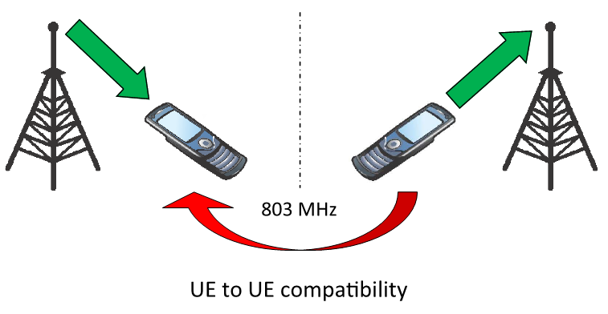

**Figure 4- Scenario (a)**

The following specific cases are considered in studies described below:

* Interference from a 5 MHz LTE mobile station (UE) operating above 803 MHz into an 5 MHz LTE UE receiver operating in 3GPP band 28 (See Annex 3 [Australia])
* Interference from a LTE mobile station (UE) in 3GPP band 27 into a LTE UE receiver operating in 3GPP band 28 (See Annex 4 [New Zealand])
* Interference from a 10 MHz LTE cellular system deployed at 3GPP band 27 into a 10 MHz 3GPP band 28 LTE cellular system (See Annex 5 [Motorola]).
* Interference from a LTE mobile station (UE) in 3GPP band 26/3GPP band 18 into an LTE UE receiver operating in 3GPP band 28 (See Annex 6 [Japan]).
* Interference from a number of LTE UEs operating above 803 MHz, into a nearby LTE UE operating immediately below 803 MHz in 3GPP band 28 (See Annex 7 [Telstra]).

## Scenario (b)

In this scenario, the effect of transmissions from an IMT BS transmitter in the 700 MHz band on an IMT BS receiver operating above 803 MHz will be assessed (as illustrated in ).

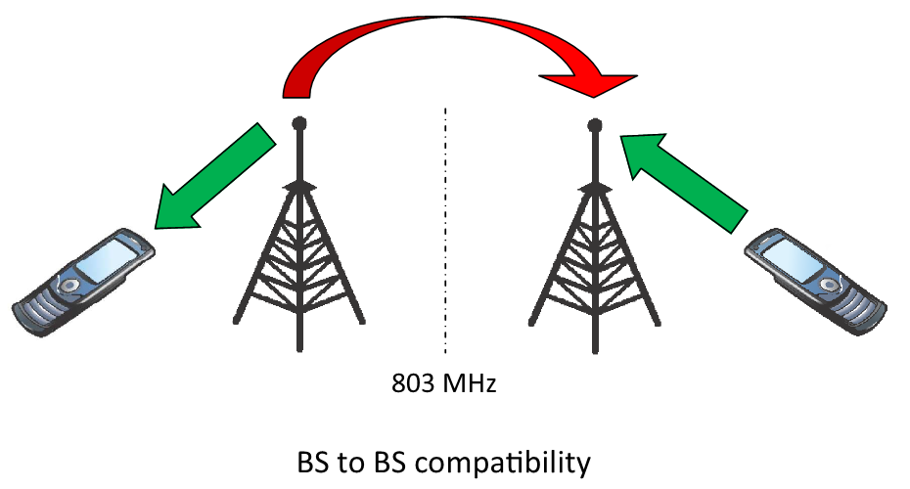

**Figure 5- Scenario (b)**

In 3GPP, BS-BS coexistence has been studied and can provide additional background from 3GPP side. The results of these studies are contained in 3GPP TR 37.806 and 3GPP TR 37.820.

More specifically, the following cases are considered in studies described below:

* Interference from a 5 MHz LTE BS transmitter operating in 3GPP band 28 on a 5 MHz LTE BS receiver operating above 803 MHz (See Annex 3 [Australia])
* Interference from a LTE BS transmitter in 3GPP band 28 into a LTE BS receiver operating in 3GPP band 27 (See Annex 4 [New Zealand])
* Probabilistic analysis of interference from an LTE base-station transmitter, operating immediately below 803 MHz with a channel width of 15 MHz, into a *co-sited* LTE base-station receiver operating above 806 MHz with a channel width of 5 or 10 MHz (see Annex 7 [Telstra])
* Probabilistic analysis of interference from several LTE base-station transmitters, operating immediately below 803 MHz, into a *non-co-sited* LTE base-station receiver operating above 806 MHz (see Annex 7 [Telstra])
* Deterministic analysis of interference from an LTE base-station transmitter, operating immediately below 803 MHz with a channel width of either 5 MHz or 20 MHz, into a) a *co-located*; and b) a *non-co-located* LTE base-station receiver operating above 809 MHz with a channel width of 10 MHz (see Annex 8 [Telstra & Telecom-NZ]).

## Scenario (c)

In this scenario, the effect of transmissions from a trunked land mobile UE transmitter operating above 803 MHz on an IMT UE receiver operating in the 700 MHz band will be assessed (as illustrated in ().

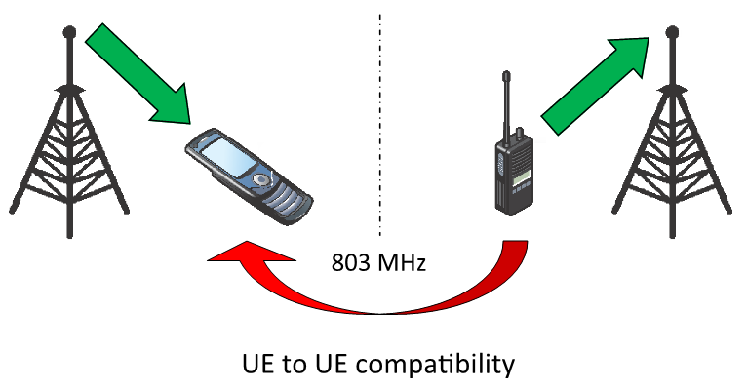

**Figure 6- Scenario (c)**

The following specific cases are considered in studies described below:

* Interference from a 25 kHz trunked land mobile UE transmitter operating above 803 MHz on a 5 MHz LTE UE receiver operating in 3GPP band 28 (See Annex 3 [Australia])
* Interference from a digital trunked mobile UE transmitter operating above 803 MHz to an IMT UE receiver operating in band 44 (See Annex 9 [China])

## Scenario (d)

In this scenario, the effect of transmissions from an IMT BS transmitter in the 700 MHz band on a trunked land mobile BS receiver operating above 803 MHz will be assessed (as illustrated in ).

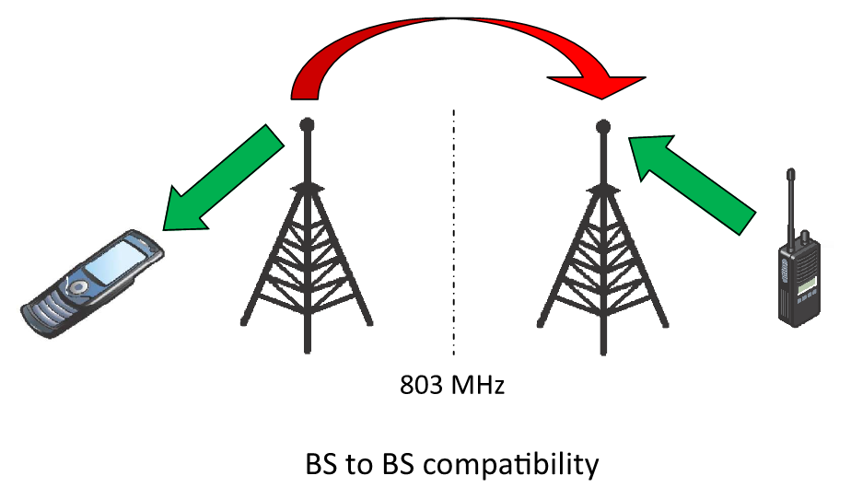

**Figure 7- Scenario (d)**

The following specific cases are considered in studies described below:

* Interference from a 5 MHz LTE BS transmitter in 3GPP band 28 to a 25 kHz trunked land mobile BS receiver operating above 803 MHz (See Annex 3 [Australia])
* Interference from an IMT BS transmitter in band 44 to a digital trunked mobile BS receiver operating above 803 MHz (See Annex 9 [China])

## Scenario (e)

In this scenario, the effect of transmissions from a two-frequency fixed point-to-point (single channel) transmitter operating above 803 MHz on an IMT UE receiver operating in the 700 MHz band will be assessed (as illustrated in ).

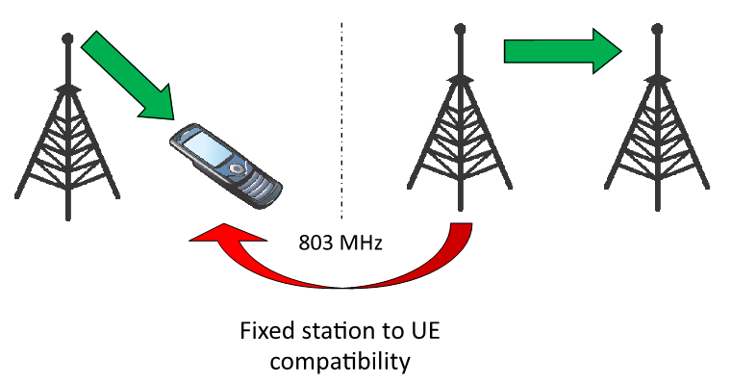

**Figure 8- Scenario (e)**

The following specific cases are considered in studies described below:

* Interference from a 25 kHz two-frequency fixed point-to-point (single channel) transmitter operating above 803 MHz on a 5 MHz LTE UE receiver operating in the 700 MHz band (See Annex 3 [Australia])

## Scenario (f)

In this scenario, the effect of transmissions from an IMT BS transmitter in the 700 MHz band on the receiver of a two-frequency fixed point-to-point (single channel) link operating above 803 MHz will be assessed (as illustrated in ).

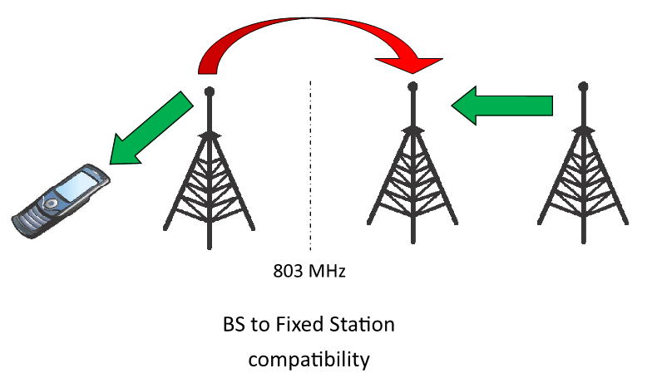

**Figure 9- Scenario (f)**

The following specific cases are considered in studies described below:

* Interference from a 5 MHz LTE BS transmitter in the 700 MHz band operating between 798-803 MHz on the receiver of a 25 kHz two-frequency fixed point-to-point (single channel) link operating above 803 MHz (See Annex 3 [Australia])

## Scenario (g)

In this scenario, the effect of transmissions from a 200 kHz two-frequency fixed point-to-point (low capacity) transmitter operating above 803 MHz on an IMT UE receiver operating in the 700 MHz band operating will be assessed (as illustrated in ).



**Figure 10- Scenario (g)**

The following specific cases are considered in studies described below:

* Interference from a two-frequency fixed point-to-point (low capacity) transmitter operating above 803 MHz on a LTE UE receiver operating in the 700 MHz band operating between 798-803 MHz (See Annex 3 [Australia])

## Scenario (h)

In this scenario, the effect of transmissions from an LTE BS transmitter in the 700 MHz band operating between 798-803 MHz on the receiver of a two-frequency fixed point-to-point (low capacity) link operating above 803 MHz will be assessed (as illustrated in ).



**Figure 11- Scenario (h)**

The following specific cases are considered in studies described below:

* Interference from a 5 MHz LTE BS transmitter in the 700 MHz band operating between 798-803 MHz on the receiver of a 25 kHz two-frequency fixed point-to-point (low capacity) link operating above 803 MHz (See Annex 3 [Australia])

## Scenario (i)

In this scenario, the effect of transmissions from a single frequency fixed point-to-point transmitter operating above 803 MHz on an IMT UE receiver operating in the 700 MHz band will be assessed (as illustrated in ).

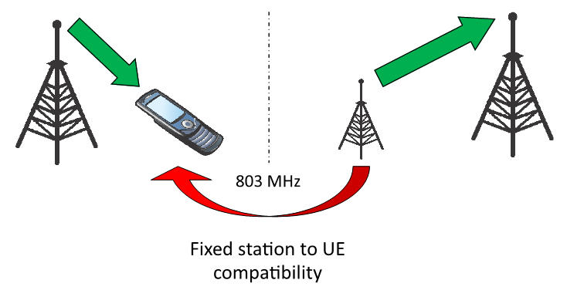

**Figure 12- Scenario (i)**

The following specific cases are considered in studies described below:

* Interference from a single frequency fixed point-to-point transmitter operating above 803 MHz on a 5 MHz LTE UE receiver operating in the 700 MHz band operating between 798-803 MHz (See Annex 3 [Australia])

## Scenario (j)

In this scenario, the effect of transmissions from an IMT BS transmitter in the 700 MHz band on the receiver of a single frequency fixed point-to-point link operating above 803 MHz will be assessed (as illustrated in ).

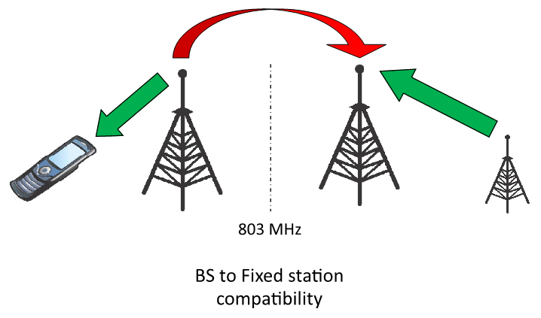

**Figure 13- Scenario (j)**

The following specific cases are considered in studies described below:

* Interference from a 5 MHz LTE BS transmitter in the 700 MHz band operating between 798-803 MHz on the receiver of a single frequency fixed point-to-point link operating above 803 MHz (See Annex 3 [Australia])

## Scenario (k)

In this scenario, the effect of transmissions from an a digital trunking mobile UE transmitter above 806 MHz on the receiver of a IMT BS operating below 806 MHz will be assessed.

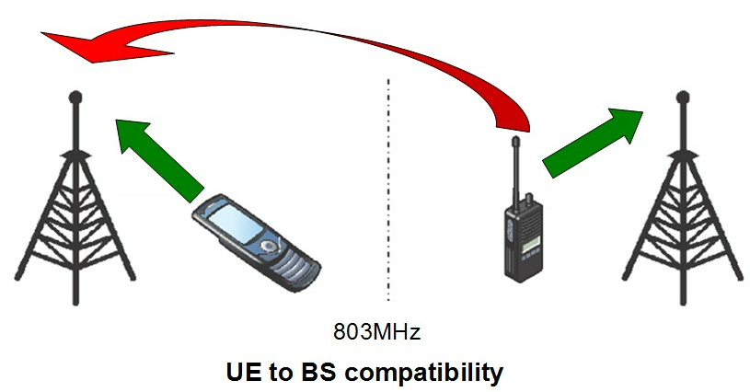

The following specific cases are considered in studies described below:

* Probabilistic analysis of interference from several digital trunked UE transmitters, operating immediately above 803 MHz with a channel width of 200 kHz or 1.25 MHz, into a IMT base-station receiver operating below 803 MHz with a channel width of 5 MHz (see Annex 9 [China])

## Scenario (l)

In this scenario, the effect of transmissions from an IMT UE transmitter in the 700 MHz band on the receiver of a digital trunking mobile BS operating above 806 MHz will be assessed.

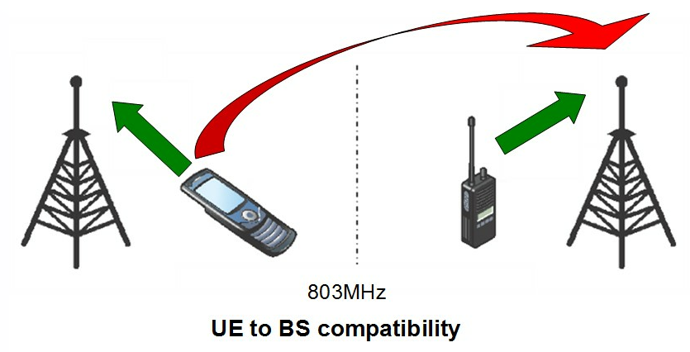

The following specific cases are considered in studies described below:

* Probabilistic analysis of interference from several LTE UE transmitters, operating immediately below 803 MHz with a channel width of 5 MHz, into a digital trunked base-station receiver operating above 803 MHz with a channel width of 200 kHz or 1.25 MHz (see Annex 9 [China])

## Methodology & Parameters

## Deterministic sharing analysis methodology

## Deterministic study D1

Study D1 (detailed in section 2.1.1 of Annex 3) was applied to scenarios (b) and (d) and involved simulations conducted using the parameters listed in the Attachment to Annex 3. This study involved the calculation of the carrier to interference plus noise ratio (CINR) value for a range of frequency separation values to determine the minimum frequency separation required for co-site operation.

## Deterministic study D2

Study D2 (detailed in section 2.1.2 of Annex 3) was applied to scenarios (f), (h) and (j) and involved simulations conducted using the parameters listed in the Attachment to Annex 3 (the Australian study). This study involved the calculation of the carrier to interference plus noise ratio (CINR) value for a range of frequency separation values to determine the minimum frequency separation required for co-site operation. Note that in this study, the Receiver mask for the LTE UE in Band 28 has been assumed to be a 5 MHz filter but for Band 28, 3GPP has specified a full 2x45 MHz operating band, which is typically implemented using a dual duplexer arrangement.

## Deterministic study D3

Study D3 (detailed in Section 2.1.1 of Annex 4) was applied to scenario (b) and involved the deterministic calculation of minimum required coupling losses for base station interference between 3GPP Band 27 and 3GPP Band 28. The first part considers the application of Adjacent Channel Leakage Ratio (ACLR) and general spurious emissions limits for base station transmitter in 3GPP Band 28 and the Adjacent Channel Selectivity (ACS) for base station receiver in 3GPP Band 27. In the second part, consideration has been given to the application of additional spurious emissions limits for base station in 3GPP Band 28 for co-existence with base station in 3GPP Band 27. In addition, the third part of this study assesses the minimum coupling loss when base stations of both 3GPP bands are co-located and subject to more critical spurious emissions limits at the transmitter coupler.

## Deterministic study D4

Study D4 (detailed in Annex 8) was applied to scenario (b), and involved the use of minimum ACLR limits and additional spurious emissions limits as specified by 3GPP, to determine if practical receiving duplex filters can ensure sufficient rejection at the assumed guard-band separation (6 MHz).

## Probabilistic sharing analysis methodology

## Probabilistic study P1

Study P1 (detailed in section 2.2.1 of Annex 3) was applied to scenarios (a) and (c) and involved simulations conducted using the parameters listed in the Attachment to Annex 3. Monte Carlo simulations were performed to calculate a percentage of events in which the minimum carrier to interference plus noise ratio (CINR) value was exceeded to determine the minimum frequency separation required for co-site operation.

## Probabilistic study P2

Study P2 (detailed in section 2.2.2 of Annex 3) was applied to scenarios (e), (g) and (i) and involved simulations conducted using the parameters listed in the Attachment to Annex 3. Monte Carlo simulations were performed to calculate a percentage of events in which the minimum carrier to interference plus noise ratio (CINR) value was exceeded to determine the minimum frequency separation required for co-site operation.

## Probabilistic study P3

Study P3 (detailed in section 2.2.1 of Annex 4) was applied to scenario (a) and involved a probabilistic Monte Carlo analysis has been employed. This analysis comprises simulations to assess probability of interference (or percentage of coverage area loss) caused to mobile network based on 3GPP Band 28 when an adjacent network based on 3GPP Band 27 is operating with its boundary frequency starting at 807 MHz, 809 MHz and 814 MHz. Additional simulations were also conducted for different combination of channel bandwidths between 3GPP Band 28 and 3GPP Band 27.

## Probabilistic study P4

Study P4 (detailed in section 2.1.1 of Annex 5) was applied to scenario (a). This study considers the case of Scenario (a), that is the impact of unwanted emissions from an IMT UE transmitter operating above 803 MHz (3GPP band 27 or 26) on an IMT UE receiver operating in the 700 MHz (3GPP Band 28).

## Probabilistic study P5

Study P5 (detailed in section 2.1.1 of Annex 6) was applied to scenario (a). In this study “In-band interference” and “Out-of-band interference” were evaluated.

In the study of “In-band interference”, the required decrease power density that is the subtraction of the total interference power density caused by unwanted emission from the interferers, whose occurrence probability is lower than 3% at an APT700 band user terminal, from the permissible interference level of the terminal of -111 dBm/MHz was calculated for each variable of unwanted emission level from user terminals above 815 MHz band into APT700 downlink band. The probable percentage of 3% is adopted in the interference evaluation in one country in Region 3. Then it was investigated whether the unwanted emission level is practical or not, taking into account of realistic duplexer characteristics, where the less-than-3% total interference becomes lower than the permissible interference level.

In the study of the out-of-band interference, the required value for improvement from the view point of the sensitivity suppression caused by the received power in the out-of-band of the receiver from the surrounding interfering mobile terminals was calculated as such by comparing the power received at the interfered mobile terminals in APT700 band, obtained by statistical simulation, with specification of sensitivity suppression power of LTE mobile terminal for a certain guard band, e.g. -44 dBm for the case of guard band of 10 MHz.

## Probabilistic study P6

Study P6 (detailed in section 2 of Annex 7) was applied to both scenarios a) and b), and involved running a series of Monte Carlo simulations while reducing the guard-band offset, to determine the minimum necessary guard-band to ensure not more than 1% likelihood of degradation of threshold SINR. This was aimed at determining a minimum necessary guard-band between the upper edge of band #27 (803 MHz) and the lower edge of an LTE system operating in the 800 MHz band.

## Probabilistic study P7

Study P7 (detailed in section 2 of Annex 9) was applied to both scenarios c) and k), and involved a Monte Carlo simulations conducted using the parameters listed in the Attachment to Annex 3. The Monte Carlo simulations were performed to determine the capacity loss of LTE, which should no more than 5%. This was aimed at determining a minimum necessary guard-band to avoid the interference from digital trunked systems into LTE system.

## Probabilistic study P8

Study P8 (detailed in section 2 of Annex 9) was applied to both scenario d) and l), and involved a Monte Carlo simulation conducted using the parameters listed in the Attachment to Annex 3. The Monte Carlo simulations were performed to determine the outage probability of digital trunked system, which should be no more than 5%. This was aimed at determining a minimum necessary guard-band to avoid the interference from LTE system into the digital trunked systems.

## Results and outcomes of studies

**Table 3** outlines the methodologies that were applied in each scenario and the sections of the report that discuss the results and outcomes.

**Table 3- Methodologies applied for each scenario considered in the report**

|  |  |  |  |  |  |  |  |  |  |  |  |  |
| --- | --- | --- | --- | --- | --- | --- | --- | --- | --- | --- | --- | --- |
| **Scenario** | **Methodology applied** | | | | | | | | | |  |  |
| **D1** | **D2** | **D3** | **D4** | **P1** | **P2** | **P3** | **P4** | **P5** | **P6** | **P7** | **P8** |
| **(a)** |  |  |  |  | Section |  | Section | Section | Section | Section 4.3.1.5 |  |  |
| **(b)** | Section |  | Section | Section  4.3.2.3 |  |  |  |  |  | Section 4.3.2.4 |  |  |
| **(c)** |  |  |  |  | Section |  |  |  |  |  | Section  4.3.3.2 |  |
| **(d)** | Section |  |  |  |  |  |  |  |  |  |  | Section  4.3.4.2 |
| **(e)** |  |  |  |  |  | Section |  |  |  |  |  |  |
| **(f)** |  | Section |  |  |  |  |  |  |  |  |  |  |
| **(g)** |  |  |  |  |  | Section |  |  |  |  |  |  |
| **(h)** |  | Section |  |  |  |  |  |  |  |  |  |  |
| **(i)** |  |  |  |  |  | Section |  |  |  |  |  |  |
| **(j)** |  | Section |  |  |  |  |  |  |  |  |  |  |
| **(k)** |  |  |  |  |  |  |  |  |  |  | Section  4.3.11.1 |  |
| **(l)** |  |  |  |  |  |  |  |  |  |  |  | Section  4.3.12.1 |

## Scenario A

## Probabilistic study P1

The results of Study P1 for scenario (a) are detailed in Section 3.1.1 of Annex 3. The results in indicate that assuming 64-QAM 4/5 rate MCS for the LTE system, the required frequency separation between the LTE system operating below 803 MHz and the LTE system operating above 803 MHz would be 0 MHz (i.e. direct adjacent channel) to allow for co-siting of the BS and an exceedence percentage of less than 5% for UE to UE interference.

## Probabilistic study P3

The results of Study P3 for scenario (a) are detailed in Section 3.1.1 of Annex 4. The Monte Carlo analysis indicated that the probability of interference (or percentage of coverage area loss) is reduced with increased frequency separation between the two systems. However, the likelihood of interference increases as the channel bandwidth of the victim 3GPP Band 28 receiver increases. It is noted that the non-linearity of the results suggested that the likelihood of interference may be dominated by channel bandwidth of the victim receiver rather than the transmitter.

## Probabilistic study P4

The results of Study P4 for scenario (a) are detailed in Section 3.1.1 of Annex 5.

This study considers the modeling of UE location distribution in a hotspot area or in a big event, where there is a very high probability of UEs from two different operators getting as close as 1~3 meters.

The methodology uses SINR degradation instead of average throughput degradation to consider user experience: a victim LTE UE that is close to its serving BS, with a very high SINR, can tolerate very high interference without loss of connection; for UEs at cell edge that already have low throughput, a small amount of interference may cause these UEs to be disconnected.

The use of average throughput degradation does not show when UEs are disconnected even though the throughput loss is small.

The result of this study show that a separation of 10 MHz between LTE uplink and LTE downlink is needed for 10-MHz LTE deployment.

## Probabilistic study P5

The results of Study P5 for scenario (a) are detailed in Section 3.1.1 of Annex 6. The result indicates that assuming LTE user terminal of 5, 10 and 15 MHz carrier size operating in the urban area, the required frequency separation would be 12 MHz to prohibit the undue in-band interference from unwanted emission of LTE user terminals to the LTE user receiver operating in APT700 MHz band below 803 MHz. Here the aggregated interference power density/aggregated interference power simulated in the occurrence probability of the event of 3% is taken into consideration for the comparison with the permissible interference level in the in-band interference case/the sensitivity suppression level in the out-of-band interference case.

If there is similar mutual relationship in the frequency deployment of the radiocommunication systems using LTE technology in other frequency band, it could be required that the guard band depending on the allocated frequency and traffic condition should be considered taking into account of the performance of the unwanted emission of the mobile terminals as mentioned above.

## Probabilistic study P6

The results of Study P6 for scenario (a) are detailed in Section 3 of Annex 7. In brief, this study demonstrated that satisfactory performance could be expected with a minimum guard-band of 3 MHz – but that improved performance might be preferred by implementing a guard-band of 4 MHz – between the upper edge of LTE systems operating in the 700 MHz band (3GPP Band 28) and the lower edge of LTE (PPDR) systems operating in the 800 MHz band (3GPP Band 27). This suggests that LTE systems deployed in the lower-800 MHz band (3GPP band #27) should observe a lower boundary of 807 MHz.

## Scenario B

## Deterministic study D1

The results of Study D1 for scenario (b) are detailed in Section 3.2.1 of Annex 3. The results indicate that co-sited operation of the 700 MHz LTE BS and 800 MHz LTE BS may be feasible with 4 MHz frequency separation between 700 MHz LTE system and 800 MHz LTE system.

## Deterministic study D3

The results of Study D3 for scenario (b) are detailed in Section 3.2.1 of Annex 4. The minimum required coupling losses are converted to minimum separation distances based on free-space path loss calculation. The first and second parts of the study resulted in a similar results where the minimum separation distances are calculated to be in the order of a little over 2 km. As for the third part of the study, it is noted that minimum coupling loss requirement for the co-located systems could be met with attenuation between vertically separated antennas and/or additional filtering.

## Deterministic study D4

The results of Study D4 for scenario (b) are detailed in Section 3 of Annex 8. This study demonstrated that successful co-existence between 5/20 MHz bandwidth LTE systems in the 700 MHz band (3GPP band #28) and 10 MHz bandwidth LTE systems operating above 809 MHz is entirely feasible with current filtering technology. Thus, a guard-band of 6 MHz above 803 MHz will ensure fully satisfactory co-existence of LTE systems, for both co-sited and non-co-sited arrangements and typical antenna arrangements.

## Probabilistic study P6

The results of Study P6 for scenario (b) are detailed in Section 3 of Annex 7. This study demonstrated that good performance could be expected with a minimum guard-band of 3 MHz – but that improved performance might be preferred by implementing a guard-band of 4 MHz – between the upper edge of LTE systems operating in the 700 MHz band (3GPP Band 28) and the lower edge of LTE (PPDR) systems operating in the 800 MHz band (3GPP Band 27). This suggests that LTE systems deployed in the lower-800 MHz band (3GPP band #27) should observe a lower boundary of 807 MHz.

## Scenario C

## Probabilistic study P1

The results of Study P1 for scenario (c) are detailed in Section 3.3.1 of Annex 3. The results indicate that in the worst case considered (64-QAM 4/5 rate MCS assumed for LTE system), then the required frequency separation between the 700 MHz LTE and 800 MHz trunked land mobile systems would be 3 MHz to allow for co-siting of the BS. This assumes an exceedence percentage of less than 5% for UE to UE interference.

## Probabilistic study P7

The results of Study P7 for scenario (c) are detailed in Section 3.1.1 of Annex 9. The results indicate that the potential for interference from UE of digital trunked system operating above 806 MHz to the LTE UE operating below 806 MHz is negligible. This assumes a capacity loss of less than 5% for LTE UE.

## Scenario D

## Deterministic study D1

The results of Study D1 for scenario (d) are detailed in Section 3.4.1 of Annex 3. The results indicate that a 700 MHz LTE BS and an 800 MHz trunked land mobile BS can operate co-site (within 200 metres) if there is a frequency separation between the services of at least 3 MHz.

## Probabilistic study P8

The results of Study P8 for scenario (d) are detailed in Section 3.2.1 of Annex 9. The results indicate that the most serious interference from IMT BS to the digital trunked base station is occurred when the distance between the BSs is 100m. In order to eliminate the harmful interference, the isolation distance or the guard-band is needed. This assumes an outage probability of less than 5% for digital trunked systems.

## Scenario E

## Probabilistic study P2

The results of Study P2 for scenario (e) are detailed in Section 3.5.1 of Annex 3. The results indicate that in the case considered when 64 QAM 4/5 rate MCS is assumed for the LTE system, the required frequency separation between the 700 MHz LTE BS and the 800 MHz two-frequency fixed point-to-point (single channel) transmitter would be 1 MHz to allow for co-siting of and achieve less than 5 % exceedence events.

## Scenario F

## Deterministic study D2

The results of Study D2 for scenario (f) are detailed in Section 3.6.1 of Annex 3. The results indicate that a 700 MHz LTE BS and a 800 MHz two-frequency fixed point-to-point (single channel) receiver can operate co-sited (within 200 metres) if there is a frequency separation between the services of at least 25 kHz.

## Scenario G

## Probabilistic study P2

The results of Study P2 for scenario (g) are detailed in Section 3.7.1 of Annex 3. The results indicate that when 64 QAM 4/5 rate MCS is assumed for the LTE system, then the required frequency separation between the 700 MHz LTE BS and 800 MHz the two-frequency fixed point-to-point (low capacity) transmitter, to achieve less than 5 % exceedence events during co-sited operation, is 1 MHz.

## Scenario H

## Deterministic study D2

The results of Study D2 for scenario (h) are detailed in Section 3.8.1 of Annex 3. The results indicate that in the worst case where services are directly frequency-adjacent, the separation distance required between the LTE BS transmitter (source of interference) and the receiver of the fixed link (subject of interference) would be greater than 5 kilometres in order to maintain a suitable CIR. With a frequency separation of one fixed service channel (200 kHz), the required separation distance would be reduced, but still greater than 5 kilometres. The LTE BS and fixed receiver are likely to be able to operate co-sited (within 200 meters) if there is a frequency separation between the services of 1 MHz. Required separation distances are further reduced if antenna discrimination is taken into account.

## Scenario I

## Probabilistic study P2

The results of Study P2 for scenario (i) are detailed in Section 3.9.1 of Annex 3. The results indicated that assuming 64 QAM 4/5 rate MCS for the LTE system, the required frequency separation between the 700 MHz LTE system and the 800 MHz single-frequency fixed point-to-point link, to achieve less than 5 % exceedence events during co-sited operation, is 1 MHz.

## Scenario J

## Deterministic study D2

The results of Study D2 for scenario (j) are detailed in Section 3.10.1 of Annex 3. The results indicate that the required frequency separation between the 700 MHz LTE system and the 800 MHz single-frequency fixed point-to-point link is at least 400 kHz (one channel).

## Scenario K

## Probabilistic study P7

The results of Study P7 for scenario (k) are detailed in Section 3.3.1 of Annex 9. The results indicate that there is a certain degree of interference from digital trunked system UEs which are operating above 803 MHz to the LTE BS operating below 803 MHz. The required frequency separation between these two systems would be less than 3 MHz. This assumes a capacity loss of less than 5% for LTE BS.

## Scenario L

## Probabilistic study P8

The results of Study P8 for scenario (l) are detailed in Section 3.4.1 of Annex 9. The results indicate that the potential interference from the LTE UE operating below 803 MHz to the digital trunked system UE operating above 803 MHz to is negligible. This assumes an outage probability of less than 5% for digital trunked systems.

# Technical Considerations

## Channel planning

## IMT services above 803 MHz

The dominant interference mechanism when assessing coexistence of IMT services operating above 803 MHz and IMT services operating in 3GPP band 28 is UE to UE (scenario (a)). That is, interference into services operating in 3GPP band 28 (UE to UE (scenario (a)) is the worst case. By analyzing the results of studies conducted for scenario (a) (UE to UE) and scenario (b) (BS to BS), the minimum guard band that should be deployed between the upper boundary of the APT 700 MHz (FDD) plan (3GPP Band 28) and LTE services above 803 MHz depends on the channel bandwidth of the deployed IMT services and technical characteristics. This may include factors such as filtering and acceptable outage probability as well as traffic volume, density of UE, allocation of LTE resource blocks and service requirements.

## Trunked land mobile services above 803 MHz

By analyzing the results of studies conducted for scenario (c) (UE to UE) and scenario (d) (BS to BS), the minimum guard band that should be deployed between the upper boundary of the APT 700 MHz (FDD) plan (3GPP Band 28) and trunked land mobile services above 803 MHz is 3 MHz. That is, LTE systems deployed in 3GPP Band 28 can coexist with trunked land mobile services deployed from 807 MHz.

## Two-frequency fixed point-to-point (low capacity) services above 803 MHz

By analyzing the results of studies conducted for scenario (e) (fixed Tx station to UE) and scenario (f) (BS to fixed Rx station), the minimum guard band that should be deployed between the upper boundary of the APT 700 MHz (FDD) plan (3GPP Band 28) and two-frequency fixed point-to-point (low capacity) services above 803 MHz is 1 MHz. That is, LTE systems deployed in 3GPP Band 28 can coexist with two-frequency fixed point-to-point (low capacity) services deployed from 804 MHz.

## Two-frequency fixed point-to-point (single channel) services above 803 MHz

By analyzing the results of studies conducted for scenario (g) (fixed Tx station to UE) and scenario (h) (BS to fixed Rx station), the minimum guard band that should be deployed between the upper boundary of the APT 700 MHz (FDD) plan (3GPP Band 28) and two-frequency fixed point-to-point (single channel) services above 803 MHz is 1 MHz. That is, LTE systems deployed in 3GPP Band 28 can coexist with two-frequency fixed point-to-point (single channel) services deployed from 804 MHz.

## Single frequency fixed point-to-point services above 803 MHz

By analyzing the results of studies conducted for scenario (i) (Fixed Tx station to UE) and scenario (j) (BS to fixed Rx station), the minimum guard band that should be deployed between the upper boundary of the APT 700 MHz (FDD) plan (3GPP Band 28) and single frequency fixed point-to-point services above 803 MHz is 1 MHz. That is, LTE systems deployed in 3GPP Band 28 can coexist with single frequency fixed point-to-point services deployed from 804 MHz.

# Deployment considerations and special considerations

## IMT services above 803 MHz

Some filtering and other mitigation mechanisms may be required to be deployed to ensure coexistence the level of which depends on the guard band put in place. Generally, a larger guard band between services in 3GPP Band 28 and LTE services above 803 MHz means less mitigation mechanisms would be required to protect services in 3GPP Band 28.

## Trunked land mobile services above 803 MHz

The study in Annex 3 considers a 5 MHz LTE channel at the upper boundary of 3GPP Band 28 and a 25 kHz trunked land mobile channel with varying amounts of frequency separation to obtain the recommended frequency separation of 3 MHz.

## Two-frequency fixed (low capacity) services above 803 MHz

The study in Annex 3 considers a 5 MHz LTE channel at the upper boundary of 3GPP Band 28 and a 200 kHz fixed service channel with varying amounts of frequency separation to obtain the recommended frequency separation of 1 MHz.

## Two-frequency fixed (single channel) services above 803 MHz

The study in Annex 3 considers a 5 MHz LTE channel at the upper boundary of 3GPP Band 28 and a 25 kHz fixed service channel with varying amounts of frequency separation to obtain the recommended frequency separation of 1 MHz.

## Single frequency fixed services above 803 MHz

The study in Annex 3 considers a 5 MHz LTE channel at the upper boundary of 3GPP Band 28 and a 400 kHz fixed service channel with varying amounts of frequency separation to obtain the recommended frequency separation of 1 MHz.

# Conclusions

This Report contains studies by APT members which provide information on how spectrum above 803 MHz can be planned in order to coexist with services operating in line with the APT 700 MHz band plan, while taking into account interference scenarios presented in various studies. These studies are contained in Annexes 3 through 9 in this report.

**Annexes**

**Annex 1- 3GPP Bands around 803 MHz**

**Annex 2- Information on LTE UL/DL co-existence**

**Annex 3- Study from Australia**

**Annex 4- Study from New Zealand**

**Annex 5- Study from Motorola Solutions**

**Annex 6- Study from Japan**

**Annex 7- Study from Telstra**

**Annex 8- Study from Telstra & Telecom NZ**

**Annex 9- Study from China**

# Annex 1- 3GPP Bands around 803 MHz

3GPP defines the following E-UTRA and UTRA operating bands (shown in and ) in the vicinity of the 803 MHz boundary. The shaded bands are cellular services deployed in the APT region based on 3GPP LTE and 3GPP UMTS (WCDMA) radio access technology.

**Table 4- E-UTRA (LTE) operating bands**

|  |  |  |  |  |  |  |  |  |
| --- | --- | --- | --- | --- | --- | --- | --- | --- |
| **E‑UTRA Operating Band** | **Uplink (UL) operating band** | | | **Downlink (DL) operating band** | | | **Duplex Mode** | **Maximum channel bandwidth** |
| **BS receive** | | | **BS transmit** | | | **(MHz)** |
| **UE transmit** | | | **UE receive** | | |  |
| **FUL_low – FUL_high** | | | **FDL_low – FDL_high** | | |  |  |
| 5 | 824 MHz | – | 849 MHz | 869 MHz | – | 894MHz | FDD | 10 |
| 8 | 880 MHz | – | 915 MHz | 925 MHz | – | 960 MHz | FDD | 10 |
| 12 | 699 MHz | – | 716 MHz | 729 MHz | – | 746 MHz | FDD | 10 |
| 13 | 777 MHz | – | 787 MHz | 746 MHz | – | 756 MHz | FDD | 10 |
| 14 | 788 MHz | – | 798 MHz | 758 MHz | – | 768 MHz | FDD | 10 |
| 17 | 704 MHz | – | 716 MHz | 734 MHz | – | 746 MHz | FDD | 10 |
| 18 | 815 MHz | – | 830 MHz | 860 MHz | – | 875 MHz | FDD | 15 |
| 19 | 830 MHz | – | 845 MHz | 875 MHz | – | 890 MHz | FDD | 15 |
| 20 | 832 MHz | – | 862 MHz | 791 MHz | – | 821 MHz | FDD | 20 |
| 26 | 814 MHz | – | 849 MHz | 859 MHz | – | 894 MHz | FDD | 15 |
| 27 | 807 MHz | – | 824 MHz | 852 MHz | – | 869 MHz | FDD | 10 |
| 28 | 703 MHz | – | 748 MHz | 758 MHz | – | 803 MHz | FDD | 20 |
| ... |  |  |  |  |  |  |  |  |
| 44 | 703 MHz | – | 803 MHz | 703 MHz | – | 803 MHz | TDD | 20 |

**Table 5- UTRA (WCDMA) FDD frequency bands**

|  |  |  |
| --- | --- | --- |
| **UTRA Operating Band** | **UL Frequencies** | **DL frequencies** |
| **UE transmit,**  **Node B receive** | **UE receive,**  **Node B transmit** |
| V | 824 - 849 MHz | 869-894 MHz |
| VIII | 880 - 915 MHz | 925 - 960 MHz |
| XII | 699 – 716 MHz | 729 – 746 MHz |
| XIII | 777 - 787 MHz | 746 - 756 MHz |
| XIV | 788 – 798 MHz | 758 – 768 MHz |
|  |  |  |
|  |  |  |
| XIX | 830 – 845MHz | 875 – 890 MHz |
| XX | 832 – 862 MHz | 791 – 821 MHz |
| XXVI | 814 – 849 MHz | 859 – 894 MHz |

From Tables 4 and 5 above, it can be noted that some regions have adjacent narrow band UL to wide band UL systems. In some cases this can result in interference to the adjacent narrow band base station in the case of the UL/UL and interference to the narrow band UE in the case of DL/DL interference.

For example, a typical narrow band system will employ one, or only a few, base stations with antennas located on high terrain, towers, buildings, etc. to provide wide-area coverage from the base station. In this case coverage is a key criterion for these narrow band systems which are noise limited and therefore coverage would be severely impact of unwanted emission in the narrow band channel.

Cellular-architecture systems, by comparison, make use of multiple, localized coverage, base stations whose antennas generally are mounted on low towers or other structures. In this case the key criterion is capacity.

# Annex 2- Information on LTE UL/DL co-existence

LTE UE UL/DL scenarios is complex and several aspects need to be considered including;

* Channel bandwidth
* Resource block (RB) transmitted
* Emission profile
* Service reliability criteria; cellular, broadcast (DTV), mission critical (Public safety) and safely critical services (GSM-R railway).

Channel bandwidth

For LTE the deployed channel bandwidth will determine the peak throughput and capacity. The channel bandwidth and available number of resources block for the different channel bandwidths are shown in below.

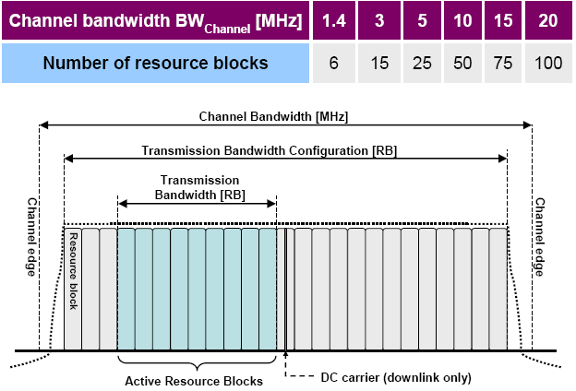

**Figure 14: LTE channel bandwidth and transmitted RB**

The OOB emission profile will scale with the channel bandwidth and transmitted resource blocks. This is in line with ITU-R Recommendation SM.329-10, "Unwanted emissions in the spurious domain"

Resources block transmitted

Full RB allocation determines the peak throughput and system capacity. Full RB allocation also determines the worst case out of band (OOB) emission profile.

Smaller RB allocations are used to address edge of cell coverage. Also 1 RB is used for uplink Control channel information. Since 1RB has a higher PSD compared with full RB allocation it determines the worst case spurious emission profile (3rd IMD) in the adjacent channel bandwidth.

A typical emission from a 10MHz LTE UE is shown below in for both the full RB allocation and 1RB allocation cases

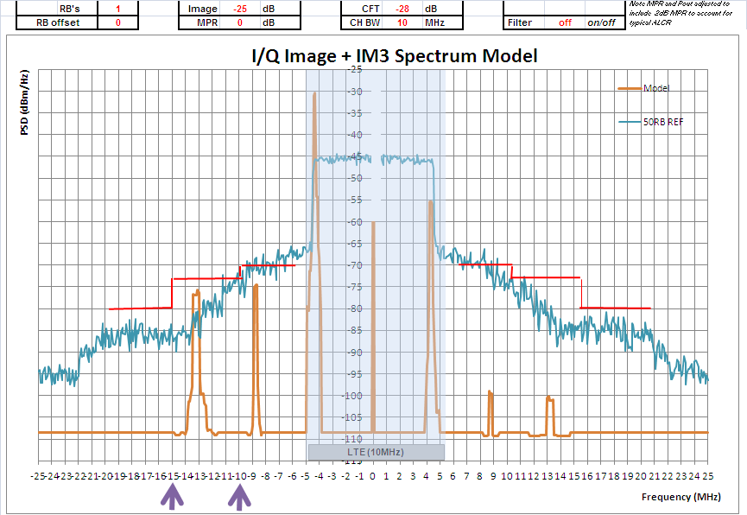

**Figure 15: Emissions from a 10 MHz E-UTRA signal**

Note that at 10MHz offset from the channel edge, the OOB is about -25dBm/MHz with full RB allocation, and with the help of duplexer, -32dBm/MHz can be met (see next section for discussion of this requirement). However, the duplexer does not help the 1RB allocation case, where the OOBE is about -15dBm/MHz due to 3rd order IMD product (360KHz bandwidth) falling into the adjacent channel (0-9MHz offset region). That’s is roughly why 10MHz UL/DL guard band is needed for 10MHz LTE deployment

Emission profile

In 3GPP the UE emission profiles in are specified to protect services deployed in B28 (protected band- source 3GPP TS36.101)

Table 6- UE emission profiles for protection of services in 3GPP Band 28



For example to protect B28 an UE cellular device operating in B27, 3GPP has specified a co-existence emission limit of -32dBm/1MHz (significantly tighter than the general emission mask) which is signaled to the UE as NS_16

NS values need to meet the different emission targets are specified in 3GPP for the different band (TS36.101subclause 6.24 UE maximum output power with additional requirements).

If the 10 MHz channel bandwidth is deployed with a larger offset from edge of B28 ≥ 812 MHz then power reduction is limited to 2dB as shown below in (Source 3GPP TS36.101).

**Table 7- A-MPR for “NS_16” with channel lower edge at = 812 MHz**



In 3GPP the emission profiles in are specified to protect bands/services adjacent to B28 (source 3GPP TS36.101)

**Table 8- Emission profiles for protection of bands/services adjacent to 3GPP Band 28**



From the above table we note a protection level of -26.2dBm/6MHz is defined to protect adjacent DTV services below 694MHz from a UE device operating in B28 (APT-700MHz)

Service reliability criteria

For the adjacent UL and DL band, the frequency offset should be larger than the corresponding LTE channel bandwidth to address UE to UE co-existence for both the full RB and particular the 1RB case

In 3GPP the default UL/DL emission protection is -50dBm/1MHz. However, in many cases this is difficult to achieve particularly for the case when the channel bandwidth is less than frequency offset. For example, in the case if only 5MHz guard band exists between adjacent UL/DL 10MHz LTE channel bandwidth systems, control channel over-provisioning and additional maximum power reduction (AMPR) will be needed. In this case a lower protection limit and/or a complex UE spectrum profile / power reduction will be needed to be specified which will lead to significant loss of uplink capacity and peak throughput.

# Annex 3- Study from Australia

# Introduction

This Study details the results of studies of the compatibility between various radiocommunications services above 803 MHz with IMT (LTE) services operating in accordance with the APT 700 MHz FDD plan.

# Methodology & Parameters

Sharing parameters are shown in the Attachment to this Annex.

## Deterministic sharing analysis methodology

## Deterministic study D1

Study D1 involved simulations conducted using the parameters listed in the Attachment to this Annex and was applied to scenarios (b) and (d).

For each scenario, the mobile transmitter communicating with the receiver (the subject of harmful interference) (operating above 803 MHz) was placed at the edge of the service area. The edge of the service area was 2.5 kilometres in scenario (b) and 40 kilometres in scenario (d). The LTE BS Transmitter (below 803 MHz (i.e. 3GPP Band 28)) was placed 100 metres from the receiver (the subject of harmful interference) (operating above 803 MHz) in the line of site between the receiver and its associated mobile transmitter.

For scenario (b), the carrier to interference plus noise ratio (CINR) value was recorded for a range of frequency separation values. CINR is the ratio of the signal from the LTE UE transmitter received at the LTE BS receiver operating above 803 MHz (i.e. the service subject to harmful interference) to the out-of-band emissions of the LTE BS transmitter operating above 803 MHz (i.e. the service which is the source of harmful interference) plus noise. For scenario (d), the carrier to interference ratio (CIR) was recorded for a range of frequency separation values. The CIR is the ratio of the signal of the service above 803 MHz (i.e. the service subject to harmful interference) to the out-of-band emissions of the LTE service below 803 MHz (i.e. the service which is the source of harmful interference).

The LTE BS Transmitter (below 803 MHz (i.e. 3GPP Band 28)) was then progressively moved away from the receiver in the line of site between the receiver and its associated mobile transmitter. The CIR was recorded for a range of frequency separation values at 500 metres, 1 kilometre, 2 kilometres and at 5 kilometres. It should be noted that coexistence at separation distances shorter than 200 metres is highly dependent on BS equipment and site configuration. For this reason, separation distances of 200 metres or less are considered to be the effective co-siting distance.

The terrestrial mobile propagation model outlined in Recommendation ITU-R P.452-14 was used for these simulations.

## Deterministic study D2

Study D2 involved simulations conducted using the parameters listed in the Attachment to this Annex and was applied to scenarios (f), (h) and (j) and involved the calculation of the carrier to interference ratio (CIR) in a range of settings. The CIR is the ratio of the signal of the service above 803 MHz (i.e. the service subject of harmful interference) to the out-of-band emissions of the LTE service below 803 MHz (i.e. the service which is the source of harmful interference). For this study, the carrier level of the signal of the service above 803 MHz at the receiver was assumed to be the sensitivity level of the receiver

For each scenario, the LTE BS Transmitter (below 803 MHz (i.e. 3GPP Band 28)) was located 100 metres from the receiver in the direction of the antenna bore-sight and the CIR was recorded for a range of frequency separation values. The LTE BS transmitter was then progressively moved away from the receiver in the direction of the antenna bore-sight and the CIR was recorded for a range of frequency separation values at 500 metres, 1 kilometre, 2 kilometres and 5 kilometres. It should be noted that coexistence at separation distances shorter than 200 metres is highly dependent on BS equipment and site configuration. For this reason, separation distances of 200 metres or less are considered to be the effective co-siting distance.

This was then repeated with the LTE BS Transmitter (below 803 MHz (i.e. 3GPP Band 28)) progressively moved away from the receiver in direction 90 degrees from the antenna bore-sight, and again with the LTE BS Transmitter (below 803 MHz (i.e. 3GPP Band 28)) progressively moved away from the receiver in direction 180 degrees from the antenna bore-sight.

The terrestrial mobile propagation model outlined in Recommendation ITU-R P.452-14 was used to simulate mobile systems and the interference path. Terrestrial fixed propagation models Recommendations ITU-R P.525 and ITU-R P.526-11were used to simulate fixed systems.

## Probabilistic sharing analysis methodology

## Probabilistic study P1

Study P1 involved simulations conducted using the parameters listed in the Attachment to this Annex and was applied to scenarios (a) and (c). Monte Carlo simulations were performed where the position of the LTE UE receiver (below 803 MHz (i.e. 3GPP Band 28)) was varied randomly around a central BS within a hexagonal cell with a cell radius of 2.5 kilometres (rural scenario) 10,001 times to give a percentage of events in which the minimum carrier to interference plus noise ratio (CINR) value was exceeded. CINR is the ratio of the signal of the service below 803 MHz (i.e. the service subject of harmful interference) to the out-of-band emissions of the service above 803 MHz (i.e. the service which is the source of harmful interference) plus noise. For these scenarios a 64-QAM 4/5 rate MCS was assumed (i.e. where a CINR of greater than 16 dB is required).

In scenario (a) the position of the interfering LTE UE transmitter (source of harmful interference (operating above 803 MHz) was varied in the same manner as the LTE UE receiver (subject of harmful interference (operating below 803 MHz (i.e. 3GPP Band 28)) described above with no separation between the two central BSs and the percentage of trials with a CINR that exceeded the wanted value was recorded for a range of frequency separation values.

In scenario (c), the position of the trunked land mobile UE transmitter (source of harmful interference (operating above 803 MHz)) was varied randomly within a 40 km circular service area around a central BS. The position of the LTE UE receiver (subject of harmful interference (operating below 803 MHz (i.e. 3GPP Band 28)) was varied as described above initially with no separation between the two central BSs and the percentage of trials with a CINR that exceeded the wanted value was recorded for a range of frequency separation values. The separation distance between the two BSs was then increased to 100 metres, 500 metres, 1 kilometre, 2 kilometres and 5 kilometres percentage of trials with a CINR that exceeded the wanted value was recorded for a range of frequency separation values. It should be noted that coexistence at separation distances shorter than 200 metres is highly dependent on BS equipment and site configuration. For this reason, separation distances of 200 metres or less are considered to be the effective co-siting distance.

The COST 231 (modified Hata) terrestrial mobile propagation model was used to simulate the mobile wanted link path and the interference path.

## Probabilistic study P2

Study P2 involved simulations conducted using the parameters listed in the Attachment to this Annex and was applied to scenarios (e), (g) and (i). Monte Carlo simulations were performed where the position of the LTE UE Receiver (below 803 MHz (i.e. 3GPP Band 28)) was varied randomly within a hexagonal cell with a cell radius of 2.5 kilometres (rural scenario) 10,001 times to give a percentage of events in which the minimum carrier to interference plus noise ratio (CINR) value was exceeded. CINR is the ratio of the signal of the service below 803 MHz (i.e. the service subject of harmful interference) to the out-of-band emissions of the service above 803 MHz (i.e. the service which is the source of harmful interference) plus noise.

For each scenario, the transmitter (source of harmful interference) and LTE BS Transmitter (below 803 MHz (i.e. 3GPP Band 28)) were firstly collocated and the percentage of trials with a CINR that exceeded the wanted value was recorded for a range of frequency separation values. The LTE BS Transmitter (below 803 MHz (i.e. 3GPP Band 28)) was then progressively moved away from transmitter (source of harmful interference) in the direction of the antenna bore-sight and the percentage of trials with a CINR that exceeded the wanted value was recorded at 100 metres, 1 kilometre and 5 kilometres for a range of frequency separation values. It should be noted that coexistence at separation distances shorter than 200 metres is highly dependent on BS equipment and site configuration. For this reason, separation distances of 200 metres or less are considered to be the effective co-siting distance.

The COST 231 (modified Hata) terrestrial mobile propagation model was used to simulate the mobile wanted link path and the interference path. Terrestrial fixed propagation models Recommendations ITU-R P.525 and ITU-R P.526-11were used to simulate fixed systems.

# Results and outcomes of studies

## Scenario A

## Probabilistic study P1

shows the results of simulations considering interference from a LTE UE transmitter operating immediately above 803 MHz and an LTE UE receiver operating immediately below 803 MHz, as illustrated in .

**Figure 16- Spectral location of LTE UE receiver (below 803 MHz) and LTE mobile UE transmitter (above 803 MHz)**

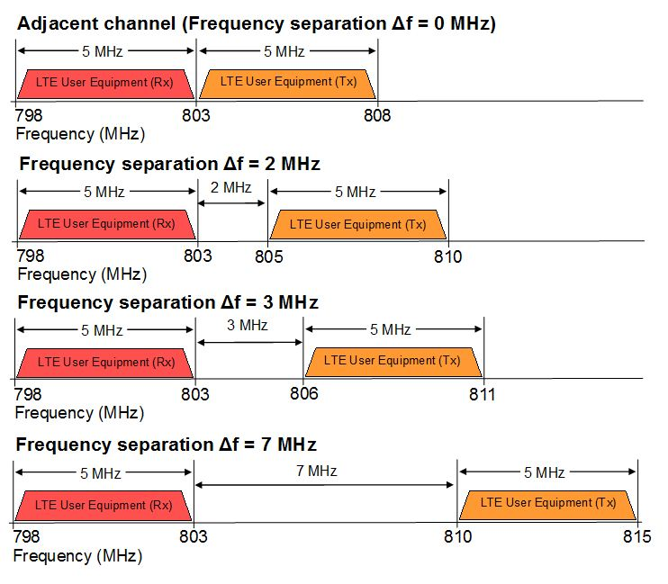

**Table 9- Results of analysis of interference from a LTE mobile UE transmitter operating above 803 MHz to an LTE UE receiver operating immediately below 803 MHz (where BSs are collocated)**

|  |  |
| --- | --- |
| **Frequency Seperation Δf (MHz)** | **% of exceedence events (CINR < 16 dB)** |
| 0 | 2.56 |
| 2 | 1.30 |
| 3 | 1.06 |
| 6 | 0.86 |
| 7 | 0.74 |

The results in indicate that in the worst case considered (64-QAM 4/5 rate MCS is used (i.e. where a CINR of greater than 16 dB is required)), then the required frequency separation between the LTE system operating below 803 MHz and the LTE system operating above 803 MHz would be 0 MHz (i.e. direct adjacent channel) to allow for co-siting. This provides an exceedence percentage of less than 5%.

## Scenario B

## Deterministic study D1

shows the results of simulations considering interference from a LTE BS transmitter operating immediately below 803 MHz into a LTE BS receiver operating above 803 MHz, as illustrated in .

**Figure 17- Spectral location of LTE BS transmitter (below 803 MHz) and LTE BS receiver (above 803 MHz)**

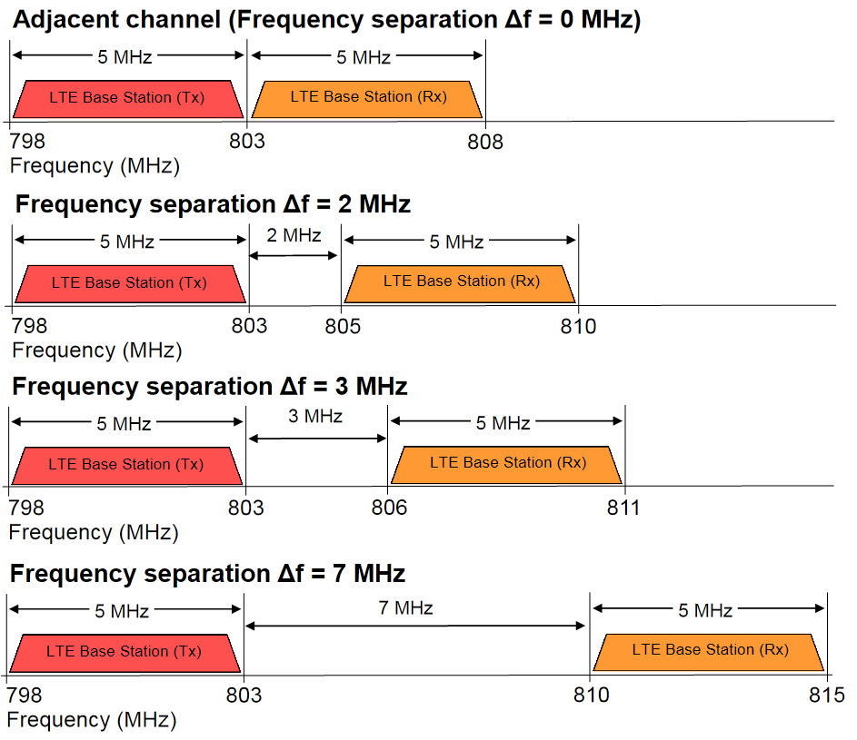

**Table 10- Results of analysis of interference from an LTE BS transmitter operating immediately below 803 MHz to a LTE BS receiver operating above 803 MHz**

|  |  |  |  |  |  |  |
| --- | --- | --- | --- | --- | --- | --- |
| **Distance (km)** | **CINR (dB)**  **Bore sight** | | | | | |
| **Frequency Separation**  **Δf (MHz)** | **0** | **2** | **3** | **4** | **6** | **7** |
| 5 | 15.85 | 25.88 | 29.85 | 30.51 | 31.12 | 31.19 |
| 2 | 8.02 | 19.09 | 25.65 | 26.93 | 29.73 | 30.09 |
| 1 | 2.05 | 13.28 | 20.60 | 23.22 | 26.79 | 27.56 |
| 0.5 | -0.14 | 11.11 | 18.55 | 21.30 | 25.23 | 26.14 |
| 0.1 | -14.10 | -2.81 | 4.81 | 8.06 | 12.41 | 13.62 |

The required separation distances derived from are summarised in .

**Table 11- Required separation distances between an LTE BS transmitter operating immediately below 803 MHz and an LTE BS receiver operating above 803 MHz to maintain a suitable CINR**

|  |  |  |  |
| --- | --- | --- | --- |
| **Rx MCS** | **QPSK**  **1/8 rate**  **(CINR < -3 dB)** | **16-QAM**  **½ rate**  **(CINR < 9 dB)** | **64-QAM**  **4/5 rate**  **(CINR < 16 dB)** |
| **Frequency separation** | **Required separation distances (metres)** | | |
| **0 MHz** | 100 – 500 | 2000 – 5000 | Greater than 5000 |
| **2 MHz** | Co-sited | 100 – 500 | 1000 – 2000 |
| **3 MHz** | Co-sited | 100 – 500 | 100 – 500 |
| **4 MHz** | Co-sited | 100 – 500 | 100 – 500 |
| **6 MHz** | Co-sited | Co-sited | 100 – 500 |
| **7 MHz** | Co-sited | Co-sited | 100 – 500 |

The results in indicate that co-sited operation of the 700 MHz LTE BS and 800 MHz LTE BS may be feasible with 4 MHz frequency separation between 700 MHz LTE system and 800 MHz LTE system. With a 4 MHz separation between channel edges there may be some service degradation between co-located equipment at the upper edge of the 700 MHz band and the lower edge of 3GPP band 7 (807 MHz). However this can be mitigated through the use of site specific solutions such as filters or split duplexers[1].

## Scenario C

## Probabilistic study P1

Table **12** shows the results of simulations considering interference from a trunked land mobile UE transmitter operating above 803 MHz and a LTE UE receiver operating immediately below 803 MHz, as illustrated in .

**Figure 18- Spectral location of LTE UE receiver (below 803 MHz) and trunked land mobile UE transmitter (above 803 MHz)**

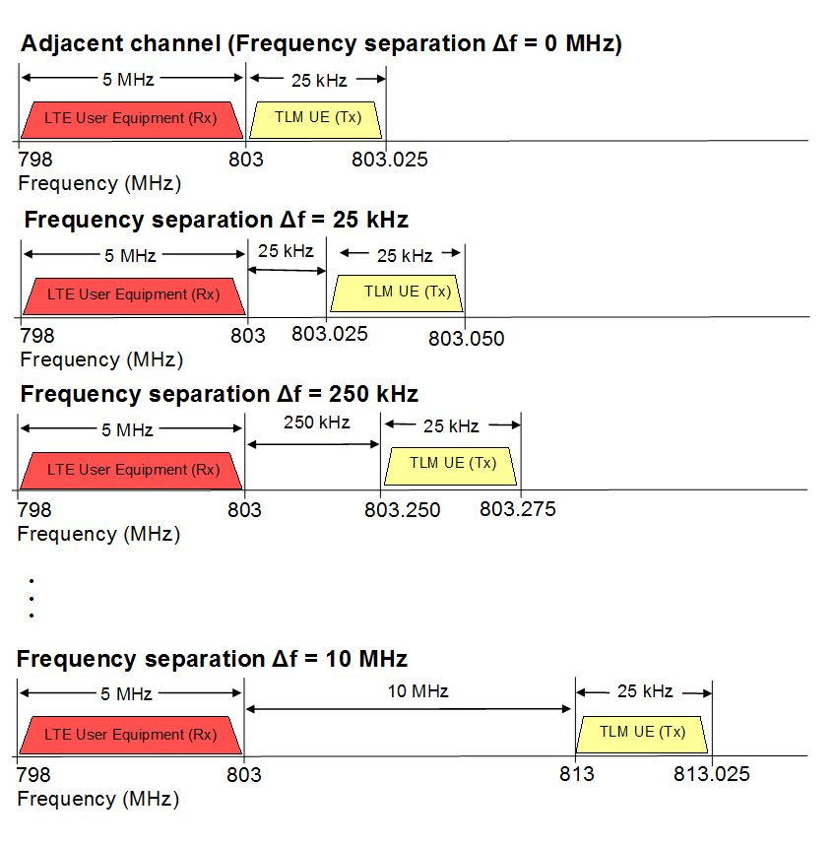

**Table 12- Results of analysis of interference from a trunked land mobile UE transmitter operating above 803 MHz to an LTE UE receiver operating immediately below 803 MHz**

|  |  |  |  |  |  |  |  |  |
| --- | --- | --- | --- | --- | --- | --- | --- | --- |
| **Distance (km)** | **% of exceedence events**  **(CINR < 16 dB)** | | | | | | | |
| **Frequency Seperation Δf (MHz)** | **0** | **0.025** | **0.25** | **1** | **2** | **3** | **5** | **10** |
| 5 | 53.91 | 51.13 | 12.12 | 0.30 | 0.22 | 0 | 0 | 0 |
| 2 | 73.11 | 70.85 | 40.27 | 6.20 | 4.04 | 3.04 | 2.84 | 2.74 |
| 1 | 77.02 | 75.20 | 50.17 | 9.70 | 4.84 | 4.56 | 3.44 | 3.22 |
| 0.5 | 78.80 | 75.70 | 50.99 | 10.26 | 5.74 | 4.78 | 4.72 | 4.24 |
| 0.1 | 77.54 | 75.66 | 51.23 | 9.68 | 5.64 | 4.54 | 3.92 | 3.78 |
| 0 | 77.40 | 75.84 | 51.61 | 10.12 | 6.10 | 4.80 | 4.40 | 4.74 |

The results in

Table **12** indicate that in the worst case considered (64-QAM 4/5 rate MCS is used (i.e. where a CINR of greater than 16 dB is required)), then the required frequency separation between the LTE and trunked land mobile systems would be 3 MHz to allow for co-siting. This assumes an exceedence percentage of less than 5%.

## Scenario D

## Deterministic study D1

Table **13** shows the results of the study of interference from an LTE BS transmitter (operating immediately below 803 MHz) to a trunked land mobile BS receiver (operating above 803 MHz), as illustrated in .

**Figure 19- Spectral location of LTE BS transmitter (below 803 MHz) and trunked land mobile BS receiver (above 803 MHz)**

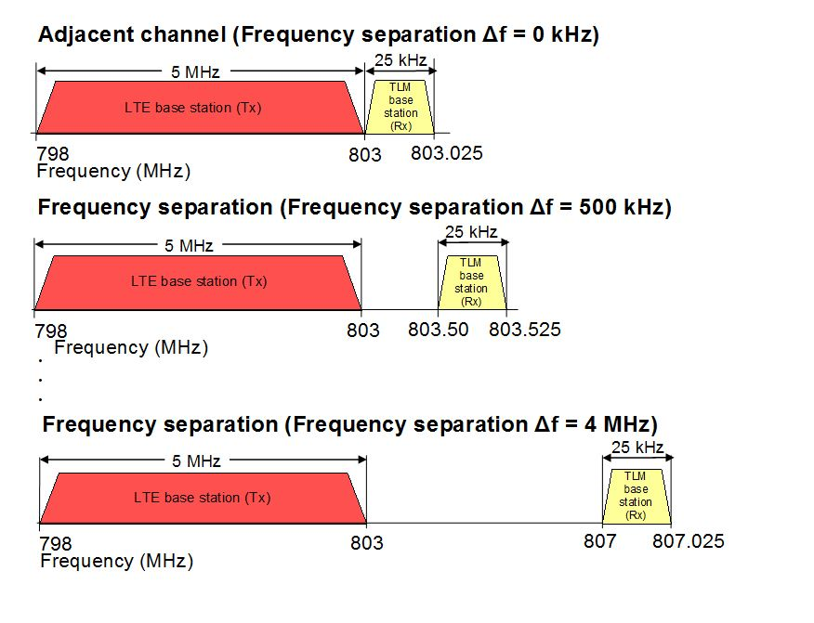

**Table 13- Results of analysis of interference from an LTE BS transmitter operating immediately below 803 MHz to a trunked land mobile receiver operating above 803 MHz**

|  |  |  |  |  |  |  |
| --- | --- | --- | --- | --- | --- | --- |
| **Distance**  **(km)** | **CIR (dB)**  **Bore sight** | | | | | |
| **Frequency**  **Separation**  **Δf (MHz)** | **0** | **0.5** | **1** | **2** | **3** | **4** |
| 5 | 7.631 | 8.729 | 8.729 | 8.729 | 28.631 | 29.729 |
| 2 | -0.323 | 0.775 | 0.775 | 0.775 | 20.677 | 21.775 |
| 1 | -6.432 | -5.244 | -5.244 | -5.244 | 14.658 | 15.756 |
| 0.5 | -12.345 | -11.246 | -11.246 | -11.246 | 8.655 | 9.753 |
| 0.1 | -16.140 | -15.042 | -15.042 | -15.042 | 4.86 | 5.958 |

The results in

Table **13** indicate that in the worst case considered where services are directly frequency-adjacent, the separation distance required is between 2 and 5 kilometres to maintain a suitable CIR (greater than 5 dB). It is expected that required separation distances would be further reduced if antenna discrimination is taken into account.

Further, based on these results, it is believed that a CIR of greater than 5 dB can be maintained when the LTE BS and trunked land mobile BS are co-sited (within 200 metres) if there is a frequency separation between the services of at least 3 MHz.

## Scenario E

## Probabilistic study P2

Table **14** shows the results of a Monte Carlo analysis of interference from a two-frequency fixed point-to-point transmitter operating above 803 MHz to a LTE UE receiver operating immediately below 803 MHz, as illustrated in .

**Figure 20- Spectral location of LTE UE receiver (below 803 MHz) and two-frequency fixed point-to-point (single channel) transmitter (above 803 MHz)**

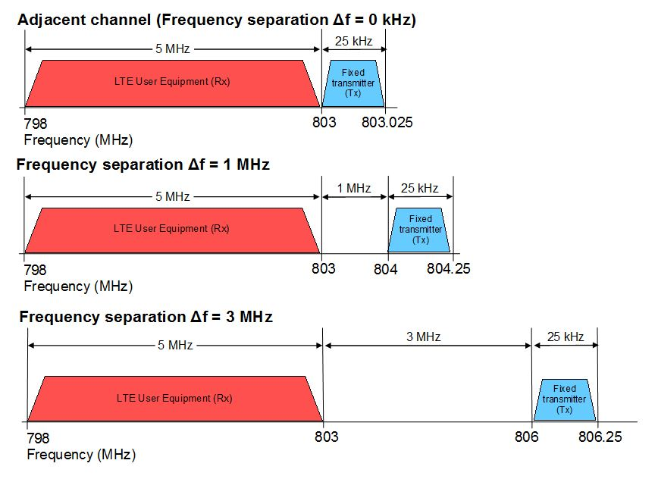

**Table 14- Results of analysis considering interference from a two-frequency fixed point-to-point (single channel) transmitter @ 1W above 803 MHz to an LTE UE receiver immediately below 803 MHz**

|  |  |  |  |
| --- | --- | --- | --- |
| **Distance (km)** | **% of exceedence events**  **(CINR < 16 dB)** | | |
| **Frequency Separation Δf (kHz)** | **0** | **1** | **3** |
| 5 | 4.05 | 0 | 0 |
| 1 | 10.15 | 0.25 | 0.06 |
| 0.1 | 6.20 | 0 | 0 |
| 0 | 0 | 0 | 0 |

The results in

Table **14** indicate that in the case considered when 64 QAM 4/5 rate MCS (i.e. where a CINR of greater than 16 dB is required) is assumed for the LTE service then the required frequency separation for co-sited operation, to achieve less than 5 % exceedence events, is 1 MHz.

## Scenario F

## Deterministic study D2

shows the results of the analysis of interference from an LTE BS transmitter (below 803 MHz) to a two-frequency fixed point-to-point receiver (above 803 MHz), as illustrated in .

**Figure 21- Spectral location of LTE BS transmitter (below 803 MHz) and two-frequency fixed point-to-point (single channel) receiver (above 803 MHz)**

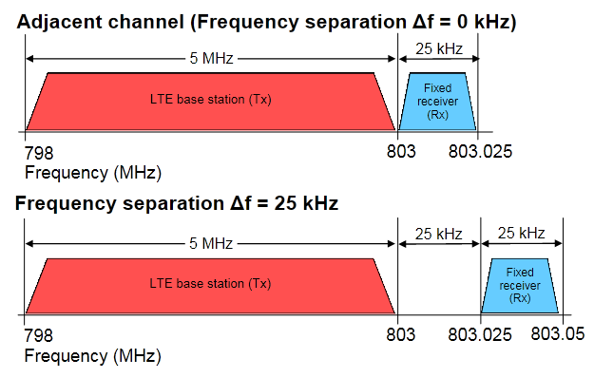

**Table 15- Results of analysis of interference from an LTE BS transmitter operating immediately below 803 MHz to a two-frequency fixed point-to-point (single channel) receiver operating above 803 MHz**

|  |  |  |  |  |  |  |
| --- | --- | --- | --- | --- | --- | --- |
| Distance (km) | CIR (dB)  Bore sight | | CIR (dB)  90° from bore sight | | CIR (dB)  180° from bore sight | |
| **Frequency Separation**  **Δf (kHz)** | **0** | **25** | **0** | **25** | **0** | **25** |
| 5 | 33.39 | 33.06 | 62.97 | 63.79 | 34.15 | 34.48 |
| 2 | 25.49 | 25.64 | 55.94 | 56.98 | 26.74 | 26.59 |
| 1 | 19.47 | 19.74 | 50.14 | 51.22 | 20.84 | 20.57 |
| 0.5 | 12.32 | 16.28 | 42.95 | 44.04 | 17.39 | 13.41 |
| 0.1 | -0.76 | 9.52 | 28.97 | 30.07 | 10.61 | 0.34 |

The results in indicate that in the worst case where services are directly frequency-adjacent, the separation distance required between the LTE BS transmitter and the fixed link receiver is between 100 and 500 metres to maintain a suitable CIR. With a frequency separation of one fixed service channel (25 kHz), the LTE BS transmitter and the fixed link receiver could be co-sited. The required separation distances can be further reduced if antenna discrimination is taken into account.

Based on these results, and without taking other losses into account (such as antenna discrimination), it is believed that a CIR of greater than 0 dB can be maintained when the LTE BS and fixed receiver are co-sited (within 200 metres) if there is a frequency separation between the services of at least 25 kHz. This figure could vary depending on the circuit length, transmit power level, and other factors.

## Scenario G

## Probabilistic study P2

and show the results of simulations considering interference from a two-frequency fixed point-to-point transmitter operating above 803 MHz at 1 Watt and 5 Watts, respectively, to a LTE UE receiver operating immediately below 803 MHz, as illustrated in

Figure **22**.

The majority of two frequency fixed point-to-point (low capacity) links have a transmitter power of either 5 Watts or 1 Watt. Simulations considered both of these scenarios.

**Figure 22- Spectral location of LTE UE receiver (below 803 MHz) and two-frequency fixed point-to-point (low capacity) transmitter (above 803 MHz)**



**Table 16- Results of simulation considering interference from an a two-frequency fixed point-to-point (low capacity) transmitter @ 1 W operating above 803 MHz to an LTE UE receiver operating immediately below 803 MHz**

|  |  |  |  |
| --- | --- | --- | --- |
| **Distance (km)** | **% of exceedence events**  (CINR < 16 dB) | | |
| **Frequency Separation Δf (MHz)** | **1** | **2** | **3** |
| 5 | 0 | 0 | 0 |
| 1 | 0.08 | 0 | 0 |
| 0.1 | 0 | 0 | 0 |
| 0 | 0 | 0 | 0 |

**Table 17- Results of simulation considering interference from an a two-frequency fixed point-to-point (low capacity) transmitter @ 5 W operating above 803 MHz to an LTE UE receiver operating immediately below 803 MHz**

|  |  |  |  |
| --- | --- | --- | --- |
| **Distance (km)** | **% of exceedence events**  (CINR < 16 dB) | | |
| **Frequency Separation Δf (MHz)** | **1** | **2** | **3** |
| 5 | 0 | 0 | 0 |
| 1 | 0.24 | 0.01 | 0 |
| 0.1 | 0 | 0 | 0 |
| 0 | 0 | 0 | 0 |

The results in indicate that when a 1 Watt fixed transmitter was considered, assuming 64 QAM 4/5 rate MCS (i.e. where a CINR of greater than 16 dB is required) for the LTE service, then the required frequency separation, to achieve less than 5 % exceedence events during co-sited operation, is 1 MHz.

The results in indicate that when a 5 Watt fixed transmitter is considered, assuming 64 QAM 4/5 rate MCS (i.e. where a CINR of greater than 16 dB is required) the LTE service, then the required frequency separation, to achieve less than 5 % exceedence events during co-sited operation, is also 1 MHz.

## Scenario H

## Deterministic study D2

shows the results of the analysis of interference from an LTE BS transmitter (below 803 MHz) to a two-frequency fixed point-to-point (low capacity) receiver (above 803 MHz), as illustrated in .

**Figure 23- Spectral location of LTE BS transmitter (below 803 MHz) and two-frequency fixed point-to-point (low capacity) receiver (above 803 MHz)**

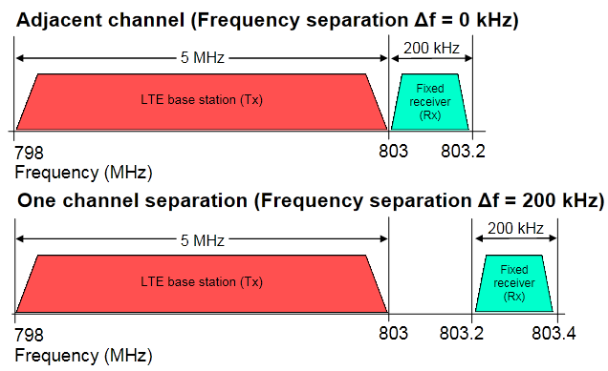

**Table 18- Results of analysis of interference from an LTE BS transmitter operating immediately below 803 MHz to a two-frequency fixed point-to-point (low capacity) receiver operating above 803 MHz**

|  |  |  |  |  |  |  |  |  |  |
| --- | --- | --- | --- | --- | --- | --- | --- | --- | --- |
| **Distance (km)** | **CIR (dB)**  **Bore sight** | | | **CIR (dB)**  **90° from bore sight** | | | **CIR (dB)**  **180° from bore sight** | | |
| **Frequency Separation**  **Δf (kHz)** | **0** | **200** | **1000** | **0** | **200** | **1000** | **0** | **200** | **1000** |
| 5 | 24.38 | 25.45 | 25.44 | 24.04 | 25.12 | 25.13 | 53.95 | 54.75 | 56.32 |
| 2 | 16.48 | 17.55 | 17.73 | 16.63 | 17.71 | 17.82 | 46.93 | 47.94 | 48.27 |
| 1 | 10.46 | 11.54 | 11.53 | 10.73 | 11.80 | 11.82 | 41.13 | 42.19 | 42.25 |
| 0.5 | 3.30 | 4.38 | 5.91 | 7.27 | 8.34 | 8.35 | 33.93 | 35.01 | 35.84 |
| 0.1 | -9.77 | -8.69 | -8.70 | 0.05 | 1.58 | 1.57 | 19.96 | 21.04 | 31.03 |

The results in indicate that in the worst case where services are directly frequency-adjacent, the separation distance required between the LTE BS transmitter (source of interference) and the receiver of the fixed link (subject of interference) would be greater than 5 kilometres in order to maintain a suitable CIR. With a frequency separation of one fixed service channel (200 kHz), the required separation distance would be reduced, but still greater than 5 kilometres. The LTE BS and fixed receiver are likely to be able to operate co-sited (within 200 meters) if there is a frequency separation between the services of 1 MHz. Required separation distances are further reduced if antenna discrimination is taken into account.

## Scenario I

## Probabilistic study P2

and show the results of a Monte Carlo analysis of interference from a single frequency fixed point-to-point transmitter operating above 803 MHz at 1 Watt and 5 Watts, respectively, to a LTE UE receiver operating immediately below 803 MHz, as illustrated in .

The majority of single frequency fixed point-to-point links have a transmit power of either 5 Watts or 1 Watt, simulations considered both of these scenarios.

**Figure 24- Spectral location of LTE UE receiver (below 803 MHz) and single frequency fixed point-to-point transmitter (above 803 MHz)**



**Table 19- Results of simulation considering interference from a single frequency fixed point-to-point transmitter @ 1 W operating above 803 MHz to an LTE UE receiver operating immediately below 803 MHz**

|  |  |  |  |
| --- | --- | --- | --- |
| **Distance (km)** | **% of exceedence events**  **(CINR < 16 dB)** | | |
| **Frequency Separation Δf (MHz)** | **0** | **1** | **3** |
| 5 | 0 | 0 | 0 |
| 1 | 0.89 | 0.11 | 0.05 |
| 0.1 | 1.920 | 0 | 0 |
| 0 | 2.499 | 0 | 0 |

**Table 20- Results of simulation considering interference from a single frequency fixed point-to-point transmitter @ 5 W operating above 803 MHz to an LTE UE receiver operating immediately below 803 MHz**

|  |  |  |  |
| --- | --- | --- | --- |
| **Distance (km)** | **% of exceedence events**  **(CINR < 16 dB)** | | |
| **Frequency Separation Δf (MHz)** | **0** | **1** | **3** |
| 5 | 1.998 | 0 | 0 |
| 1 | 5.019 | 0.300 | 0.100 |
| 0.1 | 5.419 | 0 | 0 |
| 0 | 5.379 | 0 | 0 |

The results in indicate that when a 1 Watt fixed transmitter was considered, assuming 64 QAM 4/5 rate MCS (i.e. where a CINR of greater than 16 dB is required) for the LTE service, then the required frequency separation, to achieve less than 5 % exceedence events during co-sited operation, is 1 MHz.

The results in indicate that when a 5 Watt fixed transmitter was considered, assuming 64 QAM 4/5 rate MCS (i.e. where a CINR of greater than 16 dB is required) for the LTE service, then the required frequency separation, to achieve less than 5 % exceedence events during co-sited operation, is also 1 MHz.

## Scenario J

## Deterministic study D2

Table **21** shows the results of the study of interference from an LTE BS transmitter operating immediately below 803 MHz to a single frequency fixed point-to-point receiver operating above 803 MHz, as illustrated in .

**Figure 25- Spectral location of LTE BS transmitter (below 803 MHz) and single frequency fixed**

**point-to-point receiver (above 803 MHz)**

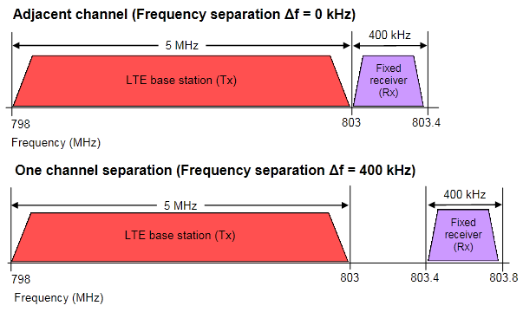

**Table 21- Results of analysis of interference from an LTE BS transmitter operating immediately below 803 MHz to a single frequency fixed point-to-point receiver operating above**

**803 MHz**

|  |  |  |  |  |  |  |
| --- | --- | --- | --- | --- | --- | --- |
| **Distance (km)** | **CIR (dB)**  **Bore sight** | | **CIR (dB)**  **90° from bore sight** | | **CIR (dB)**  **180° from bore sight** | |
| **Frequency Separation**  **Δf (kHz)** | **0** | **400** | **0** | **400** | **0** | **400** |
| 5 | 21.36 | 24.44 | 21.03 | 22.11 | 50.94 | 51.74 |
| 2 | 13.47 | 14.54 | 13.62 | 14.69 | 43.91 | 44.93 |
| 1 | 7.45 | 8.52 | 7.72 | 8.78 | 38.12 | 39.17 |
| 0.5 | 0.29 | 1.36 | 4.26 | 5.33 | 30.92 | 31.99 |
| 0.1 | -12.78 | -11.71 | -2.51 | -1.43 | 16.95 | 18.02 |

The results in

Table **21** indicate that in the worst case where services are directly adjacent, the separation distance required between the LTE BS transmitter and the receiver of the single frequency point-to-point fixed link would be between 100 and 500 metres in order to maintain a suitable CIR. With a frequency separation of one fixed channel (400 kHz), the required separation distance is reduced, but still between 100 and 500 metres. The calculated separation distances are further reduced if antenna discrimination is taken into account.

# Summary

The results of the studies discussed in this section are summarised in Table 14.

|  |  |  |  |  |
| --- | --- | --- | --- | --- |
| **Service above 803 MHz** | **Scenario** | | **Frequency seperation required for co-sited operation for each scenario** | **Frequency seperation required for co-sited operation for each service overall** |
| LTE | (a) | 700 MHz LTE UE Rx vs. 800 MHz LTE UE Tx | 0 MHz | 4 MHz |
| (b) | 700 MHz LTE Base Tx vs. 800 MHz LTE Base Rx | 4 MHz |
| Trunked land mobile | (c) | 700 MHz LTE UE Rx vs. 800 MHz two-frequency fixed (low capacity) Tx | 1 MHz | 4 MHz |
| (d) | 700 MHz LTE Base Tx vs. 800 MHz trunked land mobile Base Rx | 4MHz |
| Two frequency fixed point-to-point (single channel) | (e) | 700 MHz LTE UE Rx vs. 800 MHz two-frequency fixed (single channel) Tx | 1 MHz | 1 MHz |
| (f) | 700 MHz LTE Base Tx vs. 800 MHz two-frequency fixed (single channel) Rx | 25 kHz |
| Two frequency fixed point-to-point (Low capacity) | (g) | 700 MHz LTE UE Rx vs. 800 MHz two-frequency fixed (low capacity) Tx | 1 MHz | 1 MHz |
| (h) | 700 MHz LTE Base Tx vs. 800 MHz two-frequency fixed (low capacity) Rx | 1 MHz |
| Single frequency fixed point-to-point | (i) | 700 MHz LTE UE Rx vs. 800 MHz single frequency fixed Tx | 1 MHz | 1 MHz |
| (j) | 700 MHz LTE Base Tx vs. 800 MHz single frequency fixed Rx | 1 MHz |

# Attachment to Annex 3 - Sharing Parameters used in Australian study

# A1. 700 MHz LTE

*Proposal 1 (P1, P2, D1, D2):*

|  |  |  |  |  |
| --- | --- | --- | --- | --- |
| **700 MHz BS**  **Parameters** |  |  |  | **Reference** |
| Transmit Power | 13dBW |  |  | 36.104/25.104 |
| Transmit Frequency | 800.5 MHz |  |  | 700 MHz band frequency |
| Antenna Height | 25 m |  |  | Design parameter |
| Antenna Gain | 18 dBi |  |  | Radiocoms Advisory Guidelines |
| Antenna Beamwidth | 5 deg |  |  | Design parameter |
| Antenna Gain Floor | -27 dB |  |  | Design parameter |
| Antenna Pattern | F.1245 |  |  | ITU-R Rec F.1245 |
|  |  |  |  |  |
| Antenna Azimuth | Sector A | Sector B | Sector C |  |
|  | 120 deg | 0 deg | -120 deg | Design parameter |
| Antenna Elevation | Sector A | Sector B | Sector C |  |
|  | -2.5 deg | -2.5 deg | -2.5 deg | Design parameter |
|  |  |  |  |  |
| Polarisation | Linear Vertical |  |  |  |
|  |  |  |  |  |
| Transmitter Masks | 700 MHz TLG | Bandwidth | 5 MHz | 700 MHz TLG emission mask |
| Receiver Mask | Epcos SAW Duplexedr | | | Series B7924 V1.5 |
| Transmission Bandwidth | 5 MHz |  |  | Radiocoms Advisory Guidelines |

|  |  |  |
| --- | --- | --- |
| **700 MHz Mobile Station Parameters** |  | **Reference** |
| Receive Frequency | 800.5 MHz | 700 MHz band frequency |
| Antenna Height | 1.5 m | Design parameter |
| Antenna Gain | 0 dBi | Design parameter |
| Antenna Beamwidth | 5.0 deg | Design parameter |
| Antenna Gain Floor | 0 dBi | Design parameter |
| Antenna Pattern | Omni-directional | Design parameter |
| Polarisation | Linear Vertical | Design parameter |
| Receiver Mask | Epcos SAW Duplexer | Series B7924 V1.5 |
| Transmission Bandwidth | 5 MHz |  |
| Feeder Loss | 0 dB | Design parameter |

Transmission mask (for BS):

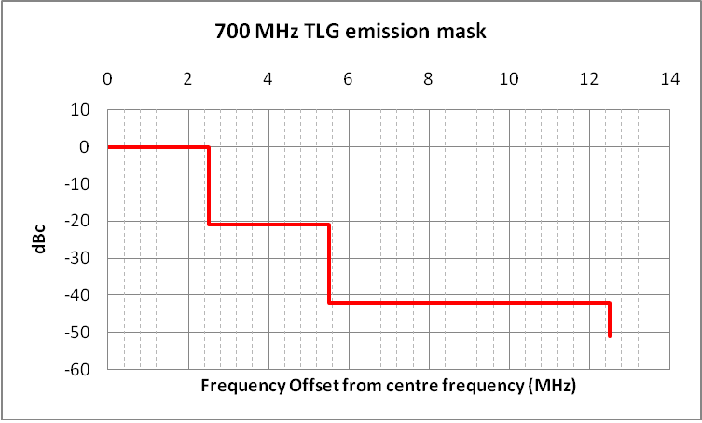

Receiver mask (for UE):

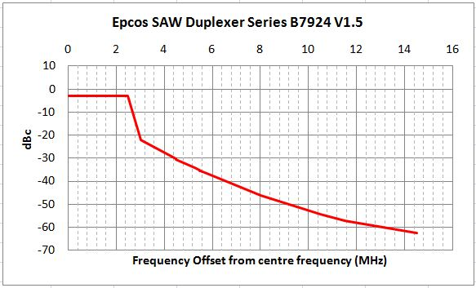

# *Proposal 2 (P4):*

|  |  |  |
| --- | --- | --- |
|  | 700 MHz BS | 800 MHz UE |
| Carrier frequency | 790 MHz | |
| Channel bandwidth | 10 MHz | |
| Cell range | 4km | |
| Cell layout | Wrap-around 19 tri-sector cells, uncoordinated | |
| Frequency reuse | 1x3x1 | |
| Pathloss model | Hata suburban: 115.6+35.2log10(R) | |
| Lognormal fading | 10 dB | |
| Antenna gain and horizontal antenna pattern | 15 dBi, = 65 degrees,  *Am* = 20 dB | Omni-directional antenna with -6 dBi. |
| Noise figure | 5 dB | 9 dB |
| Transmit power | 46 dBm | 23 dBm |
| Antenna height | 30 m | 1.5 m |

# A2. 800 MHz LTE

|  |  |  |  |  |  |
| --- | --- | --- | --- | --- | --- |
| **800 MHz BS Parameters** | **Value** | | | | **References** |
| Receive Frequency | 805.5-812.5 MHz | | | | 800 MHz band frequency |
| Antenna Height | 30m | | | | Design parameter |
| Antenna Gain | 18dBi | | | | Design Parameter |
| Antenna Beamwidth | 5deg | | | | Design parameter |
| Antenna Gain Floor | -27dB | | | | Design parameter |
| Antenna Pattern | F.1245 | | | | ITU-R Rec F.1245 |
| Antenna Azimuth | Sector A | Sector B | | Sector C |  |
| 120deg | 0deg | | -120deg | Design parameter |
| Antenna Elevation | Sector A | Sector B | | Sector C |  |
| -2.5deg | -2.5deg | | -2.5deg | Design parameter |
| Polarisation | Linear Vertical | | | |  |
| Receiver Mask/ Bandwidth | Epcos SAW Duplexer | | 5 MHz | | Series B7924 V1.5 |
| Feeder Loss | 5dB | | | | Design Parameter |

|  |  |  |
| --- | --- | --- |
| **800 MHz Mobile Station Parameters** |  | **Reference** |
| Transmit Power | 0 dBW |  |
| Transmit Frequency | 805.5-812.5 MHz | 800 MHz band frequency |
| Antenna Height | 1.5 m | Design parameter |
| Antenna Gain | 0 dBi | Design parameter |
| Antenna Beamwidth | 5.0 deg | Design parameter |
| Antenna Gain Floor | 0 dBi | Design parameter |
| Antenna Pattern | Omni-directional | Design parameter |
| Polarisation | Linear Vertical | Design parameter |
| Transmit Mask | 800 TLG | ACMA 800 MHz TLG |
| Transmission Bandwidth | 5 MHz |  |
| Feeder Loss | 0 dB | Design parameter |

Transmission mask (for UE):

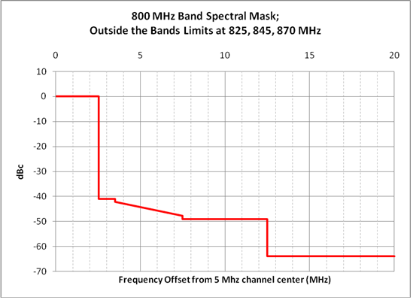

Receiver mask (for BS):



# A3. 800 MHz trunked land mobile

|  |  |  |
| --- | --- | --- |
| **Trunked land mobile BS** |  | **Reference** |
| Transmit Power | 16 dBW | RALI LM08 |
| Adjacent channel protection ratio | 5 dB | RALI LM08 |
| Transmit/Receive Frequency | 803.0125 – 806.0125 MHz | proposed frequency |
| Antenna Height | 30 m | Design parameter |
| Antenna Gain | 3 dBi | Design parameter |
| Antenna Beamwidth | 5.0 deg | Design parameter |
| Antenna Pattern | Omni-directional |  |
| Polarisation | Linear Horizontal | Design parameter |
| Transmitter Mask | Derived from RALI FX3 | RALI FX3 Appendix 3 i |
| Receiver Mask | Derived from RALI FX3 | RALI FX3 i |
| Transmission Bandwidth | 25 kHz | RALI LM08 i |
| Feeder Loss | 5 dB | Design parameter |

|  |  |  |
| --- | --- | --- |
| **Trunked land mobile UE** |  | **Reference** |
| Transmit Power | 13.97 dBW | RALI LM08 |
| Adjacent channel protection ratio | 5 dB | RALI LM08 |
| Transmit/Receive Frequency | 803.0125 – 806.0125 MHz | proposed frequency |
| Antenna Height | 1.5 m | Design parameter |
| Antenna Gain | 2.15 dBi | Design parameter |
| Antenna Beamwidth | 5.0 deg | Design parameter |
| Antenna Pattern | Omi-directional | Design parameter |
| Polarisation | Linear Horizontal | Design parameter |
| Transmitter Mask | Derived from RALI FX3 | RALI FX3 Appendix 3 |
| Receiver Mask | Derived from RALI FX3 | RALI FX3 |
| Transmission Bandwidth | 25 kHz | RALI LM08 |
| Feeder Loss | 0 dB | Design parameter |

Transmitter mask (for BS and UE):

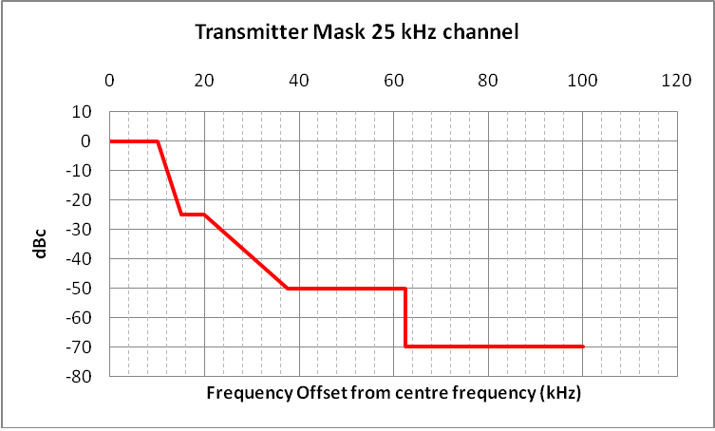

Receiver mask (for BS and UE):

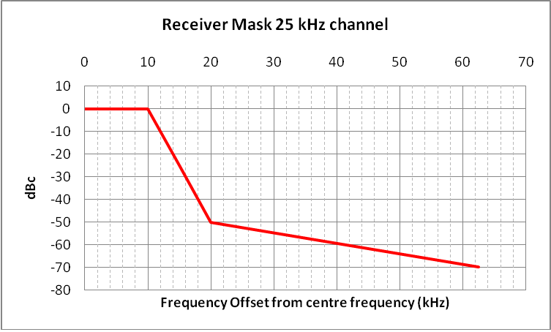

# A4. Two-frequency fixed point-to-point (single channel)

|  |  |  |
| --- | --- | --- |
| **Two-frequency Fixed link (single channel)** | | **Reference** |
| Transmit Power | 0 dBW | Design parameter |
| Adjacent channel protection ratio | 0 dB | RALI FX17i |
| Transmit/Receive Frequency | 803-806 MHz | proposed frequencies |
| Antenna Height | 30 m | Design parameter |
| Antenna Gain | 23.9 dBi | Design parameter |
| Antenna Beamwidth | 12.0 deg | Design parameter |
| Antenna Pattern | F.1245 | ITU-R Rec F.1245 |
| Polarisation | Linear Horizontal | Design parameter |
| Transmitter Mask | Derived from RALI FX3 | RALI FX3 Appendix 3i |
| Receiver Mask | Derived from RALI FX3 | RALI FX3 i |
| Transmission Bandwidth | 25 kHz | RALI FX17 i |
| Feeder Loss | 5 dB | Design parameter |
| Transmitter mask:    Receiver mask: | | |

# A5. Two-frequency fixed point-to-point (Low capacity)

|  |  |  |
| --- | --- | --- |
| **Two-frequency Fixed link (low capacity)** | | **Reference** |
| Transmit Power | 0 dBW/6.99 dBW | Design parameter |
| Adjacent channel protection ratio | 30 dB | SP6/93 |
| Transmit/Receive Frequency | 803-806 MHz | proposed frequencies |
| Antenna Height | 30 m | Design parameter |
| Antenna Gain | 23.9 dBi | Design parameter |
| Antenna Beamwidth | 12.0 deg | Design parameter |
| Antenna Pattern | F.1245 | ITU-R Rec F.1245 |
| Polarisation | Linear Horizontal | Design parameter |
| Transmitter Mask | Derived from RALI FX3 | RALI FX3 Appendix 3 i |
| Receiver Mask | Derived from RALI FX3 | RALI FX3 i |
| Transmission Bandwidth | 200 kHz | SP6/93 |
| Feeder Loss | 5 dB | Design parameter |
| Transmitter mask:    Receiver mask: | | |

# A6. Single frequency fixed point-to-point

|  |  |  |
| --- | --- | --- |
| **Single frequency Fixed link** | | **Reference** |
| Transmit Power | 0 dBW/ 6.99 dBW | Design parameter |
| Adjacent channel protection ratio | 0 dB | RALI FX11[2] |
| Transmit/Receive Frequency | 803-806 MHz | proposed frequencies |
| Antenna Height | 30 m | Design parameter |
| Antenna Gain | 23.9 dBi | Design parameter |
| Antenna Beamwidth | 12.0 deg | Design parameter |
| Antenna Pattern | F.1245 | ITU-R Rec F.1245 |
| Polarisation | Linear Horizontal | Design parameter |
| Transmitter Mask | Derived from RALI FX3 | RALI FX3 Appendix 3i |
| Receiver Mask | Derived from RALI FX3 | RALI FX3i |
| Transmission Bandwidth | 400 kHz | RALI FX11i |
| Feeder Loss | 5 dB | Design parameter |
| Transmitter mask:    Receiver mask: | | |

# Annex 4- New Zealand Study

# Introduction

This study considers the following two cases:

* transmissions from an IMT (LTE) BS transmitter in 3GPP band 28 into an IMT (LTE) BS receiver operating in 3GPP band 27 (scenario (b)) (as shown in
* Figure **26**).

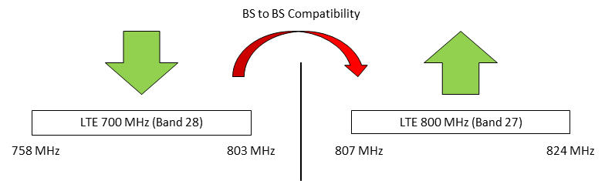

**Figure 26- Specific case of scenario (b) considered in this study**

* transmissions from an IMT (LTE) mobile station (UE) in 3GPP band 27 into an IMT (LTE) UE receiver operating in 3GPP band 28 (scenario (a)) (as shown in
* Figure **27**).

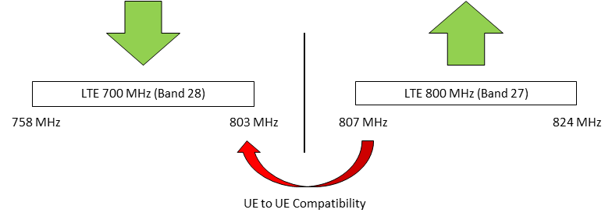

**Figure 27- Specific case of scenario (a) considered in this study**

# Methodology & Parameters

## Deterministic sharing analysis methodology

## Deterministic study D3

**BS to BS Interference**

*Specification Considerations*

The 3GPP Standards, in addressing implementation of IMT (LTE) systems, are complex. In assessing the interference scenario relating to transmissions from an IMT (LTE) BS transmitter in 3GPP band 28 into an IMT (LTE) BS receiver operating in 3GPP band 27, some of the relevant 3GPP TS 36.104 specification requirements are as follows:

* Section 6.6.2[3] outlines the ACLR requirements. This outlines the requirements used for calculating the out-of-band emission limits (for a category A wide area BS, the 1st and 2nd adjacent channel ACLR is the less stringent of: -13 dBm/MHz or 45 dBc/BWChannel).
* Table 6.6.4.1.1.1-1[4] outlines the limits of the general spurious emissions requirements (‑13 dBm/100 kHz).
* Table 6.6.4.3.1-1[5] outlines the limit which applies to additional spurious emissions in the band 807‑824 MHz (-49 dBm/MHz).
* Section 6.6.4.4[6] outlines the spurious emissions limits to be applied when co-locating with bases stations (-96 dBm/MHz).

Typically, out-of-band emissions requirements apply from the carrier frequency and extend out to 2.5 times the channel bandwidth. Emissions beyond this point are considered to be spurious emissions. For the different channel bandwidths, the following boundaries apply for emissions from IMT (LTE) BSs operating on the highest channel in 3GPP band 28:

|  |  |  |
| --- | --- | --- |
| **Channel Bandwidth (MHz)** | **Out of Band Emissions (MHz)** | **Spurious Emissions (MHz)** |
| 5 | 803 – 813 | >813 |
| 10 | 803 – 823 | >823 |
| 15 | 803 – 833 | >833 |
| 20 | 803 – 843 | >843 |

There are no specific out-of-band emissions requirements outlined in the specification, however these are often assumed to be addressed by the ACLR requirements. The ACLR criterion is 45 dB for both the first and second adjacent channel as this is less stringent than ‑13 dBm/MHz.

When assessing the interference issues between the two IMT (LTE) systems in adjacent bands (3GPP bands 28 & 27), it is not clear which are the applicable specification requirements, the combination of ACLR and spurious emissions, or the tighter “additional spurious emissions limits”. This lack of clarity arises as, aside from the specific ACLR limits specified in the 3GPP specification, the Additional Spurious Emissions Limits appear to apply to the whole band 807‑824 MHz.

Both scenarios relating to the application of ACLR limits and additional spurious emissions limits are considered separately in this paper. Additionally, in each of these scenarios, consideration has also been given to the application of the adjacent channel selectivity requirements on the receiver.

In assessing the likelihood of interference to BSs, the level of interference 10 dB below the noise floor has been used as the threshold for harmful interference. This is considered appropriate as the effect of service degradation to BSs can impact multiple users.

*Application of ACLR, Spurious Emissions & Adjacent Channel Selectivity*

This deterministic calculation provides the minimum required coupling loss for BS to BS interference where the specifications relating to ACLR and the general spurious emissions requirements are applied (i.e. The analysis in this section excludes consideration of the requirements relating to the “Additional Spurious Emissions Limits”).

The applicable calculations are as follows:

Interference threshold

|  |  |
| --- | --- |
| Interfering level | = 10 dB below the noise floor |
| Receiver bandwidth | = 1 MHz |
| Receiver noise figure | = 5 dB |
|  |  |
| Receiver noise floor (NFThermal) | = 10 log kTB |
| Where: |  |
| K | = 1.38 x 10-23 J/K |
| T | = 290 K |
| B | = 1 MHz |
|  |  |
| NFThermal | = -144 dBW |
|  | = -114 dBm |
|  |  |
| NFReceiver | = NFThermal + 5 dB |
|  | = -109 dBm/MHz |
|  |  |
| Interfering Level  (10 dB below noise floor) | = -109 dBm – 10 dB = -119 dBm/MHz |
|  |  |

Adjacent Channel Leakage Ratio and Spurious Emissions

|  |  |
| --- | --- |
|  |  |
| out-of-band Emission Limit | = -13 dBm/MHz or |
| (least stringent limit applies) | = -45 dBc/BWChannel |
|  |  |
| Power | = 40 W |
|  | = 46 dBm |
|  |  |
| Therefore out-of-band Limit | = 1 dBm/BWChannel |
| out-of-band (5 MHz) | = -6 dBm/MHz |
| out-of-band (10 MHz) | = -9 dBm/MHz |
| out-of-band (15 MHz) | = -11 dBm/MHz |
| out-of-band (20 MHz) | = -12 dBm/MHz |

In assessing the minimum coupling loss for a 5 MHz channel (3GPP band 28) interfering with a 10 MHz channel (3GPP band 27), interference may occur from a combination of out-of-band and spurious emissions. The out-of-band contribution of interference applies within the first 6 MHz of the 10 MHz channel. The spurious emission contribution to interference applies within the remaining 4 MHz of the channel. These have been assessed based on a power sum combination of the emissions as outlined overleaf:

|  |  |
| --- | --- |
| out-of-band limit | = -6 dBm/MHz |
| out-of-band bandwidth | = 6 MHz |
| out-of-band limit to apply | = 2 dBm/6 MHz |
|  | =1.5 mW |
|  |  |
| Spurious emission limit | = -13 dBm/100 kHz |
| Spurious emission bandwidth | = 4 MHz |
| Spurious emission limit to apply | = 3 dBm/4 MHz |
|  | = 2.0 mW |
|  |  |
| Total power into receiver | = 3.5 mW |
| (Power sum total) | = 5.46 dBm/10 MHz |
|  | = -4.5 dBm/MHz |
|  |  |

In all other cases of 3GPP band 28 and 3GPP band 27 channel widths, the spurious domain falls outside channel and only the out-of-band emissions fall in the 3GPP band 27 channel.

The ACS requirements for wide area BSs in 3GPP specification TS 36.104 do not extend from 3GPP band 28 into 3GPP band 27. Hence we use the ACS performance parameters agreed by the AWG Correspondence Group: 1st adjacent: 46 dB; 2nd adjacent: 58 dB and 3rd adjacent: 70 dB.



The worst case is the 5 MHz channel in 3GPP band 28 with the 10 MHz channel in 3GPP band 27, requiring 116 dB MCL.

If filters are used on both the 3GPP band 28 transmitter output and the 3GPP band 27 receiver input of say 45 dB each, the following calculation shows the resulting MCL.



The worst case MCL now reduces to 71 dB. Note that using a filter on only the transmitter or only the receiver will not achieve this level of MCL reduction.

It should be noted that these calculations for the minimum coupling loss assume the channel edges are aligned to the closest edges of the band (i.e. 803 MHz for 3GPP band 28 and 807 MHz for 3GPP band 27).

*Application of “Additional Spurious Emissions Limits”*

This deterministic calculation provides a minimum separation distance that will be necessary between BSs where the minimum specifications requirements relating to Additional Spurious Emissions Limits are met. The Additional Spurious Emission Limit is presented in the 3GPP specification as a performance criterion of the BS transmitter, independent of any other interference contributions of the transmitter, such as out-of-band emissions or general spurious emissions. However the minimum coupling loss calculations of the interference contribution of the victim receiver ACS are also to be taken into account.

The applicable calculations are as follows:

|  |  |
| --- | --- |
| Interfering Level  (from Annex A) | = -119 dBm/MHz |
|  |  |
| Spurious Emission Limit | = -49 dBm/MHz |
|  |  |



The worst case minimum coupling loss requirement is for a 5 MHz channel in 3GPP band 28 and a 10 MHz channel in 3GPP band 27, requiring 110 dB MCL.

The minimum distance to be maintained between BSs is calculated as follows:

|  |  |
| --- | --- |
| Required Total Loss (TL) | = 32.44 + 20 log dkm + 20 log fMHz – Gtx – Grx |
| Where: |  |
| Gtx =Grx | = Antenna Gain – Feeder Loss |
|  | = 15 – 2 = 13 dBi |
| fMHz | = 800 MHz |
| TL = MCL | = 110 dB |
|  |  |

|  |  |
| --- | --- |
| Solving for dkm: |  |
| 20 log dkm | = FSPL – 32.44 – 20 log fMHz + Gtx + Grx |
|  | = 110 – 32.44 – 58 + 13 + 13 |
|  | = 45.6 |
| dkm | = 189.7 km |

As the interference power from the additional spurious interference alone is much less than from the ACS derived interference, additional filtering on the 3GPP band 28 transmitter output will have no effect on the total interference, whereas filtering the 3GPP band 27 receiver input will be effective.

With a typical input band pass filter on the 3GPP band 27 receiver input of say 45 dB, a revised MCL and minimum distance is determined:



The worst case MCL now reduces to 71.1 dB.

It is noted that the 3GPP specification includes a tightened requirement for blocking when co‑locating with other BSs.[7] It is possible that this part of the specification is intended to address issues of receiver selectivity, however the specification does not comment on this matter.

*Application of Co-Location Spurious Emissions*

As noted above, for co-located systems, the BS spurious emissions limit is -96 dBm/100 kHz measured at the transmitter coupler. It is assumed that these limits are more critical than other unwanted emission parameters. Using the Interfering Level (10 dB below the noise floor) calculated above, the Minimum Coupling Loss is calculated to be 33 dB. The calculations are:

|  |  |
| --- | --- |
| Interfering Level  (10dB below noise floor) | = -119 dBm/MHz |
|  |  |
| Spurious Emission Limit | = -96 dBm/100 kHz |
|  | = -86 dBm/MHz |
|  |  |
| Minimum Coupling Loss (MCL) required | = -86 dBm – (-119 dBm) = 33 dB |

## Probabilistic sharing analysis methodology

## Probabilistic study P3

In assessing the interference scenario of transmissions from an IMT (LTE) mobile station (UE) in 3GPP band 27 into an IMT (LTE) UE receiver operating in 3GPP band 28, a probabilistic Monte Carlo analysis has been employed.

This analysis assumes the following broad parameters:

|  |  |
| --- | --- |
| UE SINR threshold | = 5.5 dB |
| UE density | = 13 users/km2 |
| UE noise figure | = 9 dB |

These and other parameters have been taken from earlier AWG work relating to the 700 MHz band.

As noted earlier, band 27 is limited by the 3GPP specification to a maximum channel bandwidth of 10 MHz. Accordingly the following channel bandwidths have been considered:

* 3GPP Band 27 – 5 & 10 MHz; and
* 3GPP Band 28 – 5, 10, 15 & 20 MHz.

In addition to analyzing various channel bandwidths, different channel boundaries for 3GPP band 27 have also been assessed. These are applied as follows:

* 807 MHz – this is the closest boundary between the highest channel in 3GPP band 28 and the lowest possible operation in 3GPP band 27 if the channel plan is developed from the bottom of 3GPP band 27.
* 809 MHz – this is the closest boundary between the highest channel in 3GPP band 28 and the lowest possible operation in 3GPP band 27 if the channel plan is developed from the top of 3GPP band 27.
* 814 MHz – this provides a further 5 MHz of separation from 809 MHz and is, coincidentally, the lowest boundary of operation of 3GPP band 26.

# Results and outcomes of studies

## Scenario A

## Probabilistic study P3

3GPP specification TR 25.942 [8] identifies a “maximum acceptable probability of interference” for UE to UE interference as 2%. It is not clear, at this stage, what other assessment criteria might be available to determine an acceptable level of interference for UE to UE interference.

Additionally, the ITU defines the term “probability of interference” as: “ratio of the area within the coverage area that would suffer interference to the total coverage area”[9].

The results from the analysis are tabulated overleaf:

|  |  |  |  |  |  |  |  |  |
| --- | --- | --- | --- | --- | --- | --- | --- | --- |
| **Band 28 UE Bandwidth (MHz)** | **Band 27 UE Bandwidth (MHz)** | **Without  interference**  **(%)** | **Boundary - 807 MHz** | | **Boundary – 809 MHz** | | **Boundary – 814 MHz** | |
| **With UE  interference (%)** | **Coverage Area Loss (%)** | **With UE  interference (%)** | **Coverage Area Loss (%)** | **With UE  interference (%)** | **Coverage Area Loss (%)** |
| 5 | 5 | 0.1 | 1.63 | 1.53 | 0.89 | 0.79 | 0.42 | 0.32 |
| 10 | 1.97 | 1.87 | 1.76 | 1.66 | 0.43 | 0.33 |
| 10 | 5 | 0.38 | 2.37 | 1.99 | 1.95 | 1.57 | 1.06 | 0.68 |
| 10 | 2.91 | 2.53 | 2.3 | 1.92 | 1.3 | 0.92 |
| 15 | 5 | 0.89 | 3.39 | 2.5 | 3.05 | 2.16 | 2.69 | 1.8 |
| 10 | 3.82 | 2.93 | 3.13 | 2.24 | 2.18 | 1.29 |
| 20 | 5 | 1.89 | 3.98 | 2.09 | 3.28 | 1.39 | 3.14 | 1.25 |
| 10 | 4.63 | 2.74 | 4.3 | 2.41 | 3.54 | 1.65 |

The probability of interference is reduced with increased frequency separation between the two systems. In addition, as the bandwidth of the 3GPP band 28 receiver increases, the likelihood of interference also increases. Interestingly, the non-linearity of the results for wider bandwidths shows that the likelihood of interference is a function of the operation of the receiver rather than of the transmitter.

It may be inferred from these results that the operation of a network in 3GPP band 28 using 15 or 20 MHz channel bandwidths at edge of coverage is likely to result in increased susceptibility to interference, simply as a result of the increased bandwidth and not necessarily as a result of services operating in adjacent or nearby bands. It is noted however that most network operators would be likely to operate wide bandwidth services for capacity rather than coverage, thus avoiding these types of interference scenarios at the limits of coverage.

It is noted that improvements to the 3GPP specifications would result in improved compatibility between the two bands.

## Scenario B

## Deterministic study D3

*Application of ACLR, Spurious Emissions & Adjacent Channel Selectivity*

This deterministic calculation provides the minimum required coupling loss for BS to BS interference where the specifications relating to ACLR and the general spurious emissions requirements are applied (i.e. The analysis in this section excludes consideration of the requirements relating to the “Additional Spurious Emissions Limits”).

The following results are obtained:

|  |  |  |
| --- | --- | --- |
| **3GPP Band 28 Channel Bandwidth (MHz)** | **3GPP Band 27 Channel Bandwidth (MHz)** | **Required Minimum Coupling Loss (dB)** |
| 5 | 5 | 113.8 |
| 10 | 115.8 |
| 10 | 5 | 110.8 |
| 10 | 111.8 |
| 15 | 5 | 108.9 |
| 10 | 109.8 |
| 20 | 5 | 107.8 |
| 10 | 108.8 |

Using this information we can calculate a minimum separation distance that will be necessary between BSs.

From the table above we can assume the worst case Minimum Coupling Loss is 116 dB. On the assumption that current BS filters typically provide attenuation of approximately 45 dB, then the total losses required between two BSs is 71 dB. These total losses are a function of the free space path loss, transmit and receive antenna gains and feeder losses. The following calculations apply:

|  |  |
| --- | --- |
| Required Total Loss (TL) | = 32.44 + 20 log dkm + 20 log fMHz – Gtx – Grx |
| Where: |  |
| Gtx = Grx | = Antenna Gain – Feeder Loss |
|  | = 15 – 2 = 13 dBi |
| fMHz | = 800 MHz |
| TL = MCL | = 71 dB |
|  |  |
| Solving for dkm: |  |
| 20 log dkm | = TL – 32.44 – 20 log fMHz + Gtx + Grx |
|  | = 70 – 32.44 – 58 + 13 + 13 |
|  | = 6.56 |
| dkm | = 2.13 km |

*Application of “Additional Spurious Emissions Limits”*

The minimum distance to be maintained between BSs is calculated based on a mutual coupling loss of 71.1 dB.

This is determined, as noted above, as the interference power from the additional spurious interference alone is much less than from the ACS derived interference, additional filtering on the 3GPP band 28 transmitter output will have no effect on the total interference, whereas filtering the 3GPP band 27 receiver input will be effective. With a typical input band pass filter on the 3GPP band 27 receiver input of 45 dB, calculations show the worst case MCL reduces to 71.1 dB and a minimum distance between BSs can be calculated as follows:

|  |  |
| --- | --- |
| Solving again for dkm: |  |
| 20 log dkm | = FSPL – 32.44 – 20 log fMHz + Gtx + Grx |
|  | = 71.1 – 32.44 – 58 + 13 + 13 |
|  | = 6.7 |
| dkm | = 2.15 km |

*Application of Co-Location Spurious Emissions*

The calculations above show the Minimum Coupling Loss to be 33 dB.

It is assumed that 33 dB of attenuation will be available, either through additional filtering or antenna isolation (which may provide additional isolation of the order of 60 dB for vertically separated antennas).

It is noted that the 3GPP standard[10] assumes that 30 dB of coupling loss is available between an interfering BS transmitter and the BS receiver when they are co-located.

A number of different specification requirements from 3GPP specification TS 36.104 have been applied in assessing the interference scenario of transmissions from an IMT (LTE) BS transmitter in 3GPP band 28 into an IMT (LTE) BS receiver operating in 3GPP band 27.

The assumption that 45 dB of filtering would be available for BS filtering of the transmitter and receiver, resulted in very similar results when considering application of the ACLR and spurious emissions limits, as for application of the additional spurious emissions limits. Each of these assessments showed that further modest filtering could be used to significantly reduce the minimum separation distances between closely sited IMT (LTE) systems. The table below outlines the required additional filtering at both the 3GPP band 28 transmitter and 3GPP band 27 receiver to reduce the required separation distance:

|  |  |
| --- | --- |
| **Additional Filtering (dB)** | **Required Separation Distance (metres)** |
| 0 | 2150 |
| 12 | 537 |
| 24 | 134 |
| 36 | 33 |
| 48 | 8 |

Where systems in the two 3GPP bands (27 & 28) are operated by different parties, bilateral coordination will be necessary to ensure suitable filtering, or other mitigation techniques are introduced at both the transmitter and the receiver.

In addition, the spurious emission limits for co-located systems should be met with modest amounts of additional filtering, but vertically separated antennas would provide ample attenuation to meet the minimum coupling loss requirements.

# Annex 5- Motorola Study

# Introduction

This study considers the case of Scenario (a), that is the impact of unwanted emissions from an IMT UE transmitter operating above 803 MHz (3GPP band 27 or 26) on an IMT UE receiver operating in the 700 MHz (3GPP Band 28). This is illustrated in Figure 4- Scenario (a) in Section 4.1.1

# Methodology & Parameters

## Probabilistic sharing analysis methodology

## Probabilistic study P4

The methodology in this section assumes a fixed physical separation distance between victim LTE UE and interfering LTE UE. Different modeling of LTE UE location distribution can change the probability of two devices getting close to each other. For example, in a hotspot area or in a big event, the probability of two UEs from two different operators getting as close as 1~3 meters is very high. On the other hand, if we assume uniform distribution of devices, then the probability of two devices getting close to each other is very low. This methodology considers the worst case user distribution scenario when considering the UE to UE coexistence.

Also the SINR degradation is used in the interference analysis in this methodology, instead of average throughput degradation. This is due to considerations of user experience. If a victim LTE UE is close to its serving BS and has a very high SINR, this UE can tolerate very high interference. It is acceptable that this UE can experience high throughput degradation) as long as required throughput can be received. However, for UEs at cell edge that already have low throughput, a small amount of interference may cause these UEs to be disconnected. Even though the throughput loss is small, it causes bad user experience. From this point of view, using average throughput degradation maybe misleading when assessing the interference problem between devices.

illustrates the interference scenario – a victim LTE UE from one operator at the edge of coverage when an interfering LTE UE from another operator is nearby (using fractional power control). The figure represents a worst case victim LTE UE location since maximum DL sensitivity is needed by the subscriber. However, in our analysis, the victim LTE UE can be anywhere within its coverage area.

In a typical worst case deterministic analysis, the victim is always receiving at the sensitivity level and the interfering LTE UE is always transmitting at the maximum power. The methodology used here try to takes into account the probability of the victim being at Rx sensitivity level and at the same time capture the probability of the aggressor’s Tx power. The probability of interference caused by the aggressor is obtained using a mixture of Monte-Carlo simulation and numerical calculation (described below).

Interfering LTE UE

Victim LTE UE

Interference

**Figure 28- Illustration of device to device interference**

The probability of a victim LTE UE being subject to harmful interference is calculated as follows:

 (1)

 Desense interference

 Desired signal level in dBm

 Interfering LTE UE transmit signal level in dBm

 LTE UE adjacent channel power in 10 MHz bandwidth, i.e., ACLR in dBc

 Minimum pathloss between an interfering LTE UE and a victim LTE UE, free space path loss model is used here, three separation distances are assumed: 1 meter, 2 meters and 5 meters

 The DL SINR seen by the LTE UE, in this study, the average SNR (about 7 dB) is used for average probability of interference calculation and the 5-percentile SNR (about -3 dB) is used for cell edge probability of interference calculation

*MUS=* Minimum usable signal level for the victim LTE UE. In this case, it’s the reference sensitivity of LTE UE, for 5 MHz channel, it is -94 dBm and for 10 MHz channel, it is -100 dBm

 Desense Margin, 5.8dB for 1dB desense and 0dB for 3dB densense.

Further rewrite the equation above, we have,



If only look at the interference occurred at the edge of the victim LTE cell, we have



We define edge of a LTE cell to be the received signal strength at most 3 dB above the MUS, i.e, . The probability density functions (PDFs) of both the LTE UE Tx power and the victim LTE UE Rx power can be obtained by Monte Carlo simulations. The victim LTE UE DL SINR can also be obtained through the Monte Carlo simulation. Once the PDFs and the SINR distribution are obtained, the above equations are evaluated numerically and the probability of interference is calculated

# Results and outcomes of studies

## Scenario A

## Probabilistic study P4

In the section, the result of LTE UE interfering LTE UE at close proximity is shown in . Three possible separation distances are analyzed. i.e., 1 meter, 3 meters and 5 meters, which correspond to 30.6dB, 40.6dB and 44.6dB free space path loss, respectively. Note that the total antenna plus body loss of -20dB from both devices are taken into account in the results. It is also assumed that the interfering LTE UE is always transmitting.

**Table 22- Probability of interference from LTE UE to LTE UE at close proximity**

|  |  |  |  |
| --- | --- | --- | --- |
|  | 1 meter separation | 3 meter separation | 5 meter separation |
| LTE UE Pmax (dBm) | 23 | 23 | 23 |
| Emission limit (dBm/MHz) | -32 | -32 | -32 |
| ACP (dBc) | 45 | 45 | 45 |
| Overall probability of interference with 3dB desense | 5.1% | 0.46% | 0.13% |
| Probability of interference at edge with 3dB desense | 14.6% | 1% | 0.25% |

Several criteria can be used here to determine if certain interference is acceptable to the victim system. For cellular services to cellular services the 3GPP optional limit for B27 LTE UE protecting B28 LTE UE (see TS36.101 Table 6.6.3.2-1) is -32dBm/1MHz OOBE, For B27 cellular to B28 cellular interference, we assume the interference is manageable if the overall probability of interference caused by the aggressing system is less than 5 %. The results show that with -32dBm/MHz, the interference caused by the aggressing system is manageable.

A typical emission from a 10 MHz LTE UE is shown below for both the full RB allocation and 1RB allocation cases are shown in (The same as , shown here for easy reference)

**Figure 29- Emissions from a 10 MHz E-UTRA signal**



At 10 MHz offset from the channel edge, the OOB is about -25 dBm/MHz with full RB allocation, -32 dBm/MHz requirement can be met with the help of duplexer. However, main issue here is due to the 3rd order IMD product (360 kHz bandwidth) falling into the adjacent channel (0-9 MHz offset region) for the 1RB case, the duplexer does not help and the OOBE is about -15 dBm/MHz. That’s is why roughly 10 MHz UL/DL guard band is needed for 10 MHz LTE deployment

Currently in many regions the bands plan immediately above 806 MHz is designed for legacy systems which are based on narrow band technology. In some regions operators would like to reuse their spectrum holding in these bands to deploy larger bandwidths systems such as LTE. However in this case we may face co-existence issues since the OOB emission mask and blocking interferer offset would scale with channel bandwidth and therefore deploying these LTE larger channel bandwidth systems could cause significant interference to LTE BS and terminal of the adjacent B28 system particularly where there is clash in duplex direction.

* For B27 cellular services the 3GPP protection limit of -32dBm/1MHz would provide overall probability of interference with 3dB desense of 5% at 1 metre separation to an adjacent B28 device
* To meet this B27 3GPP optional protection limit would require a complex emission /power profile, control channel over-provisioning and additional maximum power reduction (AMPR) for larger channel bandwidths resulting in significant loss of uplink capacity and peak throughput.
* One solution would be ensure that there is sufficient UL/DL guard band in the case a larger channel bandwidth is deployed in B27
* Alternative solution would be to restrict the deployed B27 LTE channel bandwidth at the edge of the operating band where such interference scenarios so as not to interfere with a B28 UE device
* further solution would be to maintain the current narrow band deployment at the 806/7MHz channel edge. thus minimizing the UL/DL guard band need to protect the APT-700 MHz (B28) band

**Annex 6- Japan Study**

**1. Introduction**

This study is introduced from the study performed in the consideration of introduction of LTE system in the digital dividend band in Japan. The study is based on the essence extracted from the study report on the concerned subject investigated in the Information and Communications Council of Japan placed under the Ministry of Internal Affairs and Communications. This is a case that broadband communication systems are deployed in relatively narrower separation frequency between APT700MHz band and 800MHz band as called B18 defined in 3GPP.

It is explained in this case study that the interference is caused from the 800MHz band mobile terminals to the 700MHz band mobile terminal receiver for both in-band interference and out-of-band interference.

**2. Methodology & Parameters**

**2.1. Probabilistic sharing analysis methodology**

**2.1.1. Probabilistic study P5**

Cases to be focused in the simulation study were as follows:

- Interference scenario is from the transmitter of mobile terminal in 800MHz lower band (B18 in 3GPP definition) to the receiver of mobile terminal in APT700 upper band,

- The lower edge of the 800MHz lower band is 815MHz which is the band edge of

the existing operating band, and the upper edge of the APT700 upper band is 803MHz, and this separation frequency between those band edges of12MHz is a guard band.

- Channel sizes of LTE carriers in the study were 5MHz, 10MHz and 15MHz.

* In-band interference

The probabilistic study was performed to investigate the interference power level into the in-band of the interfered mobile terminal receiver such as in APT700 upper band by the unwanted emission from the possible interfering mobile terminals such as in 800MHz band whose lower edge is 815MHz under the urban model in the simulation. Here the required decrease level of interfering level caused by unwanted emission from the transmitting terminal to the permissible interference level of -111dBm/MHz was calculated so for the occurrence probability of the event, that the total interference power received at an interfered terminal become higher than the permissible interference level of the mobile terminal, as to be less than 3%. This figure is adopted in the interference evaluation by one country in Region3. In the simulation it was assumed that cell radius of the BS is 750m and distance between concerned mobile terminals is within 100m which was adopted for the calculation. Here the guard band value is a parameter in the calculation.

* Out-of-band interference

In the study of the out-of-band interference, the required value for the received power becoming the permissible interference level was calculated as such by comparing the power received in the out-of-band of the interfered mobile terminals in APT700 band, obtained by probabilistic simulation, with the permissible interference level for the out-of-band interference of LTE mobile terminal of -44dBm for 10MHz guard band.

**3. Results and outcomes of studies**

**3.1. Scenario A**

**3.1.1. Probabilistic study P5**

When the sign of the calculated required decrease power density of the mobile terminal for the permissible in-band interference level changes from “plus” to “minus”, that is, this corresponds to the aggregate in-band interference power density under the condition of the occurrence probability of 3% becomes lower than the permissible in-band interference level, the unwanted emission level of the interfering user terminals at 803MHz for each carrier sizes are as follows:

* -32dBm/MHz for 5MHz carrier size,
* -39dBm/MHz for 10MHz carrier size, and
* -43dBm/MHz for 15MHz carrier size.

When considering both specification values for each carrier size and also practical attenuation value of the duplexer of the interfering mobile terminal, it is expected that the value of the realistic unwanted emission from the interfering mobile terminal is secured as around -40dBm/MHz in the case of LTE carrier size of 5MHz and 10MHz, and -28dBm/MHz in the case of LTE 15MHz carrier size, taking into account of both RF specification of LTE user terminal such as spurious emission mask and the RF characteristics of real duplexer of about 15dB attenuation in 12MHz guard band. Although it was resulted that additional 15dB degradation was required in case of LTE 15MHz carrier size, if the practical and technical condition on the characteristics of the filter in the market for 700MHz band, as in one country in Region2 is considered, it was confirmed that the unwanted emission level of -43dBm/MHz at the frequency of 12MHz away from the edge of the transmitting band for LTE 15MHz carrier could be realized.

Then it was thought that co-existence can be possible even in the case of LTE 15MHz carrier size if the duplexer having the equivalent characteristics with the one on the market as looked above will be used in the mobile terminal.

If to increase the attenuation of the unwanted emission power density of the mobile terminal by use of the practical performance of the duplexer is difficult, it could be expected that the unwanted emission level will be attenuated by use of the LTE system function named as A-MPR.

As another measures, if the harmful interference could be expected between LTE mobile terminals in a certain area, it could be also expected that the unwanted emission level could be decreased since the average transmission power from the mobile terminals can be controlled so as to be in lower level state by the additional installation of base stations in higher density in those area having possibly higher harmful interference.

On the out-of-band interference, as a result of the probabilistic study, the values required for the decrease of the aggregated interference power in the out-of-band, which is related to the sensitivity suppression, for each three types of LTE carrier size such as 5MHz, 10MHz, and 15MHz, become minus value when guard band of 10MHz is kept. This means enough lower power level can be aggregately received at the concerned receiver with 10MHz guard band. Then it was confirmed in such a use case that co-existence is possible with the prohibition from the out-of-band harmful interference.

In this consideration the current state on the guard band between APT700 upper band and Band 18 uplink lower band whose lowest frequency is 815 MHz is provided as an information that the guard band of 12 MHz is secured in such frequency deployment mentioned above on the scenario based on the result of the probabilistic study taking account of both 3GPP specifications on the spurious emission mask of LTE terminal and the realistic performance on the attenuation of the practical duplexer on the market used in 700 MHz band.

If there is similar frequency deployment of the radiocommunication systems using LTE technology in other frequency band, it could be required that the guard band depending on the allocated frequency and traffic condition should be considered taking account of the characteristics of the unwanted emission of the mobile terminals as mentioned above.

# Annex 7- Telstra Monte Carlo Studies

# Introduction

To investigate the likelihood of interference between 700 MHz LTE and 800 MHz LTE systems, three Monte Carlo simulation ‘scenarios’ were developed:

* A: interference from an IMT (LTE) base-station transmitter, operating immediately below 803 MHz with a channel width of 15 MHz, into a co-sited IMT (LTE) base-station receiver operating above 806 MHz with a channel width of 5 or 10 MHz;
* B: interference from a number of IMT (LTE) base-station transmitters, operating immediately below 803 MHz, into a non-co-sited PPDR (LTE) base-station receiver operating above 806 MHz; and
* C: interference from a number of PPDR (LTE) UEs operating above 806 MHz, into a nearby IMT (LTE) UE operating immediately below 803 MHz.

These scenarios are illustrated in the following diagrams:

**Figure 1: Fundamental Monte Carlo Simulation Scenarios**

***Scenario A:***

*Common site*

*LTE-700*

*LTE-800*

*PPDR*

806 MHz

Downlink

Uplink

LTE-PPDR

LTE-700

***Scenario B:***

*LTE-700*

*LTE-800*

*PPDR*

*Different sites*

806 MHz

Downlink

Uplink

LTE-PPDR

LTE-700

***Scenario C:***

*LTE-700*

*LTE-800*

*PPDR*

806 MHz

Downlink

Uplink

LTE-PPDR

LTE-700

The specific system characteristics assumed for this analysis are provided in Appendix 1 to this Annex.

# Methodology & Parameters

The IMT 700 MHz system and 800 MHz LTE systems are set up as two radio paths operating within their own performance requirements. This allows the derivation of the wanted signal at a receiver and the level of interference from the unwanted transmitter. The location of the receivers is chosen randomly so as to be uniformly distributed over each of their respective operational service areas.

**Figure 2: Wanted versus unwanted signal paths**

*LTE-700*

*LTE-800*

*PPDR*

*Interference path*

*Wanted signal*

*Unwanted signal*

*UE-to-UE Interference path*

806 MHz

Downlink

Uplink

LTE-PPDR

LTE-700

To calculate the amount of interference power, the model uses 3GPP emission masks for BS and handset transmitters [**3GPP TS 36.104** and **3GPP TS 36.101**]. At BSs, a transmitter band-pass filter is used to reduce out-of-channel emission levels. For BS receivers, a band-pass filter is used to reduce adjacent channel interference power (ie. improve Rx selectivity). No additional filter is used for handset receivers. Three components of received interference power are calculated at the victim receiver (see Figure 3):

* Firstly, transmitter power falling into the receiver pass-band (out of block power);
* Secondly, the power in the unwanted transmitter pass-band being picked up by the ‘skirts’ of the receiver filter (in-block power attenuated by the selectivity of the receive filter); and
* Thirdly, the transmitter out-of-band emission power in the frequency gap between receiver and transmitter being picked up by the ‘skirts’ of the receiver filter.

Tx

Rx

1

2

3

**Figure 3: Unwanted emissions power components**

The Signal to Interference plus Noise Ratio (SINR) is calculated using the wanted signal strength within the channel of the victim receiver and the sum of interference component powers as illustrated above. This is an *aggregate* SINR across the entire receive channel, and not a *link budget* SINR[11].

For each parameter set, the calculation was repeated a total of 2000 times – resetting the random parameters for each iteration in order to achieve a statistically reliable result.

As further described below, the sensitivity of SINR to various parameters was also explored:

* the band edge of the 800 MHz PPDR/LTE system was stepped over the range 806 MHz to 814 MHz to assess the effect of increased frequency separation (guard-band offset),
* the relative positioning of co-located 700 and 800 MHz base-station antennas to assess the effect of antenna isolation in various orientations,
* the attenuation roll-off performance of transmit and receive filters, to assess the impact of better and poorer performing filters, and
* the effective density of nearby interfering handsets, to assess the impact of multiple handsets on victim UE receiver performance.

Sensitivity Analysis

As noted above, each of the three scenarios was modelled for varying guard-band offset from 3 MHz to 11 MHz – equivalent to a *lower-boundary* of the broadband PPDR (LTE) system varying from 806 MHz up to 814 MHz. Moreover, each of the scenarios was further investigated for sensitivity to variation of several other key parameters, to explore any potential for impact on interference (*see the Attachment to* ***Annex 3****, for overview of Monte Carlo simulation cases*):

* Firstly, a baseline set of results was derived for the three scenarios with the guard-band offset varying from 3 to 11 MHz:

*3~11 MHz*

* A second set of results for each scenario, and guard-band offset, was derived using a nominal reduced filter roll-off characteristic:
  + for base-station filters, the roll-off was reduced from 40dB@3MHz-offset to 20dB@3MHz-offset; and
  + for UE filters, the roll-off was reduced from 20dB@3MHz-offset to 10dB@3MHz-offset:
* In the third set of simulations, for each scenario and guard-band offset:
  + co-sited antennas separation was changed from horizontal (2m separation) to vertical (1.7m separation); and
  + for the non-co-sited base-station case, the interfering ‘LTE-700’ base-station antenna height was reduced by 1.7m; or
  + the density of interfering UEs was increased from 9 UEs/ km2 to 18 UEs/km2.

# Results and outcomes of studies

The results of simulations have been grouped by scenarios (rather than by calculation set) and are plotted in the following sub-sections:

* co-located base-stations scenario - sub-section 1
* non-co-located base-stations scenario – sub-section 2; and
* UE-to-UE simulations – sub-section 3.

A notional *threshold* level of 5% probability of interference has been adopted in all cases, to determine the relevant minimum Signal-to-Interference-plus-Noise Ratio (SINR) – as illustrated in Figure 4:

**Figure 4: Determination of Threshold SINR**

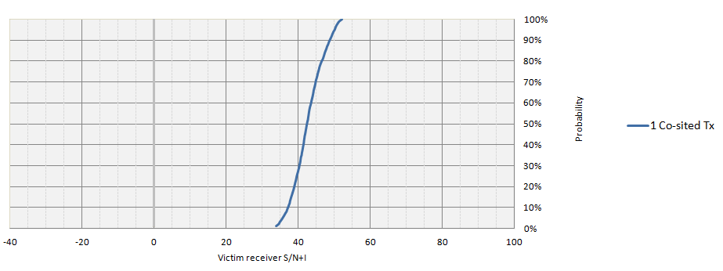

However, simulations also included investigation of application of a nominal interference threshold of 1%, as a sensitivity comparison.

Table 1 on the following page presents a summary of the simulated performance of all scenarios, and shows that the potential for interference is negligible for all but one case (which is readily resolved by base-station filtering equipment):

| ***Deployment Scenario*** | ***System Characteristics*** | ***Guard-band offset (MHz)*** | ***Simulation Case*** | ***Minimum SINR @ 5% probability*** | ***Minimum SINR @ 1% probability*** | ***Conclusions*** |
| --- | --- | --- | --- | --- | --- | --- |
| Co-located base-stations | 3GPP LTE Specifications:  - IMT: 2 x 15 MHz  - PPDR: 2 x 5/10 MHz | 3~11 MHz | Baseline:  - base-station filter roll-off = 40dB@3 MHz | >32 dB | >30 dB | Very good performance due to good antenna-to-antenna isolation |
| Relaxed IMT base-station Tx filter | >32 dB | >30 dB | Very good performance |
| Relaxed PPDR base-station Rx filter | >32 dB | >30 dB | Very good performance |
| Vertical, instead of horizontal antenna separation | >32 dB | >30 dB | Very good performance |
| Non-co-located base-stations | *Single IMT base-station interferer:*  3GPP LTE Specifications:  - IMT: 2 x 15 MHz  - PPDR: 2 x 5/10 MHz | 3~11 MHz | Baseline:  - base-station filter roll-off = 40dB@3 MHz | >22 dB | >13 dB | Good performance |
| Relaxed IMT base-station Tx filter | >22 dB | >13 dB | Good performance |
| Relaxed PPDR base-station Rx filter | >1 dB | > 3 dB for ≥ 5 MHz gap | Adequate performance |
| < 0 dB for ≤ 4 MHz gap | Poor performance |
| Vertical antenna separation | >23 dB | >15 dB | Good performance |
| *2~4 IMT base-station interferers:*  3GPP LTE Specifications:  - IMT: 2 x 15 MHz  - PPDR: 2 x 5/10 MHz | 3~11 MHz | Baseline:  - base-station filter roll-off = 40dB@3 MHz | >14 dB | >5 dB | Good to adequate performance |
| Relaxed IMT base-station Tx filter | >14 dB | >7 dB | Good to adequate performance |
| Relaxed PPDR base-station Rx filter | >5 dB for 5+ MHz | > 3 dB for 6+ MHz | Adequate performance |
| <0 dB for 3 & some 4 MHz gap cases | < 0 dB for 3, 4 & some 5 MHz gap cases | Some instances of poor performance |
| Vertical antenna separation | >15 dB | >6 dB | Good to adequate performance |
| UE to UE interference | *One surrounding PPDR UE interferer*:  3GPP LTE Specifications:  - IMT: 2 x 15 MHz  - PPDR: 2 x 5/10 MHz | 3~11 MHz | Baseline:  - UE filter roll-off = 20dB@3 MHz | >24 dB | >20 dB | Very good performance |
| Relaxed UE Rx filter performance | >24 dB | > 9 dB | Very good to adequate performance |
| Increased density of interfering UEs | >23 dB | >10 dB | Very good to good performance |
| *2 - 4 surrounding PPDR UE interferers*:  3GPP LTE Specifications:  - IMT: 2 x 15 MHz  - PPDR: 2 x 5/10 MHz | 3~11 MHz | Baseline:  - UE filter roll-off = 20dB@3 MHz | >22 dB | >7 dB | Very good to adequate performance |
| Relaxed UE Rx filter performance | >15 dB | > 2 dB for ≥ 5 MHz gap | Good to Adequate performance |
|  | < 0 dB for some 3 and 4 PPDR UE cases with 3 and 4 MHz gap | Some instances of poor performance |
| Increased density of interfering UEs | >14 dB | >1 dB | Good to adequate performance |

**Table 1: Summary of Telstra Monte Carlo Simulation Results**

Note that only in the extreme cases of a *relaxed* victim Rx filter selectivity – 20dB@3MHz for PPDR base-station receivers, and 10dB@3MHz for IMT UEs – and a non-co-located situation (with guard-band offset of 3~4 MHz) – is the SINR found to be insufficient to protect a victim receiver. While this result highlights the need for *reasonable* protective filtering, we also note that such filtering is:

1. easily implemented at base-station sites - since physical space is usually available, and the minimum filter performance (40dB@ 3MHz offset) is not unduly challenging; and
2. less stringent than minimum UE selectivity objectives defined by 3GPP specifications.

# Conclusions and Recommendations

The results compare receive ‘wanted’ power in the full channel bandwidth of a victim receiver with the received ‘umwanted’ interference also received over the full channel bandwidth. This was done for various arrangements of BS and density of user devices (UEs), and for a range of guard-band offsets and filter characteristics.

Clearly, if *reasonable* filtering[12] is implemented within base-station and UE receivers, then a guard-band of 3 MHz offers *sufficient* protection against interference between LTE-700 systems operating below 803 MHz and PPDR-LTE systems operating above 806 MHz.

Note that further simulations have also shown that increasing the guard-band offset to 4 MHz would provide sufficient protection against interference for a probability objective of less than 1%.

On the basis of this guard-band recommendation, and recognising current **3GPP** activity in relation to defining a **Band #27** (806-824/851-869 MHz), then several LTE channel *structural options* become apparent:

Case A: *Legacy narrowband PPDR systems occupy* ***lower*** *(806-809/851-854 MHz) blocks*

806 MHz

809

854

851 MHz

803

849

824 MHz

869 MHz

*5~15 MHz LTE Chans*

*5~15 MHz LTE Chans*

*LTE PPDR Application?*

*APac 700*

*Band 5*

*Band 5*

Case B: *Legacy narrowband PPDR systems occupy* ***upper*** *(821-824/866-869 MHz) blocks*

*Band 5*

806 MHz

821

866

851 MHz

803

849

824 MHz

869 MHz

*5~15 MHz LTE Chans*

*5~15 MHz LTE Chans*

*LTE PPDR Application?*

*APac 700*

*Band 5*

To provide administrations with maximum spectrum planning flexibility, it seems logical to further suggest that APT consider the proposed 3GPP Band 27 (**806-824/851-869 MHz**) be identified for purposes of deploying IMT – and more specifically for deploying LTE systems that can be used for ***harmonised* hosting of PPDR applications throughout Region 3** – and preferably on a more extensive *global* basis.

# Graphical Presentation of Results

The following graphical summary of Monte Carlo simulation results illustrates the conclusions sumarised in the preceding section:

Scenario A: Co-located base-stations

At >32 dB, the 5% probability SINR is relatively good, and the results indicate that it:

* + is **insensitive** to a decrease in guard-band offset
  + is **insensitive** to a modest degradation in the base-station Rx filter performance
  + is **insensitive** to whether co-located antennas are separated vertically or horizontally.

Thus, for the case of co-located base-stations (where bore-sight alignment of antennas is not possible), sufficient isolation can be achieved through nominal protective filtering and reasonable (>2m) separation of antennas – even for a 3 MHz guard-band between systems.

Scenario B: Non co-located base-stations

At around 20dB, for a guard-band offset of 3~4 MHz or more, the 5% probability SINR presents no significant impact. But, the results suggest that SINR is:

* + **degraded moderately** by a decrease in guard-band offset
  + **degraded significantly** by a degradation in the base-station Rx filter performance
  + **insensitive** to a small change (30 m to 28.3 m) in the vertical height of the interfering LTE 700 MHz BS antennae – although, differential antenna elevations noticeably reduces the *likelihood* of bore-sight coupling. [*The victim LTE 800 MHz BS antenna height was held constant at 30 m.*]

Thus, some degree of co-ordination may be required between IMT and PPDR base-stations, to avoid bore-sight alignment of high-gain antennas. It is further apparent that reasonably good filter performance (roll-off = 40dB@3MHz) is also necessary to avoid interference. But a minimum guard-band of 4 MHz would appear to be sufficient.

Scenario C: UE-to-UE interference

At around 22 dB for the single-interferer case, the 5% probability SINR is:

* **insensitive** to a decrease in guard-band offset in the baseline case
* **insensitive** in the one interfering UE case when the UE Rx filter performance is degraded
* **insensitive** in the one interfering UE case for the case of greater interfering UE density
* **progressively** **degraded** as the guard-band offset is reduced in the case of lower UE Rx filter roll-off
* is **progressively** **degraded** as the guard-band offset decreases for the case of greater interfering UE density.

These results indicate that, while only the LTE-700 user device may be affected in certain situations (and noting no impact on the PPDR-LTE user devices):

* UE receive filters should provide a minimum band-edge roll-off performance of 20dB@3MHz offset to achieve satisfactory operations with a 3 MHz guard-band;
* LTE-700 UEs are only affected in the case of many PPDR UEs being used simultaneously in close proximity; and
* Even in the presence of multiple active PPDR UEs, if the LTE-700 UE SINR remains above threshold, there will be no discernable degration of performance.

# Annex 8 – Telecom NZ/Telstra Deterministic Studies

# Introduction

At the 11th meeting of the APT Wireless Group (AWG-11), consensus was achieved in relation to the Region 3 channel plan and duplex arrangement for LTE services in the 700 MHz band (698 - 806 MHz). The 3GPP has subsequently (Jun, 2012) finalised the implementation and co-existence parameters for this band now designated as Band #28 (FDD) and Band #44 (TDD).

While the lower-800 MHz band (806-824 MHz) is currently used by a variety of Fixed and Mobile Services, including low-capacity fixed links, and narrowband analogue and digital Land Mobile Systems (LMS), a growing number of countries are considering this band for deployment of mobile broadband systems including future PPDR (Public Protection & Disaster Relief) applications. Depending on prevailing spectrum arrangements in each country, narrowband LMS are expected to continue operating within a portion of the band at least for some transitional period, and will thus co-exist alongside mobile broadband systems. These legacy narrowband LMS may be located either above or below the mobile broadband systems, depending on current spectrum arrangements.

At previous AWG meetings, several studies[13] were presented in regard to adjacent-band co-existence of narrowband PPDR and mobile broadband systems, as a part of the development of the final Region 3 ‘digital dividend’ band plan. These studies also considered sharing between mobile and the fixed services that currently use the 800 MHz band. These studies generally concluded that a minimum guard band of 3 MHz (803-806 MHz) was sufficient between the upper edge of future 700 MHz LTE mobile broadband systems and the lower edge of existing 800 MHz fixed and mobile systems.

# Objective & Key Conclusions

The purpose of this contribution is to present the results of studies specifically addressing the co-existence of 700 MHz LTE mobile broadband systems with 800 MHz LTE mobile broadband systems potentially serving PPDR applications. Specifically, a deterministic study of the potential for interference caused by 700 MHz LTE base-station transmitters (downlink) into the 800 MHz LTE PPDR base-station receivers (uplink) is presented as typical of a worst case scenario. The particular deployment scenario addressed comprises a 700 MHz LTE system with upper edge of a 5 MHz or 20 MHz channel at 803 MHz, and 800 MHz LTE (PPDR) system with lower edge of a 10 MHz channel at 809 MHz – that is, a 4 MHz guard-band offset between the systems. These studies have concluded that the minimum coupling loss (MCL) for co-existence can be readily achieved by use of modest base-station duplexing filters that vendors consider to be practically feasible and can be realised using current filtering technologies.

It should be further noted that the results of these deterministic studies agree very closely with independent studies recently completed by 3GPP[14] – although, to improve co-existence with existing Band #5, 3GPP decided that the lower-edge of the new lower-800 MHz band (Band #27) should be shifted upwards by 1 MHz to cover the 807-824/852-869 MHz spectrum segments. This adjustment will logically result in a 4 MHz lower guard-band further improving co-existence between 700 MHz LTE mobile broadband systems and 800MHz LTE (PPDR) mobile broadband systems operating within Band #27.

# Proposal

To reflect the important conclusions of these studies, it is therefore proposed that the text in Annex A to this contribution be included within the relevant section (possibly as part of a new section 5) of the ***APT Report on PPDR Applications using IMT-based Technologies and Networks*** (AWG-12/OUT-17) currently being developed by the AWG.

ANNEX A: proposed new Section – *APT Report on PPDR Applications using IMT-based Technologies and Networks* (AWG-12/OUT-17)

**Co-existence of Band 28 (700 MHz) and Band 27 (800 MHz) IMT Systems**

**Relevant Sharing Scenarios**

The two bands of relevance to mobile broadband co-existence studies addressed in this section are:

* 3GPP Band 28 - being a FDD structure, comprised of the blocks 703 -748 MHz (uplink) and 758-803 MHz (downlink); and
* 3GPP Band 27 – also a FDD structure, comprised of the blocks 807-824 MHz (uplink) and 852-869 MHz (downlink.

3GPP Band 28

703

748

758

803

3GPP Band 27

807

824

852

869

**Figure X.1 Relevant Bands for Mobile Broadband Co-existence**

For satisfactory co-existence (same geographic area) or co-location of a Band 28 base-station with a Band 27 (PPDR) base-station the following sharing criteria must be met.

1. The out-of-band emissions of a Band 28 base-station transmitter should not cause unacceptable degradation of a Band 27 base-station receiver;
2. The spurious emissions of a Band 28 base-station should not cause unacceptable desensitization of a Band 27 base-station receiver; and
3. The total carrier power of a Band 28 base-station transmitter should sufficiently attenuated by the Band 27 receiver RF filter (and any other filters, such as IF filters) to avoid blocking effects.

Clearly, criteria 1 and 2 impose requirements on the Band 28 base-station transmitter in regard to OOB and spurious emissions. However, criteria 3 imposes requirements on the Band 27 receive filter rejection (selectivity) performance.

Taking account of the minimum equipment performance specifications provided by 3GPP Technical Specifications (3GPP TS 36.104), the Minimum Coupling Loss (MCL) necessary to meet the above three key criteria can be readily determined. This MCL objective is then achieved by a combination of filtering equipment (such as duplexing and other site filtering) and any specific deployment arrangements aimed at minimizing interference risks.

**Key Parameters for Co-existence**

The 3GPP Technical Specification TS 36.104 and 3GPP Technical Report TS 36.820 defines the following key parameters relevant to ensuring satisfactory co-existence:

1. ACLR1 and ACLR2 = -45dBc
2. Base-station spurious emissions, in the same geographic area as base-stations operating in other frequency bands (such as Band 27) = -49 dBm/ MHz (TR 36.820 V11.0- 7.2.1)
3. Base-station transmitter PA OOB emissions = -13 dBm/MHz (for multi-standard base-stations). This is a worst-case value for systems operating below 1 GHz that have a higher OOB emission (ie. Category A).
4. Receiver desensitization: wanted-to-unwanted interfering signal in a Band 27 base-station receiver suffering 6dB sensitivity degradation = -52 dBm (for ACS), or -43 dBm (for in-band blocking). A more realistic assumption is 1dB desensitization of the victim receiver, resulting in wanted-to-unwanted ratio = -63dBm, and -54 dBm, respectively ( 3GPP TR 36.820 V11.0 sec 7.2.1)

**Interference Mechanisms**

Referring to Figure X.1 above, the key interference mechanisms that must be considered are:

1. Band 28 LTE base-station transmitter impacting on the Band 27 LTE (PPDR) base-station receiver; and
2. Band 27 LTE (PPDR) UE (or mobile device) transmitter impacting on a (nearby) Band 28 LTE UE receiver.

In the case of 2), there are statistical analyses that suggest the likelihood of such interaction is not common, and may even be considered a rare occurrence due to the involvement of a number of statistical parameters and scenarios. Therefore, this contribution specifically focuses only on the first interaction.

Investigation of co-existence between systems is usually undertaken by considering each aspect separately, and determining their relative impact:

Tx OOB zone

Tx Spurious zone

Rx

Tx

Rx channel

**Figure X.2 Interactions between Interferer Tx and Victim Rx**

The usual approach is to sequentially evaluate the worst-case required MCL value:

* The level of Tx emissions falling into the Rx channel bandwidth, due to
  + OOB emissions from the Tx; and
  + Minimum ACLR requirement of the Tx
* The victim Rx sensitivity degradation due to OOB and spurious emissions from the Tx; and
* The level of Rx blocking arising as a result of victim Rx ACS performance.

The following sub-sections present a deterministic evaluation of these scenarios, to determine the worst-case required MCL and the consequent site filtering requirements to avoid interference impacts.

**Reference System Configurations**

For the purposes of this analysis, the following system configurations are assumed:

* Band 28 LTE Interferer system:
  + Case 1: 20 MHz LTE carrier with upper edge at 803 MHz
  + Case 2: 5 MHz LTE carrier with upper edge at 803 MHz
* Band 27 LTE (PPDR) system:
  + 10 MHz LTE carrier with lower edge at 809 MHz

Interference contributions by the Band 28 LTE base-station transmitter arise from OOB and spurious emissions, depending on the relative offset of the Band 27 LTE (PPDR) receiver. According to ITU-R Rec. SM.329, the nominal OOB domain boundary occurs at an offset of 250% of channel bandwidth measured from the carrier centre. However, 3GPP has imposed more stringent requirements on IMT emissions performance (for channel bandwidths of 5-20 MHz) by defining the OOB domain boundary at an offset of 10 MHz from the carrier edge, beyond which the spurious emission limits shall apply. These parameters are shown in Figure X.3:

793

*SM.329 OOB domain = 250% channel width, measured from centre frequency (50 MHz)*

783

803

809

814

819

*700 MHz LTE Tx*

*800 MHz LTE Rx*

*813*

806

*3GPP OOB domain*

*813*

*SM.329 OOB domain (12.5 MHz)*

800.5

798

803

806

809

814

819

*800 MHz LTE Rx*

*700 MHz LTE Tx*

*3GPP OOB domain*

**Figure X.3 Reference System Configurations**

It can be readily seen that Band 28 OOB emissions will fall within the lower portion (809-813 MHz) of the 800 MHz LTE (PPDR) base-station receiver channel, while the spurious emissions limits will apply to the upper portion (813-819 MHz) of the receiver channel, for *both* cases above (ie. 20 MHz and 5 MHz LTE carriers in Band 28 will exhibit similar OOB emissions).

**Determining Worst-case OOB emissions**

The OOB emissions of the LTE BS transmitters are defined in terms of an ACLR parameter. The ACLR 1 and ACLR 2 parameters apply to the first and second adjacent channels respectively. The 3GPP technical specification TS 36.104 v10.7 (section 6.6.2.1) defines two criteria for ACLR, and the resulting OOB emissions will be the worst-case value of the two:

Criteria #1: -13 dBm/MHz (Category A), or

Criteria #2: -45 dBc (for both ACLR1 and ACLR2)

The ACLR offsets are equal to the bandwidth of the assigned transmit channel, as illustrated in the following Figure:

*f*c

*f*c + BW

fc + 2 BW

*1st adj chan*

*2nd adj chan*

*ACLR1 = -45 dBc*

*ACLR2 = -45 dBc*

BW

Figure X.4 - ACLR Definition

The determination of OOB emission levels proceeds as follows:

*ACLR Criteria 1*: = -13 dBm/MHz

*ACLR Criteria 2*:

BS Output Power = 40 W (+46 dBm)

⇒ PSD of 20 MHz LTE carrier = 33 dBm/MHz

and PSD of 5 MHz LTE carrier = 39 dBm/MHz

Maximum ACLR1/ACLR2 = -45 dBc

⇒ unwanted OOB Emissions (case 1: 20 MHz) = -12 dBm/MHz

⇒ unwanted OOB Emissions (case 2: 5 MHz) = -6 dBm/MHz

Therefore, the worst-case unwanted OOB level is determined by ACLR Criteria 2 - which suggests that the total unwanted OOB emissions falling within an adjacent 10 MHz LTE (PPDR) channel might be:

Case 1: 20 MHz LTE interferer = -2 dBm/10MHz

Case 2: 5 MHz LTE interferer = +4 dBm/10MHz

It is particularly notable that the *narrower* 5 MHz LTE case results in *higher* OOB emissions, than the case of a 20 MHz LTE carrier – due to the transmitter power being concentrated within a smaller bandwidth.

However, it should also be noted that where a *guard-band offset* is also interposed between the interferer and victim channels, the OOB emissions will typically not cover the entire victim bandwidth.

**Sensitivity Degradation of PPDR BS receivers**

In addition, analysis of the impact of OOB emissions from a Band 28 LTE base-station on the sensitivity of Band 27 LTE (PPDR) BS receivers was undertaken. Typical engineering practice seeks to ensure that any interference should be at least 10 dB below the victim receiver noise floor – that is, a minimum I/N ratio of -10 dB. This criterion is adopted below to derive a minimum coupling loss (MCL) requirement. In the following analysis, the OOB domain is assumed to extend over the entirety of the victim receiver channel, in accordance with ITU-R SM.329 – thus, represents a worst-case analysis:

*20 MHz Band 28 LTE transmitter impact on a 10 MHz Band 27 LTE (PPDR) receiver*

Let:

Relative interference level (I/N) = -10 dB

Victim Rx BW = 10 MHz

Victim Rx Noise Figure = 5 dB

Noise floor = KTB + NF

= -174 + 10.log10 (10 MHz) + 5

= -99 dBm

⇒ max allowable interference level = -109 dBm (10 dB below noise floor)

Worst-case OOB emission level = -12 dBm/MHz

for a 10 MHz victim channel = -2 dBm/10 MHz

⇒ minimum coupling loss (MCL) = -2 - -109

= 107 dB for a victim 10 MHz LTE (PPDR) Rx

Now, the deployment conditions must be considered to determine what portion of this MCL can be ascribed to deployment isolation, and what portion must be met by site filtering:

Assume two deployment scenarios:

Scenario 1: Both LTE systems are co-located on the same tower; and

Scenario 2: Respective LTE systems occupy distinct site locations.

*Scenario 1 Co-located base-stations*

Assume a typical net isolation figure of 60 dB for vertically-separated antennas, and feeder losses (FL) of 2 dB:

Isolation = Antenna isolation + FL (PPDR) + FL (LTE)

= 60 + 2 +2 dB

Target MCL = 107 dB

⇒ isolation shortfall = 43 dB

This shortfall of 43 dB must be provided by implementation of suitable duplexing/coupling filters at the Band 28 LTE base-station transmitter.

*Scenario 2 Distinct base-station sites in the same geographic area.*

In this scenario, we also assume a worst-case situation of the two sites directly ‘pointing’ towards each other, and each employing an antenna with a gain of 15 dBi.

The MCL is determined by considering:

MCL = + FL(LTE) – Ant Gain LTE + Pathloss – Ant Gain (PPDR) + FL (PPDR

= +2 -15 + Pathloss -15+2 dB

⇒ MCL = PL -26 dB

Solving for Pathloss: Pathloss = MCL +26

= 107 +26 - for a target MCL = 107 dB

= 133 dB

The above MCL value for Scenario 2 is comprised of a path loss and any additional rejection provided by the duplexing filters.

Assuming base-station filters provide rejection of the order of 43 dB, then the minimum residual required path loss will be 91 dB (that is: 133 dB - 43 dB). For a perfectly clear environment (free-space, over smooth earth), at 809MHz, this path loss equates to about 1.06 km physical separation between BSs. In practice, there urban building clutter, or rural foliage and natural terrain obstructions will arise – so the realistic separation distances will be significantly lower – around just a few hundred metres or so. **Following usual practices, specific co-ordination of base-station siting, taking account of local conditions and terrain, must be undertaken in all cases**.

But, from the above calculations it can be generally concluded that, to achieve acceptable co-existence between a 20 MHz Band 28 LTE system and a 10MHz Band 27 LTE (PPDR) system, site filtering (duplexer/coupling) should provide 43 dB of isolation as a minimum.

*5 MHz Band 28 LTE transmitter impact on a 10 MHz Band 27 LTE (PPDR) receiver*

In contrast, if the Band 28 LTE base-station transmitter is configured for a 5 MHz LTE carrier abutting the 803 MHz band edge, then according to ITU-R Rec.329, the OOB domain extends to 813 MHz with the spurious domain beyond. Under that definition, the complete emission domain includes consideration of the spurious domain. Specifically:

* The OOB emission domain (per SM.329) applies between 809 and 813 MHz which is 4 MHz of the bottom 10 MHz PPDR channel)
* The spurious domain(as per SM.329) applies between 813 and 819 MHz which is the remaining 6 MHz of the bottom 10 MHz PPDR channel)

However, achieving the OOB emission limits is usually the more challenging, simply because it lies adjacent to the main emission bandwidth - and experience to date confirms that if the OOB limits are met, then the spurious emission limits will typically also be met. Nonetheless, the calculations for each of the OOB and spurious contributions for each scenario are summarized below:

*OOB Domain Calculation (for 4MHz bandwidth window: 809-813MHz)*

Let:

Relative interference level (I/N) = -10 dB

Victim Rx BW portion = 4 MHz

Victim Rx Noise figure = 5 dB

Noise floor = KTB + NF

= -174 + 10.log10(4 MHz) + 5

= -103 dBm

⇒ max allowable interference level = -113 dBm (10 dB below noise floor)

Worst-case OOB emission level = -6 dBm /MHz

for a 4 MHz bandwidth window = 0 dBm /4MHz

⇒ minimum coupling loss (MCL) = 0 - -113

= 113 dB (for 4 MHz Rx b/w window)

*Spurious Domain calculation (for 6MHz bandwidth window: 813-819MHz)*

Spurious requirement(TS 36.104) = -36 dBm/100 kHz (Category B)

for a 6 MHz bandwidth window = -18 dBm/6 MHz

Let:

Relative interfering level (I/N) = -10 dB

Victim Rx BW portion = 6 MHz

Victim Rx Noise figure = 5 dB

Noise floor = KTB +NF

= -174 + 10log(6* 10^6) + 5

= -101 dBm

⇒ max allowable interference level = -111 dBm ( 10 dB below noise floor)

Spurious limit = -36 dBm /100 kHz

for a 6MHz bandwidth window = -18 dBm/ 6 MHz

⇒ Spurious MCL = -18 - -111

= 93 dB (for 6 MHz Rx b/w window)

Consistent with experience, the calculated MCL requirement to avoid interference due to spurious emissions (93dB) is clearly seen to be less demanding than that necessary to avoid OOB interference (113dB).

*Note*: UEs that meet only the Category A spurious performance would need a more stringent MCL, since a higher level of spurious emissions is allowed (-13dBm/100kHz). However, it is expected that the majority of UEs, designed for global markets, will meet or better the Category B spurious performance objective.

*Summary of MCL results*



Achieving the MCL objectives determined in the preceding sub-sections will rely on a combined effect of: i) the OOB and spurious rejection performance of the Band 28 base-station duplexer filter; and ii) the attenuation attributable to site deployment arrangements.

* For example, in the case of co-sited base-stations where relevant antennas are vertically separated, an incremental 60dB contribution towards the MCL can usually be achieved without difficulty.

In addition, global base-station equipment vendors have indicated that filtering performance in the order 50dB can be expected for Band 28 LTE transmitters, at an offset of 3 MHz from the channel upper edge. This advice also assumes a 200kHz drift allowance for environmental and manufacturing variations. Therefore, the total isolation requirements (MCL) achievable by base-station filter rejection and antenna isolation is clearly comparable with the MCL objectives determined above.

Note that in the case of horizontally separated antennas, isolation values of *at least* 30dB are typically achieved.

Where the relevant base-stations are located at distinct sites (within the same general geographic area), and where main-beam coupling of antennas could arise, the combination of Band 28 LTE transmit filter rejection and sufficient physical separation of the sites will combine to achieve the MCL objective. The actual minimum site separation distance required to achieve the MCL objective is likely to vary with actual environment, as local topographic and clutter information is taken into account.

**Implication of 3GPP Spurious Emissions Limit**

The 3GPP Technical Specification TS 36.104 defines the base-station co-existence spurious emissions limit, for base-stations in other frequency bands, to be -49 dBm/ MHz – and this will fall within the uplink block of the Band 27 base-station. The required MCL to meet this requirement can be readily calculated and is shown below for 1dB degradation in receiver sensitivity.

|  |  |  |  |
| --- | --- | --- | --- |
| Thermal Noise Power Density | dBm/Hz | -174 | -174 |
| Band 27 Rx Noise Figure | dB | 5 | 5 |
| **Band 27 channel bandwidth** | **MHz** | **5** | **10** |
| Band 27 noise bandwidth | MHz | 4.5 | 9 |
| ⇒ Band 27 Rx noise floor | dBm | -102.47 | -99.46 |
| Band 28 Tx spurious emissions limit | dBm/MHz | -49 | -49 |
| ⇒ interference level in Rx bandwidth | dBm | -42.5 | -39.5 |
| Max interference for 1dB Rx degradation | dBm | -108.47 | -105.46 |
| ⇒ **resulting MCL objective** | **dB** | **66** | **66** |
| Resulting Rx Interference + Noise level | dBm | -101.47 | -98.46 |
| ⇒actual Rx sensitivity degradation | dB | 1.0 | 1.0 |

These MCL values are, again, considerably less than the corresponding MCL values associated with OOB emissions due to the ACLR performance requirement. As such, if satisfactory co-existence can be demonstrated in relation to the maximum ACLR performance, the MCL objective will obviously be easily met in the case of spurious emissions. That is, if the PA output is designed to ensure a maximum OOB emission level of -13dBm/MHz (and competitive *real* equipment will typically be considerably better than this), and the duplexer filter OOB attenuation is 50 dB (or more) to ensure ACLR emissions falling within Band 27 meet 3GPP co-existence specifications, then the net spurious emissions will considerably lower than the maximum specified level of -49dBm/MHz.

**Implications of 3GPP Rx Blocking Criterion**

Turning to the 3GPP base-station receiver blocking requirements, calculation of the required Rx filter selectivity in order to avoid Band 27 receiver degradation due to Band 28 base-station transmitter power is illustrated below. In this case, the 3GPP specifications for Band 27 receiver minimum ACS performance (for 1dB sensitivity degradation) is defined to be -63 dBm, and the minimum in-band blocking immunity is -54 dBm. These parameters are then used to derive the Band 27 Rx filter performance objectives.

***Receiver ACS aspect:***

|  |  |  |
| --- | --- | --- |
| Thermal noise power density | dBm/Hz | -174 |
| Band 27 Rx Noise Figure | dB | 5 |
| Band 27 Rx channel bandwidth | MHz | 5 |
| Band 27 Rx Noise bandwidth | MHz | 4.5 |
| ⇒ Band 27 Rx Noise floor | dBm | -102.47 |
| Allowable interference level for 1dB Rx degradation | dBm | -108.47 |
| Interfering signal power ACS | dBm | -63 |
| **⇒ min Rx duplexer filter rejection** | **dB** | **45.47** |
| and **overall MCL objective**\* | **dB** | **109** |

*Assuming Band 28 Tx Power = +46dBm (ie. +46 – –63 = 109)

These filter rejection values are also valid for 10 MHz PPDR systems, as the ACS is defined for a reference bandwidth, therefore allowing the absolute level to be calculated for the 5 or 10 MHz bandwidth.

***Receiver blocking aspect***:

|  |  |  |
| --- | --- | --- |
| Thermal noise power density | dBm/Hz | -174 |
| Band 27 Rx Noise Figure | dB | 5 |
| Band 27 Rx channel bandwidth | MHz | 5 |
| Band 27 Rx noise bandwidth | MHZ | 4.5 |
| ⇒ Band 27 Rx Noise floor | dBm | -102.47 |
| Allowable interference level for 1dB Rx degradation | dBm | -108.47 |
| ⇒ Interfering signal power (in band) | dBm | -54 |
| **⇒ min Rx duplexer filter rejection** | **dBm** | **54.47** |
| **and overall MCL objective\*** | **dB** | **100** |

*Assuming Band 28 Tx Power = +46dBm (ie. +46 – –54 = 100)

Global base-station equipment vendors have indicated that typical receive filters can achieve >70dB rejection performance. Therefore, the above filter objectives associated with assuring Rx selectivity and blocking immunity performance would appear to be easily met.

**Conclusions**

The deterministic studies summarised in this contribution therefore conclude that Band 28 (700 MHz) LTE base-station transmitter can comfortably co-exist with Band 27 (800 MHz) LTE (PPDR) base-station receivers, where the lower edge of the PPDR channel is 809 MHz or higher. Satisfactory co-existence is primarily determined by the Band 28 (700 MHz) transmitter ACLR performance, and the associated MCL objective consists of a duplexing filter OOB rejection of around 50dB (or better) at 4 MHz offset, along with relatively modest deployment-based isolation (vertical antenna separation, or use of separate sites). Vendors have indicated that filters providing such performance are available today, and that co-existence of Band 28 and Band 27 systems can thus be readily achieved.

**Appendix Detailed Calculations**



# Annex 9- Studies from China on Digital Trunking coexistence with IMT

# Introduction

In China, the services operating in bands above 806 MHz are the GSM-based digital trunked mobile communication system (GT800) and the CDMA-based digital trunked mobile communication system (GOTA) as well as iDEN and TETRA.

This study considers the interference between IMT and GSM-based digital trunked mobile communication system (GT800)/ CDMA-based digital trunked mobile communication system (GOTA). In this report, IMT is mainly refers to LTE.

The following four cases were studied:

1. A: interference from a digital trunked mobile UE transmitter operating above 806 MHz to an IMT UE receiver operating in band 44 (scenario (c) in AWG-13/TEMP-39).
2. B: interference from an IMT BS transmitter in band 44 to a digital trunked mobile BS receiver operating above 803 MHz (scenario (d) in AWG-13/TEMP-39).
3. C: interference from a digital trunked mobile UE transmitter operating above 803 MHz to an IMT BS receiver operating below 803MHz (new defined scenario (k) for AWG-13/TEMP-39).
4. D: interference from an IMT UE transmitter in band 44 to a digital trunked mobile BS receiver operating above 803 MHz (new defined scenario (l) for AWG-13/TEMP-39).

The following figure shows the interference scenarios between IMT and digital trunked systems.

IMT BS

case B

case *A*

IMT UE

Trunked BS

case *D*

case *C*

Trunked UE

Figure 1: Interference Scenarios between digital trunked mobile communication system and IMT

# Parameters & Methodology

# Sharing Parameters

# IMT system

The parameters of IMT system are mainly chosen from 3GPP standard, the density of the active users is refers to Annex 2 of the last ITU-R JTG5-6 Chairman's Report. The main parameters are summarized as follows:

Table 1 IMT Parameters

| Parameters | BS | UE |
| --- | --- | --- |
| Duplex mode | FDD/TDD | |
| Maximum spectral power density, dB(mW/Hz) | −23 | −42.5 |
| Transmitter e.i.r.p. (dBm) | 55 | 23 |
| Typical height of the transmitting antenna (m) | 30 | 1.5 |
| Transmitting antenna type (sectorized/omnidirectional) | 3 sectors | Omni |
| Transmitting antenna gain, dBi | 15 | 0 |
| Feeder loss (dB) | 3 | 0 |
| Antenna down tilt | 3° | -- |
| Channel bandwidth (MHz)[15] | 5 | 5 |
| Power control range (dB) | 20 | 60 |
| density of the active users (number per km2) | Urban/In-building : 18 | |
| density of user equipments (number per km2) simultaneously operating in a 5 MHz bandwidth | Urban = 3 (Freq reuse=1) | |
| Coverage radius | Urban: 0.5 km | |

# The GSM-based Digital Trunked Mobile Communication System (GT800)

The GSM-based digital trunked mobile communication system (GT800) is based on GSM system, the bandwidth of GT800 is 200 kHz. The following table provides the parameters of the GT800 systems which are adopted according to YDC 030-2004.

Table 2 GT800 parameters

|  |  |  |
| --- | --- | --- |
| BS | | |
| **Parameters** | **Requirement** | **Description** |
| **transmitter nominal power** | 2.5W~640W | divided into 8 power levels |
| sub-carrier | 200KHz |  |
| **Typical height of the transmitting antenna** | 60m |  |
| **Maximum adjacent power levels** | -57dBc | Frequency offset ：400KHz |
| -67dBc | Frequency offset ：600KHz |
| -74dBc | Frequency offset ：1200KHz |
| -74dBc | Frequency offset ：1800KHz |
| **Discrete spurious** | ≤－36dBm/100KHz | 9KHz～1GHz |
| ≤－30dBm/1MHz | 1～12.75GHz |
| **Wideband noise** | -80dBc | 100kHz～250kHz |
| -85dBc | 250kHz～500kHz |
| -90dBc | 500kHz～5frb2 |
| -100dBc | ＞frb |
| **Transmitter intermodulation attenuation** | ≥ 40dB/30KHz | Extra-BS：One transmitter |
| ≥ 70dB/30KHz | Extra -BS：Othere cases |
| ≤-60dBc/30KHz | Intra-BS |
| **Reference sensitivity** | ≤-106 dBm/200KHz |  |
| **Reference interference co-channel（C/Ic）** | 9dB |  |
| **Reference interference adjacent channel（C/Ia）** | -9dB |  |
| **Blocking characteristics** | -26dBm | Frequency offset ： 0KHz～600KHz |
| -16dBm | Frequency offset ：800kHz～3MHz |
| -13dBm | Frequency offset ：＞3MHz |
| 8dBm | Out of Band |
| MS | | |
| **Parameters** | **Requirement** | **Description** |
| **transmitter nominal power** | 39dBm | divided into 4 power levels |
| **Antenna gain** | 0dBi | Omin1 |
| **Typical height of the transmitting antenna** | 1.5m |  |
| **Maximum adjacent power levels** | -30dBc | Frequency offset ：200KHz |
| -33dBc | Frequency offset ：250KHz |
| -60dBc | Frequency offset ：400KHz |
| -60dBc | Frequency offset ：600KHz |
| -60dBc | Frequency offset ：600KHz~1800KHz |
| -63dBc | Frequency offset ：>1800KHz |
| **Discrete spurious** | ≤－36dBm/100KHz | 9KHz～1GHz |
| ≤－30dBm/1MHz | 1～12.75GHz |
| **Wideband noise** | -80dBc | 100kHz～250kHz |
| -85dBc | 250kHz～500kHz |
| -90dBc | 500kHz～5frb2 |
| -100dBc | ＞frb |
| **Transmitter intermodulation attenuation** | ≥ 70dB/30KHz |  |
| **Reference sensitivity** | ≤-102dBm |  |
| **Reference interference co-channel（C/Ic）** | >9dB |  |
| **Reference interference adjacent channel（C/Ia）** | >-9dB | The first adjacent channel |
| >-41dB | The second adjacent channel |
| >-49dB | The third adjacent channel |
| **Blocking characteristics** | -38dBm | Frequency offset ： 600KHz～800KHz |
| -33dBm | Frequency offset ：800kHz～1.6MHz |
| -23dBm | Frequency offset ：1.6MHz～3MHz |
| -23dBm | Frequency offset ：≥3MHz |
| 0dBm | Out of band |

**NOTE:**

1: Antenna gain provided here is in accordance with the reality in China.

2: frb denotes the frequency offset corresponding to the near edge of the received band or 10 MHz whichever is greater.

# The CDMA-based Digital Trunked Mobile Communication System (GOTA)

The CDMA-based digital trunked mobile communication system (GOTA) is based on IS-95 systems, the bandwidth of GOTA is 1.25MHz and the chip rate is 1.228Mcps. The following table provides the parameters of the GOTA system which is adopted according to YDC 031-2004.

Table 3 GOTA parameters

|  |  |  |
| --- | --- | --- |
| BS | | |
| **Parameters** | **Requirement** | **Description** |
| **transmitter nominal power** | 40W | adjustment down 15dB, step is 1dB |
| sub-carrier | 1.25MHz |  |
| **Typical height of the transmitting antenna** | 60m |  |
| **Maximum adjacent power levels** | ≤-45dBc/30KHz | Frequency offset ：750KHz~1.98MHz |
| ≤-60dBc/30KHz | Frequency offset ：1.98MHz~4MHz |
| ≤-13dBm/100KHz | Frequency offset ：≥ 4MHz |
| **Transmitter intermodulation** | -52dBm | Frequency offset：±900KHz, ±1700KHz |
| **Reference sensitivity** | ≤-124 dBm |  |
| **Target CIR** | -17dB |  |
| **Drop of Calls** | CIR < target CIR-0.5dB |  |
| **Blocking characteristics** | -26dBm | Frequency offset ： 0KHz～600KHz |
| -16dBm | Frequency offset ：800kHz～3MHz |
| **Maximum receiving signal level** | -65dBm |  |
| **Noise** | ≤-108dBm/1.23MHz |  |
| MS | | |
| **Parameters** | **Requirement** | **Description** |
| **transmitter nominal power** | 23dBm |  |
| **Antenna gain** | 0dBi | Omin |
| **Typical height of the transmitting antenna** | 1.5m |  |
| **Maximum adjacent power levels**  **Discrete spurious** | ≤-42dBc/30KHz | Frequency offset ：850KHz~1.98MHz |
| ≤-54dBc/30KHz | Frequency offset ：1.98MHz～4MHz |
| ≤-30dBm/100KHz | Frequency offset ：≥ 4MHz |
| **Target CIR** | -15.5dB |  |
| **Drop of Calls** | CIR < target CIR-0.5dB |  |
| **Maximum receiving signal level** | ≥ -25dBm |  |
| **Reference sensitivity** | ≤-104dBm |  |
| **Noise** | ≤-104dBm/1.23MHz |  |
| **Blocking characteristics** | -30dBm | Frequency offset ： 900KHz |

# Sharing analysis methodology

In assessing the interferences between IMT system and GT800/GOTA, the Monte Carlo simulations were employed. The parameters involved in simulation are listed in 2.1. The position of the digital trunked mobile UE transmitter is deployed randomly within a 4km circular area around a central digital trunked base station.

For the cases of IMT interfering digital trunked systems (case B and case D), the base station of digital trunked system is placed at the center of the IMT area. This is the worst case for the interference from IMT to digital trunked system. In this scenario, 19 base stations, which are equivalent to 57 sectors in the IMT system, are considered. The topology is shown in Figure 2, where the separation distance between base station of digital trunked system and the central BS of IMT is increased for 0m to 50m, 100m, 150m, 200m and 250m as indicated by the red broken line. The user density and services model in the IMT system are refer to the Annex 2 of Chairman’s Report in the last ITU-R JTG5-6 meeting (5-6/180).



Figure 2 Topology of IMT Interfering digital trunked system

For the cases of digital trunked system, including GT800 and GOTA, interfering IMT (case A and case C), there are also 19 base stations of IMT system in the topology. IMT system is located at the junction of the coverage of three base stations of digital trunked system, where the base station of digital trunked system has a wider coverage than IMT BS. Because of the power control of the uplink of digital trunked system, the terminals located on the edge of its coverage will transmit at a higher power than any other locations, which result in the worst case for the interference of digital trunked system to the IMT system.

Figure 3 shows the topology of these cases. There are five users in each sector in the IMT system, and all the resources in this sector are allocated evenly among them.



Figure 3 topology of digital trunked system interfering IMT

The propagation model adopted in this report is the same as that used in ITU-R JTG5-6. The propagation model is based on a set of reference parameters, ‘Hata’ model is used for short distances (0 km to 0.1 km), and the Rec. ITU-R P.1546-3 is used for long distances (1.0 km to 1 000 km). A method is used for interpolating between the predictions at 0.1 km and those at 1.0 km, details can be found in the Annex 6 of the last Joint Task Group 5-6 Chairman's Report (Document 5-6/180-E).

The interference mechanisms are illustrated in the following Figures, respectively:

Guard band

Figure12: In-band Interference (ACLR)

Tx

Rx

Tx

Rx

Figure 13: Out-of-band Interference (ACS)

Guard band

The ACLR of a signal is defined as the ratio of the signal’s power (nominally equal to the power over the signal’s pass-band) divided by the power of the signal when measured at the output of a (nominally rectangular) receiver filter centered on an adjacent frequency channel. The ACS of a receiver is defined as the ratio of the receiver’s filter attenuation over its pass-band divided by the receiver’s filter attenuation over an adjacent frequency channel.

The ACIR is a total index to evaluate the interference between two systems. ACIR is defined as the ratio of the power of an adjacent-channel interferer as received at the victim, divided by the interference power “experienced” by the victim receiver as a result of both transmitter and receiver imperfections. ACIR will be derived from ACLR and ACS. ACIR can be calculated via the following expression:



The interference evaluation criteria of the IMT and digital trunked system are different. For IMT system, the capacity loss is under consideration where the capacity loss less than 5% is acceptable. For digital trunked system, the interference from IMT system to GT800 or GOTA base station has to satisfy the reference interference co-channel(C/Ic) and the outage probability under 5% is tolerable.

# Results and outcomes of studies

# Scenario A

# Probabilistic study P7

Taking into account the mobility of terminals, the probability of collision between IMT UE and digital trunked UE is very low. The simulation results are shown in figure 4 and figure 5, the potential interference is negligible for this case.

**Interference between IMT and GT800**

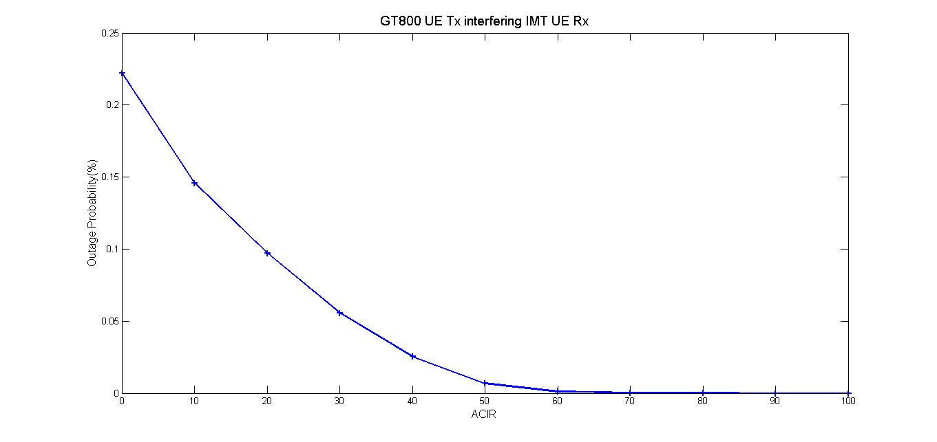

Figure 4 Results of GT800 UE Tx interfering IMT UE Rx

**Interference between IMT and GOTA**

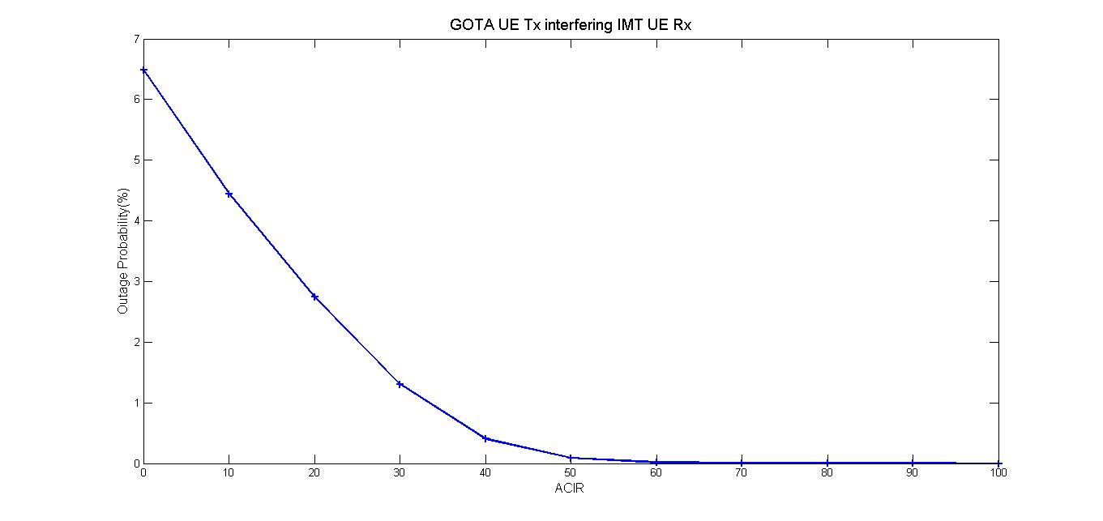

Figure 5 Results of GOTA UE Tx interfering IMT UE Rx

# Scenario B

# Probabilistic study P8

In this scenario, the separation distance between digital trunked base station and the central BS of IMT is increased from 0m to 250m, the step is 50m. Simulation results are shown in figure 6 and figure 7. The most serious interference from IMT BS to the digital trunked base station is occurred when the distance between the BSs is 100m. In order to eliminate the harmful interference, the isolation distance or the guard-band is needed.

**Interference between IMT and GT800**

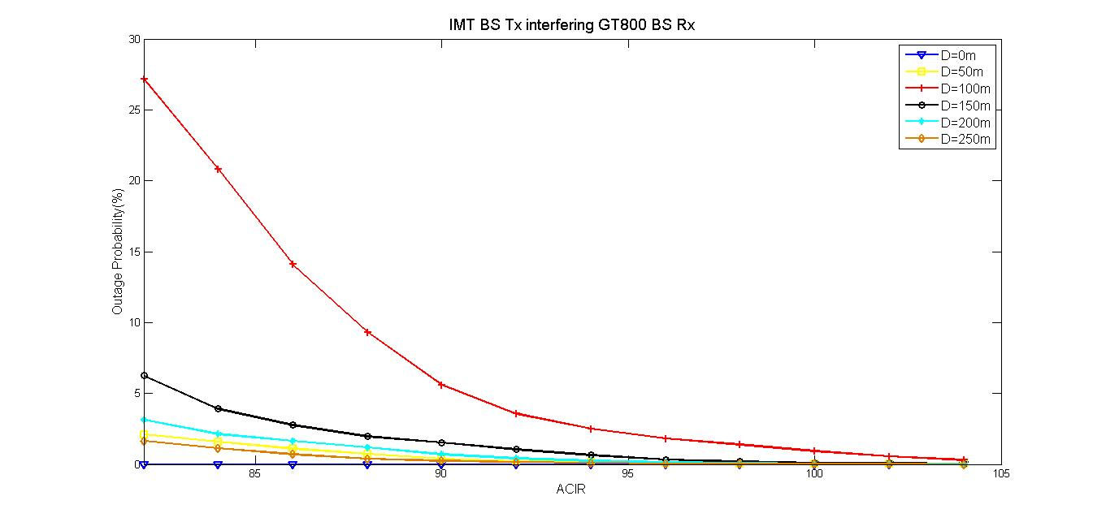

Figure 6 Results of IMT BS Tx interfering GT800 BS Rx

**Interference between IMT and GOTA**

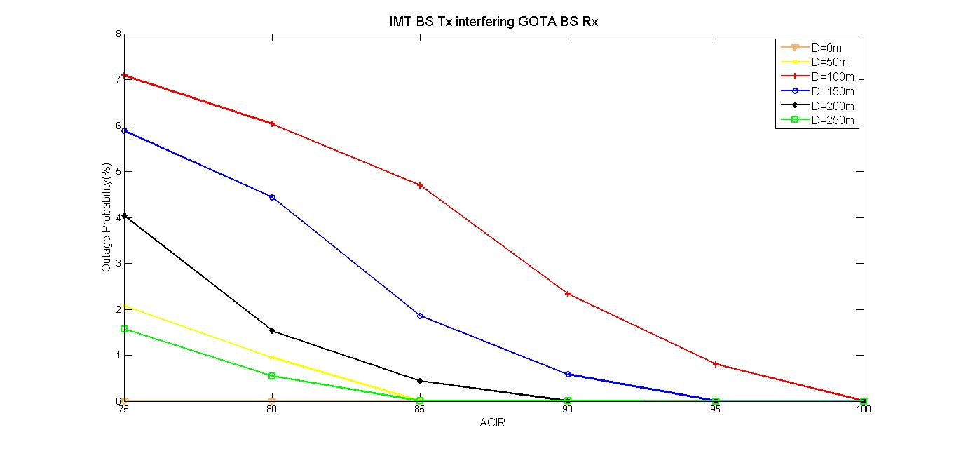

Figure 7 Results of IMT BS Tx interfering GOTA BS Rx

# Scenario C

# Probabilistic study P7

Simulation results indicate that there is a certain degree of interference from GT800/GOTA UE to the base station of LTE. The required ACIR is about 38.5dB for the case of GT800 interfering LTE and about 54.5dB for the case of GOTA interfering LTE, as shown in figure 8 and figure 9.

**Interference between IMT and GT800**

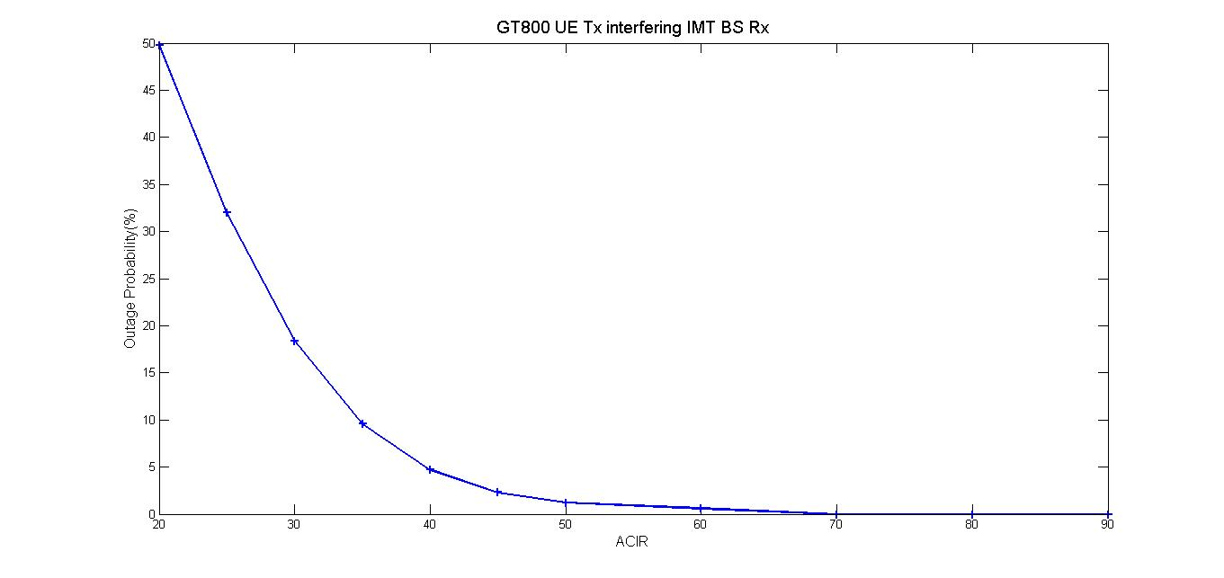

Figure 8 Results of GT800 UE Tx interfering IMT BS Rx

**Interference between IMT and GOTA**

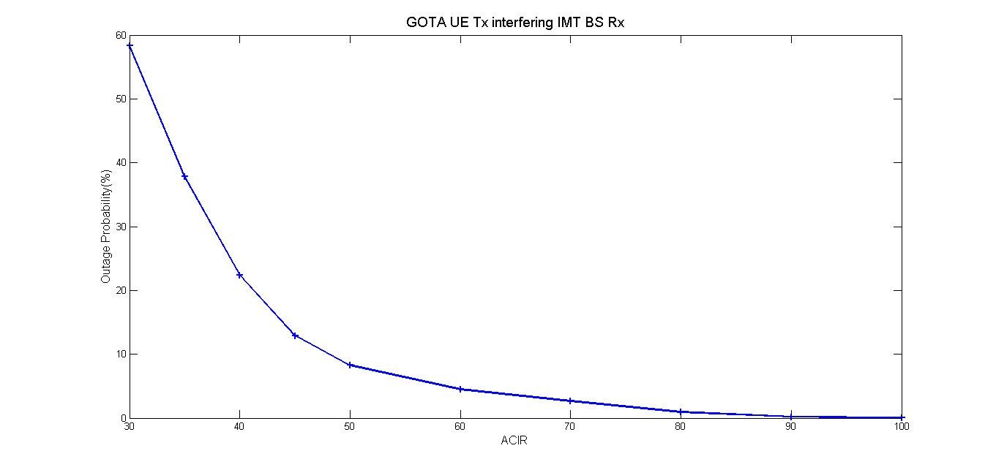

Figure 9 Results of GOTA UE Tx interfering IMT BS Rx

# Scenario D

# Probabilistic study P8

The maximum interference in this scenario occurred when the separation between digital trunked base station and the IMT base station is 100m. The simulation result shown that the interference is negligible in this scenario in case the outage probability less than 5% is acceptable for both GT800 and GOTA.

**Interference between IMT and GT800**

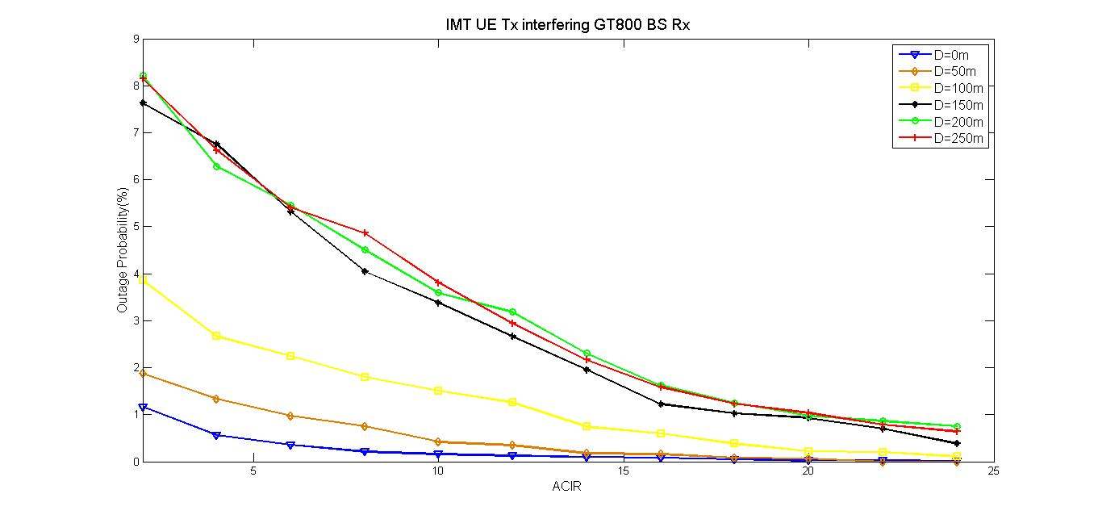

Figure 10 Results of IMT UE Tx interfering GT800 BS Rx

**Interference between IMT and GOTA**

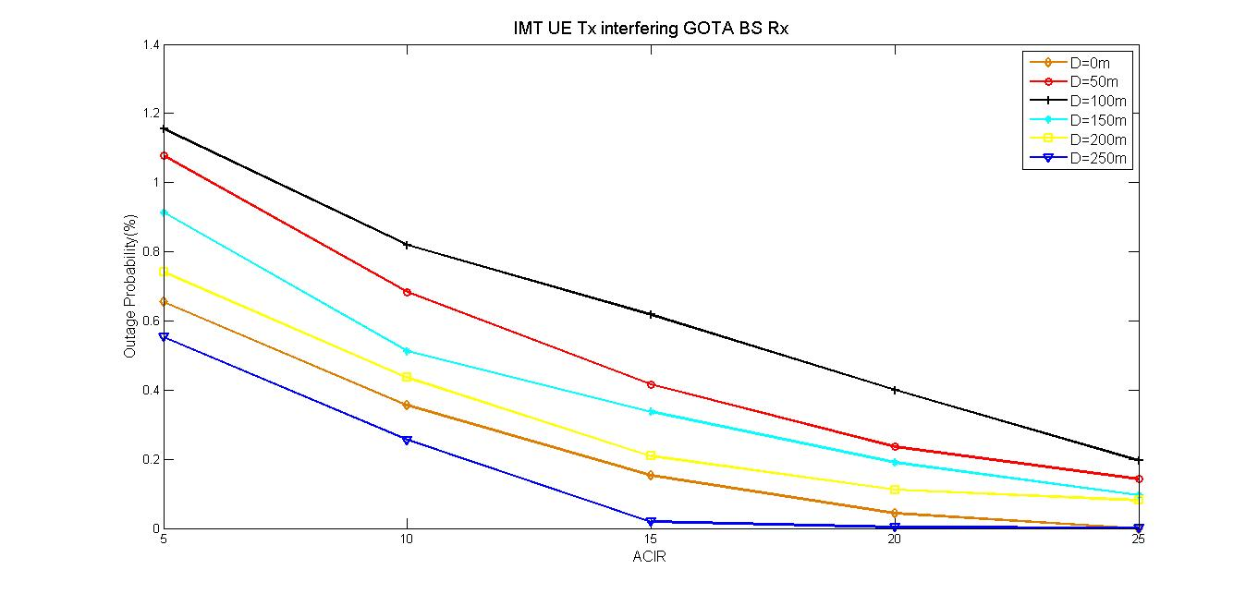

Figure 11 Results of IMT UE Tx interfering GOTA BS Rx

# Conclusions

***Results and analysis:***

1.  In the scenario of case A and D, simulation results indicate that no additional isolation requirements are needed.

2. For case B, the most serious interference occurred when the separation distance is 100 meters. The required ACIR is about 90.5dB for GT800 and about 83.8dB for GOTA. The specified emission mask of LTE base station will reach 45dB on the first adjacent channel. Therefore, additional ACLR isolation of LTE base station is about 31.5dB for protecting GT800 and about 32.7 for protecting GOTA (taking into account the equivalent bandwidth). This additional isolation requirement could be met by introducing several practical engineering deployment methods, e.g., physical separation, avoiding the assignment digital trunked channels nearby or improving RF filtering of LTE Base station. Manufacturers have indicated that this additional ACLR can be reached easily when the guard-band is 3MHz. On the other hand, GT800 and GOTA can be considered as narrow-band systems comparing with LTE system, the ACS performance can be easily reached on the 3MHz guard-band.

3. For case C, the required ACIR is about 38.5dB for GT800 and about 54.5dB for GOTA. From the parameters shown in 2.1, more than 70dB ACLR value of GT800 and more than 50dB ACLR value of GOTA can be achieved when the guard-band is larger than 1.8MHz. Therefore, no additional ACLR is required to meet the isolation requirements. On the other hand, the specified ACS of LTE BS could reach 45dB on the first adjacent channel. According to the simulation results, the additional ACS value of 9.5 dB for LTE BS is required in order to co-existence with GOTA system. In the same way, this requirement can be easily resolved by reserving 3MHz guard-band with proper RF filter.

The studies in this contribution conclude that the LTE system operating in band 44 can comfortably co-exist with the GT800 and GOTA systems operating above 806MHz.

1. 3GPP TR 37.806 v2.0.0 TS 
2.
3. 3GPP TS 36.104 V11.1.0 (2012-07), page 31.
4. 3GPP TS 36.104 V11.1.0 (2012-07), page 45.
5. 3GPP TS 36.104 V11.1.0 (2012-07), page 49.
6. 3GPP TS 36.104 V11.1.0 (2012-07), page 54.
7. 3GPP TS 36.104 V11.1.0 (2012-07), section 7.6.2, page 71.
8. 3GPP TR 25.942 v10.1.0 (2012-06), section 4.2, page14.
9. Recommendation ITU-R SM.1271 (1997).
10. 3GPP TS 36.104 V11.1.0 (2012-07), sections 6.6.4.4 & 7.6.2.
11. For LTE, a *link budget SINR* would be calculated for each sub-carrier.
12. By referring to *reasonable* filtering, we suggest the following band-edge roll-off performance: 40dB@3MHz for IMT base-stations; and 20dB@3MHz for IMT UEs.
13. For example:AWG-11/INP-46, AWG-11/INP-81, AWG-12/INP-24, and AWG-12/INP-60
14. Refer to summary technical report: 3GPP TR 36.820
15. This value refers to the block size.