APT REPORT ON

services and applications of Wireless Power TransmissioN technology

No. APT/AWG/REP-71
Edition: April 2017

Adopted by

21st Meeting of APT Wireless Group
3 – 7 April 2017
Bangkok, Thailand

(Source: AWG-21/OUT-17)

APT report on services and applications of Wireless Power TransmissioN technology

Contents
1. Introduction 3
2. Terminologies and definitions 3
2.1 Definitions 3
2.2 Abbreviations and acronyms 3
3. Devices applying WPT technology and service 4
3.1 Health and personal care goods 4
3.2 Kitchen appliances 4
3.3 Home appliances 5
3.4 Mobile devices 6
3.5 Wearable devices 9
3.6 Electric vehicles 9
3.7 Medical devices and Robots 11
4. Expected infrastructures providing WPT services 12
4.1 Home and office 12
4.2 In-vehicles 13
4.3 Public spaces 13
5. Considerations for WPT services 17
5.1 Deployment of WPT infrastructure 17
5.2 Approaches of deploying WPT infrastructure 18
5.2.1 Type 1: Charging private device using private WPT charger 18
5.2.2 Type 2: Charging public device using commercial WPT charger 18
5.2.3 Type 3: Charging public device using private WPT charger 18
5.2.4 Type 4: Charging private device using public WPT charger 19
5.2.5 Type 5: Combination with other services 19
Summary 19
References 20

1. Introduction
The APT Survey Report on WPT (AWG-16-OUT-20) concluded that only limited APT members could provide information about WPT because it was considered that WPT was still in the early stage of development although there are already many products available in the world and its standardization activities are in progress.
For WPT technology deployment in APT countries it is useful that the APT member countries can continue sharing further information on WPT, especially services and application of WPT. This information sharing would be also useful to APT member administrations for regulatory considerations and discussion to introduce WPT technology in their country.
This report focuses sharing WPT information on services and applications, which are commercially available, prototyped for products, or are studied for concept development, by analysis of devices and services applying WPT technology, and by analysis of expected infrastructures as well as study items and scenarios for deploying WPT services.

2. Terminologies and definitions

2.1 Definitions

Wireless Power Transmission | The transmission of power from a power source to an electrical load without using wires.

2.2 Abbreviations and acronyms

AC | Alternating Current
APT | Asia Pacific Telecommunity
CNG | Compressed Natural Gas
COCN | Council on Competitiveness-Nippon
EMC | Electromagnetic Compatibility
EMF | Electromagnetic Field
EV | Electric Vehicle
IH | Induction Heating
IoT | Internet of Things
LED | Light Emitting Diode
PHEV | Plug-in Hybrid Electric Vehicle
PMA | Power Matters Alliance
USB | Universal Serial Bus
Wi-Fi | Wireless Fidelity
WPC | Wireless Power Consortium
WPT | Wireless Power Transmission

3. Devices applying WPT technology and service
This clause introduces existing, prototyped products or concepts applying WPT technology with value that users expect from wireless charging function for each product category. WPT technology has been already widely used for the certain applications, and WPT implementation has been studied in wider ranges of applications. Showing this information would encourage regulators to start considering regulatory preparations on WPT technologies.
Tables in each sub-clause introduces values and examples of specification for each product in each category.
Note: The power and frequency in the tables under “Examples of specification” are just an example. The specified power or frequency cannot be used in some countries. The power or frequency that can be used are dependent upon the regulation of each country.

3.1 Health and personal care goods
WPT has been used for many years in health and personal goods. Rechargeable electric toothbrush and electric razor/shaver are popular examples. Table 1 introduces the examples of products.
Table 1 Health and personal care goods applying WPT technologies
Product | Values | Examples of specification
Rechargeable electric toothbrush | - Untethered from a power cable, water resistance | Product, Inductive coupling
Rechargeable electric razor/shaver | - Untethered from a power cable, water resistance
Rechargeable electric facial cleanser (makeup remover) | - Untethered from a power cable, water resistance | Product, Inductive coupling

Recently in Korea, a rechargeable electric facial cleanser using inductive WPT has been commercialized since 2014. The electric facial cleaner is electrically charged when it is placed over the WPC Qi charging pad. With WPT charging for three hours, it is possible to use the device for one minute every day for a month. The charging pad can be used to charge any WPC Qi device. Since the electric facial cleanser does not use any battery or contact-based material, it is easily manageable and fully waterproof [1]. The picture of the product are found in [1].

3.2 Kitchen appliances
Applying WPT to kitchen appliances have been considered and studied by manufacturers. Although no major standard technology has been developed, but many concepts or prototypes have been introduced as shown in Table 2.
Table 2 Kitchen appliance applying WPT technologies
Product | Values | Examples of specification
Juicer | - Untethered from a power cable for moving on the kitchen table | 800W, Concept
Grill pan | - Untethered from a power cable | Inductive coupling, 1kW, Prototype
Fryer | - Untethered from a power cable | Inductive coupling, 1.5kW, Prototype
Coffee maker | - Untethered from a power cable for moving on the kitchen table | 2kW, Concept
Kettle | - Untethered from a power cable for moving on the kitchen table | Inductive coupling, 2.4 kW, Prototype
Blender | - Untethered from a power cable for moving on the kitchen table | Inductive coupling, 2.4kW, Prototype
Kitchen table with IH heating (as a wide area charger) | - Providing charging area for all appliances | Concept

One of Korea’s home appliance company has developed 2.4 kW WPT kettle and WPT blender using inductive WPT technology. The 2.4 kW of electricity is acceptable to be used in many home appliances. This company is planning to register this technology to the WPC. They also plan to apply the inductive 2.4 kW WPT technology to the commercial products after standardization [2]. The pictures of these prototypes are found in [2].

3.3 Home appliances
Home appliance is one category under study for applying WPT by a couple of manufacturers as shown in Table 3.
Table 3 Home appliances applying WPT technologies
Product | Values | Examples of specification
Television | - Replacing power cable | Concept
Vacuum cleaner | - Untethered from a power cable | Concept
Charging mat | - Providing a charging spot | Prototype
Doorbell | - Untethered from a power cable  - No need to replace battery | Product

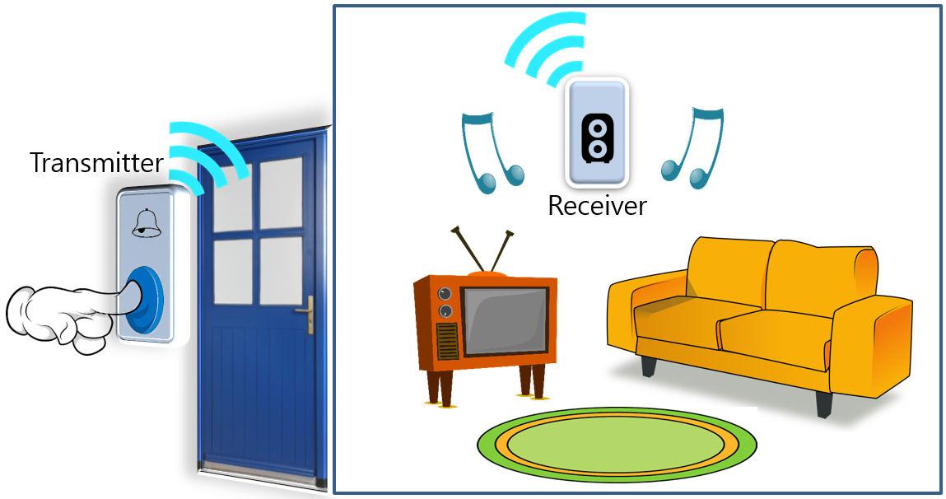
Figure 1 Doorbell without need of power source
There is a doorbell that does not need wire or power source. It is configured of a transmitter with a button in which the visitor can press and a receiver in which it rings. The transmitter and receiver are connected wirelessly. When a visitor presses the button of the transmitter, it moves the magnet and coil which produce electricity through electromagnetic induction. This electricity is transmitted to the receiver wirelessly. It is also possible for one transmitter to transfer power to multiple receivers, and multiple transmitters can transfer power to a single receiver [3].
With this feature, it is possible to install a doorbell even in temporary building and environment. Since it does not need connection to power source or use of any battery, there is no problem of missing any important doorbell due to power failure.

3.4 Mobile devices
WPT implementation to mobile device is leading the WPT commercialization and deployment. Especially WPT for smartphones are widely used in the world. WPT applications to mobile devices include charged devices (embedded, charging sleeve) and charging pats and chargers as shown in Table 4.
Table 4 Mobile devices applying WPT technologies
Product | Values | Examples of specification
Smartphone (embedded) | - Keep battery topped off anywhere | Inductive coupling, 5W, 110kHz to 200kHz, Product
 |  | Magnetic resonance, 5W, 6.78MHz, Prototype
Smartphone charging sleeve | - Keeps battery topped off anywhere | Inductive coupling, 5W, 110kHz to 200kHz, Product
 |  | Magnetic resonance, 5W, 6.78MHz, Prototype
Tablet (embedded) | - Keep battery fully charged anywhere | Magnetic resonance, 10W to20W, 6.78MHz, Prototype
 |  | Inductive coupling, 5W, 110kHz to 200kHz, Product
Tablet charging sleeve | - Keeps battery fully charged anywhere | Capacitive coupling, 10W to 20W, 400kHz, Product
 |  | Magnetic resonance, 10W to 20W, 6.78Mhz, Prototype
Note PC (embedded) | - Keeps battery fully charged anywhere  - Replacing an AC adapter | Magnetic resonance, 20W to 30W, 6.78MHz, Prototype
Note PC sleeve | - Keeps battery fully charged anywhere  - Replacing an AC adapter | Capacitive coupling, 20W to 30W, 400kHz, Prototype
PC peripheral (keyboard, mouse) | - Untethered from power cable | Concept
Music player | - Replacing power cable | Concept
Portable power box | - Replacing battery and AC adapter | Inductive coupling, 5W, 110kHz to -200kHz, Product
Smart phone charger as desktop light | - Providing charging spot | Inductive coupling, 5W, 110kHz to -200kHz, Product
Charging pat (for smartphone) | - Providing charging spot | Inductive coupling, 5W or 5W x 2, 110kHz to 200kHz, Product
 |  | Magnetic resonance, 6.78MHz, Prototype
Charging pat (for tablet or PC) | - Providing charging spot | Inductive coupling, 110kHz to 200kHz, Prototype
 |  | Magnetic resonance, 30W, 6.78MHz, Prototype
 |  | Capacitive coupling, 20W to 30W, 400kHz, Product
Charging mat under the table | - Providing charging spot  - Providing charging area without spoiling the sight | Magnetic resonance, 6.78MHz, Prototype
Charging mat on the table | - Providing charging spot | Inductive coupling, 5W, 110kHz to 200kHz, Prototype
 |  | Magnetic resonance, 5W to 30W, 6.78MHz, Prototype
 |  | Capacitive coupling, 20W to 30W, 400kHz, Product

One of the multinational furniture companies has unveiled furniture installed with WPT charging spot for smartphones. They have released various options of bedside table, floor and table lamp, and working lamp equipping WPT charging technology. These products have charging spot with “plus mark” for the smartphone to be placed for charging. The WPT chargers are approved by the WPC Qi and are compatible with every devices that support WPC Qi [3]. The picture of the product are found in [4]
This furniture company offers single WPT charging mat where a single smartphone can be charged and a triple WPT charging pad where up to three smartphones can be charged simultaneously. They also released an attachable WPT charger which can be installed in any existing furniture. They announced that the WPT charger can be used conveniently throughout the household. It minimizes the electrical wires to improve home decoration. This company also offers a charging sleeve for smartphone that does not support WPC Qi.
One of the Korea’s material and component manufacturers has developed 15-watt transmission modules for WPT charger. This transmission module has been developed for charging smartphones with performance almost equivalent to wired chargers.
WPT charger consists of transmitter and receiver. The transmitter supplies power to smartphone in the form of a charging pad or a holding platform. Embedded in a smartphone, the receiver charges its battery by generating induced current by responding to the transmitter part.
They have further enhanced the charging speed, compatibility, and application areas with the new 15-watt transmission module for WPT chargers. The module for WPT chargers supplies power to charge a fully-discharged battery up to 50% within 30 minutes. Its charging speed is three times faster than the existing 5-watt wireless charging modules.
This product interoperates with the 9-watt receiving modules that were recently supplied along with WPC-15W standard or PMA-5W standard. It also follows the standards of both WPC and AirFuel Alliance, which enhances user’s convenience. The 15-watt transmission module can be used on WPT chargers installed on vehicles as well as home and office.
A Korea’s smartphone manufacturer provides smartphone supporting both WPC and PMA standards to provide wireless charging without the need of wireless charging back cover. The previous released versions were subsequently equipped with the same capability but users were required to purchase a separate wireless charging back cover and a wireless charging pad [5].
This smartphone with WPT works with any wireless pad in the market that meets either WPC or PMA standard. This company’s engineers minimized the thickness of wireless charging hardware components and improved efficiency. This required that the coil was made as smallest as possible by combining two separate coils and adding two overlapping layers of magnetic shielding to prevent the magnetic field from leaking. As a result, engineers were able to produce a component that was only 0.27mm thick. They also minimized size and cost by developing them in a single component.
This smartphone with WPT charges 1.5 times faster compared to the previous models. Ten minutes of charging provides users with enough power for four hours of usage. The smartphone requires 180 minutes and its larger-size model needs 120 minutes using the company’s own wireless charging pad to fully charge the battery with WPT [6].
The company has also introduced a smart manager application that provides users with an overall view of applications with battery consumption with just a single touch on the screen, allowing them to easily and conveniently manage their battery usage.
In October 2016, a company in Korea have announced the commercialization of a 15-watt wireless charging pad which can charge a smartphone as fast as when using a wired charging module. The wireless charging pad is a device which supplies electric power to a smartphone in a slim pad form. The 15-watt wireless charging pad’s charging speed is three times faster than an existing 5-watt wireless charging module. It can charge a completely empty battery to the level of 50% within 30 minutes. It meets the standards of WPC [7].
This wireless charging pad uses an embedded sensor to measure the temperature to prevent the pad from overheating during charging to reduce the risk of the explosion of the battery and performance degradation of the smartphone [7].
Company in Europe and US are developing variety of wireless power transfer chipsets including ones that comply with the AirFuel’s magnetic resonance specification. The use of magnetic resonance technology brings advantages over other wireless charging methods including the ability to charge metal-bodied smartphones, tablets and smartwatches. This technology can be used in various consumer electronics, mobile computing, automotive, medical, and industrial applications [8].

3.5 Wearable devices
As a part of IoT devices wearable devices are getting users’ interests. For example in order to avoid replacing small/button batteries, implementation of WPT has been studied. AirFuel Alliance has been working on standardization for low power (5-watt) WPT. No product is available yet, but many concepts have been introduced.
Table 5 Wearable devices applying WPT technologies
Product | Values | Examples of specification
Smart glasses | - Wearable with no power cable  - Battery replacement free | Magnetic resonance, 6.78MHz, Concept
Smart watch | - Wearable with no power cable  - Battery replacement free  - Button battery free for safety | Magnetic resonance, 1W, 6.78MHz, Concept
 |  | Inductive coupling, 110-200kHz, Product
BLE earphone | - No power connector  - Battery replacement free | Magnetic resonance, 6.78MHz, Prototype
Smart earbuds (with monitoring sensors for health care ) | - No power connector  - Battery replacement free | Magnetic resonance, 6.78MHz, Prototype
Charging bawl | - Charge wearable gadgets with various form factors simultaneously in a bawl | Magnetic resonance, 6.78MHz, Prototype
Charging backpack | - Charging various devices simultaneously | Inductive coupling, Product

A Korean company has released smart watch with battery lasting for two to three days [9]. It has built-in WPT charger, and it’s easy to keep the smart watch powered up by simply setting it on the wireless charging dock. It has removed the charging cables, and made the smart watch simpler and convenient.
There is a backpack with wireless charging feature, which is capable of charging various portable devices for travelers. It has10,000 mAh built-in battery pack that is charged in just eight to ten hours at home. It has a sensor that alerts when the zippers are open accidentally. Also, it can close all the zippers with a push of a single button. This backpack has dual charging station equipped with a transmitter on its left shelf that can charge a Qi-compatible device in eight to ten hours [10].

3.6 Electric vehicles
WPT for electric vehicles has been studied for long enough years, and its prototyping and global standardization activities are in progress. Commercial applications and services are already available in some countries.
Table 6 Electric vehicles applying WPT technologies
Product | Values | Examples of specification
Passenger vehicle (ex. Wireless Power Transfer Electric Vehicle) | - Replacing power cable  - Charging spot everywhere  - Charging a battery easily | Magnetic resonance, 3.3kW, 85kHz, Prototype
Passenger vehicle (ex. Wireless Power Transfer Electric Vehicle | - Keep its battery fully charged anywhere  - Charging battery easily | Magnetic resonance, 6.6kW, 85kHz, Prototype
Wireless Power Transfer heavy-duty vehicle (e.g. Bus, truck, tram) | - Keep its battery fully charged anywhere  - Replacing an AC adapter | Magnetic coupling , 100kW, 20kHz or 60kHz, Product
Electric motorcycle | - Untethered from a power cable | Concept
Automated Guided Vehicle/ Robot car | - Only solution for charging | Concept
Charging pad on the road | - Charging spot everywhere | 50kW, Prototype

Regarding passenger vehicles, an automobile company has announced a plan to release the compact EV with WPT charging system using resonant magnetic coupling with 6.6kW of WPT electricity [11]. They plan to embed the electric power line under the public road to produce magnetic field to be converted into energy for use as electric source for the compact EV. This method does not need the use of charging plug during charging which can prevent accidents that can occur especially during rain or cold weather. The company that developed the WPT charging system for EV proclaims that they had developed the WPT module with focus on reliable high electric transmission and human safety. The module concentrated on interoperability between electric receiving unit and electric transmission unit which meets both EMF/EMC safety regulation and vehicle safety regulation.
Regarding heavy-duty vehicles, at Gumi city in Korea the local government has operated four electric buses using WPT for public transportation from 2013. This would be the first time in the world to use commercially WPT on public transportation. The electric buses are powered by electric power line embedded under the public road to produce magnetic field to be converted into energy for use as an electric source. With the success of running two electric buses with WPT to transport citizens, Gumi city added two more electric buses using WPT in 2016. The new buses are equipped with improved battery and motors for better performance compared to the two older buses [12].
Gumi city announced that using the WPT powered buses have shown 38% expense savings compared to diesel bus and 33% expense savings compared to CNG hybrid bus with zero carbon emission. Other cities in Korea announced plan to use the WPT electric bus for public transportation.

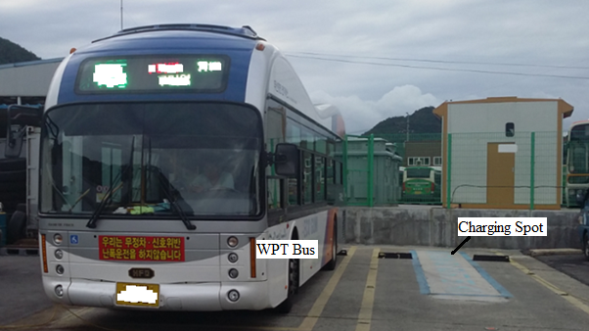
Figure 2 Public transport WPT electric bus
An US company provides in-route charging with WPT technology, which is available for electric-powered buses at the Bay Area’s Walnut Creek BART station in San Francisco, California. The charging pad lies flush with the pavement, and is sturdy enough to be run over all day without damage, and it wirelessly charges the bus during routine stops. In-route charging means less batteries, less vehicle weight, higher passenger capacity and extending vehicle range. This company has delivered 50kW chargers to ships, buses (coach), trolleys, etc. This US company is currently taking orders for 250kW wireless charger. The CEO has announced that “…opportunity or in-route charging…that means we can do more runs per bus per day and not send it back to the depot for charging, which would otherwise require more buses, more drivers, and additional costs [13].”

3.7 Medical devices and Robots
There are no major studies announced on applying WPT to medical devices and robots, but medical devices and robots are future potential application areas for WPT.
Regarding medical devices, implantable devices would be strong candidates, such as cardiac pacemaker, artificial heart, cochlea implant and implantable sensors. These batteries have to be replaced periodically, therefore non-invasive charging is very helpful to patients. An inductive, wireless, and contact-free rechargeable hearing aid has been released. It can be fully charged in four hours, and is then ready to use for at least 24 hours without recharging, even if the wearer is streaming audio full-time. It has integrated lithium-ion power cell with inductive charging to eliminate the need for any exact alignment of charging contact to make it easier to charge. For travellers, the charger unit is equipped with a standard micro USB interface, enabling charging with nearly any USB-compatible power source (e.g., laptops, car adapters, or power packs). It does not have any battery door, eliminates battery exchange, and also, it is nearly sealed with robustness and resistant against dust and humidity [14].
Robots are getting more interest to be used for daily life. For both autonomous and guided robots wireless charging is the critical function to be implemented for autonomous charging and easy maintenance for buttery charging. Targeted products would be industrial mobile robots, service robots for home, public space and specific environment, and drones.

4. Expected infrastructures providing WPT services
Deployment of WPT service infrastructures are critical for users to utilize WPT technologies as well as the WPT technology deployment itself. This chapter introduces WPT service infrastructures under consideration in different use scenarios.

4.1 Home and office
Home and office can provide WPT charging to any device from small device such as smart phone, notebook PC to larger device such as vacuum cleaner, TV, EV, etc.
Table 7 WPT infrastructure for home and office
Target application | Target user | Service provider | Values | Examples of specification
Charging pad for toothbrush and razor | - Personal | N/A | - One charger covers all products | Inductive coupling, 5W [21]
 |  |  |  | Magnetic resonance, 15W [22]
Kitchen table with IH heating | - Personal | House constructer | - No power cable construction required  - Simple design and easy usage  - Electric shock free | Concept,  Inductive coupling
WPT kit | - Personal | N/A | - Provide WPT charging to any electric device  - No requirement of WPT capability to electric device. | Product,  Inductive coupling

Israel’s companies have developed wireless charging mechanism using laser. It is believed that using photon resonance can be used for long range wireless power in confined spaces such as room or café to charge various IT devices such as smartphone. Photon resonance long range wireless power technology uses lasers from photon resonance to charge IT devices using light. The transmitter emits photon which are gathered by the receiver to change light to energy for charging IT devices [14]. The photon resonance stops the wavelength which does not create energy when touched by human. Without any separate operation, it finds the IT device and starts charging automatically. It is known to transmit 10 watts within 10 meters. On safety evaluation, IEC 60825 class 1 is applied, which is the same class with the optical mouse.
A Korean company plans to apply this technology to the smart devices and to deploy this technology to large-scale franchise coffee shops. They also plans to apply this WPT module to IoT and wearable devices [15].

Figure 3 Long distance wireless power using photon resonance
A plug & play design kit for wireless charging has been developed. The kit is WPC Qi 1.2 certified and is expected to facilitate the introduction of wireless charging in new applications requiring higher power, but also accelerate adoption in applications that can benefit from wireless charging. It consists of its latest transmitter and a receiver module, a LED load module, a Quick Start guide, and various power adapters [16]. Application scenarios for wireless power in the medium power range are numerous: charging stations for smartphones and tablets, portable devices in the medical and industrial sector, or devices with a high number of charging cycles that make high mechanical demands of plug-in connectors [17]

4.2 In-vehicles
Vehicles can provide WPT charging to any portable devices such as smart phone, notebook PC, etc. WPT charging in the driver’s cockpit is one of WPT charging infrastructures deployed commercially.
Table 8 WPT infrastructure for “in-vehicle” usage
Target application | Target user | Service provider | Values | Examples of specification
Charging pad for mobile device in car, bus, train, and airplane | - Driver and passenger | Vehicle manufac-turer | - Keep the device fully charged | Inductive coupling, 5W [21]
 |  |  |  | Magnetic resonance, 15W [22]

4.3 Public spaces
There are many location in the public space where people tend to stop to have their devices charged with electricity. If the public space has WPT infrastructure, people only need to take the devices for use and are relieved from carrying power adaptors, cables, or extra battery.

Table 9 WPT infrastructures in public spaces
Target application | Target user | Service provider | Values | Examples of specification
Battery charging station for EV | - Driver | Gas station | - Electric shock free | Prototype
Charging pad for mobile device in cafe | - Customer | Business owner | - Charge on the go | Inductive coupling
Battery charging station for personal mobility vehicle including micro EV, electric bike, electric cart, robot and other devices | - Users of personal mobility vehicle, Owners of parking lot, shopping store  - EV sharing provider  - Car and personal mobility vehicle rental service provider | WPT service provider | - Charge on the go | Concept
Use of street light for charging pad | - Street pedestrian | WPT service provider | - Charge devices in the street | Prototype

In Japan, Council on Competitiveness-Nippon (COCN) has started “Project for Market Expansion and Infrastructure Development of WPT Systems” in 2015.
Background of this project is as follows;
- WPT can be applied to very wide areas and can contribute to the future innovated world,
- Currently, R&D, international and national rule making and standardization are in very hot and active phase,
- Development of WPT infrastructure systems is important issue to accelerate their commercialization.
Purpose of this project is to build new business models, to clarify the concept and specification of WPT infrastructure systems, and to survey problems and propose their solutions. Important points considered in this project are to match with current conductive charging infrastructure systems and to cover EV/PHEVs, personal mobility vehicles, robots and other mobility devices.
The following directionalities have been confirmed as a result of discussions in 2015.
- WPT system specifications based on Japanese new regulation
New Japanese national regulation for WPT systems for EVs has been published in March, 2016. This project is focusing to use this new WPT regulation and to broaden the usage areas. The conditions and specifications of this new regulation are as follows;
- WPT technology: inductive coupling (magnetic coupling / magnetic resonance), One-way power transfer,1 to 1 power transfer,
- WPT frequency: 85 kHz-band (79 kHz to 90 kHz),
- Transfer power: 3 kW-class to 7 kW-class,
- Transfer distance: 10 cm to 30 cm.
Figure 4 shows a typical WPT system considered in this project.

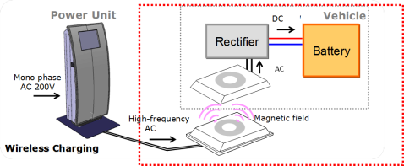
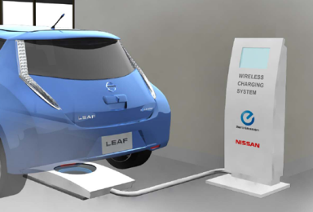

Figure 4 WPT systems considered in COCN project

- Candidate business models covered by the WPT infrastructure system
Many business models are discussing in this project. Important viewpoints in this discussion are to clarify users of WPT systems, their merits and effectiveness, to indicate advantages of WPT comparing with current conductive power supply systems, to recover the investment and get gains, and so on. Figure 5 shows the candidate business models discussed in this project.

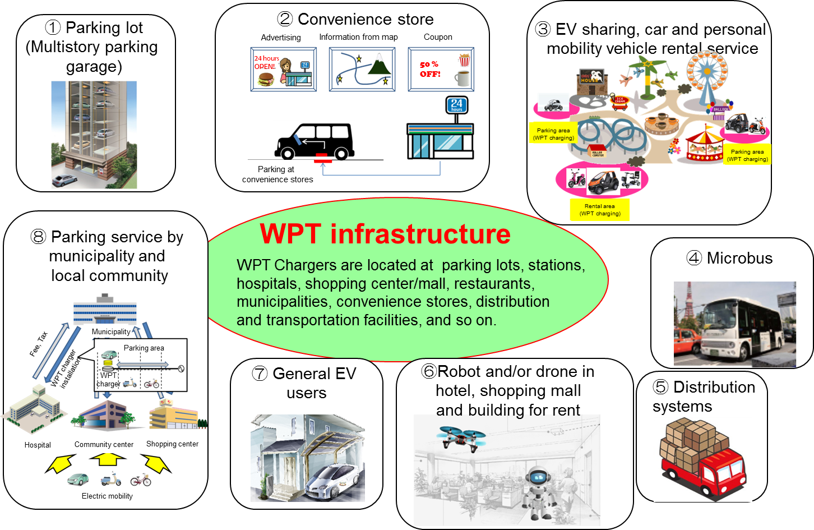
Figure 5 Candidate business models covered by WPT infrastructure system

- Framework to spread WPT infrastructure systems
This project members are also discussing about ways to develop WPT infrastructure systems and to spread them. Some project members have an intention to establish cooperative organization, such as limited liability companies for this purpose. Figure 6 describes the base line of proposed framework which supplies WPT charging services and develops WPT infrastructure systems.

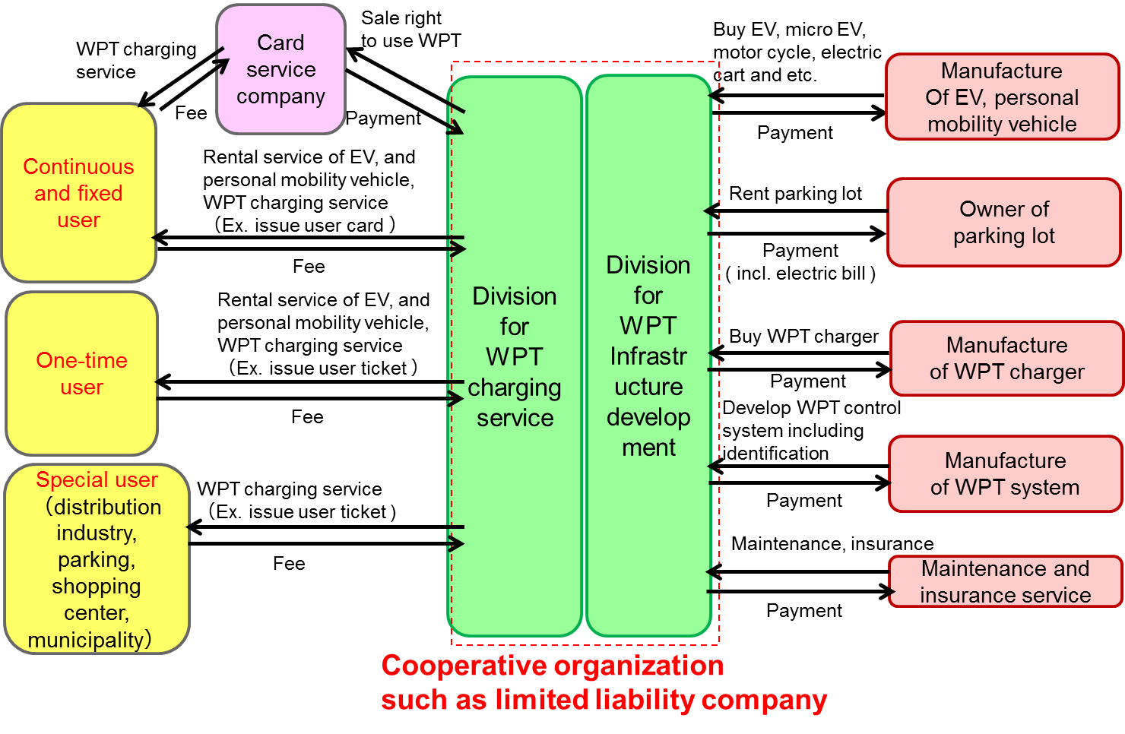
Figure 6 Framework to spread WPT infrastructure systems

This COCN project is active from June 2015 to March 2017. The following goals of project are estimated.
- Clarify WPT business models to spread WPT market widely.
- Design the cooperative organization for WPT infrastructure development and charging services. (The cooperative organization will be established in 2019 or 2020.)
- Finalize planning of the demonstration experiment. (Before establishment of the cooperative organization, the project of demonstration experiment will be performed to check effectiveness of selected WPT business models and to appeal the advantageous and validity of WPT systems.)
- Solve political problems for WPT infrastructure development and WPT market expansion, and then propose their solutions to Japanese government.

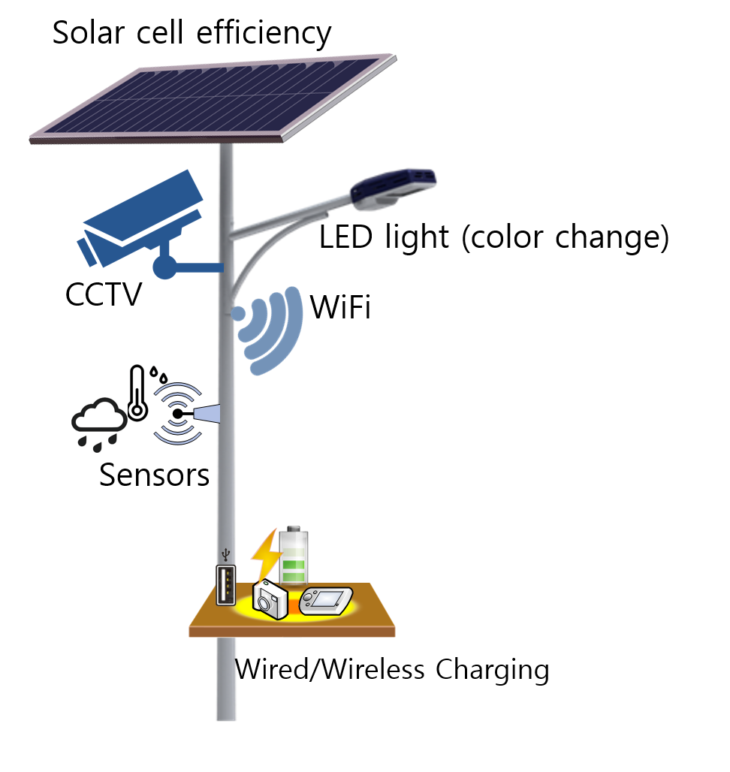
Figure 7 Solar-kinetic streetlights

In Las Vegas, solar-kinetic streetlights is installed, which is a street lighting technology that combines both kinetic and solar energy in a completely off-grid solution [18]. The new LED streetlight is powered by an integrated solar panel and pedestrian footsteps. The energy is harvested every time someone steps on the kinetic pads strategically placed in front of each street light. It is expected to produce 4W to 8W energy. It has motion sensors that allow for light on demand [19]. It has add-ons like USB port, wireless charging, sensors to gather data for air quality and traffic, video surveillance, a bit of integrated Wi-Fi and even a water detector (rain meter)[18][19]. This concept of using streetlights is one of an example of deploying WPT in the public streets.

5. Considerations for WPT services

5.1 Deployment of WPT infrastructure
Deploying WPT in the public space can provide convenience to users carrying various electric devices, drivers of EVs, etc. It can be deployed by the public authority or any organization that are willing to provide WPT service for the public. However, such involved party needs to be careful in developing WPT service infrastructure to the public space, since it is difficult to change the infrastructure once it is deployed. There are various issues that need to be carefully studied before design and development of the WPT infrastructure. Some issues includes EMC, EMF, health, safety, convenience, usability, effectiveness, regulation, etc.
The involved party needs to develop a detailed plan on how to efficiently deploy WPT through various research, experiments, trial test, field test, etc. The involved party can apply the WPT infrastructure in the public property such as bus stops, parks, public parking lots, public spaces, train station, subway station, etc. If many people find it very convenient in using WPT, the private enterprise will start proving WPT service in their own properties such as café, restaurant, hotel, shopping centre, etc.
In the beginning, the involved party should set an easy goal for developing WPT infrastructure such as extending the battery-power usage time. In the future, the involved party can consider expanding the WPT service to 24-hour automatic charging service. Although it is important to create a WPT charging infrastructure itself, the involved party should also make careful plan in building infrastructure to support newly created services based on WPT technology.

5.2 Approaches of deploying WPT infrastructure

5.2.1 Type 1: Charging private device using private WPT charger
WPT can be used in private area such as home, office, private car, etc. There are many appliances and devices used in every part of the house and office. With use of WPT, devices can be completely sealed and waterproof avoiding electric shock hazard especially in kitchen and bathroom. Other benefits include ease of charging position of devices, ease of power usage control, etc.
In this environment, devices should be authenticated in order to prevent unauthorized use of the wireless electricity. However, there is no need for dynamic authentication process whenever the device needs power in homes or offices, since the owner can register the information related to the WPT charging when the device is used for the first time. Such information can include the identification, WPT charging rate, charging amount required, etc.
To charge device in this environment, WPT charger and device identifies and locate each other. Since the WPT charger already has the information needed, it electrically charges the device with the pre-defined criteria.

5.2.2 Type 2: Charging public device using commercial WPT charger
Commercial area such as restaurant and café can provide WPT service for customers. The owner of the restaurant and café can provide free charging service using his/her commercial WPT charger to the public device of the customer. The owner would want to provide this service only to customers who purchase their products or who make payment in using the WPT service. Normally, in commercial area, WPT service is provided to the customers only for the prearranged period of time and amount of electricity, e.g., length of stay, amount of power charged. In order to realize this use case, owner can provide a temporary code that is valid for selected period of time. The owner may need a storage that carries and manages the temporary codes.
In this environment, a user is registered to access to the commercial WPT charger. After registration, the user is authenticated for the use of WPT services. The device that will be used is authenticated in this process. Through user and device authentication, it is possible to use the WPT service without repeating authentication process. The user is authorized to use WPT service according to the pre-established agreement.

5.2.3 Type 3: Charging public device using private WPT charger
A private WPT charger can be used for the public purpose. On such example is proving WPT service to a friend’s device visiting one’s home. A homeowner can provide free charging of the small device, such as laptop, smart phone, etc. However, the visiting friend would not want to burden the homeowner when charging his/her car at the garage. The friend may want to use the WPT service but is willing to pay the fee for service usage.
Similar scenario can be considered in proving WPT service in the parking lot of the apartment. The WPT chargers are shared by the residents and the payment of the WPT service usage should be made to each resident who is using the WPT service.
After authentication of user and device, the user is authorized to use the WPT service with limited set by his/her credits, not by the WPT charger. In this approach, WPT service should be measured by both device and the WPT charger. Auditing process is needed to prevent overcharge.

5.2.4 Type 4: Charging private device using public WPT charger
When leaving outdoors, people carry many devices such as mobile phone, laptop, headsets, healthcare equipment, etc. There are many public areas in which people may want to charge their handheld devices. Such area includes bus stop, train stop, public transportation, etc. The WPT charger can be installed in bus/rail stops, streetlights, traffic lights, electric poles, etc. In this approach, public authentication system is needed for the user to use the WPT service with its service fees charged to his/her account. In order to make this possible, the public will need perform user management for authentication of the service users.
Different service providers can set different charging price for their services. The WPT service user, such as EV driver, can choose WPT service providers who provide electricity with reasonable rate. A user may set constraints on charging amount as according to the cost of electricity. For example, this user would want to charge small amount when cost of electricity is high, and would want to fully charge the EV when the cost is low.

5.2.5 Type 5: Combination with other services
Wireless sensors are used everywhere. It can be used in farms, buildings, bridges to diagnose various statuses. It can be installed in underground facilities such as sewage, electric wires, gas line, to detect operational status, leakage, or malfunctions. Human can carry the sensors in portable medical devices to trace and diagnose one’s health. These sensors provide reports on the collected information to the monitoring system.
The greatest problem of sensor is to maintain battery power, because communication with the monitoring system causes much power consumption. For sensors installed in the underground, it is almost impossible to recharge these batteries. These sensors can bring the highest potential when combined with WPT service. WPT charger can wirelessly charge the sensors and collect information during WPT charging. WPT service security is needed between the sensors and WPT charger to provide accurate information during data exchange.

Summary
Devices with WPT technology are commercially available already in some product categories, and WPT technologies keep evolving for new applications and services in the variety of product categories. The development of prototypes with new usage concept is under progress, too.
In mobile device category, number of products are in the market, because global standards on WPT technology in this product category has become mature enough.
Some devices in other categories; such as health and personal care goods, and wearable devices are commercially available with WPT function based on proprietary technologies. Regarding a wearable device, WPT is necessary function for its use cases so that it is expected that WPT for wearable devices would become popular, once its standardization is completed and its technology becomes stable.
WPT for kitchen appliances, home appliances, medical devices and robots are attractive, and prototype and concept development are in progress. However, we might need to wait for the standardization activity getting ready and mature enough before these products will be available in the market.
Electric vehicle would be the promising category in which we can expect to see products and services soon. Many experiments with prototypes were demonstrated, and its global standardization has been in progress.
WPT technology users cannot have any benefit of “wireless” only with devices having WPT function without WPT service infrastructure. Especially in public spaces, constructing WPT service infrastructure is critical for WPT technology deployment. This report introduces the outcome from the project studying market expansion and infrastructure development of WPT systems for electric vehicles. In addition, for deploying WPT services in public spaces, there are key subjects to be considered before implementation, and key subjects in the five use cases were studied and shown.
This report shows the current status of WPT technology deployment by introducing commercially available devices, prototypes and concepts under development in each category. It also shows the status of WPT infrastructure development with necessary future considerations.
WPT technology is getting more visible and commonly available in recent years. It is expected that this report would help APT members to pay more attention to the deployment of WPT technology in each country.

References

[1] | "Makeon, beauty device with WPT (Korean Language)," kukinews, 7 May 2015. [Online]. Available:  http://news.kukinews.com/news/article.html?no=269804. http://www.makeonbeauty.co.kr/en/en_product_view.do?i_sProductcd=SPR001
[2] | "Kitchen appliance with WPT, LG to develop 2.4kW WPT technology (Korean Language)," etnews, 19 November 2015. [Online]. Available: http://www.etnews.com/20151118000435.
[3] | “Linebell, No need of wire and power (Korean Language)”, ZDNet Korea, 02 November 2016. [Online] Avaliable: http://www.zdnet.co.kr/news/news_view.asp?artice_id=20161102090255
[4] | "KWPF April WPT report (Korean Language)," KWPF, April 2014. [Online]. Available: http://www.kwpf.org/bbs/bbs_download.php?idx=387&download=1&filename=bbs_file&PHPSESSID=33cf4205556d662df71246248c75240a  http://www.ibtimes.co.uk/samsung-ikea-help-wireless-charging-surge-into-mainstream-1490383
[5] | "Charged Up: Galaxy S6 and S6 edge Lead Smartphone Battery Revolution," Samsung newroom, 2 March 2015. [Online]. Available: https://news.samsung.com/global/charged-up-galaxy-s6-and-s6-edge-lead-smartphone-battery-revolution
[6] | "Galaxy S6 edge+ and Galaxy Note5: Even Faster Wired and Wireless Charging," Samsung newroom, 26 August 2015. [Online]. Available: https://news.samsung.com/global/galaxy-s6-edge-and-galaxy-note5-even-faster-wired-and-wireless-charging
[7] | “LG Innotek Introduces the Quick Wireless Charging Pad”, LG Innotek press release, October 12, 2016. [Online] Avaliable: http://www.lginnotek.com/community/news_view.jsp?seq=628  http://www.businesskorea.co.kr/english/news/ict/16180-first-commercialization-lg-innotek-introduces-15-watt-quick-wireless-charging-pad
[8] | “WiTricity, STMicroelectronics team on wireless power”, EETimes Europe, October 16, 2016. [Online] Avaliable:  http://www.electronics-eetimes.com/news/witricity-stmicroelectronics-team-wireless-power-0
[9] | "Samsung reveals Gear 2 spec with battery lasting 2~3 days also with WPT (Korean Language)," The Kookje, 2 September 2015. [Online]. Available: http://www.kookje.co.kr/news2011/asp/newsbody.asp?code=0100&key=20150902.99002002222.
[10] | “Barracuda Konzu could be the world’s most advanced backpack”, Gizmotimes, November 15, 2016. [Online] Avaliable:  https://www.gizmotimes.com/smart-stuff/barracuda-konzu-backpack/17384
[11] | "Soul EV with WPT (Korean Lanaguage)," etnews, 4 May 2015. [Online]. Available: http://m.etnews.com/20150430000267  http://www.electricvehiclesresearch.com/articles/8323/kia-soul-ev-being-used-for-wireless-charging-development
[12] | "Gumi City, expand operation on next generation WPT EV bus (Korean Language)," Timenews, 24 March 2016. [Online]. Available: http://www.timenews.co.kr/web/news/article/1044940
[13] | “WAVE announces wireless charging at Walnut Creek BART station”, Busride, November 2016. [Online] Avaliable:  http://busride.com/2016/11/wave-announces-wireless-charging-at-walnut-creek-bart-station/
[14] | “Cellion primax Lithium-ion Inductive-charging Hearing Aid”, The HearingReview, October 18, 2016. [Online] Avaliable:  http://www.hearingreview.com/2016/10/cellion-primax-lithium-ion-inductive-charging-hearing-aid/
[15] | "Wi-Charge charging smartphone as WI-FI to be commercialized in Korea (Korean Language)," money today, 26 April 2016. [Online]. Available: http://news.mt.co.kr/newsPrint.html?no=2016042613575006244&type=1&gubn=undefined  http://www.wi-charge.com/
[16] | "Creatus, start of long distance wireless charging in Korea (Korean Language)," The bell, 27 April 2016. [Online]. Available: http://www.thebell.co.kr/front/free/contents/news/article_view.asp?key=201604270100051100003138
[17] | “ROHM Semiconductor to present new medium power design kit for wireless charging”, Rohm Semiconductor news, November 10, 2016. [Online] Avaliable:  http://www.rohm.com/web/eu/news-detail?news-title=2016-11-10_news_electronica_wireless&defaultGroupId=false
[18] | “Electronica: Würth and Rohm show Qi standard charger”, Electronics Weekly.com, November 8, 2016. [Online] Avaliable:  http://www.electronicsweekly.com/market-sectors/power/electronica-wurth-rohm-show-qi-standard-charger-2016-11/
[19] | “EnGoPlanet Street Lights Dazzle In Las Vegas”, Clean Technica, March 18, 2016. [Online] Avaliable:  https://cleantechnica.com/2016/03/18/engoplanet-street-lights-dazzle-las-vegas/
[20] | “Las Vegas gambles on green with world’s first solar-kinetic street lights”, Eco Techtube, March 16, 2016. [Online] Avaliable:  http://www.ecotechtube.com/flashes/detail/343/las-vegas-gambles-on-green-with-worlds-first-solar-kinetic-street-lights
[21] | WPC, "WPC specification v.1.1," [Online]. Available: https://www.wirelesspowerconsortium.com/
[22] | Airfuel, "Airfuel BSS v.1.2.1," [Online]. Available:  http://airfuel.org/
 | Note: Some drawings in the figures follows Attribution ShareAlike 2.0 Generic (CC BY-SA 2.0) license

