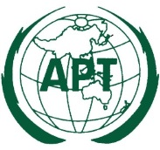 | ASIA-PACIFIC TELECOMMUNITY
 | The South Asian Telecommunication Regulator’s Council (SATRC)

SATRC REPORT ON
MOBILE ROAMING WITHIN THE SATRC MEMBER COUNTRIES

Prepared by
SATRC Working Group on Policy, Regulation and Services

Adopted by
15th Meeting of the South Asian Telecommunications Regulator’s Council
05 – 07 August 2014, Paro, Bhutan

Contents
Executive Summary 1
1.Introduction 2
1.1 Objective of the study 2
1.2 Benefit of mobile roaming within the region 2
2. Current Status of Mobile Roaming within the SATRC Member Countries 3
3. International Mobile Roaming Trend 7
4. Issues related to International Mobile Roaming 9
4.1 Wholesale rate - Mobile termination rate 9
4.2 Retail price 10
4.3 Double Taxation 10
4.4Transparency of mobile roaming prices 11
5. Mobile Roaming initiatives 11
5.1 Regional 12
5.1.1 European 12
5.1.2 Arab States 12
5.1.3 Southern Africa 13
3.1.4 Southeast Asia 13
5.2 Bilateral initiatives 14
5.2.1 Malaysia and Singapore model 14
5.2.2 Trans-Tasman Model 14
5.3 Individual Operators initiatives 15
3.3.1 CELTEL 15
3.3.2 Airtel 15
6. Findings 16
7. Recommendation for implementing Mobile roaming within the SATRC Member countries 17
9. Conclusion 21
10. Reference 22

Executive Summary

The 13th South Asian Telecommunications Regulators’ Council (SATRC) meeting held in Kathmandu, Nepal from 18-20 April 2010 adopted the SATRC Action Plan (SAP) Phase IV for the duration of year 2012-2013. One of the activities identified under SAP IV is to conduct a study on mobile roaming within the SATRC region and come out with recommendation to reduce the ultra-high roaming rates within the SATRC member countries.

This report reviews the current mobile roaming market in the SATRC region, and explores possible principles that could form the basis for good practices in international mobile roaming (IMR) agreements amongst SATRC member countries.

This report will be submitted and deliberated during the 15th SATRC Meeting to be held in Paro, Bhutan from 05 to 07 August 2014.

Introduction

International mobile roaming (IMR) enables consumers to use their domestic mobile phone services when travelling internationally by accessing partner networks in each visited country. This enables consumers to make and receive voice calls, make and receive SMS and also upload and download data.

While there have been reductions in international roaming charges over recent years, IMR prices still remain very high when compared to prices for similar domestic services in many countries.

One of the major hindrances associated with the IMR is the persistence of high prices, despite the presence of competition in other mobile markets. The market dynamics are insufficient to produce reasonably competitive wholesale prices, and many regulators have taken regulatory steps to simulate effective competition, including improving consumer awareness and protection. These actions have been effective in regions such as Europe, resulting in fairer consumer prices for regional mobile roaming services.

Objective of the study

The main objective of this study was to review the current mobile roaming in the SATRC member countries; examine some of the approaches taken to integrate those best practices by the regional as well as bilateral regulatory organizations and individual mobile operators, and then make recommendation to improve the IMR markets in the SATRC member countries.

1.2 Benefit of mobile roaming within the region

Benefits related to mobile roaming within a region include:

- Promotion of Trade and Services
Affordable regional mobile roaming significantly reduces barriers to regional trade by making it easier to conduct business while travelling. Thus, regional free trade agreement such as South Asian Free Trade Area (SAFTA) is likely to be more successful if regional mobile roaming is made available at a reasonable cost.

- Lower costs for mobile service providers
In absence of an affordable roaming facility, customers visiting a foreign country will obtain a local service which will be used only for the duration of the visit (and maybe subsequent visits), incurring avoidable administrative costs. This practice also generates an inefficient use of SIM cards, and unnecessary direct cost of the SIM card borne by the respective operators.

- Improve mobile number management
Each SIM card obtained by an international visitor also requires a mobile number to be assigned and these numbers will only be used for the duration of the visit and maybe subsequent visit, if any. Normal practice followed by most of the mobile operators is to quarantine such numbers for a period of three to six months before it is re-used. This depletes the pool of available numbers and increase the administrative cost of number management.
- Enhancement of National Security
The GSMA white paper on the Mandatory Registration of Prepaid SIM Card Users (November 2013) reveals that the criminals and terrorists use prepaid SIM cards to help stay anonymous and avoid easy detection. This paper also confirms that the SIM card registration would help safeguard the public from criminal activities that are assisted by mobile phone.
With good roaming facilities, arrangement and procedures in place, it may be possible to assist individual government or regional governments to track any foreigners involved in anti-national activities, and thus may assist in enhancing the national security of the country.

2. Current Status of Mobile Roaming within the SATRC Member Countries

- Intra-SATRC roaming arrangement

Currently, there is no single country level agreement for intra-SATRC roaming arrangement. The individual operators bilaterally enter into roaming agreement with other operators in the region. Due to this arrangement, there is a huge disparity in the mobile roaming charges in the region.

- Intra-SATRC roaming price

Although some of the intra-SATRC roaming tariffs are much lower compared to few years back, the current status of the mobile roaming within the SATRC countries is not very impressive.
In general, there have been drastic reductions in the intra-SATRC roaming tariffs, especially in the case of in-coming call tariffs when compared to the tariff in 2011. For the purpose of this study, the LIRNEAsia report (2011) is used to compare the current roaming rates. The compiled roaming tariff by LIRNEasia for year 2011 is shown in Annex A.

The table below shows the percentage reduction/increases in March 2014 relative to 2011.

 | AFG | BAN | BHU | IND | IRA | NEP | MAL | PAK | SRI
AFG |  | - | - | - | - | - | - | - | -
BAN | -20% |  | - | -17% | - | -65% | +39% | +21% | -54%
BHU | - | -35% |  | -46% | - | -60% | -60% | - | -53%
IND | -60% | -73% | -48% |  | - | -80% | -78% | - | -53%
IRA | - | - | - | - |  | - | - | - | -
NEP | -65% | -22% | - | -49% | - |  | -59% | +16% | -45%
MAL | -45% | +12% | - | -29% | - | +8% |  | +19% | -61%
PAK | - | - | - | - | - | - | - |  | -
SRI | -66% | -31% | - | -97% | - | +3% | -9% | -13%
Table 1: Roaming: In-Coming call tariffs

 | AFG | BAN | BHU | IND | IRA | NEP | MAL | PAK | SRI
AFG |  | - | - | - | - | - | - | - | -
BAN | +12% |  | - | +85% | - | +19% | +183% | -3% | +165%
BHU | - | -48% |  | -40% | - | -52% | -155% | - | -34%
IND | -47% | -29% | -54% |  |  | -74% | -34% | - | -24%
IRA | - | - | - | - |  | - | - | - | -
NEP | -64% | +6% | - | -7% | - |  | -32% | -51% | +2%
MAL | +165% | +20% | - | -3.4% | - | -28% |  | +2% | -16%
PAK | - | - | - | - | - | - | - |  | -
SRI | -80% | -80% | - | -96% | - | -82% | -66% | -86%
Table 2: Roaming: Out-going call tariffs
Note: Dash (-) indicates “No data”.
-------------------------------------------
From the above table (Table 1), it is evident that there has been a significant reduction in tariff for receiving calls while roaming in most of the SATRC member countries compared to few years back (2011). For instances, there has been a reduction of 96% in tariff for receiving calls from home (India) while roaming in Sri Lanka.

However, there are also cases where few member countries, like Maldives and Bangladesh, have also increased the tariff for receiving calls for mobile roamers from countries like Pakistan, Nepal etc.

Except Bhutan, India and Sri Lanka, all the member countries have increased the tariffs for calling home while roaming in their respective countries. The increment ranges from 2% to 183% (Table 2). The out-going Call tariff of Nepal (table 4 below) indicates the rebalancing of tariff to ensure same charges for all the countries except Iran, and thus result into slight increase of tariff for mobile roamers from Sri Lanka.

The current mobile roaming rates (March 2014) is shown in the tables below:

 | AFG | BAN | BHU | IND | IRA | NEP | MAL | PAK | SRI
AFG |  | - | - | - | - | - | - | - | -
BAN | 0.85 |  | 1.20 | 0.89 | 1.07 | 0.56 | 1.10 | 0.57 | 0.55
BHU | 1.0 | 1.0 |  | 1.0 | 1.0 | 1.0 | 1.0 | 1.0 | 1.0
IND | 0.6 | 0.5 | 1.1 |  | 0.5 | 0.6 | 0.6 | - | 0.3
IRA | 30 | 30 | 30 | 30 |  | 30 | 30 | 30 | 30
NEP | 0.52 | 0.52 | 0.52 | 0.52 | 0.52 |  | 0.52 | 0.52 | 0.52
MAL | 0.55 | 0.55 | 0.55 | 0.55 | 0.55 | 0.55 |  | 0.55 | 0.55
PAK | - | - | - | - | - | - | - |  | -
SRI | 0.68 | 0.27 | 1.40 | 0.02 | 0.54 | 0.58 | 0.69 | 0.23
Table 3: Roaming: In-Coming call tariff (USD per minute)

 | AFG | BAN | BHU | IND | IRA | NEP | MAL | PAK | SRI
AFG |  | - | - | - | - | - | - | - | -
BAN | 2.25 |  | 2.29 | 1.50 | 2.60 | 1.36 | 2.66 | 1.44 | 2.70
BHU | 1.65 | 1.65 |  | 1.25 | 1.65 | 1.65 | 1.65 | 1.65 | 1.65
IND | 1.6 | 1.5 | 1.3 |  | 2.4 | 0.9 | 2.2 | - | 2.1
IRA | 80 | 55 | 55 | 55 |  | 30 | 130 | 55 | 55
NEP | 1.09 | 1.09 | 1.09 | 1.09 | 1.49 |  | 1.09 | 1.09 | 1.09
MAL | 5.30 | 1.90 | 2.30 | 2.30 | 5.30 | 2.30 |  | 2.30 | 1.90
PAK | - | - | - | - | - | - | - |  | -
SRI | 1.02 | 0.44 | 2.17 | 0.08 | 2.44 | 0.65 | 1.04 | 0.4
Table 4: Roaming: Out-going call tariff (USD per minute)

The table 3 and 4 shows the presence of disparities in the tariff for receiving and making calls while roaming.
 | AFG | BAN | BHU | IND | IRA | NEP | MAL | PAK | SRI
AFG |  | - | - | - | - | - | - | - | -
BAN | Free |  | Free | Free | Free | Free | Free | Free | Free
BHU | Free | Free |  | Free | Free | Free | Free | Free | Free
IND | - | - | - |  | - | - | - | - | -
IRA | Free | Free | Free | Free |  | Free | Free | Free | Free
NEP | Free | Free | Free | Free | Free |  | Free | Free | Free
MAL | 0.30 | 0.30 | 0.30 | 0.30 | 0.30 | 0.30 |  | 0.30 | 0.30
PAK | - | - | - | - | - | - | - |  | -
SRI | Free | Free | Free | Free | Free | Free | Free | Free
Table 5: Roaming: In-coming (USD per SMS)
 | AFG | BAN | BHU | IND | IRA | NEP | MAL | PAK | SRI
AFG |  | - | - | - | - | - | - | - | -
BAN | 0.56 |  | 0.54 | 0.32 | 0.52 | 0.44 | 0.61 | 0.40 | 0.38
BHU | 0.25 | 0.25 |  | 0.25 | 0.25 | 0.25 | 0.25 | 0.25 | 0.25
IND | 0.5 | 0.3 | 0.3 |  | 0.3 | 0.3 | 0.5 | - | 0.2
IRA | 15 | 15 | 15 | 15 |  | 15 | 15 | 15 | 15
NEP | 0.21 | 0.21 | 0.21 | 0.21 | 0.21 |  | 0.21 | 0.21 | 0.21
MAL | 0.45 | 0.45 | 0.45 | 0.45 | 0.45 | 0.45 |  | 0.45 | 0.45
PAK | - | - | - | - | - | - | - |  | -
SRI | 0.38 | 0.15 | 0.38 | 0.07 | 0.31 | 0.23 | 0.23 | 0.19
Table 6: Roaming: Out-going (USD per SMS)
The Table 5 indicates that most of the member countries, with the exception of Maldives, do not charge for receiving SMS, but do charge for sending SMS while roaming. When compared to 2009 (table 7), there is a significant reduction in the cost of sending SMS.
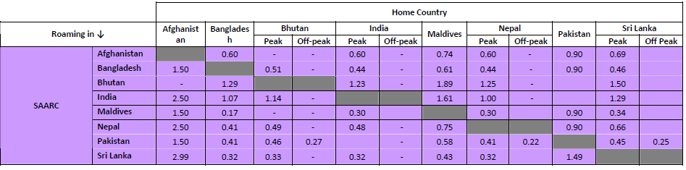Table 7: Roaming: Out-going (USD per SMS) (LIRNEasia, International Roaming Benchmarking, 2009)

3. International Mobile Roaming Trend

The ITU estimates that the penetration of mobile cellular services will reach 96 percent by the end of 2013, with Asia Pacific region at 3.5 billion, representing more than half of the worldwide figure of 6.8 billion. While growth in mobile-cellular penetration is flattening, mobile broadband continues to grow strongly, on average by around 40 per cent annually between 2010 and 2013.

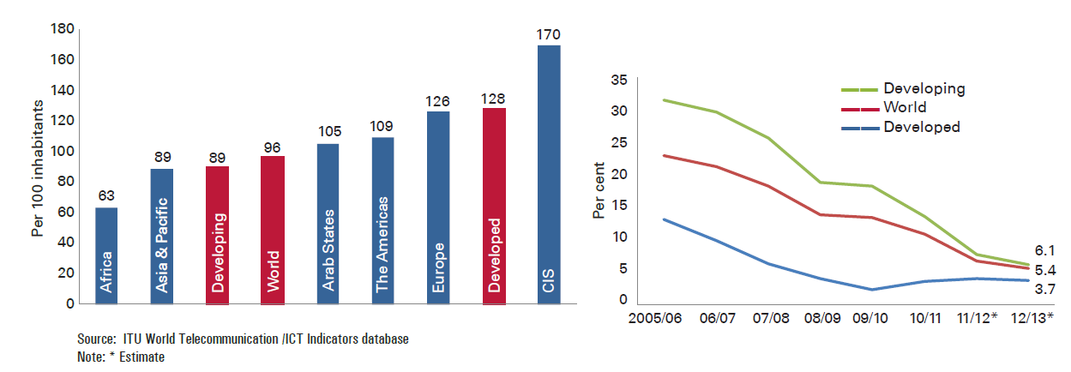 Figure 1: Mobile cellular penetration (2013) and Mobile growth (2003-2013)
Whilst the global mobile market is growing strongly, the roaming market is still in the early stages of development. A good proxy to measure the strength of the roaming market is related to the ratio of international trips to population. Based on the statistics published by the WTO in 2010, the current ratio of international trips to population is significantly lower in regions outside the EU, as can be seen in Figure 2.
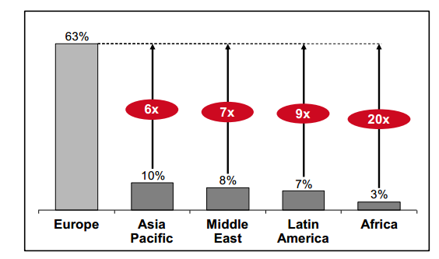
Figure2: Ratio of international trips to population for selected regions (2010)
However, continued regional economic integration has begun to promote growth in business traffic and tourism, and thus enhancing the growth in roaming usage. While there have been reductions in roaming charges; in some regions and countries in recent years, the prices still remain very high.
According to the OECD study, the prices of roaming services have generally not moved downwards in line with national pricing patterns resulting in an increasing gap between national and roaming mobile call charges. Due to this disparity, many mobile users still limit their usage and often either switch off their phones or disable certain applications or seek to find – imperfect– substitutes to using their regular services while travelling aboard.
In order to narrow the disparity between the national and roaming mobile call charges, many bilateral or regional initiatives are taking place, especially between those countries that have free trade or regional trade agreements, or strong bilateral ties in terms of trade or tourism.
European Union has shown the way forward for regulating the mobile roaming charges within the EU region through series of revision of their telecommunication legislation. The European Union approach used the mobile termination rate (MTR) benchmark as a reference to establish the regulated roaming price. EU aims at creating “one single market for Europe” by bringing down the difference between roaming and domestic prices to zero by 2015.
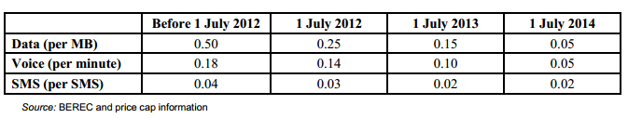Table 8: EU Wholesale Roaming Price Caps 2012-2014, EUR
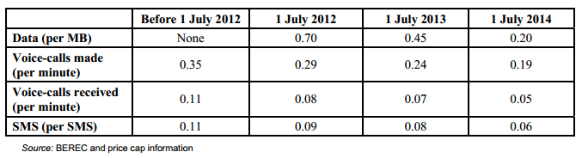Table 9: EU Retail Price Caps 2012-2014, EUR

4. Issues related to International Mobile Roaming

Some of the most important issues related to International Mobile Roaming are listed below:

4.1 Wholesale rate - Mobile termination rate

Studies have shown that, without regulatory intervention, the high mobile terminating rate (also known as the mobile interconnection rate) cannot be solved by market force as still the mobile terminating operator has monopoly on call termination for their subscribers. .
As the termination rate provides significant revenue to the mobile operators, there is little if any incentive for them to reduce this rate. The termination rate faced by call originating service providers has direct impact on the retail price charged to its subscriber, restricting their retail pricing flexibility.

In order to ensure effective competition in the domestic mobile termination rates and maintain good consumer welfare, many of the regulators have begun to intervene in regulating wholesale termination rates.

4.2 Retail price

Studies have shown that, besides regulating whole-sale prices, it is also equally important to regulate retail prices as there is very little competition at the retail level, and consequently little incentive to pass on lower wholesale rates to the retail price. Such practice has raised the consideration for requirement of both wholesale and retail rates to be regulated.

Also, if a regulator of a country does not have the legal power to take regulatory action on wholesale rates, then an alternative approach for such regulators would be to make determination on the retail rates for IMR.

At present, the European Union is the only regulator regulating both the price of the wholesale and retail mobile roaming services.

4.3 Double Taxation

The general taxation principle is that the taxation of consumption should take place where consumption takes place. However, with respect to roaming services, the application of this principle has generated controversy. Arguments have been made that the main components of the service are provided by the roamer's service provider in the home country despite the billing and authentication (which is a small part of the service) in the visited country. Nevertheless, other countries, for example, India, have argued that the service is consumed in the visited country; hence inbound roamers should be taxed.

If a roaming call is taxed in both the home country and the visited country, the resulting double taxation inflates retail prices, affecting the industry and mobile users. For example, in Latin America value-added tax (VAT) ranges from 7 to 27 percent and the estimated impact of double taxation is an increase in prices by 35-60 per cent

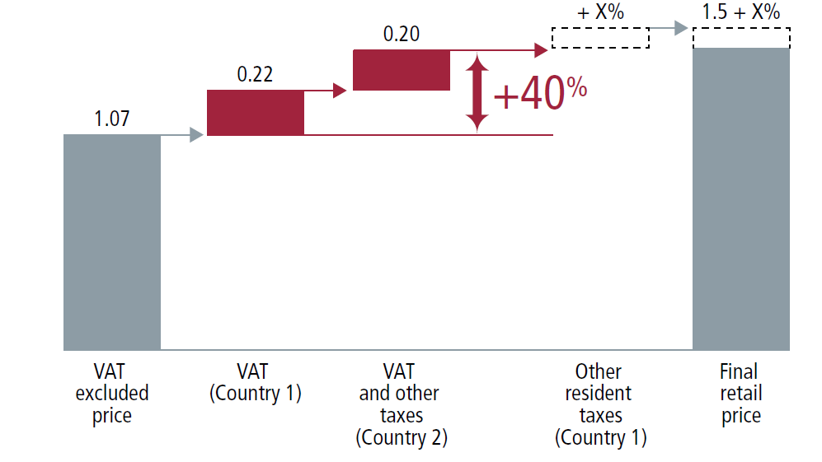
Figure 3: Impact of double taxation on mobile retail price

The issue of double taxation brings into conflict the desire of telecommunication regulatory authorities to ensure that prices are competitive and benefit users, and the taxation authorities concerned with raising revenue.

Transparency of mobile roaming prices
The increasing ubiquity of the smart phone, coupled with affordable international travel for both business and recreation, has resulted in increased use of international roaming services. With consumers often unaware of the high IMR prices, the result is an increasing incidence of “bill shock”.
Regulators from around the world have expressed concerns about the transparency of international roaming prices, bill-shock, and high prices.

5. Mobile Roaming initiatives

National regulators cannot be effective unilaterally in dealing with mobile roaming charges as at least one operator (the home or visited network operator) is not within their jurisdiction. However, there have been many bilateral or regional initiatives aimed at lowering roaming charges. Such initiatives generally occur between countries that have free trade or regional trade agreements, or strong bilateral ties in terms of trade or tourism.

5.1 Regional

5.1.1 European
In order to lower mobile roaming rates within the region, the European Union has taken three regulatory decisions on mobile roaming in June 2007, June 2009 and June 2012.

The EU Roaming regulation of 2007 introduced caps on roaming prices ("Eurotariff") which imposed maximum prices for phone calls made and received within the EU.

The Rules of July 2009 reduced voice call roaming prices and introduced new caps on SMS tariffs ("Euro SMS tariff") to safeguard consumers against data roaming bill shocks.

From July 2012 new roaming regulations further reduced roaming prices. This regulation also mandated that from 1 July 2014, consumers should be able to purchase roaming services separately from their domestic mobile service.

As part of EU’s programme to create one single market for Europe, they aim at bringing down the difference between roaming and domestic prices to zero by 2015.

5.1.2 Arab States
The 2005 study on international mobile roaming by the General Secretariat of the Arab Council of Telecom Ministers found that those Arab roamers were paying very high price for roaming within the Arabian Peninsula.Based on this finding, in order to enhance inter-Arab business and tourism and communication between the people of the Arab countries, the Members of the Arab Regulators’ Network (AREGNET) signed a Memorandum of Understanding (MoU) to lower regional mobile roaming charges through determining retail and wholesale rates using price caps.
However unlike EU, ARGNET’s MoU lacks a common regulatory framework for determining termination rates (including the intra-ARGNET interconnection rate) and the initiatives of ARGNET were not achieved.

5.1.3 Southern Africa
In 2008, the Communication Regulators’ Association of South African (CRASA) formed a Regional Alliance Task Team (RATT) to study the issues associated with high international mobile roaming charges and submitted their findings to Southern African Development Community (SADC).
Based on the findings, the RATT began to implement greater IMR price transparency through SMS notification while travelling, setting bill limits and notifying the mobile users when bill limits are being approached. RATT also commenced the collection of comparable roaming price data by the respective regulators.

3.1.4 Southeast Asia
The Association of Southeast Asian Nations (ASEAN) Telecommunications Regulators’ Council (ATRC) is working towards strengthening telecommunication regulations to bring down the intra-ASEAN mobile roaming charges. This issue has also been highlighted in their ASEAN ICTMasterplan 2015 (AIM2015).

In August 2012, Indonesia’s Minister for Communications and Information indicated his country’s support for a "roaming-free" Asian region and hopes to achieve this by 2014.

5.2 Bilateral initiatives
Beside regional initiatives, there have been many initiatives by countries to negotiate bilateral mobile roaming arrangements.

5.2.1 Malaysia and Singapore model
The joint study of 2011 by the regulators on current industry practice and charging models found that mobile roaming prices between Malaysia and Singapore were well above cost, and recommended a series of wholesale and retail price controls.
Based on this study, the governments of Singapore and Malaysia agreed to progressively reduce bilateral roaming rates and it was formalized in a legal agreement between the two regulators.
The regulators worked very closely with the mobile operators, resulting in a reduction of up to 30% for voice calls and up to 50% for SMS from all mobile operators in both Singapore and Malaysia.
Currently the regulators are studying charges for data roaming service including MMS and video calls.

5.2.2 Trans-Tasman Model
A joint investigation on the price for mobile roaming services by the governments of Australia and New Zealand revealed that despite falling prices over the years, the prices charged still remained unreasonably high.
On 9 February 2013, the Prime Ministers of Australia and New Zealand announced that their countries will work together to address high mobile roaming charges to bring down the price through legislation by end of 2013.
Since this announcement, the operators in Australia and New Zealand have individually begun to reduce the cost of roaming.

5.3 Individual Operators initiatives

3.3.1 CELTEL
In September 2006, CELTEL launched "One Network", the world's first borderless network across East Africa, enabling its subscribers to roam seamlessly to 15 African countries across its network at local rates with free incoming calls. CELTEL’s subscribers could also recharge their credit (for pre-paid users) using local top-up card in the visited country while roaming.
“One Network” was made possible by routing its traffic through Kenya Data Network’s (KDN) link, avoiding the gateway of the former monopoly state-run Telkom Kenya.
The initiative of CELTEL forced the dominant players (Vodacom in Tanzania, Safaricom in Kenya, MTN and UTL in Uganda and MTN Rwanda) to offer roaming services at the price of the country of origin in order to remain competitive, thus removing the mobile roaming charges across all networks in East Africa.

3.3.2 Airtel
India’s Bharti Airtel has also introduced the “one network" scheme and claims to be the world’s first free intercontinental incoming roaming service by adding India, Bangladesh and Sri Lanka to its One Network roaming service for its African customers. It also operates one network in 17 African countries.

The Bharti Airtel customers can also use their local Airtel SIM cards while travelling abroad to access cheaper rates for making calls, as well as data/value added services. It also provides the ability to recharge mobile credit using local top up vouchers in the country visited.

6. Findings
Some of the findings with related to International Mobile roaming as well as intra-SATRC roaming are listed below:
- Intra-SATRC roaming is based on bilateral agreement
The study found that the mobile roaming with the SATRC member countries was purely driven by operator’s individual initiatives. There is no government support or intervention despite strong commitment expressed by regional leaders at different regional forum.
The complexity of bilateral agreement has resulted in certain disparities in the price bargain. Many small operators could not avail the benefit from this arrangement and thus landed paying higher.
- Positive trend in reduction of intra-SATRC roaming tariff
The study also had shown a positive trend in the market with decrease in mobile roaming tariffs within the SATRC member countries without any major role or intervention from the national regulators. Most of the member countries, with the exception of Maldives, do not charge for receiving SMS, but do charge for sending SMS while roaming within intra-SATRC region (Table 7).
- Regulatory power
For effective implementation of regional mobile roaming arrangement, it is important to empower the national telecommunication regulators in the region with the necessary authority and jurisdiction to do so.

As demonstrated by regulators in Arab States (AREGNET), lack of regulatory power to enforce the proposed ARGNET’s MoU has resulted into non-uniform adoption and failed to achieve its objective of having a common regional roaming regulatory framework for determining termination rates (including the intra-ARGNET interconnection rate).

- Greater collaboration and commitment of the regulators

There is a need for the national telecommunication regulators to understand that the retail price for roaming services while abroad and imposed on its consumers by its national operators is highly dependent on the wholesale prices imposed by operators outside its jurisdiction. Therefore, in order to control roaming prices, given the structure of the market and the interplay of wholesale and retail transactions in different countries, it is essential to have a high level of co-operation, understanding and commitment from all the regulators in the region as demonstrated by EU and Malaysia-Singapore model.

- Double Taxation
There is strong evidence that the double taxation inflates retail prices and makes retail prices inefficiently high.
Besides, the study also reveals following pertinent issues concern with intra-SATRC mobile roaming:
- High intra-SATRC roaming tariffs
Although intra-SATRC roaming tariffs have reduced over the years, especially for receiving calls, the current average roaming tariffs are still high. It is still expensive to call home. The lowest rate for calling home is for Indian while roaming in Sri Lanka, which is 0.08 USD per minute. However, an Iranian pays the highest while roaming in Maldives (5.30 USD) followed by Indian in Maldives (2.30 USD).
- Increase in tariffs for out-going calls
The comparative data (Table 2) shows an increase in the tariffs for out-going calls by some of the member countries. For instance, Bangladeshi while roaming within the SATRC pays high, ranging 12 to 183% when compared to the tariff in 2011.
Maldives has also increased the out-going tariff while roaming in Afghanistan, Bangladesh and Pakistan.
- Local communications services still a preference while travelling
From this study, it is clear that, while travelling within the SATRC member countries, the travelers still prefer to use either local fixed line or SIM to call home. With stiff competition within the domestic mobile market, the tariffs for mobile service (both local and international) have reduced drastically. For instance, while in Bhutan, an Indian can call India using either local fixed phone or mobile for 0.14 USD per minutes while he would be charged 1 USD per minutes if he uses roaming facilities.
Thus, the high intra-SATRC mobile rates have become a hindrance, and discourage majority of the traveller from availing the mobile roaming facilities.
- Lack of transparency and uniformity mobile tariff
The variation of roaming pricing plans within the SATRC region is vast. For example, a network operator in Bhutan has multiple agreements with almost all mobile operators in India. As a result, for a Bhutanese while roaming in India, the cost of receiving calls or calling home would be different based on the network he or she gets connected.
When there is a huge variation in price within a single country, for the SATRC region such variation will be vast. The lack of transparency and uniformity in regional mobile roaming pricing often causes the “bill shock” phenomena for frequent users of international roaming, and discourages them for availing such services again.

7. Recommendation for implementing Mobile roaming within the SATRC Member countries

The mobile roaming market within the intra-SATRC region has shown significant improvement over the last few years. Prices for roaming have declined and the choices in the market provided by alternative service providers have increased. However, such improvement still could not translate into promoting regional mobile roaming due to disparities in tariffs. In order to implement effective mobile roaming within the region, the following recommendations are made:
  - Best regulatory practice

Some of the recommendations for best regulatory practices for implementing regional mobile roaming are listed below:
- Transparency of prices
Transparency of the roaming tariff is an essential element to raise awareness and provide consumers with greater control while roaming. This will provide confidence and assurance for them to use roaming services.

Without transparency, even if the roaming tariff is reduced, the lingering perceptions that roaming services are expensive can still persist. Therefore, the national regulators need to play important role in ensuring price transparency is maintained by all operators offering roaming services.

In order to prevent consumers from “bill shock”, the regulators could impose the requirement to publish the roaming rate on operators’ website. Another alternative is to make it a requirement for home network operator to send an SMS to their customers while arriving in a foreign country on the choice of network including various charges applicable for roaming. Further, the regulators could also impose complemented requirement to set safeguard limits as an additional measures.

In countries that lack tariff transparency, it is recommended that regulations are in place to compel operators to widely publish roaming tariffs via all communication media including on their website to prevent “bill shock”.

- Price regulation

A uniform International roaming tariff is a complex issue as the wholesale and downstream retail markets are always in different countries. For example, if an operator in country A wishes to offer its customers the ability to roam in country B, it purchases a wholesale service from an operator based in country B, but sells it as a retail service in country A. Due to this complexity, in general the regulators are not in a position to tackle roaming at a national level except to address certain transparency issues for their own consumers.

As most of the regulators in the SATRC region do not have the ability to regulate both wholesale and retail roaming markets, it is important to enter into regional agreement, as well as seek cooperation and coordination with their counterparts in other countries and implement effective roaming price regulation as in the case of EU and Malaysia-Singapore.

EU’s roaming price regulation is the most success case; they have successfully achieved their obligations to reduce the prices. Now they are trying to eliminate the difference between roaming tariffs and national tariffs by 2015.

The important aspect of the EU price regulation is the obligation for operators to charge roaming subscribers for actual consumption; per second pricing for voice and pricing per kilobyte for data.

- An appropriate approach to regulatory intervention
Since IMR is a complex service, involving many different factors that can influence price and in order to avoid significant risk that regulatory measures will result in unintended and detrimental consequences for consumers, governments and the industry, it is recommended to consult and engage industry throughout the process as well as seek their support in solving this complexity.
- Double Taxation
If double taxation ever exists within the SATRC region then its removal will have a direct impact on lowering the price of services such as roaming. The double taxation could be avoided as per Paragraph 8.3 of the International Telecommunication Regulation (ITR) which states "Where, in accordance with the national law of a country, a fiscal tax is levied on collection charges for international telecommunication services, this tax shall normally be collected only in respect of international services billed to customers in that country, unless other arrangements are made to meet special circumstances."

  - Appropriate approach to implement regional mobile roaming

Currently, there are two effective models for implementing regional mobile roaming; European and private operators’ initiative model.

European model would only work provided there is a strong common legally binding regulation for the SATRC region and it may not be possible due to diversified laws and regulation in different member countries.

Private operators’ initiative model works well provided a single or group of operators operate in all SATRC regions. However, there is no single operator operating in all SATRC countries.

For SATRC region, we may have to come out with a different model that would best suite our environment. For effective implementation of the regional mobile roaming, provided all member countries are committed to this initiative, a simple and effective strategy should be coined. This study recommends two strategies; short term and long term.

- Short term strategy: Since the proportionate of tariff between roaming and international calls (either by fixed or mobile phone) are huge, it is recommended that different a mark-up of certain percent, imposed for receiving calls as well as making calls while roaming.
To start with, it is proposed ten percent (10%) mark-up be imposed over current existing international calls as the tariff for making calls and ten percent (10%) mark-up on local calls for receiving calls .
- Long term strategy: in the absence of proper Hub for regional traffic, individual operator needs to enter into bilateral agreement with every regional mobile operator. Therefore, it is recommended:
- Firstly to explore the possibilities of establishing a regional Hub to which all regional mobile operators could be connected. This will facilitate direct exchange of traffic within the region and assist in reduction of cost of connectivity.
- Secondly need to explore the possibilities of come out with uniform regional mobile roaming rate for the region as in the case of EU. The current disparities of roaming tariffs need to be harmonized into single uniform tariff for the region. This can be achieved by conducting proper studies as well as through series of consultation with all regional mobile operators.
In order to evolve a common framework on regional mobile roaming, it is recommended to sets of two sets of committees under the aegis of SATRC for the following activities:
- Committee of Carriers: to compile roaming settlement charges levied by the carriers in each member countries and to devise an enabling framework to achieve uniform settlement rates charged amongst themselves by the carriers.
- Committee of NRA: to compile best regulatory practices on international roaming in each member countries and devise an enabling framework to achieve reasonable (and preferable uniform) retail tariffs. This includes removing hindrances such as double taxation, if any.

9. Conclusion
International mobile roaming is a service that allows ease of communication for travelers and facilitates cross-border communication, and such strong communication link has good potential to bring together countries as strong and vibrant region. One of the main obstacles in facilitating regional mobile roaming is the cost of roaming. In order to ensure affordable regional mobile roaming charges, it is evident that a greater level of regional collaboration and commitment is essential as demonstrated by the European Union and Malaysia-Singapore.

ANNEX: A

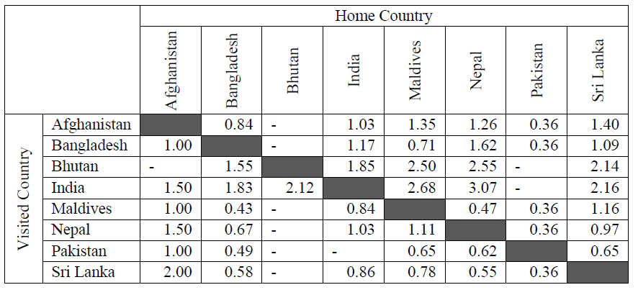Table 8: Roaming – Incoming call Tariffs (LIRNEasia, 2011)

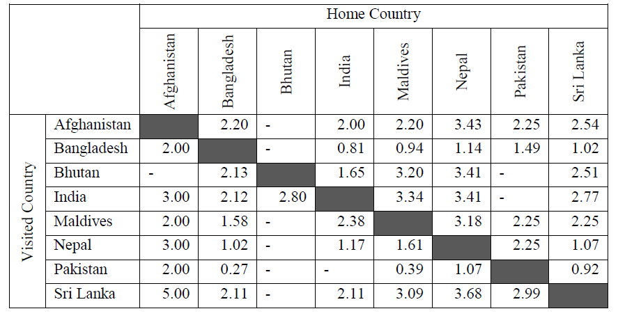Table 9: Roaming – Outgoing Call (Home Country) Tariffs (LIRNEasia, 2011)

The SATRC Action Plan aims at addressing regulatory issues and challenges of the common concern to its members that arise due to technological, market dynamic, and innovations and developments in services in the field of information and communications so as to harness their full potential in a harmonious manner for the benefit of all by utilizing the expertise and financial resources available from within its member countries.
http://saarc-sec.org/areaofcooperation/detail.php?activity_id=5
Some service providers offer “Plastic Roaming” where they supply he foreign SIM cards to their customers rather than the customers needing to approach the Foreign Service provider directly.
. The average cost of a blank SIM card can be anywhere between USD 0.70 and USD1. http://www.alibaba.com/showroom/blank-sim-card.html
. “International voice tariffs: Disparities and Recommendations for Convergence in South Asian”, LIRNEasia (2011). LIRNEasia annually benchmark report of South Asian roaming tariffs charged by network operators with significant market share.
The current mobile roaming rates are collected from respective regulators from the SATRC member countries
ITU’s ICT Facts and Figure 2013
Report on Measuring the Information Society 2013
OECD Digital Economy Papers No. 223” International Mobile Agreements”, OECD(2013)
http://ec.europa.eu/digitalagenda/en/news/one-single-telecom-market-europe
International Mobile Roaming service: Facilitating Competition and Protecting Users ( ITU, September 2013)
Page 13 of ITU Report “ International Mobile Roaming service: Facilitating Competition and Protecting Users ( September 2013)
Page 19 of ITU Report” “ International Mobile Roaming service: Facilitating Competition and Protecting Users ( September 2013)
Regulation (EU) No.531/2012 of the European Parliament and the Council of 13 June 2012 on roaming on public mobile communications network within the Union
ITU report on “ International mobile roaming services: facilitating competition and protecting users ( Sept, 2013) , page 25
Source: GSMA
Source : GSMA “ International Mobile roaming explained – Latin America” July 2012
In telecommunications, “ Bill shock” is the negative reaction a subscriber can experience if their phone bill has unexpected charges or the shock that the subscribers receive when they first see their international roaming charges on their bill
, ITU Report “ International Mobile Roaming service: Facilitating Competition and Protecting Users ( September 2013
Page 59 , ITU Report “ International Mobile Roaming service: Facilitating Competition and Protecting Users ( September 2013
Under this regulation, mobile phone operators are obliged to offer their customers the monthly USD 66 cut-off limit, but they can also offer them any other limit
Regulation (EU) No.531/2012 of the European Parliament and the Council of 13 June 2012 on roaming on public mobile communications network within the Union
http://ec.europa.eu/digitalagenda/en/news/one-single-telecom-market-europe
Around 15-500% higher for a local call terminated on a fixed network and between 15% and 700% for a local call terminated on a mobile network within the visited country and around 180 % higher to make international call when compared with local call www.wto.org/english/tratop_e/serv_e/ym_march12_e/presentation_%20maitha_jaffar.pdf.
The MoU was a result of Ministers of telecommunications and Information of Arab States directive to reduce the mobile roaming in 2005. http://www.tra.org.bh/en/pdf/Roaming-MOU-Final.pdf
www.crasa.org
The study included collection of regular roaming data, multilateral cost reduction measures and roaming issue, increased transparency and consumer protection and price control by agreement (Source: ITU)
The Southern African Development Community (SADC) is an inter-governmental organization headquartered in Gaborone, Botswana for socio-economic cooperation and integration as well as political and security cooperation among 15 southern African states. It complements the role of the African Union. ( source: Wikipedia)
Joint Ministerial Statement of the 11th ASEAN Telecommunications and IT Ministers Meeting and its Related Meeting with External Parties at Myanmar, 9 December 2011, www.aseansec.org/25751.htm
www.aseansec.org/documents/annual%20report%202011-2012.pdf
The Infocomm Development Authority of Singapore (IDA) and the Malaysian Communications and Multimedia Commission (MCMC).
OECD Report on International Mobile Roaming ( 3 June 2013)
Trans-Tasman roaming, Final Report, February 2013, www.dbcde.gov.au/__data/assets/pdf_file/0003/161274/TTR_Final_Report.pdf
OECD Report on International Mobile Roaming ( June 2013)
CELTEL is the largest pan-African wireless cell-phone operator and has around 15 million Customers across Africa.
Kenya, Uganda , Tanzania, Gabon, the Democratic Republic of Congo, Congo Brazzaville, Malawi, Zambia, Burkina Faso ,Chad, Malawi, Niger, Nigeria, Sierra Leone, Madagascar
Kenya Data Networks (KDN), is Kenya's largest private data carrier and infrastructure provider and operates a combination of microwave radio and fibre optical links, over which it provides layer 2 carrier services (Ethernet, Frame Relay) to corporate customers ( Wikipedia)
Alision Gillwald and Muriuti Mureitti, “Regulatory intervention or disruptive competition? Lessons from East Africa on the end of International Mobile roaming charges (2011)
http://www.telegeography.com/products/commsupdate/articles/2012/11/16/airtel-links-africa-and-south-asia-with-one-network/
Kenya, Burkina Faso, Chad, Congo Brazzaville, Democratic Republic of Congo, Gabon, Ghana, Madagascar, Malawi, Niger, Nigeria, Rwanda, Seychelles, Sierra Leone, Tanzania, Uganda, Zambia
12th SARRC summit ( Islamabad , January 2004) and followed by 15th SAARC summit ( Colombo, 2008)
The comparison is made with the study (tariff) conducted by LIRNEasia in 2011.
Call to India is Nu. 8 (0.13 USD) per minutes.
See The Digital Agenda, http://ec.europa.eu/digital-agenda/about-our-goals.
One of the principal purposes of the ITRs is to promote efficient operation and harmonious development of telecommunication services across jurisdictions.
Paragraph 8.3, www.itu.int/en/wcit-12/Documents/final-acts-wcit-12.pdf
This mark-up could be discuss and agreed during the 15th SATRC meeting to be held in Paro, Bhutan.

