 | ASIA-PACIFIC TELECOMMUNITY
 | 2nd Meeting of SATRC Working Group on Spectrum in SAP-IV | Document  WGSPEC-02/INP-04
 | 11-12 March 2014, Tehran, Iran | 11 March 2014

Communication Regulatory Authority of Islamic Republic of Iran

SUGGESTION FOR CALCULATION OF SPECTRUM REQUIREMENTS FOR MOBILE BROADBAND

Introduction:
More than 90 percent of the world’s population is under the coverage of mobile networks, and the first and the only way to access the internet, for many people in the developing countries, is IMT network and IMT network traffic is quickly increasing in accordance with the new services and applications development based on the broadband. Therefore the required bandwidth for IMT would be also increased day-to-day and numerous appeals have been sent to the regulators by mobile operators for increasing the required bandwidth. Now, one of the main and the important concerns for the world regulators is forecasting the required spectrum for IMT networks in the future so that they can supply the required spectrum of IMT network based on the market's requirement through policing and planning accurately and allocating the suitable frequency sub-bands. In this regard, an Agenda Item 1.1 entitled "additional spectrum allocations to the Mobile Service on a primary basis and identification of additional frequency bands for International Mobile Telecommunications (IMT) and related regulatory provisions" was approved in WRC-2012 in order to study and make decision in WRC-2015. As regards, the first step for making decision about Agenda Item 1.1 is estimating the required spectrum for IMT and the countries membered in SATRC shall supply and support the required spectrum for IMT in order to plan and policy accurately and also declare the required spectrum of countries membered in SATRC to regional and international councils, this document has been prepared under Work Item S.2 entitled "Study of Regional Requirements and Availability of Spectrum for Wireless Broadband" and requested from the countries membered in SATRC to estimate the required spectrum of the countries in 2020 and after gathering the responses, a report will be prepared entitled "SATRC Report on spectrum requirements for IMT".

Background:
Numerous activities have been performed in regional and international studying group regarding with the estimation of the required bandwidth for IMT. The first serious activities of forecasting the required spectrum for IMT have been performed by America, Australia and England in 2010 & 2011. It was determined the sever growth of IMT Networks traffic and also the first alarm for impossibility to supply the required spectrum for IMT in the close future out of the existing allocated frequency bands. At 16th meeting of ITU-R WP 5D, the Working Group has prepared the required spectrum for IMT as regards to WRC-2015 Agenda Item 1.1 and it has been sent through a Liaison statement for JTG 4-5-6-7. The required spectrum for both of IMT-2000 and IMT Advanced technologies in 2020 have been estimated. Moreover, the performed estimations in this report have been estimated according to methodology mentioned in recommendation ITU-R M.1768-1 and input parameter values to be used in this report have been updated from those employed in Report ITU-R M.2078 in order to reflect the recent developments in mobile telecommunication markets. It should be noted that the updated radio aspect parameters used in the estimation are contained in Report ITU-R M.2289. In accordance with this document and the studying activities performed in ITU-R WP 5D, Report ITU-R M.2290-0 has been published on January 2014, as the estimation of the required spectrum for IMT in future.
TABLE 1
Total spectrum requirements in the year 2020 calculated by ITU-R WP 5D
 | Spectrum requirements |  | Total spectrum requirements
 | for RATG 1 | for RATG 2
Lower user density settings | 440 MHz | 900 MHz | 1 340 MHz
Higher user density settings | 540 MHz | 1 420 MHz | 1 960 MHz

Studying activities are also performed in order to estimate the required spectrum for IMT by Asia-Pacific Telecommunity Wireless Group (AWG). Through the report presented in 13rd Meeting, this group requested from the membered countries to estimate their required spectrum up to 2020. In 15th Meeting and as the results concluded by the cooperation of China, Australia, Japan and India, Report AWG15/OUT-11 of Asia-Pacific Telecommunity Wireless Grouphas been published and entitled "Regional spectrum requirements estimates related to WRC-2015 Agenda Item 1.1". It shall be considered that the required spectrum of countries for IMT, considering that their real data are different with the world averages data and other countries' data, could be more or less than the required spectrum estimated in M.2290-0 or other countries' reports and this subject shows that it is necessary for each country to estimate the required spectrum in accordance with the market trends, traffic, user density, used technologies and Radio environments.
Table 2
Estimated spectrum requirements in some APT countries mentioned in Report AWG15/OUT-11

Countries | China | Australia | Japan | India
Spectrum  requirements | Total spectrum requirements of 570-690 MHz  (Year 2015)  1490-1810 MHz  (Year 2020) | Total spectrum requirements of approximately  1 100 MHz  (Out to year 2020) | Total spectrum requirements ofapproximately  1 825 MHz  (by around year 2020) | Additional requirement of 300 MHz by 2017  Additional requirement of another 200 MHz by 2020

Spectrum Estimation Methodologies:
A method for estimating the required spectrum for networks based on IMT-2000 technology has been presented in recommendation ITU-R M.1390. This methodology based on a systematic approach is considered the whole effects related to geographical areas, markets, types of services and various traffics, technical and systematic issues and would be compatible with both radio transmission technologies included packet-switched and circuit-switched. As regards this methodology has been presented for estimating the required spectrum based on IMT-2000 Technology and also entering the new technologies in mobile networks in accordance with the technology development such as IMT Advanced Technology and also emerging the convergence of mobile and fixed telecommunication and multi-network environments and changing the mobile network traffics from Voice Communication to Multimedia Communication, the more comprehensive methodology has been presented for estimating the required spectrum for IMT Networks in recommendation ITU-R M.1768-1 in 2013. This methodology is presented a comprehensive, systematic and flexible approach which is usable for any types of service categories (a combination of service type and traffic class), service environment (a combination of service usage pattern and teledensity), radio environments and radio access technique groups (RATG). This methodology is compatible with the both radio transmission technologies included packet-switched and circuit-switched. In this methodology, service categories, service environments, radio environments and types of RATGs with the relevant attributes shall be defined for the first step. Then types of services and applications used in market shall be determined and arranged in the relevant service category and the attributes of the service or application including user density, session arrival rate per user, mean service bit rate and average session duration along with the percent related to mobility ratio for the various service environments will be gathered for the next step. The collected market data would be analyzed and the traffic related to each service or application in the relevant service category for the various service environments estimated. The traffic would be distributed according to technical limitations of each system and the real status of radio systems implementation between various RATGs for the next step. Then the capacity of each radio system for transmitting the relevant traffic based on allowed blocking rate or allowed mean packet delay, separately, is determined for both radio transmission technologies included packet-switched and circuit-switched and the required spectrum for each RATGwould be estimated based on the mentioned capacity and after performing the necessary adjustments. Then spectrum requirements of various RATGswould be aggregated and the total required spectrum would be estimated.

Spectrum Estimation Software:
Various countries and studying groups have proceeded to implement the presented models in the above-mentioned recommendations in the various programming environments. One of these implementations has been performed by ITU-R WP 5D in accordance with the model mentioned in recommendation ITU-R M.1768-1 in Excel Software and this software is usable for individuals who have TIES Password in ITU-R WP 5D web-page in ITU Site with the following address:
http://www.itu.int/ITU-R/index.asp?category=study-groups&rlink=rwp5d&lang=en

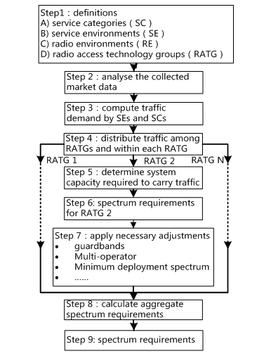
Figure 1
Flow chart ofITU-R M.1768-1 Methodology

This software consists of 27 worksheets and seven modules of macros. The software's main worksheet is the first worksheet which the operational modules of macros are located therein. The software has two types of input. A series of input are variable in time and place and usage patterns, such as data which are related to services attributes or applications or technical and operational parameters of radio systems, of which this data shall be estimated for the considered time and completed exactly in the relevant worksheets and another series of input are independent from time and once define in system. After entering the first type data in system, respectively, the modules of macros in the first page shall be executed until the software estimates the spectrum. As an example and according to technical parameters mentioned in report ITU-R M.2289 and the world averages of market data mentioned in report ITU-R M.2078, the software has been estimated the required spectrum for IMT in 2020. User guide of this software is also mentioned in 5D Working Group in ITU Site with the following address:
http://www.itu.int/ITU-R/index.asp?category=study-groups&rlink=rwp5d&lang=en

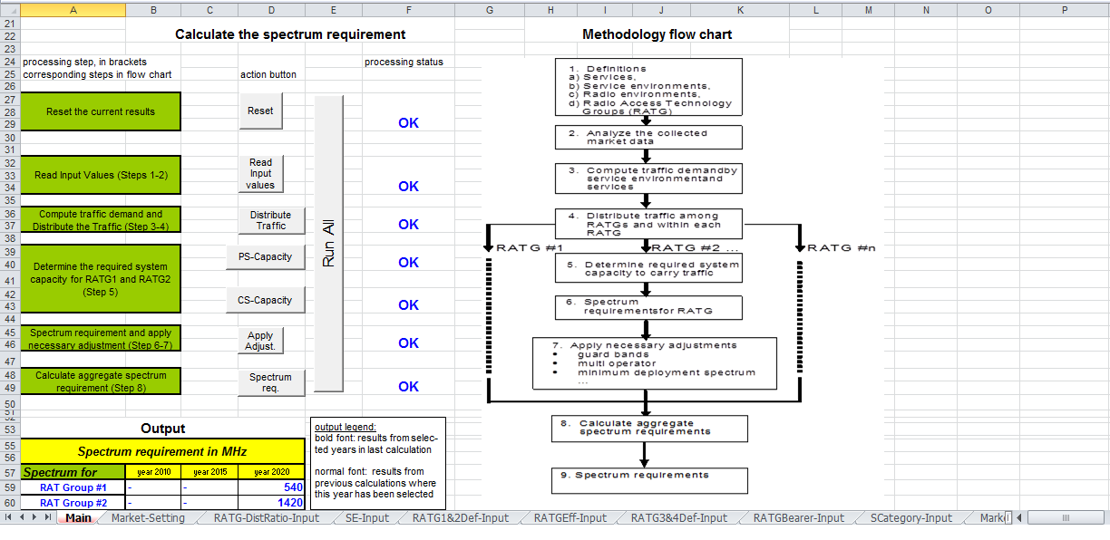
Figure 2
Main Worksheet of the IMT Spectrum Requirement Estimation Software
Iran has also proceeded for implementing the presented model in recommendation ITU-R M.1768-1 in C Sharp (#C). Considering the necessity of eliciting the input of the spectrum estimation software such as services attributes or applications or technical and operational parameters of radio systems from user traffic Consumption real patterns and also the real implementation of radio systems performed by mobile operators and their further plans and as per the best authority for gathering data, are mobile operators, the software has been planned in the way that step-by-step receives the required input for estimating the spectrum as a flexible E-questionnaire from operators and then the regulator review the input registered by operators and also perform the necessary amendments and proceed the data aggregation regarding with the spectrum estimation.

Suggestion:
Considering the importance of estimating the required spectrum for IMT in order to policy and plan regulators for supplying the required spectrum of IMT networks and also declaring for the required spectrum of countries membered in SATRC to regional and international councils in order to make accurately decision regarding with Agenda Item 1.1 of WRC-2015, it is hereby suggested to proceed for estimating the required spectrum for IMT in 2020 and in accordance with the methodology mentioned in recommendation ITU-R M.1768-1 and send their results within the next two months in order to prepare report entitled "SATRC Report on spectrum requirements for IMT". Also Iran is ready to send the E-questionnaire within the next two weeks as the applicant country and in the case of completing the questionnaire and sending it, it can be estimated the required spectrum.

